

**MINISTRY OF**

**EDUCATION AND TRAINING**

**FPT UNIVERSITY**

Capstone Project Document

**Online Storytelling Generator System**

|  |  |
| --- | --- |
| **GROUP 16** | |
| **Group members** | Bùi Đức Tài – SE62836 (Leader)  Trần Hà Trâm Anh – SE141171  Nguyễn Tấn Đạt – SE61735  Nguyễn Viết Hải - SE62107 |
| **Supervisor** | Nguyễn Duy Thanh |
| **Ext. Supervisor** | N/A |
| **Capstone Project code** | StoryArt |

- Ho Chi Minh City, ***21th April, 2020*** -

*This page is intentionally left blank*

Table of Contents

List of Figures 7

List of Tables 12

A. Introduction 18

1. Project Information 18

2. Introduction 18

3. Current Situation 18

4. Problem Definition 18

5. Proposed Solution 19

5.1. Feature functions 19

5.2. Advantages and disadvantages 19

6. Functional Requirements 20

7. Role and Responsibility 20

B. Software Project Management Plan 21

1. Problem definition 21

1.1. Name of this Capstone Project 21

1.2. Problem Abstract 21

1.3. Project Overview 21

2. Project Organization 24

2.1. Software Process Model 24

2.2. Roles and Responsibilities 25

2.3. Tools and Techniques 26

3. Project Management Plan 26

3.1. Product Backlog 26

3.2. Sprint Backlog 26

3.3. All Meeting Minutes 26

4. Project Management Plan 26

C. Software Requirement Specification 27

1. User Requirement Specification 27

1.1. Guest Requirement 27

1.2. User Requirement 27

1.3. Admin Requirement 28

1.4. System Admin Requirement 28

2. System Requirement Specification 28

2.1. External Interface Requirement 28

2.2. System Overview Use Case 29

2.3. List of use case 31

3. Software System Attribute 128

3.1. Usability 128

3.2. Reliability 128

3.3. Availability 128

3.4. Security 128

3.5. Maintainability 128

3.6. Portability 128

3.7. Performance 128

4. Conceptual Diagram 129

D. Software Design Description 129

1. Design Overview 129

2. System Architectural Design 130

2.1. Web Application Architectural Description 130

2.2. Web Service Architectural Description 131

3. Component Diagram 131

4. Detailed Description 132

4.1. Class Dictionary 134

4.2. Class Diagram Explanation 135

4.3. Interaction Diagram 144

5. Interface 150

5.1. Guest 150

5.2. User 161

5.3. Administrator 187

5.4. System admin 203

6. Database Design 206

6.1. Entity Relationship Diagram 206

6.2. Data Dictionary 208

7. Algorithms 208

7.1. Find users the others users that have similar stories rating 208

7.2. Predicting stories rating for requested user 212

E. System Implementation & Test 215

1. Introduction 215

1.1. Overview 215

1.2. Test Approach 215

2. Data Relationship Diagram 216

2.1. Physical Diagram 216

2.2. Database Diagram Explanation 219

3. Test Plan 225

3.1. Feature to be tested 225

3.2. Feature not to be tested 225

4. System testing test case 225

4.1. <User> Story test 226

4.2. <User> Comment test 228

4.3. <User> Reaction test 228

4.4. <User, Adminstrator> Report test 228

4.5. <Administrator> Tag test 229

4.6. <Guest, User, Administrator, System Admin> User test 230

F. Software User’s Manual 239

1. Installation Guide 239

1.1. Setting up environment at server side 239

1.2. Deployment at server side 240

1.3. Setting up environment at client side 242

2. User Guide 243

2.1 System Admin 243

2.2 Administrator 246

2.3 User 254

2.4 Guest 265

G. Appendix 268

# List of Figures

Figure 1 - Scrum Process 25

Figure 2 – System overview use case 30

Figure 3 - <Guest> Overview Use Case 31

Figure 4 - <Guest> Login 32

Figure 5 - <Guest> Register 34

Figure 6 - <Guest> Reset password 36

Figure 7 - <Guest> View other user’s profile 39

Figure 8 - <Guest> Search stories 41

Figure 9 - <Guest> View list stories 43

Figure 10 - <Guest> View story’s detail 44

Figure 11 - <Guest> Read story 47

Figure 12 - <Guest> Get story suggestions 49

Figure 13 - <User> Overview use case 52

Figure 14 - <User> Generate story 53

Figure 15 - <User> View own story list 57

Figure 16 - <User> View story statistics 58

Figure 17 - <User> Change story publishing status 60

Figure 18 - <User> Delete story 61

Figure 19 - <User> Update story 63

Figure 20 - <User> Edit profile 68

Figure 21 - <User> Logout 71

Figure 22 - <User> Change password 73

Figure 23 - <User> Rate story 75

Figure 24 - <User> View history 77

Figure 25 - <User> Send comment 78

Figure 26 - <User> Update comment 80

Figure 27 - <User> Delete comment 82

Figure 28 - <User> Report comment 84

Figure 29 - <User> Report story 86

Figure 30 - <User> Like/Dislike comment 88

Figure 31 - <User> View own profile 90

Figure 32 - <Administrator> Overview use case 93

Figure 33 - <Administrator> View user list 93

Figure 34 - <Administrator> Deactivate/activate user account 94

Figure 35 - <Administrator> Create user 96

Figure 36 - <Administrator> View list reports 98

Figure 37 - <Administrator> View report detail 101

Figure 38 - <Administrator> Handle report 104

Figure 39 - <Administrator> View list tags 106

Figure 40 - < Administrator > Add Tag 108

Figure 41 - < Administrator > Update Tag 110

Figure 42 - < Administrator > Activate/Deactivate tag 112

Figure 43 - <System admin> Overview use case 114

Figure 44 - <System admin> View admin list 114

Figure 45 - <System admin> Deactivate/activate admin 116

Figure 46 - <System admin> Create admin 118

Figure 47 - <System handler> Overview use case 121

Figure 48 - <System handler> Suggest stories 121

Figure 49 - <System handler> Collect user’s activities 124

Figure 50 - <System handler> Hanlde reading process 126

Figure 51 – Conceptual diagram 129

Figure 52 - System Architectural Design 130

Figure 53 – System Component Diagram 131

Figure 54 – Class diagram 133

Figure 55 - <Interaction diagram> Register 144

Figure 56 - <Interaction diagram> Login 144

Figure 57 - <Interaction diagram> Generate story 145

Figure 58 - <Interaction diagram> Read story 146

Figure 59 - <Interaction diagram> Send comment 146

Figure 60 - <Interaction diagram> Create tag 146

Figure 61 - <Interaction diagram> Update tag 147

Figure 62 - <Interaction diagram> Update admin 147

Figure 63 - <Interaction diagram> Update user 148

Figure 64 - <Interaction diagram> Create admin 148

Figure 65 - <Interaction diagram> Create user 149

Figure 66 - <Interaction diagram> Get story suggestions 149

Figure 67 - <Interaction diagram> Handle report 150

Figure 68 - <Interaction diagram> Edit user profile 150

Figure 69 - <Guest> Menu bar interface 150

Figure 70 - <Guest> Login interface 151

Figure 71 - <Guest> Register interface 152

Figure 72 - <Guest> Homepage interface 153

Figure 73 - <Guest> Submit email interface 154

Figure 74 - <Guest> Reset password interface 155

Figure 75 - <Guest> Navigation interface 155

Figure 76 - <Guest> Story detail interface 156

Figure 77 - <Guest> Search story interface 157

Figure 78 - <Guest> Select tag interface 159

Figure 79 - <Guest> Introduction screen interface 159

Figure 80 - <Guest> Content screen interface 160

Figure 81 - <Guest> End screen interface 160

Figure 82 - <User> User menu interface 161

Figure 83 - <User> User settings menu interface 162

Figure 84 - < User > User navigation interface 162

Figure 85 - < User > User history navigation interface 163

Figure 86 - < User > User reading history tab interface 164

Figure 87 - < User > User comment history tab interface 165

Figure 88 - < User > User edit comment dialog interface 166

Figure 89 - < User > User delete comment dialog interface 167

Figure 90 - < User > User reaction history tab interface 168

Figure 91 - < User > User delete reaction dialog interface 168

Figure 92 - < User > User introduction interface 169

Figure 93 - < User > User stories view statictic interface 169

Figure 94 - < User > User’s stories search interface 170

Figure 95 - < User > User’s story settings interface 172

Figure 96 - < User > User edit profile interface 173

Figure 97 - < User > User change password interface 174

Figure 98 - < User > User report story interface 175

Figure 99 - <User> Create story navigation interface 176

Figure 100 - <User> Story introduction detail tab interface 178

Figure 101 - <User> Select tag interface 179

Figure 102 - < User >Embed video interface 179

Figure 103 - < User >Add story information interface 180

Figure 104 - < User >Story screens detail tabinterface 184

Figure 105 - < User > Preview screen interface 186

Figure 106 - <Admin> View user account 187

Figure 107 - <Admin> Add user account interface 188

Figure 108 - <Admin> Deactive/active user 188

Figure 109 - <Admin>Admin menu interface 189

Figure 110 - <Admin> Admin settings menu interface 189

Figure 111 - < Admin > Admin navigation interface 190

Figure 112 - <Admin> View story list interface 191

Figure 113 - < User > Story settings interface 192

Figure 114 - < Admin> Admin report navigation interface 193

Figure 115 - <Admin> View comment report tab interface 194

Figure 116 - < Admin> Admin handle comment report dialog interface 195

Figure 117 - < Admin> Admin handle options menu interface 196

Figure 118 - <Admin> View story report tab interface 196

Figure 119 - < Admin> Admin handle story report dialog interface 198

Figure 120 - < Admin> Admin handle options menu interface 199

Figure 121 - <Admin> View tag list interface 200

Figure 122 - <Admin> Add tag dialog interface 201

Figure 123 - <Admin> Add tag dialog interface 202

Figure 124 - <Admin> Tag status menu interface 203

Figure 125 - <System Admin> System admin navigation interface 203

Figure 126 - <System Admin> View admin list interface 204

Figure 127 - <System Admin> Add admin account interface 205

Figure 128 - <Admin> Deactive/active admin 206

Figure 129- Entity Relationship Diagram 207

Figure 130 - Finding most similar algorithm 212

Figure 131 - Suggesting user algorithm 215

Figure 132 – Physical Diagram 217

Figure 133 - Configure eureka server 240

Figure 134 – Configure api gateway service 241

Figure 135 – Configure story service 241

Figure 136 – Configure user service 242

Figure 137 – Configure comment service 242

Figure 138 - <Admin> View admin list 243

Figure 139 - <Admin> Create admin guide 244

Figure 140 - <Admin> Deactivate/Activate admin 245

Figure 141 - <Admin> View user list 246

Figure 142 - <Admin> Create user guide 247

Figure 143 - <Admin> Deactivate/activate user 248

Figure 144 - <Admin> View story list 249

Figure 145 - <Admin> Deactivate/activate story 250

Figure 146 - <Admin> View report list 251

Figure 147 - <Admin> Handle report 251

Figure 148 - <Admin> View tag list 252

Figure 149 - <Admin> Create tag guide 253

Figure 150 - <Admin> Update tag guide 254

Figure 151 - <User> Generate story guide 255

Figure 152 - <User> Rate story guide 255

Figure 153 - <User> Send comment guide 256

Figure 154 - <User> Report story guide 257

Figure 155 - <User> Report comment guide 258

Figure 156 - <User> Edit comment guide 259

Figure 157 - <User> Edit comment guide 260

Figure 158 - <User> View profile guide 261

Figure 159 - <User> Edit profile guide 263

Figure 160 - <User> View story’s statistics guide 265

Figure 161 - <Guest> Search story guide 266

Figure 162 - <Guest> Search story guide 268

# List of Tables

Table 1 - Role and Responsibility 21

Table 2 - Hardware Requirements for Server 23

Table 3 - Hardware requirement for PC 23

Table 4 - Software Requirement 24

Table 5 - Role and Responsibilities Details 26

Table 6 - Tools and Techniques 26

Table 7 - <Guest> Login use case specification 33

Table 8 - <Guest> Register use case specification 36

Table 9 - <Guest> Reset password usecase specification 38

Table 10 - <Guest> View other user’s profile use case specificaion 40

Table 11 - <Guest> Search stories use case specification 42

Table 12 - <Guest> View list stories use case specification 44

Table 13 - <Guest> View story’s detail use case specification 47

Table 14 - <Guest> Read story use case specification 48

Table 15 - <Guest> Get story suggestions use case specification 52

Table 16 - <User> Generate story use case specification 57

Table 17 - <User> View own story list use case specification 58

Table 18 - <User> View story statistics use case specification 60

Table 19 - <User> Change story publishing status use case specification 61

Table 20 - <User> Delete story use case specification 63

Table 21 - <User> Update story use case specification 67

Table 22 - <User> Edit profile use case specification 71

Table 23 - <User> Logout use case specification 73

Table 24 - <User> Change password use case specification 75

Table 25 - <User> Rate story use case specification 76

Table 26 - <User> View history use case specification 78

Table 27 - <User> Send comment use case specification 80

Table 28 - <User> Update comment use case specification 82

Table 29 - <User> Delete comment use case specification 83

Table 30 - <User> Report comment use case specification 86

Table 31 - <User> Report story use case specification 88

Table 32 - <User> Like/Dislike comment use case specification 90

Table 33 - <User> View own profile use case specification 92

Table 34 - <Administrator> View user list use case specification 94

Table 35 - <Administrator> Deactivate/activate user account use case specification 96

Table 36 - <Administrator> Create user use case specification 98

Table 37 - <Administrator> View list reports use case specification 101

Table 38 - <Administrator> View report detail use case specification 104

Table 39 - <Administrator> Handle report use case specification 106

Table 40 - <Administrator> View list tags use case specification 107

Table 41 - <Administrator> Add tag use case specification 109

Table 42 - <Administrator> Update tag use case specification 111

Table 43 - <Administrator> Activate/Deactivate tag use case specification 114

Table 44 - <System admin> View admin list use case specification 116

Table 45 - <System admin> Deactivate/activate admin use case specification 117

Table 46 - <System admin> Create admin use case specification 120

Table 47 - <System handler> Suggest stories use case specification 123

Table 48 - <System handler> Collect user’s activities use case specification 126

Table 49 - <System handler> Handle reading process use case specification 128

Table 50 - System Component Dictionary 132

Table 51 - Class Diagram Dictionary 134

Table 52 - Story Attribute 135

Table 53 - Story Method 135

Table 54 - Report Attribute 136

Table 55 - Report Method 136

Table 56 - Comment Attribute 136

Table 57 - Comment Method 137

Table 58 - Reaction Attribute 137

Table 59 - Reaction Method 137

Table 60 - User Attribute 138

Table 61 - User Method 138

Table 62 - Role Attribute 138

Table 63 - Role Method 138

Table 64 - Rating Attribute 138

Table 65 - Rating Method 139

Table 66 – Reading History Attribute 139

Table 67 – Reading History Method 139

Table 68 - Tag Attribute 139

Table 69 - Tag Method 139

Table 70 - Screen Attribute 140

Table 71 - Screen Method 140

Table 72 - Action Attribute 140

Table 73 - Action Method 141

Table 74 – Information Action Attribute 141

Table 75 - Information Action Method 141

Table 76 - Information Attribute 142

Table 77 - Information Method 142

Table 78 - Information Condition Attribute 142

Table 79 - Information Condition Method 142

Table 80 – Screen Reading Time Attribute 143

Table 81 - Screen Reading Time Method 143

Table 82 – Story Tag Attribute 143

Table 83 - Story Tag Method 143

Table 84 – Click Link Attribute 143

Table 85 – Click Link Method 143

Table 86 - <Buttons/Hyperlinks> Story detail 157

Table 87 - <Fields> Search story 158

Table 88 - <Buttons/Hyperlinks> Search story 158

Table 89 - <Buttons/Hyperlinks> Select tag 159

Table 90 - <Buttons/Hyperlinks> Introduction screen 159

Table 91 - <Buttons/Hyperlinks> Content screen 160

Table 92 - <Buttons/Hyperlinks> End screen 161

Table 93 - <Buttons/Hyperlinks> User menu 161

Table 94 - <Buttons/Hyperlinks> User settings menu bar 162

Table 95 - <Buttons/Hyperlinks> User navigation 163

Table 96 - <Buttons/Hyperlinks> User history navigation 164

Table 97 - <Buttons/Hyperlinks> User reading history tab 165

Table 98 - <Buttons/Hyperlinks> User comment history tab 166

Table 99 - <Fields> User edit comment dialog 166

Table 100 - <Buttons/Hyperlinks> User edit comment dialog 167

Table 101 - <Buttons/Hyperlinks> User edit comment dialog 167

Table 102 - <Buttons/Hyperlinks> User comment history tab 168

Table 103 - <Buttons/Hyperlinks> User delete reaction dialog 169

Table 104 - <Buttons/Hyperlinks> User introduction 169

Table 105 - <Buttons/Hyperlinks> User stories view statistic 170

Table 106 - <Fields> View user’s stories 171

Table 107 - <Buttons/Hyperlinks> View user’s stories 171

Table 108 - <Buttons/Hyperlinks> User’s story settings interface 172

Table 109 - <Fields> User edit profile 173

Table 110 - <Buttons/Hyperlinks> User edit profile 174

Table 111 - <Fields> User change password 174

Table 112 - <Buttons/Hyperlinks> User change password 175

Table 113 - <Fields> User report story 175

Table 114 - <Buttons/Hyperlinks> User report story 175

Table 115 - <Buttons/Hyperlinks> Create story navigation 176

Table 116 - <Fields> Story introduction detail tab 178

Table 117 - <Buttons/Hyperlinks> Story introduction detail tab 178

Table 118 - <Buttons/Hyperlinks> Select tag 179

Table 119 - <Fields> Embed video 180

Table 120 - <Buttons/Hyperlinks> Embed video 180

Table 121 - <Fields> Add story information 181

Table 122 - <Buttons/Hyperlinks> Add story information 182

Table 123 - <Fields>Story screens detail tab 184

Table 124 - <Buttons/Hyperlinks>Story screens detail tab 185

Table 125 - <Buttons/Hyperlinks> Preview screen 186

Table 126 - <Fields> View user list 187

Table 127 - <Buttons/Hyperlinks> View user list 187

Table 128 - <Fields> Add user 188

Table 129 - <Buttons/Hyperlinks> Add user 188

Table 130 - <Buttons/Hyperlinks> Deactive/active user 189

Table 131 - <Buttons/Hyperlinks> User menu 189

Table 132 - <Buttons/Hyperlinks> Admin settings menu bar 190

Table 133 - <Buttons/Hyperlinks> Admin navigation 190

Table 134 - <Fields> View stories 191

Table 135 - <Buttons/Hyperlinks> View user’s stories 192

Table 136 - <Buttons/Hyperlinks> Story settings 193

Table 137 - <Buttons/Hyperlinks> Admin report navigation 193

Table 138 - <Fields> View stories 194

Table 139 - <Buttons/Hyperlinks> View user’s stories 194

Table 140 - <Buttons/Hyperlinks> Admin handle comment report dialog 195

Table 141 - <Buttons/Hyperlinks> Admin handle option menu 196

Table 142 - <Fields> View stories 197

Table 143 - <Buttons/Hyperlinks> View user’s stories 197

Table 144 - <Buttons/Hyperlinks> Admin handle comment report dialog 199

Table 145 - <Buttons/Hyperlinks> Admin handle option menu 199

Table 146 - <Fields> View tag list 200

Table 147 - <Buttons/Hyperlinks> View tag list 200

Table 148 - <Fields> View tag list 201

Table 149 - <Buttons/Hyperlinks> Add tag 201

Table 150 - <Fields> Edit tag 202

Table 151 - <Buttons/Hyperlinks> Edit tag 202

Table 152 - <Buttons/Hyperlinks> Tag status menu 203

Table 153 - <Buttons/Hyperlinks> System admin navigation 203

Table 154 - <Fields> View admin list 204

Table 155 - <Buttons/Hyperlinks> View admin list 205

Table 156 - <Fields> Add admin 205

Table 157 - <Buttons/Hyperlinks> Add admin 206

Table 158 - <Buttons/Hyperlinks> Deactive/active admin 206

Table 159 - Entity Relationship Diagram Dictionary 208

Table 160 – The matrix information of the stories and rating each user has rated 209

Table 161 – Information of the average of each user has rated 210

Table 162 – The matrix information of the stories and rating each user has rated after normalized 211

Table 163 – Predict rate of requested user to each stories before 214

Table 164 – Predict rate of requested user to each stories 214

Table 165 - Physical Diagram Dictionary 219

Table 166 - Story Attribute 219

Table 167 - User Attribute 220

Table 168 - Report Attribute 220

Table 169 - Screen Attribute 221

Table 170 - Tag Attribute 221

Table 171 - Action Attribute 221

Table 172 - Information Attribute 222

Table 173 – Info_condition Attribute 222

Table 174 – Information_action Attribute 222

Table 175 - Comment Attribute 223

Table 176 - Reaction Attribute 223

Table 177 - Story_tag Attribute 223

Table 178 - Reading_history Attribute 224

Table 179 - Role Attribute 224

Table 180 – Screen_reading_time Attribute 224

Table 181 – Click_link Attribute 224

Table 182 – Rating Attribute 225

Table 183 - <User> Story test 228

Table 184 - <User> Comment test 228

Table 185 - <User> Reaction test 228

Table 186 - <User, Administrator> Report test 229

Table 187 - <Administrator> Tag Test 230

Table 188 - <Guest, User, Administrator, System Admin> User Test 238

Table 189 - Hardware requirement for server 239

Table 190 - Software requirement for server 239

Table 191 - <Admin> View admin list 243

Table 192 - <Admin> Create admin guide 244

Table 193 - <Admin> Deactivate/Activate admin 245

Table 194 - <Admin> View user list 246

Table 195 - <Admin> Create user guide 247

Table 196 - <Admin> Deactivate/activate user 248

Table 197 - <Admin> View user list 249

Table 198 - <Admin> Deactivate/activate story 250

Table 199 - <Admin> View report list 251

Table 200 - <Admin> Handle report 252

Table 201 - <Admin> View tag list 252

Table 202 - <Admin> Create tag guide 253

Table 203 - <Admin> Update tag guide 254

Table 204 - <User> Generate story guide 255

Table 205 - <User> Rate story guide 256

Table 206 - <User> Send comment guide 256

Table 207 - <User> Report story guide 257

Table 208 - <User> Report comment guide 258

Table 209 - <User> Edit comment guide 259

Table 210 - <User> Edit comment guide 260

Table 211 - < User > View profile guide 261

Table 212 - <User> Edit profile guide 263

Table 213 - < User > View story’s statistics guide 265

Table 214 - <Guest> Search story guide 266

Table 215 - <Guest> Search story guide 268

# A. Introduction

## 1. Project Information

* Project Name: **Online storytelling generator system**
* Project code: **StoryArt**
* Product Type: **Website Application, Web Service**
* Start Date: **January 14th, 2020**
* End Date: **April 30th, 2020**

## 2. Introduction

The world has evolved from sign language to the written language with the pupose to store, pass-on knowledge and inspire the next generation. The traditional way of telling story was one-way from the author to the reader, what if we can enable author to generate altenative ending, a story-line that can be spread to multiple direction instead of one direction?

We introduce a platform that enable author to generate interactive story, with audio, visual effect, and multiple storyline. Imagine, as an author, you can build a thrilling adventure, where your characters can have alternative actions of their owns and different storyline can evolve; and as a reader, you’re in an adventure where the character’s next destination is your choice. Your story will never be left untold.

## 3. Current Situation

There are many tools in the market that enable author to generate their stories but those tools can’t meet up their expectation and can’t express all the authors’ idea. With traditional stories telling, it seems not to be able to attract readers anymore, our platform support the tool for generating a story with interaction, audio, video effect, multi storyline and the power to publish it. The written stories can be used for many kind of aspects such as marketing, education, game, entertainment.

## 4. Problem Definition

Below are the disadvantages of the current situation:

* Lack of meaningful contents: Internet is filled with boring contents and many of these wasted our time.
* No interaction between visitor and story: Visitor usually read stories written by an author from start to end without interactions or deflect the story line. It makes the story became normally and boring.
* Low-educational contents: Can’t touch much by these online stories.
* Need of high-quality marketing content: People are bothered and even uncomfortable by dozens of advertisements per day in a website.

## 5. Proposed Solution

Our solution is web application named “StoryArt”. It assists authors to post their story, advertisement or even game in a convenient and reliable place to make visitor relaxed and advertise their products.

### 5.1. Feature functions

* Provide tools to generate/create story.
* Search/suggest stories.
* View/interact stories.
* Manage stories.
* Rate stories.
* View story statistics.

### 5.2. Advantages and disadvantages

The advantages and disadvantages of the proposed solution:

* **Advantages:**
* Easy to search stories by tag.
* Provide the the creative ways for authors to generate the story. The authors can create their stories by their own way combining the screen, options, information, animation.
* Stories recommendation based on user’s ratings can bring to user many suitable, interesting stories.
* Brings out a whole new experience of reading stories to end users. Users will be interested in the storyline that lead them to surprise.
* A game can be created for the end users to play while reading the story.
* The authors can bring their business brands to the stories for marketing purpose so that their business can spread out to customers easily and naturally.
* Provide a channel for education: the website contains the stories that bring out the useful meaning to readers. They will learn a lot and enhance the knowledge by reading the high-educational stories.
* **Disadvantages:**
* Do not manage to authenticate links inputted in story.
* Do not check the content of users’ stories before publishing. The content will be checked after system received users’ reports.
* The format of creating the story may be complicated to authors because they have to generate the screen, information, animation along with the content they input.
* New users visit the website may not understand the idea of interactive storytelling, so the website need to serve the demo when users first come to website.
* Some administrator function need to do manually.

## 6. Functional Requirements

Function requirements of the system are listed as below:

* **Authentication and Authorization:**
* Authenticate and authorize users to use configuration and management functions**.**
* **Admin:**
* Manage users.
* Manage users’ stories.
* **Data Collector:**
* Collect data from users by tracking their activities like: click link, time reading per screen, …
* **Data Analytic:**
* Automatically analyze collected data by applying recommendation algorithms.
* Automatically analyze collected data for viewing story’s statistics.
* **Users:**
* Search stories to read.
* Get story suggestions based on their questionnaires.
* Get story trends.
* Interact with the story while reading (select options, input information).
* Manage their own stories (create, publish, delete, deactivate, update).
* **System admin:**
* Manage admin (create, deactivate/activate).

## 7. Role and Responsibility

|  |  |  |  |  |
| --- | --- | --- | --- | --- |
| **No** | **Full name** | **Role** | **Position** | **Contact** |
| 1 | Nguyễn Duy Thanh | Project Owner | Advisor | hello@nguyenduythanh.com |
| 2 | Bùi Đức Tài | Scrum Master | Leader | taibdse62836@fpt.edu.vn |
| 3 | Trần Hà Trâm Anh | Developer | Member | anhthtse141171@fpt.edu.vn |
| 4 | Nguyễn Tấn Đạt | Developer | Member | datntse61735@fpt.edu.vn |
| 5 | Nguyễn Viết Hải | Developer | Member | hainvse62107@fpt.edu.vn |

Table 1 - Role and Responsibility

# B. Software Project Management Plan

## 1. Problem definition

### 1.1. Name of this Capstone Project

* Official name: Online storytelling generator system
* Vietnamese name: Hệ thống tạo nội dung kể chuyện trực tuyến
* Abbreviation: StoryArt

### 1.2. Problem Abstract

We provide Online storytelling generator system (StoryArt). StoryArt is a website containing stories and games. StoryArt will let authors create their own stories and games then show them up to visitors to read and play. StoryArt’s main characteristics focus in which stories that contains highly educated, marketing and entertaining contents. StoryArt lets author to create games that has points is defined as a parameter in story. StoryArt provides suggestions based on users’ ratings, the current trend of stories.

Authors can create a story having multiple storylines. StoryArt let author to divide their story into many chapters as they want. In the end of each chapter except these final chapters will have a few options that allow readers to choose what they expect to read next. A storyline is created by connected chapters from start of the story to the end.

StoryArt helps author manipulate their stories and games by providing mechanism of creating multistep story, animation, store and suggest them to proper visitors. StoryArt collects data about ratings to recommend useful and suitable contents.

### 1.3. Project Overview

#### 1.3.1. Current Situation

Below are the problems encountered in this project:

* **Absence of team member:** team member absence in meeting schedule because of class or work schedule, etc.
* **New technique:** Some team members are new to the techniques used in project. We need a lot of time to training.
* **Reliability:** It is hard to confirm information of user or product. We should build something to reduce risk can happen.
* **Lack of experience in writing story:** No one in team members have ability to write a story, so we have some problem in how the story is created. We need a lot of time to research and read more stories.
* **Lack of knowledge of AI:** No one in the team have deep understanding about Machine Learning.

#### 1.3.2. The Proposed System

Our proposed solution is to build an online storytelling generator system named StoryArt to resolve the current situations by allowing user to create their own stories in creative way that can interact with readers, searching stories by category, receiving recommended stories, managing their own stories, rating stories. As for administrators, they can manage stories by viewing stories’ reports, deleting stories. Besides, they can manage users by viewing user’ profile, receiving and processing all problems about users, banning users.

Our system consists of four main subsystems: Website for users to create, read, interact and manage their stories, web application for administrators, web application for system admin and web services to process requests.

#### 1.3.3. Boundaries of the System

The system can:

* Provide tools for users can create their stories in creative way.
* Allow users to read and interact with the story.
* Allow users to search for stories by story name, author name, multiple tags.
* Allow users to get trending stories.
* Allow users to rate, report the story.
* Allow users to comment in story.
* Allow users to report, react comment.
* Allow admin to manage users, stories, reports, tags.
* Recommend suitable stories users based on the similarities among users and stories.

The system cannot:

* Check the content in story before it is published.

#### 1.3.4. Future Plans

* Current system only runs on website. We will support mobile application in the future.
* We will provide tools and staffs to check the content in story before publishing.
* We will support multiple paramenters in story.
* We will support real-time update.
* Some charity activities in our website need to create donation method, they need to use some third-party website. We will design a system to help user can donate online:
  + Donate by user ‘s wallet: each user has personal wallet to store money in system.
  + Donate by third partner: user can pay online by third partner (Nganluong.vn, baokim.vn, payoo.vn, momo, …).

#### 1.3.5. Development environment

##### 1.3.5.1. Hardware requirements

* **For server**

|  |  |  |
| --- | --- | --- |
| **Hardware** | **Minimum Requirement** | **Recommended** |
| Internet Connection | Cable, Wi-Fi (8 Mbps) | Cable, Wi-Fi (32 Mbps or more) |
| Operation System | XP, Vista, 7, 10, Window Server 2008 | 10, Window server 2008 |
| Computer Processor | Intel® Xeon ® 1.4GHz | Intel® Xeon ® Quad Core (12M Cache, 2.50 GHz) or above |
| Computer memory | 4GB RAM | 8 GB RAM or more |
| Storage space | 1GB | 5GB or more |

Table 2 - Hardware Requirements for Server

* **For PC**

|  |  |  |
| --- | --- | --- |
| **PC** | **Minimum Requirements** | **Recommended** |
| Internet Connection | Cable, Wi-Fi (4 Mbps) | Cable, Wi-Fi (8 Mbps or more) |
| Operating System | Window 7, IOS 9 | Windows 10, IOS 10. |
| Computer Processor | Intel® Core i3 1.4GHz | Intel® Core i5 2.50GHz or above |
| Computer Memory | 4GB RAM | 8GB RAM or more |
| Web Browser | Chromes (v42 or higher) | Chrome latest stable version |

Table 3 - Hardware requirement for PC

##### 1.3.5.2. Software requirement

|  |  |  |
| --- | --- | --- |
| **Software** | **Name / Version** | **Description** |
| Operation System | Windows 10 | Operating system and platform for development |
| Environment | Java EE 8.0, NodeJS v10, npm v6 | Specification for developing web application and mobile application |
| Modeling tool | Lucid Chart | Used to design diagram |
| IDE | IntelliJ IDEA 2019.1.4, Visual Studio Code | Programming tools |
| DBMS | MySQL WorkBench | Used to create & manage the database for system |
| Source control | GitHub/Git cmd/Git SCM | Used for source control |
| Web browser | Chrome 69 or above | Testing browser |

Table 4 - Software Requirement

## 2. Project Organization

### 2.1. Software Process Model

This project is developed using Scrum model for Software development project. Our team choose Scrum model because of the following reasons:

* Our team only has 4 members and with this model we can communicate and working together more frequently.
* Team can change project’s priorities after every sprint
* Scrum model is easy to learn and also reduce the risk of building the product by increments.
* With nature of our project problem in data transferring and interface, the intermediate product can be shown to the Project Owner after each sprint so he can estimate it.

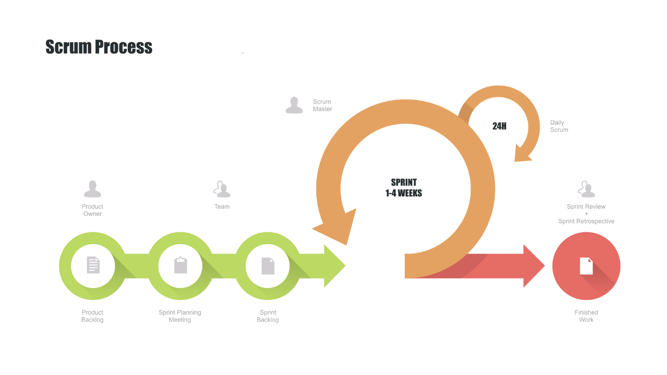

Figure 1 - Scrum Process

### 2.2. Roles and Responsibilities

|  |  |  |  |
| --- | --- | --- | --- |
| **No** | **Full name** | **Role in Group** | **Responsibilities** |
| **1** | Nguyễn Duy Thanh | Project Owner | * Specifying user requirements * Controlling the development process * Giving out technique and business analysis support |
| **2** | Bùi Đức Tài | Scrum Master | * Managing process * Designing database * Clarifying requirements * Preparing documents * Designing GUI * Creating test plan * Coding * Testing * Arranging Meeting * Managing Risks |
| **3** | Nguyễn Tấn Đạt | Developer | * Designing database * Clarifying requirements * Preparing documents * Designing GUI * Creating test plan * Coding * Testing |
| **4** | Nguyễn Viết Hải | Developer | * Designing database * Clarifying requirements * Preparing documents * Designing GUI * Creating test plan * Coding * Testing |
| **5** | Trần Hà Trâm Anh | Developer | * Designing database * Clarifying requirements * Preparing documents * Designing GUI * Creating test plan * Coding * Testing |

Table 5 - Role and Responsibilities Details

### 2.3. Tools and Techniques

|  |  |
| --- | --- |
| **Tool/Technique** | **Name** |
| Front-end | HTML, CSS, JavaScript, React Js |
| Back-end | Java 8, Spring Framework |
| IDE | IntelliJ 2019.1.3 |
| DBMS | MySQL Workbench |
| Source Control | Github, Sourcetree, GitSCM |
| Modeling tool | StarUML, Lucid Chart |

Table 6 - Tools and Techniques

## 3. Project Management Plan

### 3.1. Product Backlog

All product backlogs could be found [here](https://drive.google.com/open?id=1g1sVXD5wHlbgvnjk9pgMSr8KxSgFNbRWOe9g_iEB2AM).

### 3.2. Sprint Backlog

All sprint backlogs could be found [here](https://drive.google.com/open?id=1g1sVXD5wHlbgvnjk9pgMSr8KxSgFNbRWOe9g_iEB2AM).

### 3.3. All Meeting Minutes

All meeting documents could be found [here](https://drive.google.com/open?id=1dbVwQsPsyON-LCWIJwRLc6yiFglWqVk-).

## 4. Project Management Plan

**Summary:**

* Naming Convention:
  + Variable names should be short yet meaningful. The choice of a variable name should be designed to indicate to the casual observer the intent of its use.
  + Methods should be verbs, in mixed case with the first letter lowercase, with the first letter of each internal word capitalized.
* Indentation:
  + One declaration per line is recommended since it encourages commenting.
  + In absolutely no case should variables and functions be declared on the same line.
  + Do not put different types on the same line.
* Declarations Convention:
  + One declaration per line is recommended since it encourages commenting.
  + Using Java Code Convention from:

[*http://www.oracle.com/technetwork/java/codeconvtoc-136057.html*](http://www.oracle.com/technetwork/java/codeconvtoc-136057.html)

# C. Software Requirement Specification

## 1. User Requirement Specification

### 1.1. Guest Requirement

Guest is a person who does not have access into the system. Guest can use most basic of web applications. Guest should have these following abilities:

* Search stories
* View list stories
* View story’s detail
* Read story
* Get story’s suggestions
* Log in
* Register
* Reset password

### 1.2. User Requirement

User is a guest who logged in to the system with the role “user”. User have ability to create story, judging story, comment, report, ... Member have all abilities like guest and allow performing more functions like these followings:

* Log out.
* Change password.
* View/ edit profile.
* Generate story.
* Update story.
* Delete/Hide story.
* Rate story.
* Comment.
* Like/dislike comment.
* Report comment.
* Report story.
* View statistics (story statistics).

### 1.3. Admin Requirement

Admin is a guest who logged in to the system with role “admin”. System admin have all abilities like guest and user. Admin have permission to monitor and control the system’s content and user like:

* Manage user’s accounts.
* Manage reports.
* Manage tags.
* Manage stories.

### 1.4. System Admin Requirement

System admin is a guest who logged in to the system with role “system admin”. System admin have all abilities like guest, user and admin. Admin have permission to manage user has role “admin” like:

* Manage admins.

## 2. System Requirement Specification

### 2.1. External Interface Requirement

#### 2.1.1. User Interface

The web application user interface will be in Vietnamese and provide the following components:

* GUI should be simple, clear and have recognizable elements.
* Intuitive navigation functions.
* User registration and user login page.
* Plain text field, dropdown box to search filter for recruitments.
* Page for user to manage profile, their stories and view statistics.
* Page for user can read story.
* Page for user can create story.
* Page for user can view list story.

The web administration user interface will be in Vietnamese and contain the following components:

* Intuitive navigation functions.
* Intuitive data table for each management function.
* Page for system admin manage admin.
* Pages for admin manage users, stories, reports, tags.

#### 2.1.2. Hardware Interface

N/A

#### 2.1.3. Software Interface

* Web application: browser Google Chrome (version 69 or higher) and Firefox (version 52 or higher).

#### 2.1.4. Communication Protocol

* HTTP protocol version 1.1 for communication between: web service and web application or mobile application that consumes the services.

### 2.2. System Overview Use Case

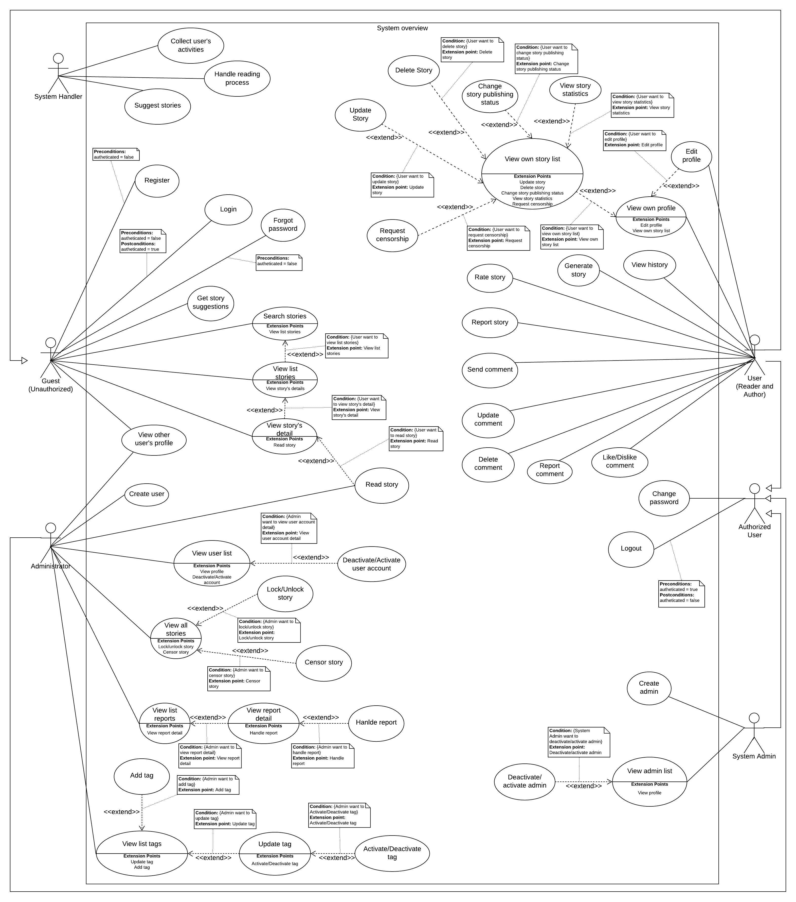

Figure 2 – System overview use case

### 2.3. List of use case

#### 2.3.1. <Guest> Overview Use Case

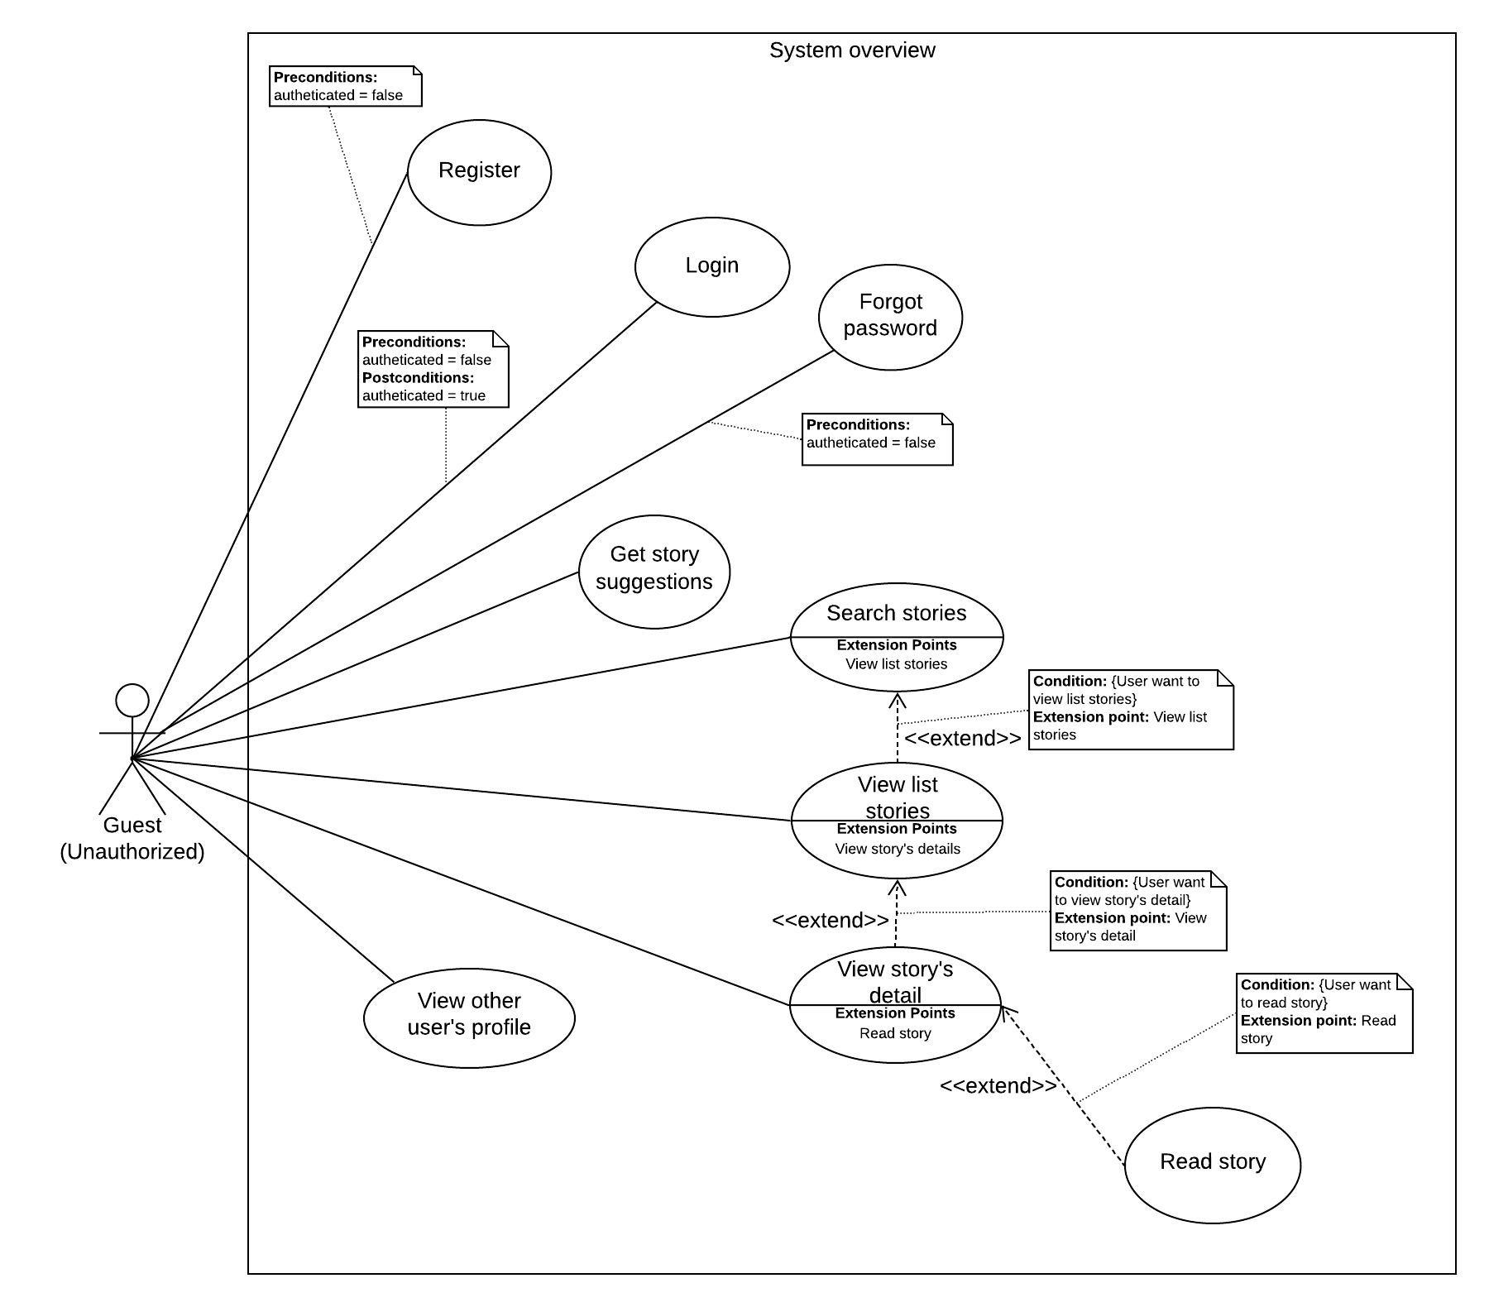

Figure 3 - <Guest> Overview Use Case

##### 2.3.1.1. Login

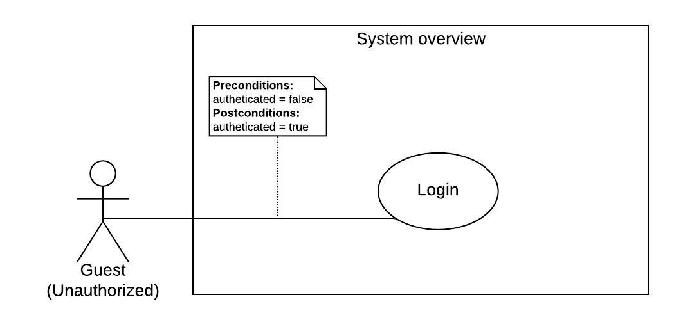

Figure 4 - <Guest> Login

|  |  |  |  |
| --- | --- | --- | --- |
| **USE CASE – StoryArt_G_01** | | | |
| **Use Case No.** | StoryArt_G_01 | **Use Case Version** | 2.0 |
| **Use Case Name** | Login | | |
| **Author** | AnhTHT | | |
| **Date** | 09/04/2020 | **Priority** | Normal |
| **Actor:**   * Guest   **Summary:**   * This use case allows guest to login the system.   **Goal:**   * Guest can login the system.   **Triggers:**   * Guest clicks on “Đăng nhập” button in home page.   **Preconditions:**   * Guest is not authenticated.   **Post conditions:**   * Guest is authenticated.   **Success:** Guest is exactly authorized with specific role in the system.  **Fail:** System shows error messages.  **Main Success Scenario:**   |  |  |  | | --- | --- | --- | | **Step** | **Actor Action** | **System Response** | | 1 | Guest click “Đăng nhập” on menu in home page. |  | | 2 | Guest goes to login view. | System requires identity information from Guest:  -Tên đăng nhập: blank text input  -Mật khẩu: blank text input | | 2 | Guest inputs information[Alternative 1,2] |  | | 3 | Guest click “Đăng nhập” button to login to system. | Guest logins into system with his/her specific role. [Exception 1,2] |   **Alternative Scenario: N/A**  **Exceptions:**   |  |  |  | | --- | --- | --- | | **No** | **Actor Action** | **System Response** | | 1 | Guest enters wrong password with entered username | System shows error message “Mật khẩu không đúng. Vui lòng nhập lại” | | 2 | Guest enters username and password of an account that deactived by adminstrator | System shows error message “Tài khoản của bạn đã bị khoá. Vui lòng liên hệ với quản trị viên” |   **Relationships:** **N/A**  **Business Rules:**  After login to system, guest will be redirected to specific view based on their role on the system: user, administrator or system administrator.  If role is “User”, the system will display user page.  If role is “Admin”, the system will display admin page.  If role is “System admin”, the system will display system admin page. | | | |

Table 7 - <Guest> Login use case specification

##### 2.3.1.2. Register

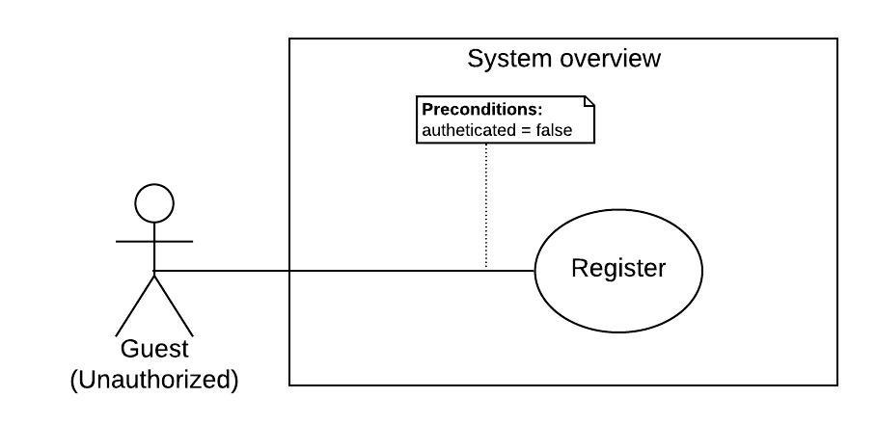

Figure 5 - <Guest> Register

|  |  |  |  |
| --- | --- | --- | --- |
| **USE CASE – StoryArt_G_02** | | | |
| **Use Case No.** | StoryArt_G_02 | **Use Case Version** | 2.0 |
| **Use Case Name** | Register | | |
| **Author** | AnhTHT | | |
| **Date** | 10/04/2020 | **Priority** | Normal |
| **Actor:**   * Guest   **Summary:**   * This use case allows guest to register account into the system.   **Goal:**   * Guest can register account into the system.   **Triggers:**   * Guest clicks on “Đăng ký” button in home page.   **Preconditions:**   * Guest not logged into the system.   **Post conditions:**   * Guest register successfully and system direct guest to login page.   **Success:** Guest success to register account.  **Fail:** System shows error messages.  **Main Success Scenario:**   |  |  |  | | --- | --- | --- | | **Step** | **Actor Action** | **System Response** | | 1 | Guest click “Đăng ký” on menu in home page. | System redirect guest to register view | | 2 | Guest inputs information[Alternative 1] | System requires identity information from Guest:  -Tên đăng nhập: blank text input  -Mật khẩu: blank text input  -Tên đầy đủ: blank text input  - Email: blank text input  - Thông tin giới thiệu về bạn: blank text input | | 3 | Guest click “Đăng ký” button to register to system. | Guest registers into system with his/her specific role and redirect guest to login page [Exception 1,2,3,4,5,6,7,8] |   **Alternative Scenario: N/A**  **Exceptions:**   |  |  |  | | --- | --- | --- | | **No** | **Actor Action** | **System Response** | | 1. 1 | Guest does not enter, enter blank or enter username not be between 3 and 15 characters. | System shows error message “Tên đăng nhập phải có từ 3 đến 15 ký tự ” | | 1. 22 | Guest does not enter , enters blank or enter name not be between 3 and 40 characters | System show error message “ Tên phải có từ 3 đến 15 ký tự” | |  | Guest does not enter , enters blank or enter password not be between 8 and 100 characters. | System show error message “Mật khẩu phải có từ 8 đến 100 ký tự” | | 1. 3 | Guest does not enter email or enters blank | System shows error message “Email không được để trống” | System shows error message “Tên đăng nhập không được để trống” | | 1. 5 | Guest enters email is not validated with email standard form | System show error message “Email không đúng định dạng. Vui lòng nhập lại” | |  | Guest enters an username used by another account | System shows error message “Tên đăng nhập này đã được đăng ký bởi ai đó” | |  | Guest enters an email used by another account | System shows error message “Email này đã được đăng ký bởi ai đó” | |  | Guest does not enter, enter blank or enter introduction information has not a maximum length of 300 characters | System shows error message “Thông tin giới thiệu có độ dài tối đa là 300 ký tự” |   **Relationships:** N/A  **Business Rules:**   * Introduction information has a maximum length of 300 characters. * Email must be validated email standard form. * Email must not be blank. * Name must be between 3 and 40 characters. * Username must be between 3 and 15 characters. * Password must be between 8 and 100 characters. * An email is only used to register for one person. * A username is only used to register for one person. | | | |

Table 8 - <Guest> Register use case specification

##### 2.3.1.3. Forgot password

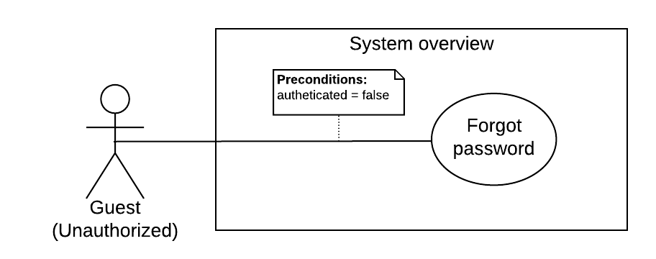

Figure 6 - <Guest> Forgot password

|  |  |  |  |
| --- | --- | --- | --- |
| **USE CASE – StoryArt_G_03** | | | |
| **Use Case No.** | StoryArt_G_03 | **Use Case Version** | 2.0 |
| **Use Case Name** | Forgot password | | |
| **Author** | AnhTHT | | |
| **Date** | 11/4/2020 | **Priority** | Normal |
| **Actor:**   * Guest   **Summary:**   * This use case allows guest to reset an account password   **Goal:**   * Guest can chage their password when they forgot it.   **Triggers:**   * Guest click “Đăng nhập in top menu of homepage”   **Preconditions:**   * Guest not logged into the system.   **Post conditions:**   * Success: System shows success message and rediect to home page logged with reset password account. * Fail: System shows error messages.   **Main Success Scenario:**   |  |  |  | | --- | --- | --- | | **Step** | **Actor Action** | **System Response** | | 1 | Guest clicks “Đăng nhập” button on top menu in home page. | System goes to login page. | | 2 | Guest clicks “Quên mật khẩu” button in login page. | System goes to forgot password page. System requires information from Guest:  - Email: blank text input | | 3 | Guest inputs email address. Guest clicks “Gửi hướng dẫn” button. | System show message that instruction has send to submited email[Exception 1,2] | | 4 | Guest clicks on reset password link from email receive from system email address. | System shows guest reset password page. [Exception 3]  System required guest enter :  - Mật khẩu mới: blank password input  -Nhập lại mật khẩu mới: blank password input | | 5 | Guest enter password and enter re-password field. |  | | 6 | Guest click on “Lưu thay đổi” button | System show message “Lưu thành công” and redirect guest to home page logged with reset password account. [Exception 4,5] |   **Exceptions:**   |  |  |  | | --- | --- | --- | | **No** | **Actor Action** | **System Response** | | 1 | Guest input wrong email standard form | System shows error message “Email không đúng định dạng. Vui lòng nhập lại” | | 2 | Guest inputs not registered email address | System shows error message “Không tồn tại người dùng với email này” | | 3 | Guest click in reset link since more than 30 minutes from sending time | System shows error message “Token đã hết hạn. Vui lòng gửi lại yêu cầu đạt lại mật khẩu” | | 4 | Guest enters re-password that not same with password | System shows error message “Mật khẩu nhập lại không trùng.” | | 5 | Guest does not enter password or enter password that not between 8 and 100 characters. | System shows error message “Mật phải có từ 8 đến 100 ký tự” |   **Relationships:** N/A.  **Business Rules:**   * Password must be between 8 and 100 characters. * Re-password must same with password * Guest must be redirect to home page after successfully reset password logged with reset password account | | | |

Table 9 - <Guest> Forgot password usecase specification

##### 2.3.1.4. View other user’s profile

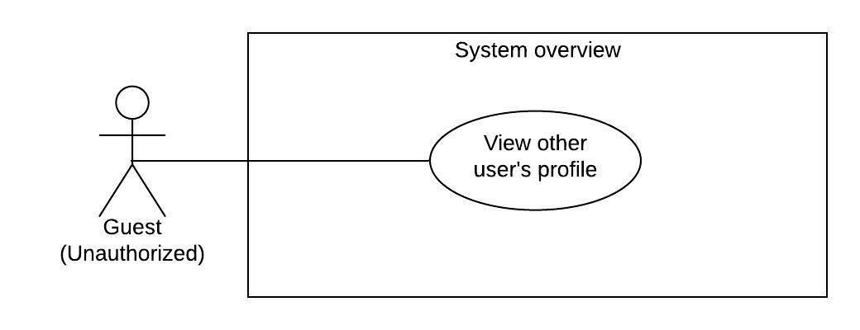

Figure 7 - <Guest> View other user’s profile

|  |  |  |  |
| --- | --- | --- | --- |
| **USE CASE – StoryArt_G_04** | | | |
| **Use Case No.** | StoryArt_G_04 | **Use Case Version** | 2.0 |
| **Use Case Name** | View other user's profile | | |
| **Author** | HaiNV | | |
| **Date** | 24/02/2020 | **Priority** | Normal |
| **Actor:**   * Guest   **Summary:**   * This use case allows Guest to view other user's profile in system   **Goal:**   * Other user's profile is shown successfully   **Triggers:**   * Guest click on user name or avatar of user.   **Preconditions:**   * Guest not logged into the system.   **Post Conditions:**   * Success: The other user's profile is displayed. * Fail: System shows error messages.   **Main Success Scenario:**   |  |  |  | | --- | --- | --- | | **Step** | **Actor Action** | **System Response** | | 1 | Guest click on user name or avatar of user. | System shows on “Tài Khoản của tác giả” with following labels and fields:  First Section:   * Profile and Avatar Image: image * Name: text * CreatedDate: text * Intro content: text   Second Section:   * “Truyện của tác giả”: (label)   System shown on list of stories created by author  [Exception 1] |   **Alternative Scenario:** N/A  **Exceptions 1 :**   |  |  |  | | --- | --- | --- | | **Step** | **Cause** | **System Response** | | 1 | There are some unexpected exceptions while sending request, i.e. network exception | System failed to load profile. |   **Relationships:** N/A  **Business Rules:**   * Guest click on user name or avatar of user. System will show his/her profile. * Guest can view list of stories created by author filtering by name and tag | | | |

Table 10 - <Guest> View other user’s profile use case specificaion

##### 2.3.1.5. Search story

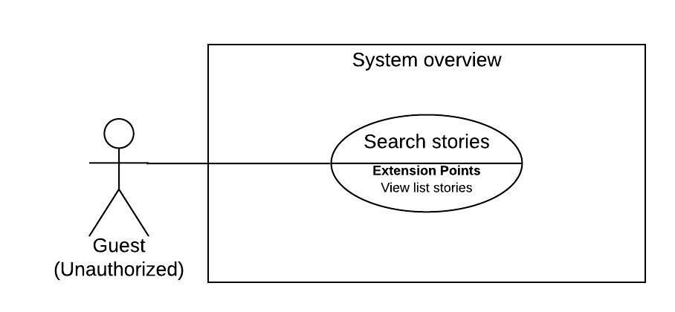

Figure 8 - <Guest> Search stories

|  |  |  |  |
| --- | --- | --- | --- |
| **USE CASE – StoryArt_U_05** | | | |
| **Use Case No.** | StoryArt_U_05 | **Use Case Version** | 2.0 |
| **Use Case Name** | Search stories | | |
| **Author** | DatNT | | |
| **Date** | 22/03/2020 | **Priority** | Normal |
| **Actor:**   * Guest   **Summary:**   * This use case allows guest to search stories in the system.   **Goal:**   * Guest can see a list of stories after search in the system.   **Triggers:**   * Guest sends search request.   **Preconditions:**   * Guest click on “Tìm kiếm truyện” in sidebar.   **Post conditions:**   * Success: Guest can see results; this result is related to search keyword in the system. * Fail: System shows error messages.   **Main Success Scenario:**   |  |  |  | | --- | --- | --- | | **Step** | **Actor Action** | **System Response** | | 1 | Guest inputs search keyword in text input. | - Search box: blank text input  [Alternative 1] | | 2 | Guest choose dropdown category of tags. | [Alternative 2] | | 3 |  | System finds event by keyword at search text input in database. System responses result. [Alternative 3] [Exception 1] |   **Alternative Scenario:**   |  |  |  | | --- | --- | --- | | **No** | **Actor Action** | **System Response** | | 1 | Guest inputs empty text input and chooses dropdown category of tags. | System responses a list of stories relate to tags. | | 2 | Guest inputs search text input and does not choose dropdown category of tags. | System finds by keyword at search text input in database. System responses result. | | 3 |  | Not found any result. System will show nothing. |   **Exceptions:**   |  |  |  | | --- | --- | --- | | **No** | **Actor Action** | **System Response** | | 1 | Lost internet connection. | System failed to search story. |   **Relationships:** StoryArt_G_06  **Business Rules:**  Search function will be automatically run after user input text in search box or select tag.  After searching, guest will see a list of stories. | | | |

Table 11 - <Guest> Search stories use case specification

##### 2.3.1.6. View list stories

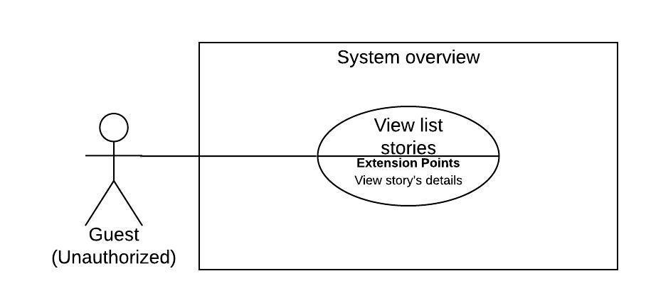

Figure 9 - <Guest> View list stories

|  |  |  |  |
| --- | --- | --- | --- |
| **USE CASE – StoryArt_G_06** | | | |
| **Use Case No.** | StoryArt_G_06 | **Use Case Version** | 2.0 |
| **Use Case Name** | View list stories | | |
| **Author** | DatNT | | |
| **Date** | 22/03/2020 | **Priority** | Normal |
| **Actor:**   * Guest   **Summary:**   * This use case allows guest to view list stories in the system.   **Goal:**   * Guest can see lists of stories in the system.   **Triggers:**   * Guest go to homepage * Search stories (StoryArt_G_05)   **Preconditions:**   * Guest want to view suggestion and trending story list. * Guest want to view other user’s profile.   **Post conditions:**   * Success: Guest can see list events in the system. * Fail: System shows error messages.   **Main Success Scenario:**   |  |  |  | | --- | --- | --- | | **Step** | **Actor Action** | **System Response** | | 1 | Guest go to homepage.  [Alternative 1] | System show the following lists:  - “Danh sách thịnh hành”  - “Gợi ý cho bạn”  [Exception 1] |   **Alternative Scenario:**   |  |  |  | | --- | --- | --- | | **No** | **Actor Action** | **System Response** | | 1 | Guest search in search page. | System finds by keyword at search text input in database. System responses result. |   **Exceptions:**   |  |  |  | | --- | --- | --- | | **No** | **Actor Action** | **System Response** | | 1 | Lost internet connection. | System failed to load list stories. |   **Relationships:** StoryArt_G_05, StoryArt_G_07  **Business Rules:**  “Danh sách thịnh hành” is a list of stories that show stories have most views in this week.  “Gợi ý cho bạn” is a list of stories that show stories is suitable for user. | | | |

Table 12 - <Guest> View list stories use case specification

##### 2.3.1.7. View story detail

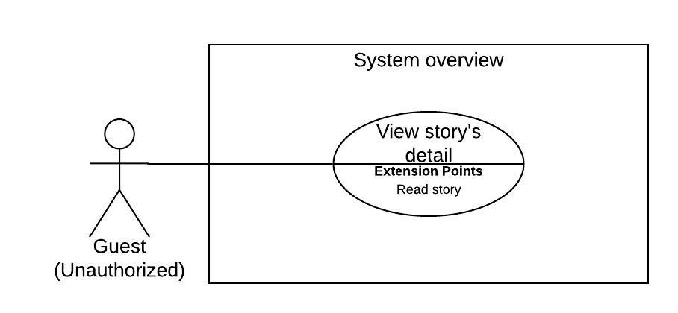

Figure 10 - <Guest> View story’s detail

|  |  |  |  |
| --- | --- | --- | --- |
| **USE CASE – StoryArt_G_07** | | | |
| **Use Case No.** | StoryArt_G_07 | **Use Case Version** | 2.0 |
| **Use Case Name** | View story’s detail | | |
| **Author** | DatNT | | |
| **Date** | 22/03/2020 | **Priority** | High |
| **Actor:**   * Guest   **Summary:**   * This use case allows guest to view story detail in the system.   **Goal:**   * Guest can see story’s detail in the system.   **Triggers:**   * Guest click on story in list stories.   **Preconditions:**   * Guest want to see story’s detail.   **Post conditions:**   * Success: Guest can see story’s detail in the system. * Fail: System shows error messages.   **Main Success Scenario:**   |  |  |  | | --- | --- | --- | | **Step** | **Actor Action** | **System Response** | | 1 | Guest clicks on story in stories list. | System show story detail page with following information:  - Story’s name: text  - Story’s author name: text  - Story’s date create: text  - Story’s intro content: text  - Story’s average rating point: text  - Story’s total number of rating: text  - Comment: blank text input  - Send comment button  - Read story button  - Report story button  - Rating bar  - Share button  - List of comments, each comment contains following information:  + Comment owner name: text  + Time create: text  + Comment content: text  + Avatar: image  + Number of likes  + Number of dislikes  + Like button  + Dislike button  + Report button  + Edit comment button  + Delete comment button  [Exception 1][Alternative 1] |   **Alternative Scenario:**   |  |  |  | | --- | --- | --- | | **No** | **Actor Action** | **System Response** | | 1 | Do not have any comment. | System show “Truyện chưa có bình luận, hãy để lại một bình luận nhé.”. |   **Exceptions:**   |  |  |  | | --- | --- | --- | | **No** | **Actor Action** | **System Response** | | 1 | Lost internet connection. | System failed to load story detail. |   **Relationships:** StoryArt_G_06, StoryArt_G_08  **Business Rules:**  If story is deactivated by admin, system show not found.  If owner of this story is deactivated by admin, system show not found. | | | |

Table 13 - <Guest> View story’s detail use case specification

##### 2.3.1.8. Read story

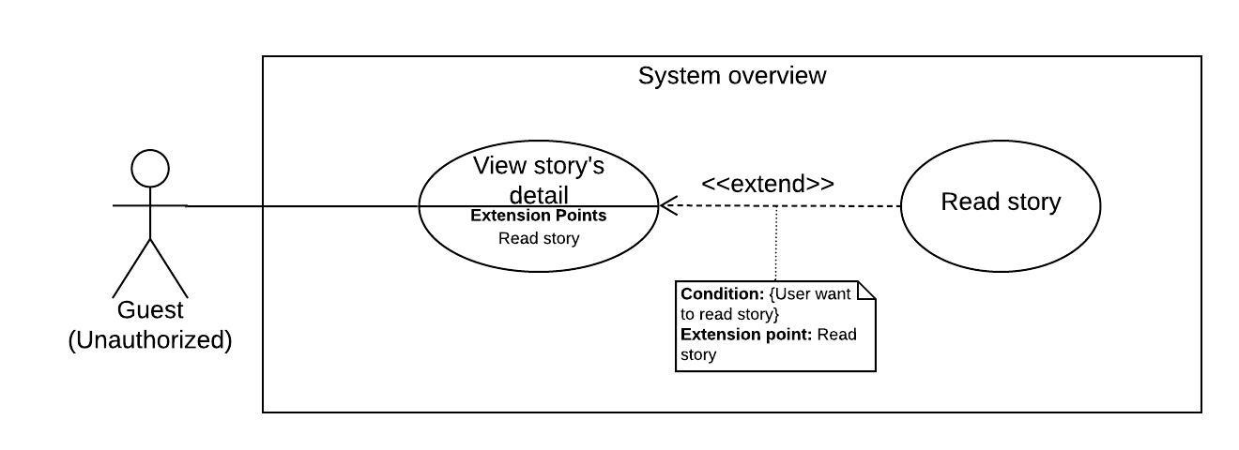

Figure 11 - <Guest> Read story

|  |  |  |  |
| --- | --- | --- | --- |
| **USE CASE – StoryArt_G_08** | | | |
| **Use Case No.** | StoryArt _G_08 | **Use Case Version** | 2.0 |
| **Use Case Name** | Read story | | |
| **Author** | DatNT | | |
| **Date** | 22/03/2020 | **Priority** | Normal |
| **Actor:**   * Guest.   **Summary:**   * Allow guest read story.   **Goal:**   * Guest can read story in system.   **Triggers:**   * Guest sends request read story.   **Preconditions:**   * Guest not logged into the system. * Guest want to read story.   **Post conditions:**   * Success: System displays story. * Fail: System shows error messages.   **Main Success Scenario:**   |  |  |  | | --- | --- | --- | | **Step** | **Actor Action** | **System Response** | | 1 | User clicks button “Đọc truyện” button in story detail page. | [Exception 1]  System show summary screen of story include:  - “Nội dung tóm tắt”: text  - “Bắt đầu đọc truyện”: button | | 2 | User clicks button “Bắt đầu đọc truyện” in summary page. | System show screen detail include:   * Screen title: text * Screen content: text * Actions: buttons * Information: text * Go back to detail: button | | 3 | User clicks on action button. | New screen will be generated. |   **Alternative Scenario:** N/A  **Exceptions:**   |  |  |  | | --- | --- | --- | | **No** | **Actor Action** | **System Response** | | 1 | Lost internet connection. | System fail to load story. |   **Relationships:** StoryArt_G_07  **Business Rules:**  Any action in a screen will have one of those action types:   * “Đi tới màn hình”: go to the next screen. * “Chuyển hướng đến”: go to a link, url. * “Cập nhật thông tin”: update information if the story has information.   Information will display if the story has information.  When reading, if user doesn’t have any activity like: mouse move, scroll, click, key press. System will show a pop up ask user want to continue reading or not.  Ending of story will display:   * A button for user can go back to story detail page. * A button for user can read story again. * Share buttons. | | | |

Table 14 - <Guest> Read story use case specification

##### 2.3.1.9. Get stories suggestion

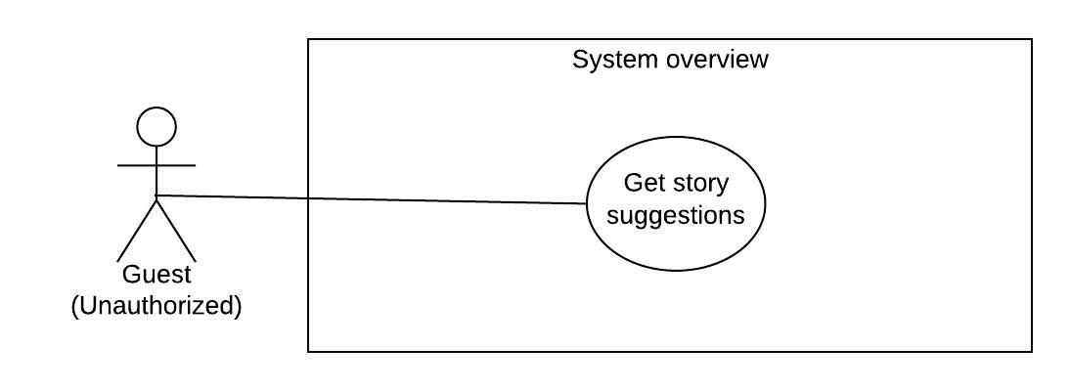

Figure 12 - <Guest> Get story suggestions

|  |  |  |  |
| --- | --- | --- | --- |
| **USE CASE – StoryArt_G_09** | | | |
| **Use Case No.** | StoryArt_G_09 | **Use Case Version** | 2.0 |
| **Use Case Name** | Get Stories Suggestion | | |
| **Author** | HaiNV | | |
| **Date** | 24/02/2020 | **Priority** | Normal |
| **Actor:**   * Guest, User   **Summary:**   * This use case allows Guest and User to get list of stories suggestion in system when user and guest access to homepage   **Goal:**   * The list of suggested stories is displayed successfully.   **Triggers:**   * Guest access to homepage * Guest logged into the system as User and access to homepage   **Preconditions:**   * Guest go to homepage.   **Post Conditions:**   * Success: The suggested stories list is displayed. * Fail: System shows error messages.   **Main Success Scenario:**   |  |  |  | | --- | --- | --- | | Step | Actor Action | System Response | | 1 | Guest click access to Homepage  [Alternative 1] | System shows on “Danh Sách Gợi ý” with the list of suggested stories by top view of all time.  System shows on “Danh Sách Thịnh Hành” with the list of suggested stories by top view previous 7 days  [Exception 1] |   **Alternative Scenario:**   |  |  |  | | --- | --- | --- | | No | Actor Action | System Response | | 1 | Guest logged into the system as User and access homepage  User have enough data for System Handler to calculate Suggestion  [Alternative 2] | System shows on “Danh Sách Gợi ý” with the list of suggested stories by Rating though algorithm  System shows on “Danh Sách Thịnh Hành” with the list of suggested stories by top view previous 7 days  [Exception 1] | | 2 | Guest logged into the system and access homepage.  User do not have enough data for System Handler to calculate Suggestion. | System shows on “Danh Sách Gợi ý” with the list of suggested stories by top view of all time.  System shows on “Danh Sách Thịnh Hành” with the list of suggested stories by top view of previous 7 days  [Exception 1] |   **Exceptions 1 :**   |  |  |  | | --- | --- | --- | | Step | Cause | System Response | | 1 | There are some unexpected exceptions while sending request, i.e. network exception | System failed to load story suggestions |   **Relationships:** N/A  **Business Rules:**  - When Guest click access to Homepage, list of suggested stories is based on top view of all time in system  - When Guest logged into the system and do not have enough data to calculated, list of suggested stories is based on top view of all time in system  - When Guest logged into the system and do have enough data to calculated, list of suggested stories is based on the similarity of the Rating between the readers and calculate probability future Rating.  - The list of suggested stories based on Most view in the previous 7 days is always shown  The internet connection is required to run this function. | | | |

Table 15 - <Guest> Get story suggestions use case specification

#### 2.3.2. <User (Reader and Author)> Overview Use Case

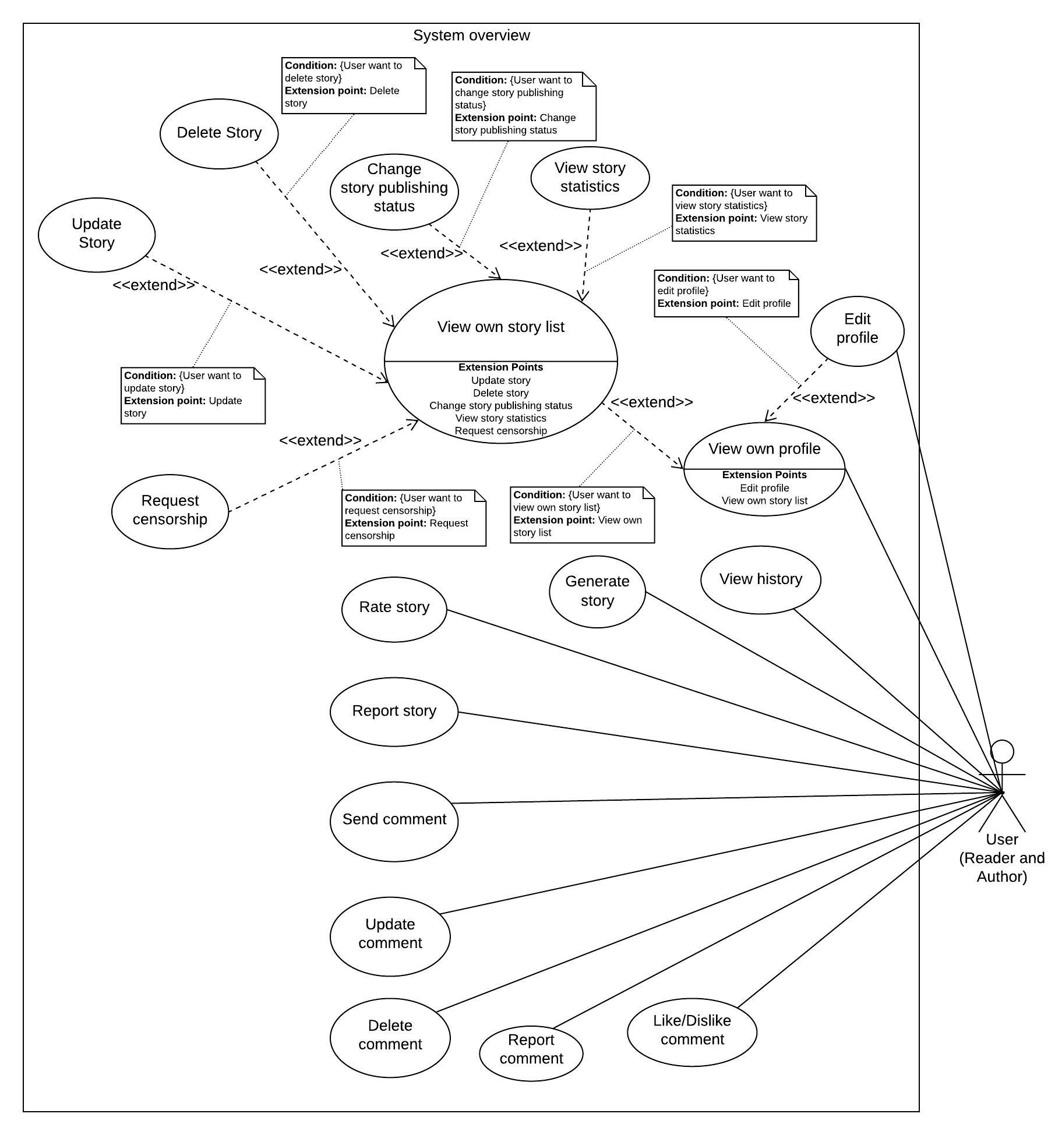

Figure 13 - <User> Overview use case

##### 2.3.2.1. Generate story

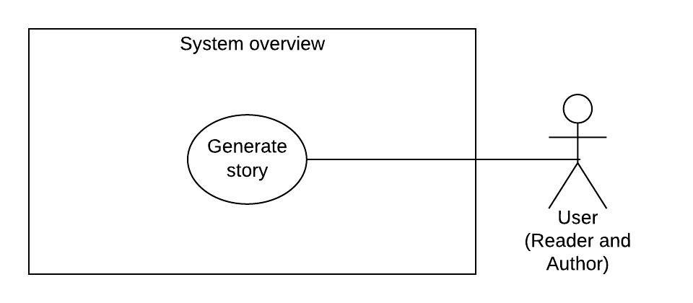

Figure 14 - <User> Generate story

|  |  |  |  |
| --- | --- | --- | --- |
| **USE CASE – StoryArt_U_01** | | | |
| **Use Case No.** | StoryArt _U_01 | **Use Case Version** | 2.0 |
| **Use Case Name** | Generate story | | |
| **Author** | TaiBD | | |
| **Date** | 22/03/2020 | **Priority** | Normal |
| **Actor:**   * User   **Summary:**   * Allow user create story.   **Goal:**   * User can create new story in system.   **Triggers:**   * User sends request create story.   **Preconditions:**   * Guest logged into the system with role “User”. * User create new story.   **Post conditions:**   * Success: System displays uploaded story. * Fail: System shows error messages.   **Main Success Scenario:**   |  |  |  | | --- | --- | --- | | **Step** | **Actor Action** | **System Response** | | 1 | User clicks button “Tạo truyện” button in menu bar. | System show create story page include two tabs:  - “Chi tiết truyện” tab includes:  + “Tiêu đề truyện”: required, blank text input area  + “Chọn ảnh”: button  + Image  + “Tóm tắt truyện”: required, blank text input area  + “Chọn hiệu ứng màn hình”: dropdown box  + “Chọn màn hình đầu tiên”: required, dropdown box  + “Chọn thể loại”: required, selected box  + “Thêm thông tin”: button  + “Lưu truyện và yêu cầu kiểm duyệt”: button  + “Lưu truyện”: button  - “Màn hình truyện” tab includes:  + Total number of screens: text  + Add new screen button  + Story-line chart.  + Screen detail input form.  + Preview button. | | 2 | User clicks button “Lưu truyện” on create story page. | [Exception 1] [Exception 2]  A draft of story will be save in the system. User can view and edit later. | | 3 | User clicks button “Lưu truyện và yêu cầu kiểm duyệt” on create story page. | [Exception 1] [Exception 2]  Story will be saved and request admin to censor it. | | 4 | User clicks button preview in “Màn hình truyện” tab. | A preview of this screen will be displayed. | | 5 | User clicks button add new screen in “Màn hình truyện” tab. | A new blank screen detail input form will be displayed with following information:  - “Tiêu đề”: required, blank text input  - “Nội dung màn hình”: required, blank text input  - “Xóa màn hình”: button  - “Thêm hành động”: button  - “Dung lượng”: text | | 6 | User clicks on “Thêm hành động” button in screen detail input form. | Following fields will be displayed:  - “Nội dung”: required, blank text input  - “Loại hành động”: dropdown box | | 7 | User clicks button “Thêm thông tin” in “Chi tiết truyện” tab. | Story information will be displayed with following information:  - “Tên thông tin”: required, blank text input  - “Kiểu thông tin”: dropdown box  - “Đơn vị khởi đầu”: required, blank text input  - “Thêm điều kiện”: button | | 8 | User clicks button “Thêm điều kiện” in story information. | All of following information will be displayed:  - Condition type: dropdown box  - Information start value: blank text input  - “Đi tới màn kế tiếp”: dropdown box |   **Alternative Scenario:** N/A  **Exceptions:**   |  |  |  | | --- | --- | --- | | **No** | **Actor Action** | **System Response** | | 1 | Lost internet connection | System failed to save story. | | 2 | Lack of required information. | System shows error messages about which information is lacking. |   **Relationships:** N/A.  **Business Rules:**  Maximum size of “Nội dung màn hình” and “Tóm tắt truyện” is 2MB.  Image in “Nội dung màn hình” and “Tóm tắt truyện” is saved as Base64 in database.  Maximum number of screens is 100.  Maximum number of actions is 8.  User can see total size of each screen at “Dung lượng” field in kb type.  “Loại hành động” includes three actions:   * “Đi tới màn hình”: go to the next screen. * “Chuyển hướng đến”: go to a link, url. * “Cập nhật thông tin”: update information if the story has information.   “Kiểu thông tin” includes two type:   * “Số”: number * “Chuỗi kí tự”: text   Condition type includes:   * “=”: equal * “>”: bigger * “<”: smaller * “>=”: equal or bigger * “<=”: equal or smaller   With information type “Chuỗi kí tự”, condition type has only equal.  In case of any condition with information, screen with be directed to a specified screen.  “Đi tới màn kế tiếp” includes all screens of the story.  After saved story, a draft version of story will be save.   * If user request to censor story. Admin will receive request. * If admin approve, user can public their story whenever they want. | | | |

Table 16 - <User> Generate story use case specification

##### 2.3.2.2. View own story list

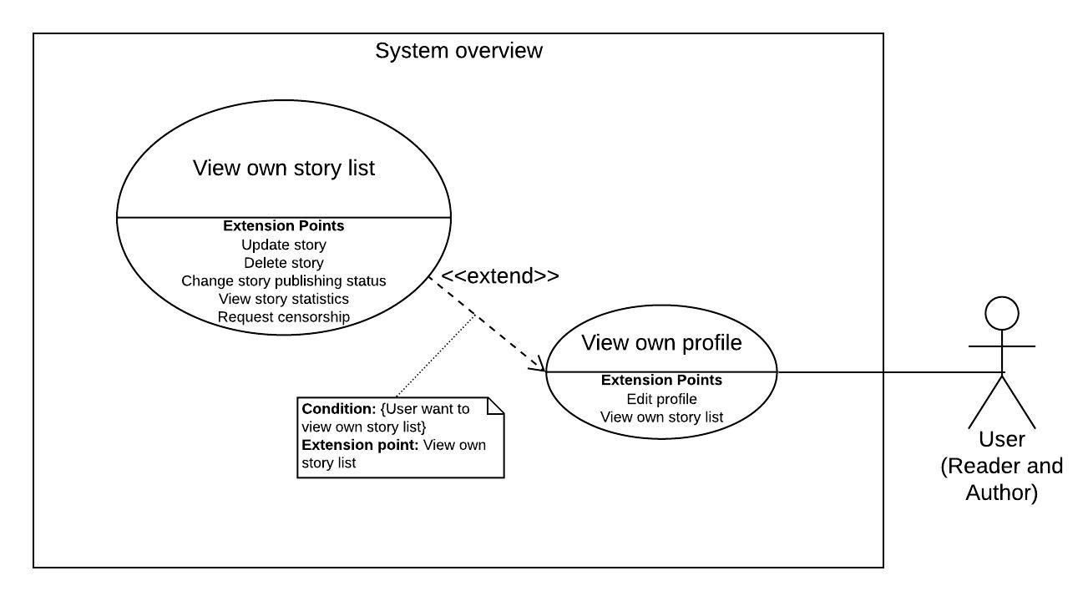

Figure 15 - <User> View own story list

|  |  |  |  |
| --- | --- | --- | --- |
| **USE CASE – StoryArt_U_02** | | | |
| **Use Case No.** | StoryArt_U_02 | **Use Case Version** | 2.0 |
| **Use Case Name** | View own story list | | |
| **Author** | DatNT | | |
| **Date** | 21/03/2020 | **Priority** | Normal |
| **Actor:**   * User   **Summary:**   * Allow user to view their own story list.   **Goal:**   * User can view their own story list.   **Triggers:**   * User goes to profile page.   **Preconditions:**   * Guest logged into the system with role “User”.   **Post conditions:**   * Success: System shown their own story list. * Fail: System shows error messages.   **Main Success Scenario:**   |  |  |  | | --- | --- | --- | | **Step** | **Actor Action** | **System Response** | | 1 | User clicks go to profile page. | System shown their own story list with tabs depend on censorship status.  [Exception 1] |   **Alternative Scenario: N/A**  **Exceptions:**   |  |  |  | | --- | --- | --- | | **No** | **Actor Action** | **System Response** | | 1 | Lost internet connection. | System failed to load their own story list. |   **Relationships:** StoryArt_U_16  **Business Rules:**  System will show list story and divide tabs based on censorship status.  List of stories will show 10 record each page. | | | |

Table 17 - <User> View own story list use case specification

##### 2.3.2.3. View story statistics

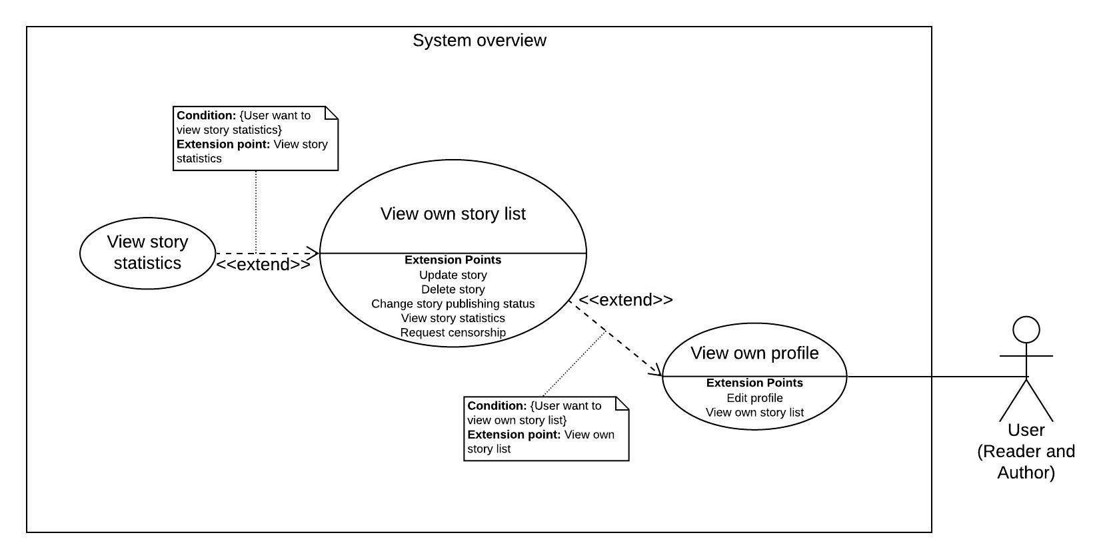

Figure 16 - <User> View story statistics

|  |  |  |  |
| --- | --- | --- | --- |
| **USE CASE – StoryArt_U_03** | | | |
| **Use Case No.** | StoryArt_U_03 | **Use Case Version** | 2.0 |
| **Use Case Name** | View story statistics | | |
| **Author** | AnhTHT | | |
| **Date** | 10/04/2020 | **Priority** | Normal |
| **Actor:**   * User   **Summary:**   * This use case allows user to view statistics of his story   **Goal:**   * User can see statistics of selected story.   **Triggers:**   * User clicks on “Quản lý tài khoản” on side bar. * User clicks on button “Xem thống kê” of a story.   **Preconditions:**   * User have created one story.   **Post conditions:**   * Success: System redirect user to the story statistics * Fail: System shows error messages.   **Main Success Scenario:**   |  |  |  | | --- | --- | --- | | **Step** | **Actor Action** | **System Response** | | 1 | User click on “Xem thống kê” button of row in his story list table | System redirects User to view his story statistics.  [Exception 1] |   **Alternative Scenario:** N/A  **Exceptions:**   |  |  |  | | --- | --- | --- | | **No** | **Actor Action** | **System Response** | | 1 | Lost internet connection. | System failed to load story statistics. |   **Relationships:** StortyArt_U_02, StortyArt_U_16  **Business Rules:**   * User that created a story can view his story statistics | | | |

Table 18 - <User> View story statistics use case specification

##### 2.3.2.4. Change story publishing status

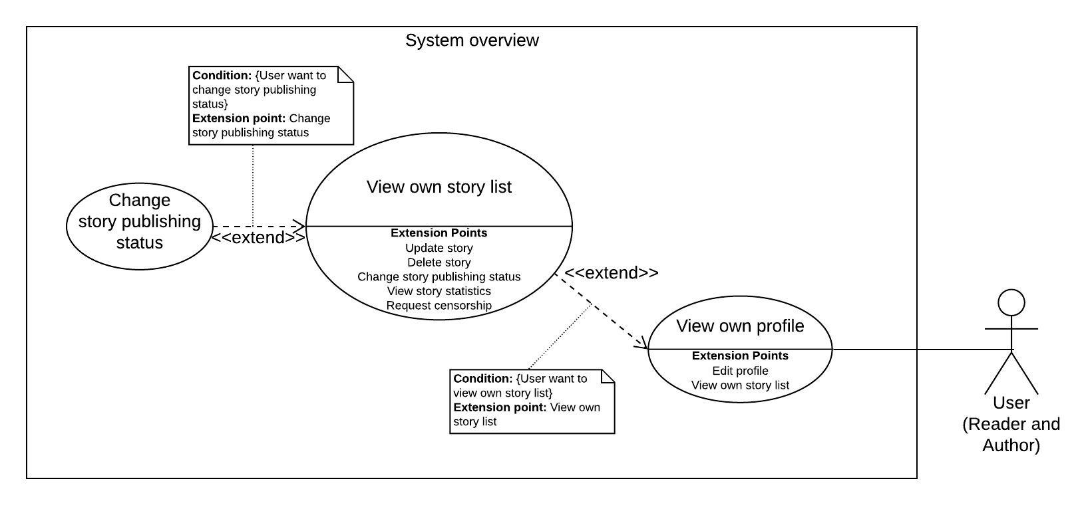

Figure 17 - <User> Change story publishing status

|  |  |  |  |
| --- | --- | --- | --- |
| **USE CASE – StoryArt_U_04** | | | |
| **Use Case No.** | StoryArt_U_04 | **Use Case Version** | 2.0 |
| **Use Case Name** | Change story publishing status | | |
| **Author** | TaiBD | | |
| **Date** | 21/03/2020 | **Priority** | Normal |
| **Actor:**   * User   **Summary:**   * Allow user to change story publishing status.   **Goal:**   * User can change story publishing status.   **Triggers:**   * User goes to profile page. * User send request to change story publishing status.   **Preconditions:**   * Guest logged into the system with role “User”. * Guest created at least one story.   **Post conditions:**   * Success: System change story publishing status in user’s story list. * Fail: System shows error messages.   **Main Success Scenario:**   |  |  |  | | --- | --- | --- | | **Step** | **Actor Action** | **System Response** | | 1 | User clicks on change story publishing status in profile pages. | System change story publishing status in story list.  [Exception 1] |   **Exceptions:**   |  |  |  | | --- | --- | --- | | **No** | **Actor Action** | **System Response** | | 1 | Lost internet connection | System failed to change story publishing status. |   **Relationships:** StortyArt_U_02, StortyArt_U_16  **Business Rules:**  User can only change story publishing status of their own stories. | | | |

Table 19 - <User> Change story publishing status use case specification

##### 2.3.2.5. Delete story

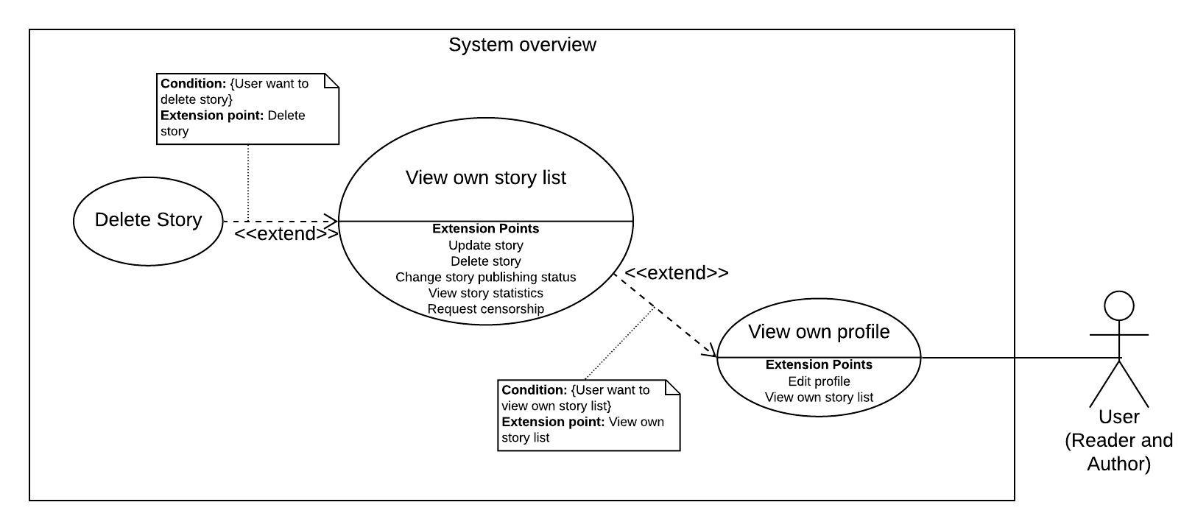

Figure 18 - <User> Delete story

|  |  |  |  |
| --- | --- | --- | --- |
| **USE CASE – StoryArt_U_05** | | | |
| **Use Case No.** | StoryArt_U_05 | **Use Case Version** | 2.0 |
| **Use Case Name** | Delete comment | | |
| **Author** | TaiBD | | |
| **Date** | 21/03/2020 | **Priority** | Normal |
| **Actor:**   * User   **Summary:**   * Allow user to delete their story.   **Goal:**   * User can delete story.   **Triggers:**   * User goes to profile page. * User send request to delete story.   **Preconditions:**   * Guest logged into the system with role “User”. * Guest created at least one story.   **Post conditions:**   * Success: System remove story in user’s story list. * Fail: System shows error messages.   **Main Success Scenario:**   |  |  |  | | --- | --- | --- | | **Step** | **Actor Action** | **System Response** | | 1 | User goes to profile pages. | [Exception 1]  System shows their list stories. With each story have:  - “Xóa truyện”: button | | 2 | User clicks on “Xóa truyện” button. | System show delete story popup with two button for user can select:  - “Đồng ý” button.  - “Hủy bỏ” button. | | 3 | User clicks on “Đồng ý” button. | System delete story from system.  [Exception 1] | | 4 | User clicks on “Hủy” button. | Close popup, nothing change. |   **Exceptions:**   |  |  |  | | --- | --- | --- | | **No** | **Actor Action** | **System Response** | | 1 | Lost internet connection | System failed to delete story |   **Relationships:** StortyArt_U_02, StortyArt_U_16  **Business Rules:**  User can only delete story of themselves. | | | |

Table 20 - <User> Delete story use case specification

##### 2.3.2.6. Update story

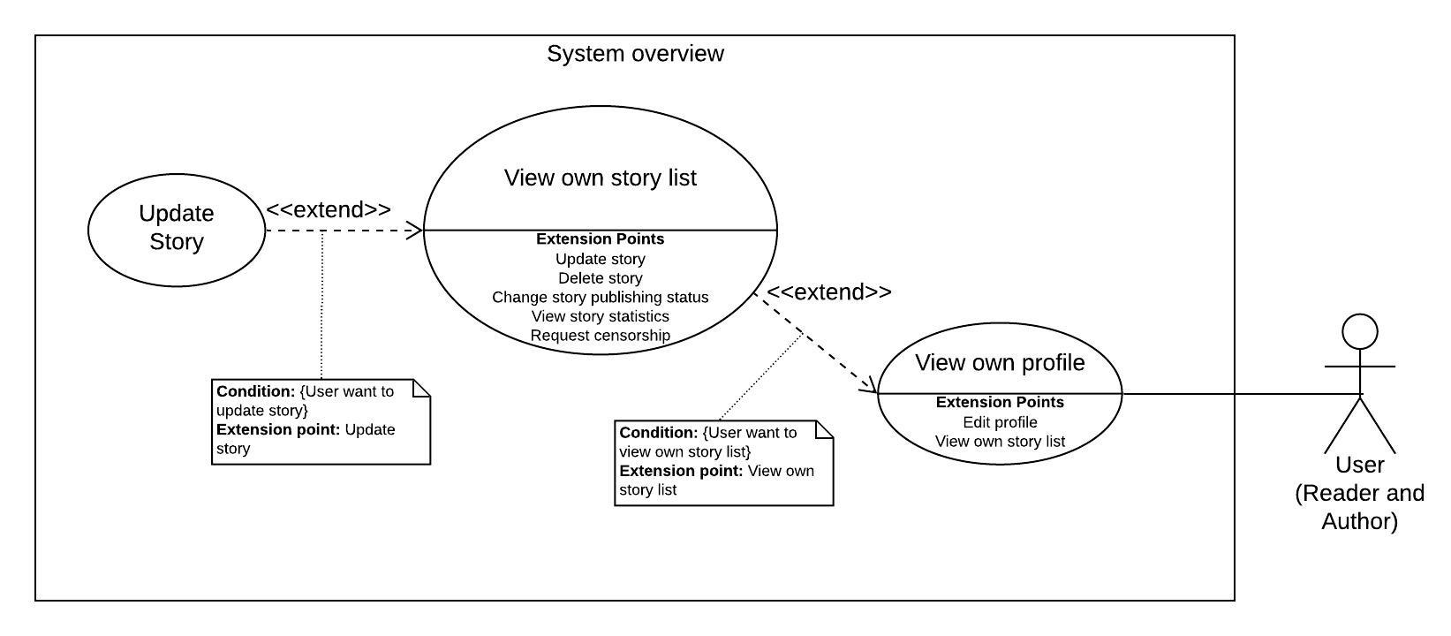

Figure 19 - <User> Update story

|  |  |  |  |
| --- | --- | --- | --- |
| **USE CASE – StoryArt_U_06** | | | |
| **Use Case No.** | StoryArt _U_06 | **Use Case Version** | 2.0 |
| **Use Case Name** | Update story | | |
| **Author** | TaiBD | | |
| **Date** | 22/03/2020 | **Priority** | Normal |
| **Actor:**   * User   **Summary:**   * Allow user update story.   **Goal:**   * User can update their own story.   **Triggers:**   * User sends request update story.   **Preconditions:**   * Guest logged into the system with role “User”. * Guest created at least one story.   **Post conditions:**   * Success: System displays uploaded story. * Fail: System shows error messages.   **Main Success Scenario:**   |  |  |  | | --- | --- | --- | | **Step** | **Actor Action** | **System Response** | | 1 | User clicks button “Cập nhật” button in their own story list. | [Exception 1]  System show update story page with all information of story is loaded include two tabs:  - “Chi tiết truyện” tab includes:  + “Tiêu đề truyện”: required, blank text input area  + “Chọn ảnh”: button  + Image  + “Tóm tắt truyện”: required, blank text input area  + “Chọn hiệu ứng màn hình”: dropdown box  + “Chọn màn hình đầu tiên”: required, dropdown box  + “Chọn thể loại”: required, selected box  + “Thêm thông tin”: button  + “Quay lại bản kiểm duyệt gần nhất”: button  + “Lưu truyện và yêu cầu kiểm duyệt”: button  + “Lưu truyện”: button  - “Màn hình truyện” tab includes:  + Total number of screens: text  + Add new screen button  + Story-line chart.  + Screen detail input form.  + Preview button.  - “Xóa truyện”: button. | | 2 | User clicks button “Lưu truyện” on create story page. | [Exception 1] [Exception 2]  A draft of story will be save in the system. User can view and edit later. | | 3 | User clicks button “Lưu truyện và yêu cầu kiểm duyệt” on create story page. | [Exception 1] [Exception 2]  Story will be saved and request admin to censor it. | | 4 | User clicks button preview in “Màn hình truyện” tab. | A preview of this screen will be displayed. | | 5 | User clicks button add new screen in “Màn hình truyện” tab. | A new blank screen detail input form will be displayed with following information:  - “Tiêu đề”: required, blank text input  - “Nội dung màn hình”: required, blank text input  - “Xóa màn hình”: button  - “Thêm hành động”: button  - “Dung lượng”: text | | 6 | User clicks on “Thêm hành động” button in screen detail input form. | Following fields will be displayed:  - “Nội dung”: required, blank text input  - “Loại hành động”: dropdown box | | 7 | User clicks button “Thêm thông tin” in “Chi tiết truyện” tab. | Story information will be displayed with following information:  - “Tên thông tin”: required, blank text input  - “Kiểu thông tin”: dropdown box  - “Đơn vị khởi đầu”: required, blank text input  - “Thêm điều kiện”: button | | 8 | User clicks button “Thêm điều kiện” in story information. | All of following information will be displayed:  - Condition type: dropdown box  - Information start value: blank text input  - “Đi tới màn kế tiếp”: dropdown box | | 9 | User clicks button “Xóa truyện” in update story page. | [Exception 1]  System deleted story. | | 10 | User clicks button “Quay lại bản kiểm duyệt gần nhất” in update story page. | [Exception 1] [Exception 3]  System show lastest story with APPROVED censorship status. |   **Alternative Scenario:** N/A  **Exceptions:**   |  |  |  | | --- | --- | --- | | **No** | **Actor Action** | **System Response** | | 1 | Lost internet connection | System failed to load story information. | | 2 | Lack of required information. | System shows error messages about which information is lacking. | | 3 | User revert story with PENDING, APRROVED, REJECTED censorship status. | System shows error messages “Bạn không thể quay lại bản kiểm duyệt gần nhất vì truyện của bạn đã hoặc đang được kiểm duyệt.” |   **Relationships:** StortyArt_U_02, StortyArt_U_16  **Business Rules:**  Maximum size of “Nội dung màn hình” and “Tóm tắt truyện” is 2MB.  Image in “Nội dung màn hình” and “Tóm tắt truyện” is saved as Base64 in database.  Maximum number of screens is 100.  Maximum number of actions is 8.  User can see total size of each screen at “Dung lượng” field in kb type.  “Loại hành động” includes three actions:   * “Đi tới màn hình”: go to the next screen. * “Chuyển hướng đến”: go to a link, url. * “Cập nhật thông tin”: update information if the story has information.   “Kiểu thông tin” includes two type:   * “Số”: number * “Chuỗi kí tự”: text   Condition type includes:   * “=”: equal * “>”: bigger * “<”: smaller * “>=”: equal or bigger * “<=”: equal or smaller   With information type “Chuỗi kí tự”, condition type has only equal.  In case of any condition with information, screen with be directed to a specified screen.  “Đi tới màn kế tiếp” includes all screens of the story.  After update story, system will create an update version of this story.   * If the story is approved before. System will make an update version different with current version. * If admin approve censorship, this update version will be applied to current version.   User can revert their draft story to lastest APPROVED story by clicks button “Quay lại bản kiểm duyệt gần nhất”.  Story with PENDING,APRROVED,REJECTED censorship status cannot be allowed to revert. | | | |

Table 21 - <User> Update story use case specification

##### 2.3.2.7. Edit profile

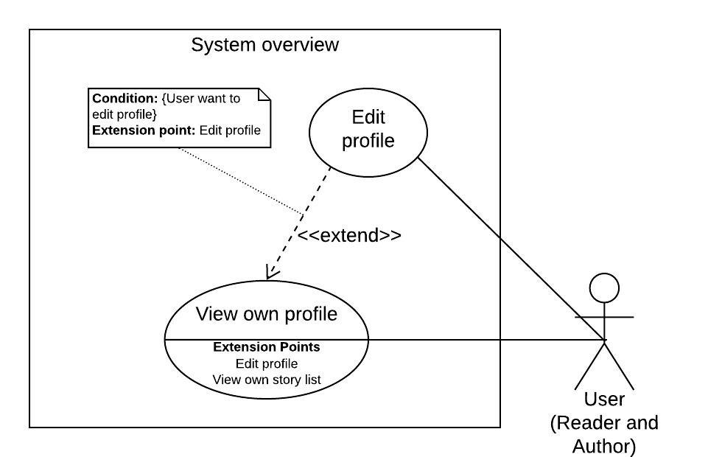

Figure 20 - <User> Edit profile

|  |  |  |  |
| --- | --- | --- | --- |
| **USE CASE – StoryArt_U_07** | | | |
| **Use Case No.** | StoryArt_U_07 | **Use Case Version** | 2.0 |
| **Use Case Name** | Edit Profile | | |
| **Author** | HaiNV | | |
| **Date** | 24/02/2020 | **Priority** | Normal |
| **Actor:**   * User   **Summary:**   * Allow User to edit their profile   **Goal:**   * User update profile successfully   **Triggers:**   * User clicks on “Cập Nhật” Button   **Preconditions:**   * Guest logged into the system with role “User”.   **Post Conditions:**   * Success: profile must be edited * Fail: System shows error messages.   **Main Success Scenario:**   |  |  |  | | --- | --- | --- | | **Step** | **Actor Action** | **System Response** | | 1 | User clicks on “Cập Nhật” button | “Cập Nhật Tài Khoản” screen is shown with following labels and fields:   * profile Image (image) * avatar Image (image) * choose File (button) * Lưu Avatar: (button) * Lưu Hình Nền (button) * Tên của bạn: (text, length must be from 3 to 40) * Tên Đăng Nhập: (text: required, length must be from 3 to 15, Not blank) * Email: (text: required) * Giới thiệu cho mọi người về bạn: (textArea, max lenth is 300) | | 2 | User click on option “File Upload” on status bar  User click on “Lưu Avatar” button | System allow user to upload Avatar image into server and return that image url.  Image Avatar is shown up in the screen.  New avatar will be inserted into system.  [Exception 6] | | 3 | User click on option “File Upload” on status bar  User click on “Lưu Hình Nền” button | System allow user to upload Profile image into server and return that image url.  Profile Image is shown up in the screen.  New profile Image will be inserted into system.  [Exception 6] | | 4 | User fills out data fields and clicks on “Xác Nhận” button. | [Exception 1, 2, 3, 4, 5, 6]  System validates inputted data and shows “Lưu Thành Công” notification. |   **Alternative Scenario:** N/A  **Exceptions :**   |  |  |  | | --- | --- | --- | | **Step** | **Cause** | **System Response** | | 1 | Tên Đăng Nhập is Empty | System shows error message "Xin hãy điền tên Tài Khoản” and highlights the empty fields. | | 2 | Tên Đăng Nhập is existed | System show error message “Tên đăng nhập đã tồn tại” and highlight the error field. | | 3 | Email is existed | System show error message “Email đã được đăng ký bởi ai đó” and highlight the error field. | | 4 | Email is not right pattern | System show error message “không đúng định dạng. Vui lòng nhập lại email” and highlight the error field. | | 5 | User clicks on “Thoát” button. | System shows “Thông Tin Thẻ” screen | | 6 | There are some unexpected exceptions while sending request, i.e. network exception | System failed to edit profile |   **Relationships:** StortyArt_U_16  **Business Rules:**  User, Administartor and System Admin can update their profile in system  When user click on Choose File, system allow user to upload an image into server as avatar/profile Image  When User click on Lưu hình nền/Lưu Avatar, system allow user to save url of image ino system, the following data must be updated:  + avatar: string, max length is 1000 character  + profile_image: string, max length is 1000 character  When User clicks on “Xác Nhận” button, the following data must be updated:  + name: string  + username: string  + email: string  + intro_content: string | | | |

Table 22 - <User> Edit profile use case specification

##### 2.3.2.8. Rate story

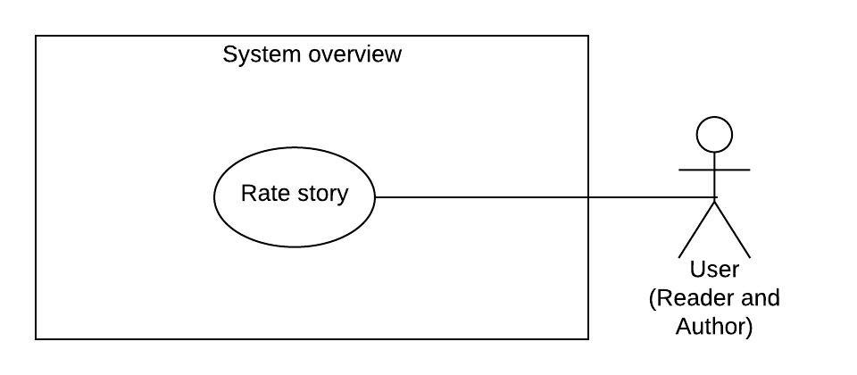

Figure 21 - <User> Rate story

|  |  |  |  |
| --- | --- | --- | --- |
| **USE CASE – StoryArt_U_08** | | | |
| **Use Case No.** | **StoryArt_U_08** | **Use Case Version** | 2.0 |
| **Use Case Name** | Rate story | | |
| **Author** | TaiBD | | |
| **Date** | 21/03/2020 | **Priority** | Normal |
| **Actor:**   * User   **Summary:**   * Allow user to rate another user’s story.   **Goal:**   * User can rate story.   **Triggers:**   * User goes to story detail. * User send request to rate story.   **Preconditions:**   * Guest logged into the system with role “User”.   **Post conditions:**   * Success: Rating is sent to system. * Fail: System shows error messages.   **Main Success Scenario:**   |  |  |  | | --- | --- | --- | | **Step** | **Actor Action** | **System Response** | | 1 | User goes to story detail. | Systems shows Rating Bar. | | 2 | User clicks number of rating in rating bar. | System will show a success message and a rating bar with number user chosen.  [Exception 1] [Exception 2] |   **Alternative Scenario: N/A**  **Exceptions:**   |  |  |  | | --- | --- | --- | | **No** | **Actor Action** | **System Response** | | 1 | User not logged in. | System failed to send rate story | | 2 | Lost internet connection | System failed to send rate story |   **Relationships:** N/A.  **Business Rules:**  Authorized User can rate any story.  User can change rating number how many time they want. | | | |

Table 23 - <User> Rate story use case specification

##### 2.3.2.9. View history

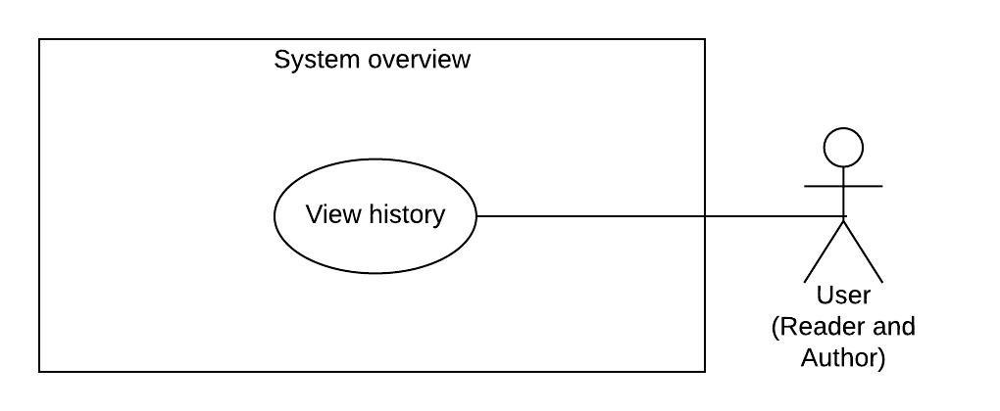

Figure 22 - <User> View history

|  |  |  |  |
| --- | --- | --- | --- |
| **USE CASE – StoryArt_U_09** | | | |
| **Use Case No.** | StoryArt_U_09 | **Use Case Version** | 2.0 |
| **Use Case Name** | View history | | |
| **Author** | DatNT | | |
| **Date** | 10/04/2020 | **Priority** | Normal |
| **Actor:**   * User   **Summary:**   * This use case allows user to view their history of readings, comments and reactions.   **Goal:**   * User can view their history of readings, comments and reactions.   **Triggers:**   * User clicks on “Lịch sử” on side bar.   **Preconditions:**   * Guest logged into the system with role “User”.   **Post conditions:**   * Success: System shown user’s history. * Fail: System shows error messages.   **Main Success Scenario:**   |  |  |  | | --- | --- | --- | | **Step** | **Actor Action** | **System Response** | | 1 | User click on “Lịch sử” button on side bar. | System redirects User to view their history of readings, comments and reactions.  [Exception 1] |   **Alternative Scenario: N/A**  **Exceptions:**   |  |  |  | | --- | --- | --- | | **No** | **Actor Action** | **System Response** | | 1 | Lost internet connection. | System fail to load user’s history. |   **Relationships:** **N/A**  **Business Rules:**  User can edit/delete comment in history.  User can delete reaction in history. | | | |

Table 24 - <User> View history use case specification

##### 2.3.2.10. Send comment

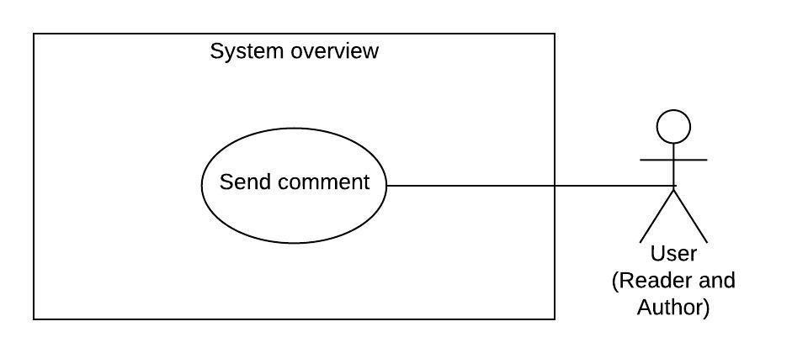

Figure 23 - <User> Send comment

|  |  |  |  |
| --- | --- | --- | --- |
| **USE CASE – StoryArt_U_10** | | | |
| **Use Case No.** | StoryArt_U_10 | **Use Case Version** | 2.0 |
| **Use Case Name** | Send comment | | |
| **Author** | DatNT | | |
| **Date** | 21/03/2020 | **Priority** | Normal |
| **Actor:**   * Authorized User   **Summary:**   * Allow user to send comment in any story that they want.   **Goal:**   * User can send comment.   **Triggers:**   * User goes to story detail page. * User sends request to send comment.   **Preconditions:**   * Guest logged into the system with role “User”. * User comment in story detail page.   **Post conditions:**   * Success: Comment is shown in comment list. * Fail: System shows error messages.   **Main Success Scenario:**   |  |  |  | | --- | --- | --- | | **Step** | **Actor Action** | **System Response** | | 1 | User goes to story detail. | System requires identity information from User:  - Comment content: required, blank input text area  - “Gửi”: button | | 2 | User inputs content of comment. |  | | 3 | User clicks on “Gửi” button. | System create new comment of this story. Comment is shown in comment list  [Exception 1][Exception 2][Exception 3] [Exception 4] |   **Alternative Scenario: N/A**  **Exceptions:**   |  |  |  | | --- | --- | --- | | **No** | **Actor Action** | **System Response** | | 1 | User inputs empty content of comment. | System shows error message: “Xin vui lòng nhập bình luận”. | | 2 | User inputs over max length content of comment. | System shows error message: “Nội dung bình luân phải dưới 10000 kí tự.” | | 3 | User not logged in. | System shows error message: “Bạn phải đăng nhập để sử dụng tính năng này.” | | 4 | Lost internet connection | System failed to send comment. |   **Relationships:** N/A.  **Business Rules:**  User, Admin and System Admin can comment in a story.  After user sent comment, system will update in list comments of that story.  User can comment how many time they want in a story. | | | |

Table 25 - <User> Send comment use case specification

##### 2.3.2.11. Update comment

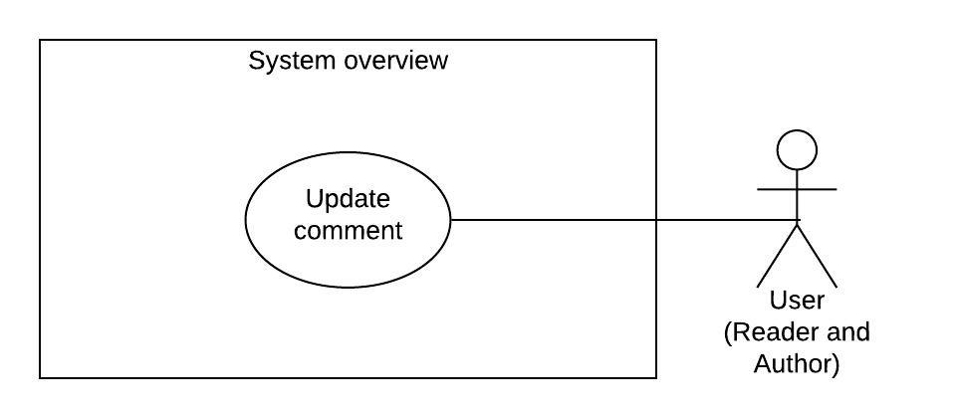

Figure 24 - <User> Update comment

|  |  |  |  |
| --- | --- | --- | --- |
| **USE CASE – StoryArt_U_11** | | | |
| **Use Case No.** | StoryArt_U_11 | **Use Case Version** | 2.0 |
| **Use Case Name** | Update comment | | |
| **Author** | DatNT | | |
| **Date** | 21/03/2020 | **Priority** | Normal |
| **Actor:**   * User   **Summary:**   * Allow user to update their comment in a story.   **Goal:**   * User can update comment.   **Triggers:**   * User goes to story detail. * User send request to update comment.   **Preconditions:**   * Guest logged into the system with role “User”.   **Post conditions:**   * Success: System shows updated comment in comment list. * Fail: System shows error messages.   **Main Success Scenario:**   |  |  |  | | --- | --- | --- | | **Step** | **Actor Action** | **System Response** | | 1 | User goes to story detail. | System shows list comments of story. If comment of user can update, systems will shows update button. | | 2 | User clicks on update button. | System will show a popup requires identity information of comment from User to update:  - Comment content: required, input text area  - “Chỉnh sửa”: button  - “Hủy”: button | | 3 | User clicks on “Hủy” button. | Close popup, nothing change. | | 4 | User inputs content of comment. |  | | 5 | User clicks on “Chỉnh sửa” button. | System shown updated comment in comment list.  [Exception 1][Exception 2][Exception 3] |   **Alternative Scenario: N/A**  **Exceptions:**   |  |  |  | | --- | --- | --- | | **No** | **Actor Action** | **System Response** | | 1 | User inputs empty content of comment. | System shows error message: “Xin vui lòng nhập bình luận”. | | 2 | User inputs over max length content of comment. | System shows error message: “Nội dung bình luân phải dưới 10000 kí tự.” | | 3 | Lost internet connection | System failed to update comment. |   **Relationships:** N/A.  **Business Rules:**  Authorized User can update comment of themselves in a story.  User can edit their comment how many time they want. | | | |

Table 26 - <User> Update comment use case specification

##### 2.3.2.12. Delete comment

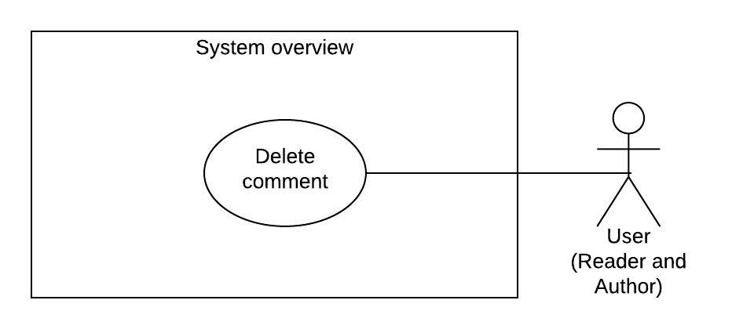

Figure 25 - <User> Delete comment

|  |  |  |  |
| --- | --- | --- | --- |
| **USE CASE – StoryArt_U_12** | | | |
| **Use Case No.** | StoryArt_U_12 | **Use Case Version** | 2.0 |
| **Use Case Name** | Delete comment | | |
| **Author** | DatNT | | |
| **Date** | 21/03/2020 | **Priority** | Normal |
| **Actor:**   * User   **Summary:**   * Allow user to delete their comment in a story.   **Goal:**   * User can delete comment.   **Triggers:**   * User goes to story detail. * User send request to delete comment.   **Preconditions:**   * Guest logged into the system with role “User”.   **Post conditions:**   * Success: System remove comment in comment list. * Fail: System shows error messages.   **Main Success Scenario:**   |  |  |  | | --- | --- | --- | | **Step** | **Actor Action** | **System Response** | | 1 | User goes to story detail. | System shows list comments of story. If comment of user can remove, systems will shows remove button. | | 2 | User clicks on edit button. | System show popup with two button for user can select:  - “Xóa” button.  - “Hủy” button. | | 3 | User clicks on “Hủy” button. | Close popup, nothing change. | | 4 | User clicks on “Xóa” button. | System removed comment in comment list.  [Exception 1] |   **Alternative Scenario: N/A**  **Exceptions:**   |  |  |  | | --- | --- | --- | | **No** | **Actor Action** | **System Response** | | 1 | Lost internet connection | System failed to delete comment. |   **Relationships:** N/A.  **Business Rules:**  Authorized User can delete comment of themselves in a story. | | | |

Table 27 - <User> Delete comment use case specification

##### 2.3.2.13. Report comment

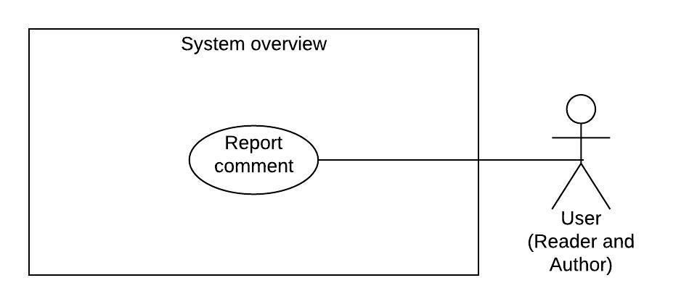

Figure 26 - <User> Report comment

|  |  |  |  |
| --- | --- | --- | --- |
| **USE CASE – StoryArt_U_13** | | | |
| **Use Case No.** | StoryArt_U_13 | **Use Case Version** | 2.0 |
| **Use Case Name** | Report comment | | |
| **Author** | DatNT | | |
| **Date** | 21/03/2020 | **Priority** | Normal |
| **Actor:**   * User   **Summary:**   * Allow user to report another user’s comment in a story.   **Goal:**   * User can report comment.   **Triggers:**   * User goes to story detail. * User send request to report comment.   **Preconditions:**   * Guest logged into the system with role “User”.   **Post conditions:**   * Success: Report is sent to system. * Fail: System shows error messages.   **Main Success Scenario:**   |  |  |  | | --- | --- | --- | | **Step** | **Actor Action** | **System Response** | | 1 | User goes to story detail. | System shows list comments of story. If comment does not belong to this user, systems will shows report button. | | 2 | User clicks on report button. | System will show a popup requires identity information of report from User to edit:  - Report content: required, input text area  - “Gửi”: button  - “Hủy”: button | | 3 | User clicks on “Hủy” button. | Close popup, nothing is sent. | | 4 | User inputs content of report. |  | | 5 | User clicks on “Gửi” button. | System shown edited comment in comment list.  [Exception 1][Exception 2][Exception 3][ Exception 4] |   **Alternative Scenario: N/A**  **Exceptions:**   |  |  |  | | --- | --- | --- | | **No** | **Actor Action** | **System Response** | | 1 | User inputs empty content of comment. | System shows error message: “Xin vui lòng nhập nội dung báo cáo”. | | 2 | User inputs over max length content of report. | System shows error message: “Nội dung report phải dưới 10000 kí tự.” | | 3 | User reported this comment already. | System shows error message: “Bạn đã báo cáo bình luận này, xin vui lòng chờ admin xử lí.” | | 4 | Lost internet connection | System failed to send report comment. |   **Relationships:** N/A.  **Business Rules:**  User can report any another user’s comment in a story.  User can report one time for each comment and need to wait for admin handled it. After that user can continue report the same comment.  Report content cannot be allowed to edit after sent. | | | |

Table 28 - <User> Report comment use case specification

##### 2.3.2.14. Report story

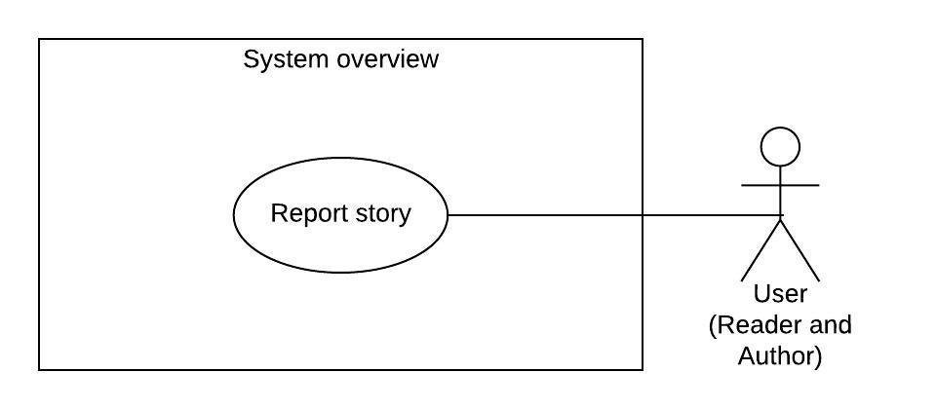

Figure 27 - <User> Report story

|  |  |  |  |
| --- | --- | --- | --- |
| **USE CASE – StoryArt_U_14** | | | |
| **Use Case No.** | StoryArt_U_14 | **Use Case Version** | 2.0 |
| **Use Case Name** | Report story | | |
| **Author** | DatNT | | |
| **Date** | 21/03/2020 | **Priority** | Normal |
| **Actor:**   * User   **Summary:**   * Allow user to report another user’s story.   **Goal:**   * User can report story.   **Triggers:**   * User goes to story detail. * User send request to report story.   **Preconditions:**   * Guest logged into the system with role “User”.   **Post conditions:**   * Success: Report is sent to system. * Fail: System shows error messages.   **Main Success Scenario:**   |  |  |  | | --- | --- | --- | | **Step** | **Actor Action** | **System Response** | | 1 | User goes to story detail. | If story does not belong to this user, systems will shows “Báo cáo” button. | | 2 | User clicks on “Báo cáo” button. | System will show a popup requires identity information of report from User to edit:  - Report content: required, input text area  - “Gửi”: button  - “Hủy”: button | | 3 | User clicks on “Hủy” button. | Close popup, nothing is sent. | | 4 | User inputs report content. |  | | 5 | User clicks on “Gửi” button. | System shown edited comment in comment list.  [Exception 1][Exception 2][Exception 3][ Exception 4] |   **Alternative Scenario: N/A**  **Exceptions:**   |  |  |  | | --- | --- | --- | | **No** | **Actor Action** | **System Response** | | 1 | User inputs empty content of comment. | System shows error message: “Xin vui lòng nhập nội dung báo cáo”. | | 2 | User inputs over max length content of report. | System shows error message: “Nội dung báo cáo phải dưới 10000 kí tự.” | | 3 | User reported this story already. | System shows error message: “Bạn đã báo cáo truyện này, xin vui lòng chờ admin xử lí.” | | 4 | Lost internet connection | System failed to report story. |   **Relationships:** N/A.  **Business Rules:**  User can report any another user’s story.  User can report one time for each story and need to wait for admin handled it. After that user can continue report the same story.  Report content cannot be allowed to edit after sent. | | | |

Table 29 - <User> Report story use case specification

##### 2.3.2.15. Like/Dislike comment

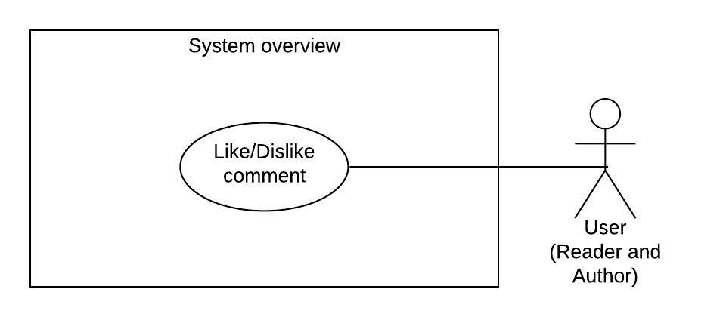

Figure 28 - <User> Like/Dislike comment

|  |  |  |  |
| --- | --- | --- | --- |
| **USE CASE – StoryArt_U_15** | | | |
| **Use Case No.** | StoryArt_U_15 | **Use Case Version** | 2.0 |
| **Use Case Name** | Like/dislike comment | | |
| **Author** | DatNT | | |
| **Date** | 21/03/2020 | **Priority** | Normal |
| **Actor:**   * User   **Summary:**   * Allow user to like/dislike any comment in a story.   **Goal:**   * User can like/dislike comment.   **Triggers:**   * User goes to story detail. * User send request to like/dislike comment.   **Preconditions:**   * Guest logged into the system with role “User”.   **Post conditions:**   * Success: System show comment is liked/disliked, add number of likes/dislikes in comment list. * Fail: System shows error messages.   **Main Success Scenario:**   |  |  |  | | --- | --- | --- | | **Step** | **Actor Action** | **System Response** | | 1 | User goes to story detail. | System shows list comments of story. Each comment will display a like and a dislike button. | | 2 | User clicks on like button. | [Exception 1] [Exception 2]  System show change icon of like button to liked, increase number of likes. | | 2 | User clicks on dislike button. | [Exception 1] [Exception 2]  System show change icon of like button to disliked, increase number of dislikes. |   **Alternative Scenario: N/A**  **Exceptions:**   |  |  |  | | --- | --- | --- | | **No** | **Actor Action** | **System Response** | | 1 | User not logged in. | System shows error message: “Bạn phải đăng nhập để sử dụng tính năng này.” | | 2 | Lost internet connection | System failed to send like/dislike. |   **Relationships:** N/A.  **Business Rules:**  Authorized User can like any comment of any user in comment list. | | | |

Table 30 - <User> Like/Dislike comment use case specification

##### 2.3.2.16. View own profile

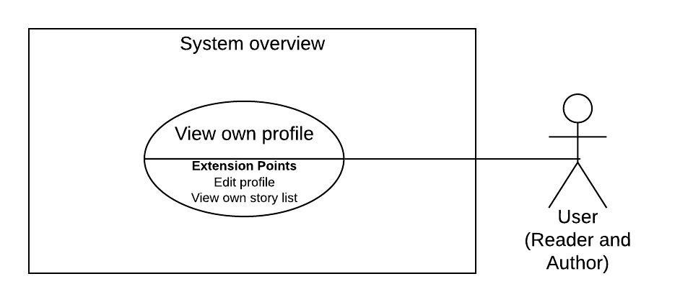

Figure 29 - <User> View own profile

|  |  |  |  |
| --- | --- | --- | --- |
| **USE CASE – StoryArt_G_16** | | | |
| **Use Case No.** | StoryArt_G_16 | **Use Case Version** | 2.0 |
| **Use Case Name** | View own profile | | |
| **Author** | HaiNV | | |
| **Date** | 24/02/2020 | **Priority** | Normal |
| **Actor:**   * User   **Summary:**   * This use case allows user to view own profile in system   **Goal:**   * The profile is shown successfully   **Triggers:**   * User click on “Quản Lý Tài Khoản” in navigator bar   **Preconditions:**   * Guest logged into the system with role “User”.   **Post Conditions:**   * Success: The profile is displayed. * Fail: System shows error messages.   **Main Success Scenario:**   |  |  |  | | --- | --- | --- | | **Step** | **Actor Action** | **System Response** | | 1 | User click on “Quản Lý Tài Khoản” in navigator bar | System shows on “Tài Khoản của bạn” with following labels and fields:  First Section:   * Profile and Avatar Image: image * Name: text * CreatedDate: text * Intro content: text * “Cập Nhật”: (button)   Second Section:   * System shown on list of stories created by user and its statistical information with following management option:   + “Xem thống kê”  + “Cập Nhật”  + “Hủy xuất bản truyện”  + “Xóa truyện”  [Exception 1] |   **Alternative Scenario: N/A**  **Exceptions 1 :**   |  |  |  | | --- | --- | --- | | **Step** | **Cause** | **System Response** | | 1 | There are some unexpected exceptions while sending request, i.e. network exception | System failed to load profile. |   **Relationships:** StoryArt_U_07, StoryArt_U_02  **Business Rules:**  User click on “Quản Lý Tài Khoản” in navigator bar, System will show his/her profile.  User can search or sort by filtering list of stories by options. | | | |

Table 31 - <User> View own profile use case specification

##### 2.3.2.17. Request censorship

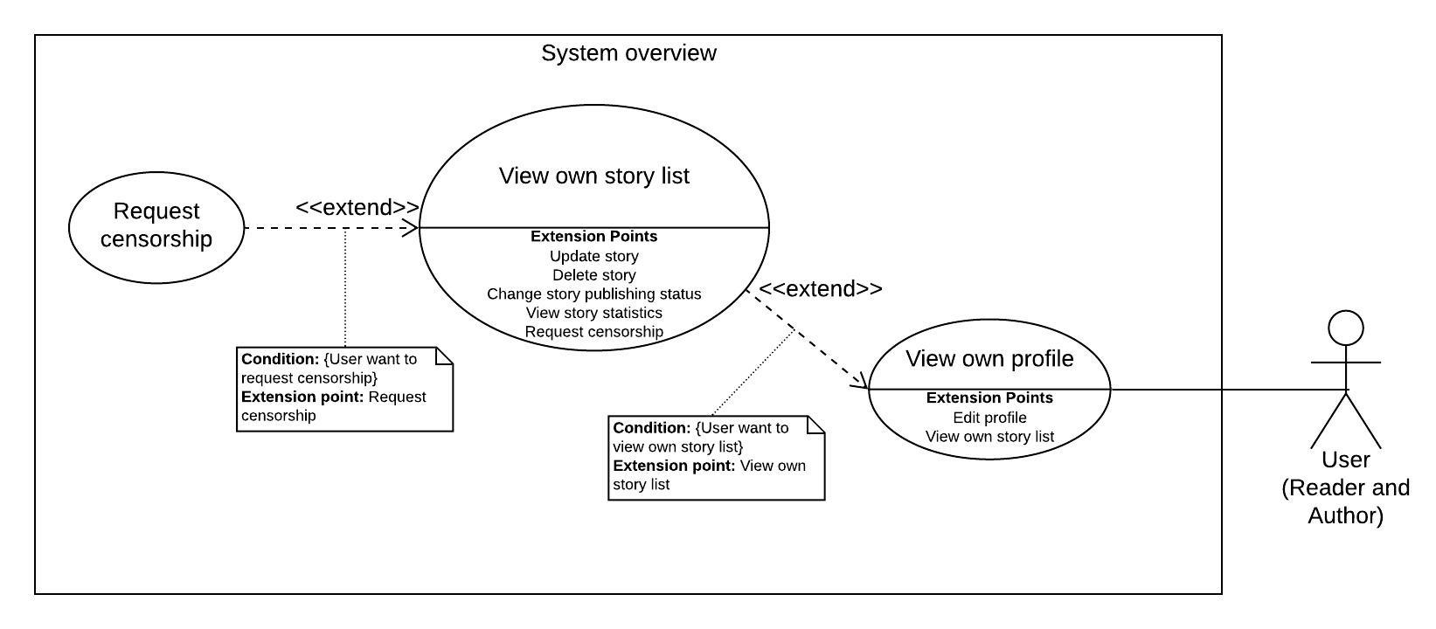

Figure 30 - <User> Request censorship

|  |  |  |  |
| --- | --- | --- | --- |
| **USE CASE – StoryArt_U_17** | | | |
| **Use Case No.** | StoryArt_U_17 | **Use Case Version** | 2.0 |
| **Use Case Name** | Request censorship | | |
| **Author** | DatNT | | |
| **Date** | 07/06/2020 | **Priority** | Normal |
| **Actor:**   * User   **Summary:**   * Allow user to request censorship. * Allow user to view censorship history.   **Goal:**   * User can request censorship. * User can view censorship history.   **Triggers:**   * User goes to profile page. * User send request to request censorship.   **Preconditions:**   * Guest logged into the system with role “User”. * Guest created at least one story.   **Post conditions:**   * Success: System send request censorship to administrator. * Fail: System shows error messages.   **Main Success Scenario:**   |  |  |  | | --- | --- | --- | | **Step** | **Actor Action** | **System Response** | | 1 | User goes to profile pages. | [Exception 1]  System shows their list stories. With each story have:  - “Xem kiểm duyệt”: button | | 2 | User clicks on “Xem kiểm duyệt” button. | [Exception 1]  System show censorship story popup with following information:  - “Nội dung yêu cầu”: text input.  - “Yêu cầu kiểm duyệt” button.  - List of censorship history includes:   * User note: text * Admin note: text * Created time: text * Handled time: text * Status: text | | 3 | User clicks on “Yêu cầu kiểm duyệt” button. | System change status of story to pending and send it to admin.  [Exception 1][Exception 2] | | 4 | User clicks on “Đóng” button. | Close popup. |   **Exceptions:**   |  |  |  | | --- | --- | --- | | **No** | **Actor Action** | **System Response** | | 1 | Lost internet connection | System failed to load censorship history/ send request censorship. | | 2 | Duplicated request. | System show error message “Truyện này đã yêu cầu kiểm duyệt rồi” |   **Relationships:** StortyArt_U_02, StortyArt_U_16  **Business Rules:**  Each story always has censorship status:   * APPROVED * REJECTED * PENDING   And a draft status for draft story.  User can send request censorship fo only draft and REJECTED story.  After update any story, status of story will change to draft. Current version is keep in system.  After story is APPROVED, the approved version will be applied to current version.  System will save censorship history for admin and user to review. | | | |

Table 32 - <User> Request censorship use case specification

#### 2.3.3. <Administrator> Overview Use Case

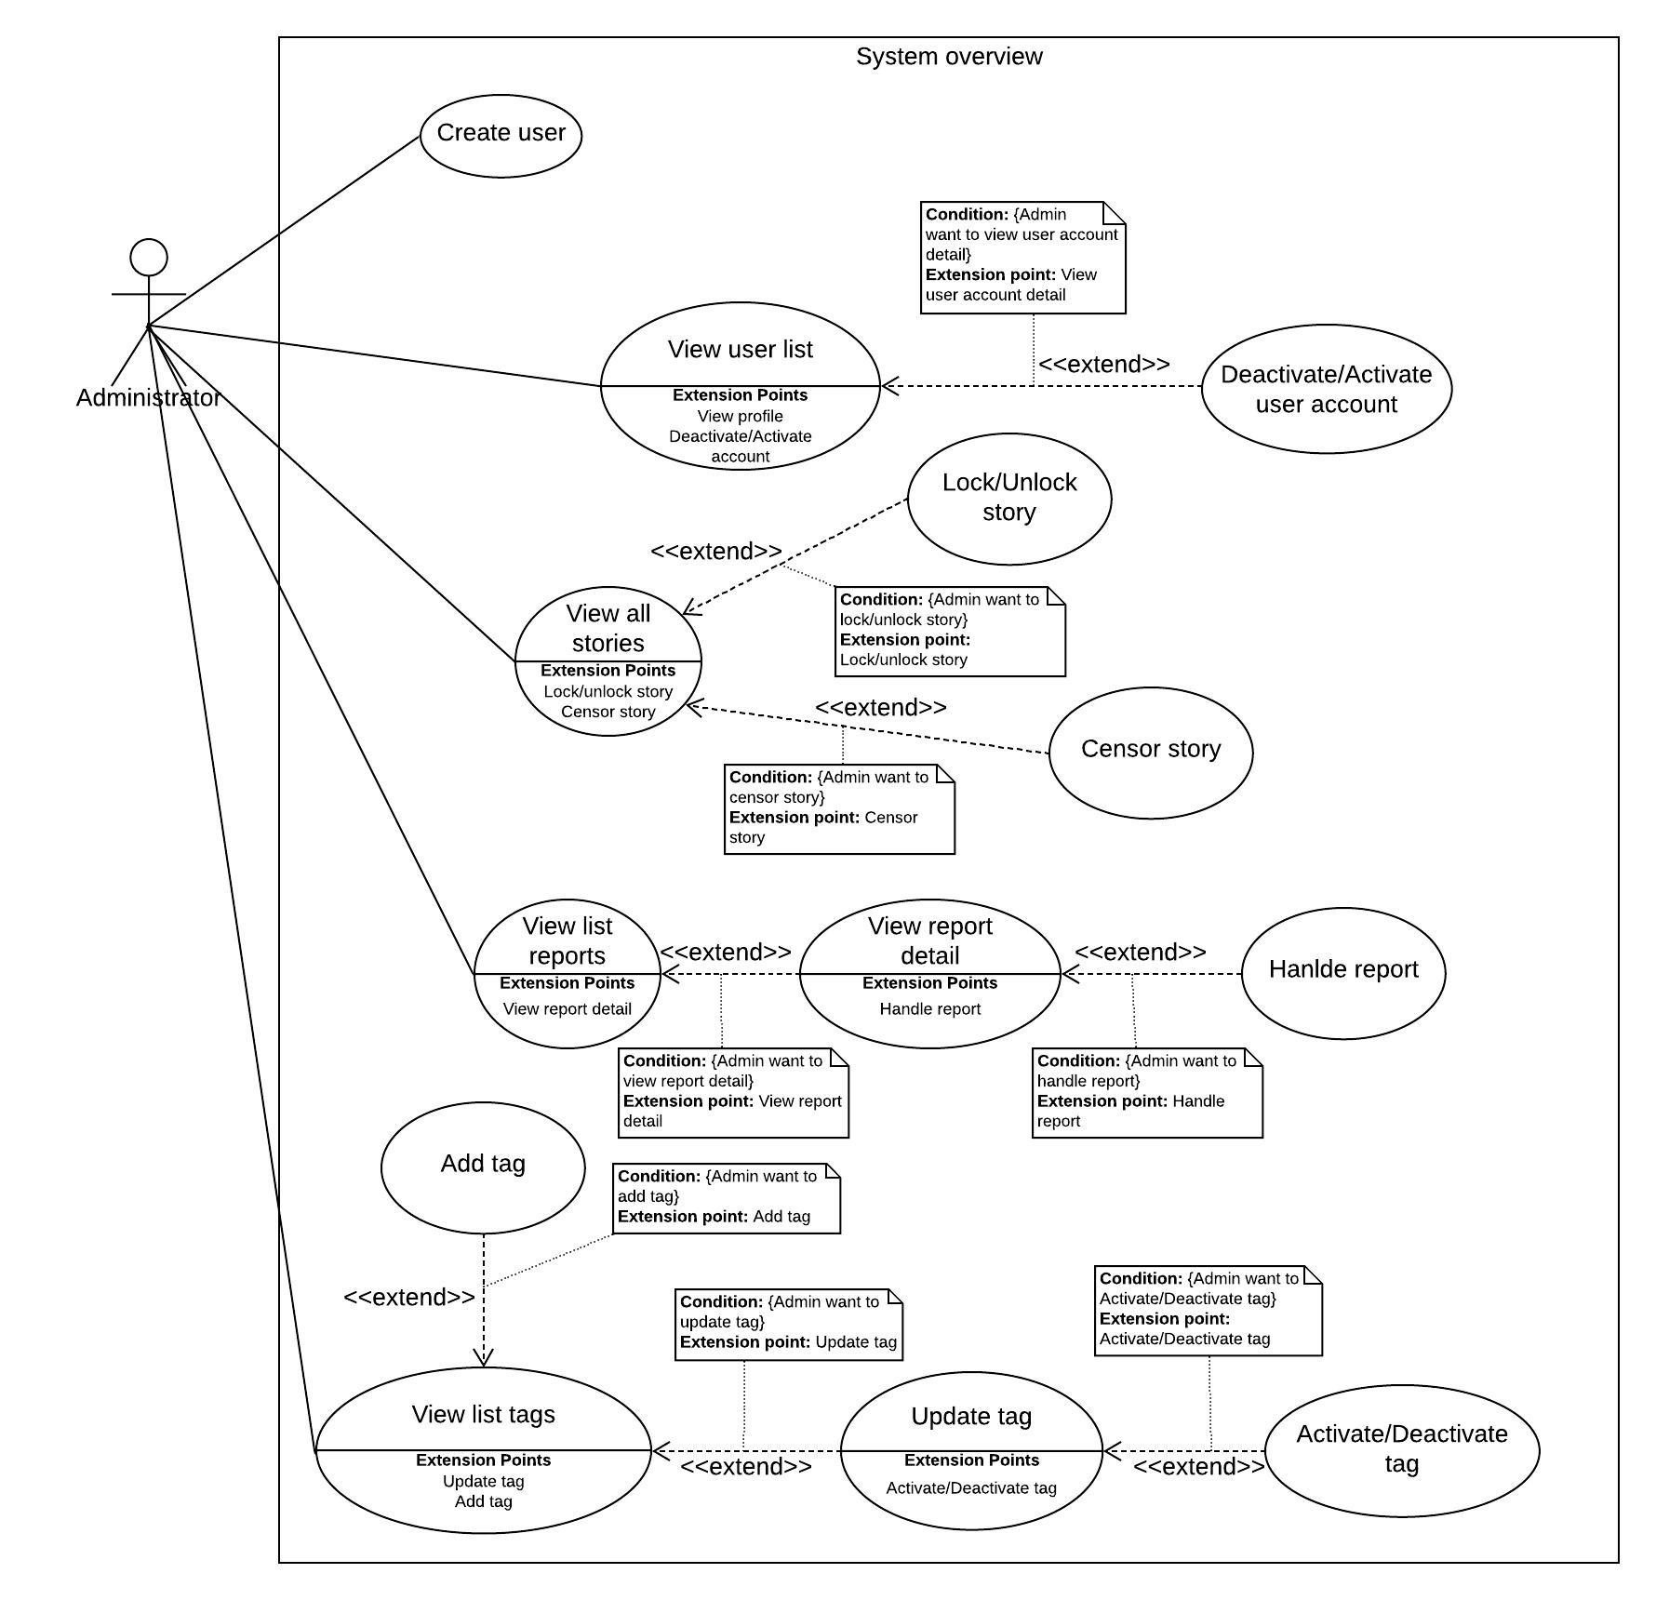

Figure 31 - <Administrator> Overview use case

##### 2.3.3.1. View list user accounts

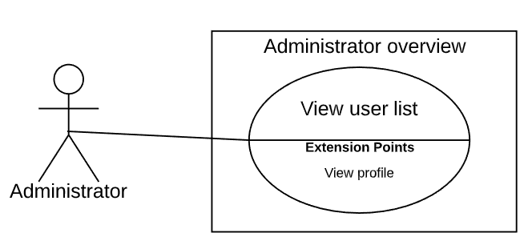

Figure 32 - <Administrator> View user list

|  |  |  |  |
| --- | --- | --- | --- |
| **USE CASE – StoryArt_A_01** | | | |
| **Use Case No.** | StoryArt_A_01 | **Use Case Version** | 2.0 |
| **Use Case Name** | View user list | | |
| **Author** | AnhTHT | | |
| **Date** | 10/4/2020 | **Priority** | Normal |
| **Actor:**   * Administrator   **Summary:**   * This use case allows administrator to view user accounts in the system.   **Goal:**   * Administrator can view user accounts in the system.   **Triggers:**   * Administrator click on “Đi tới trang quản lý” button in the menu.   **Preconditions:**   * Guest logged into the system with role “Administrator”.   **Post conditions:**   * **Success:** Administrator see a table user acccount in the system. * **Fail:** System shows error messages.   **Main Success Scenario:**   |  |  |  | | --- | --- | --- | | **Step** | **Actor Action** | **System Response** | | 1 | Administrator clicks “Đi tới trang quản lý” button on menu in home page. | [Exception 1]  System redirects administrator to user list page that contain table of user accounts |   **Alternative Scenario: N/A**  **Exceptions:**   |  |  |  | | --- | --- | --- | | **No** | **Actor Action** | **System Response** | | 1 | Lost internet connection. | System failed to load user list. |   **Relationships:** StoryArt_A_02  **Business Rules:**  Table of accounts has maximum 10 row items.  Admin can deactivate/activate user in table of accounts. | | | |

Table 33 - <Administrator> View user list use case specification

##### 2.3.3.2. Deactivate/Activate account

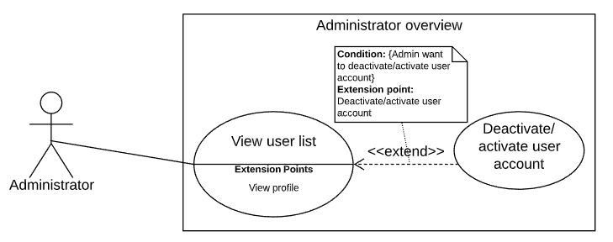

Figure 33 - <Administrator> Deactivate/activate user account

|  |  |  |  |
| --- | --- | --- | --- |
| **USE CASE – StoryArt_A_02** | | | |
| **Use Case No.** | StoryArt_A_02 | **Use Case Version** | 2.0 |
| **Use Case Name** | Deactivate/activate user account | | |
| **Author** | AnhTHT | | |
| **Date** | 10/04/2020 | **Priority** | Normal |
| **Actor:**   * Administrator   **Summary:**   * This use case allows administrator to deactivate or activate user account.   **Goal:**   * Status of selected user changed   **Triggers:**   * Administrator clicks on status button of a user account.   **Preconditions:**   * Guest logged into the system with role “Administrator”.   **Post conditions:**   * **Success:** Status of user account changed. * **Fail:** System shows error messages.   **Main Success Scenario:**   |  |  |  | | --- | --- | --- | | **Step** | **Actor Action** | **System Response** | | 1 | Administrator clicks on status button of an user account | System shows administrator a confirm modal | | 2 | Administrator clicks “Đồng ý” button change status of user account[Alternative 1] | [Exception 1]  System closes the modal and refresh page that contents changed status user account |   **Alternative Scenario:**   |  |  |  | | --- | --- | --- | | **No** | **Actor Action** | **System Response** | | 1 | Administrator clicks on “Huỷ bỏ” button or outside the area of modal to cancel request change status | System closes modal. |   **Exceptions:**   |  |  |  | | --- | --- | --- | | **No** | **Actor Action** | **System Response** | | 1 | Lost internet connection. | System failed to load user list. |   **Relationships:** StoryArt_A_01  **Business Rules:**  Administrator that is deactivated by system administrator is not allow to change status of user account.  Administrator can activate/deactivate user how many time they want. | | | |

Table 34 - <Administrator> Deactivate/activate user account use case specification

##### 2.3.3.3. Create user

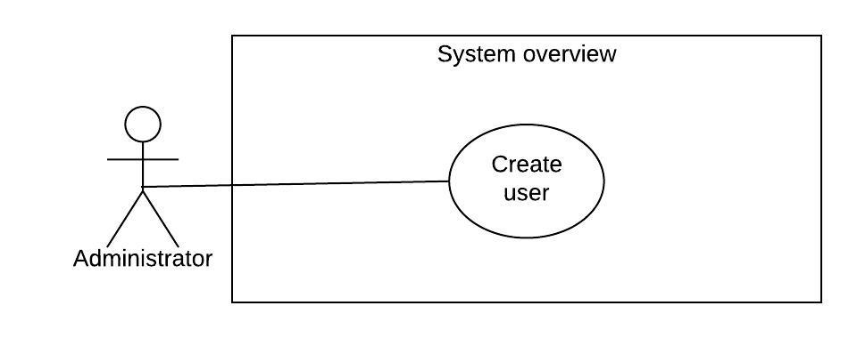

Figure 34 - <Administrator> Create user

|  |  |  |  |
| --- | --- | --- | --- |
| **USE CASE – StoryArt_A_03** | | | |
| **Use Case No.** | StoryArt_A_03 | **Use Case Version** | 2.0 |
| **Use Case Name** | Create user | | |
| **Author** | AnhTHT | | |
| **Date** | 10/04/2020 | **Priority** | Normal |
| **Actor:**   * Administrator   **Summary:**   * This use case allows administrator to add user into the system.   **Goal:**   * Administrator can add user into the system.   **Triggers:**   * System administrator clicks on “Đi tới trang quản lý” button in the menu home page   **Preconditions:**   * Guest logged into the system with role “Administrator”.   **Post conditions:**   * **Success:** Created user row added in top of list user table * **Fail:** System shows error messages.   **Main Success Scenario:**   |  |  |  | | --- | --- | --- | | **Step** | **Actor Action** | **System Response** | | 1 | Administrator clicks “Thêm người dùng” on menu in home page. | System shows dialog:  -Tên đăng nhập: blank text input  -Mật khẩu: blank text input  -Tên đầy đủ: blank text input  - Email: blank text input  - Thông tin giới thiệu về bạn: blank text input | | 2 | Administrator inputs information |  | | 3 | Administrator clicks “Lưu” button to add user to system. [Alternative 1] | [Exception 1,2,3,4,5,6,7,8]  System closes dialog and shows table of users that has created user row |   **Alternative Scenario:**   |  |  |  | | --- | --- | --- | | **No** | **Actor Action** | **System Response** | | 1 | Administrator clicks on “Thoát” | System closes dialog. |   **Exceptions:**   |  |  |  | | --- | --- | --- | | **No** | **Actor Action** | **System Response** | | 1 | Administrator does not enter, enter blank or enter username not be between 3 and 15 characters. | System shows error message “Tên đăng nhập phải có từ 3 đến 15 ký tự ” | | 2 | Administrator does not enter , enters blank or enter name not be between 3 and 40 characters | System shows error message “ Tên phải có từ 3 đến 15 ký tự” | | 3 | Administrator does not enter , enters blank or enter password not be between 8 and 100 characters. | System shows error message “Mật khẩu phải có từ 8 đến 100 ký tự” | | 4 | Administrator does not enter email or enters blank | System shows error message “Email không được để trống” | System shows error message “Tên đăng nhập không được để trống” | | 5 | Administrator enters email is not validated with email standard form | System shows error message “Email không đúng định dạng. Vui lòng nhập lại” | | 6 | Administrator enters an username used by another account | System shows error message “Tên đăng nhập này đã được đăng ký bởi ai đó” | | 7 | Administrator enters an email used by another account | System shows error message “Email này đã được đăng ký bởi ai đó” | | 8 | Administrator does not enter, enter blank or enter introduction information has not a maximum length of 300 characters | System shows error message “Thông tin giới thiệu có độ dài tối đa là 300 ký tự” |   **Relationships:** N/A  **Business Rules:**   * Introduction information has a maximum length of 300 characters. * Email must be validated email standard form. * Email must not be blank. * Name must be between 3 and 40 characters. * Username must be between 3 and 15 characters. * Password must be between 8 and 100 characters. * An email is only used to register for one person. * A username is only used to register for one person. | | | |

Table 35 - <Administrator> Create user use case specification

##### 2.3.3.4. View list reports

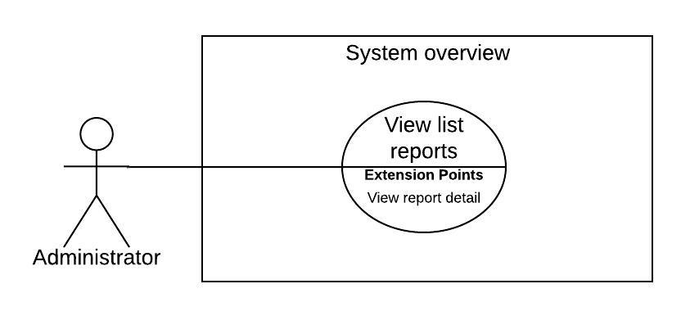

Figure 35 - <Administrator> View list reports

|  |  |  |  |
| --- | --- | --- | --- |
| **USE CASE – StoryArt_A_04** | | | |
| **Use Case No.** | StoryArt_A_04 | **Use Case Version** | 2.0 |
| **Use Case Name** | View list reports | | |
| **Author** | DatNT | | |
| **Date** | 21/03/2020 | **Priority** | Normal |
| **Actor:**   * Administrator   **Summary:**   * Allow Administrator to views list reports of all members with all status in system.   **Goal:**   * Administrator can view their list report with all status.   **Triggers:**   * Administrator goes to admin page. * Administrator clicks “Quản lý báo xấu” menu.   **Preconditions:**   * Guest logged into the system with role admin.   **Post conditions:**   * Success: System shows list reports with all status. * Fail: System shows error messages.   **Main Success Scenario:**   |  |  |  | | --- | --- | --- | | **Step** | **Actor Action** | **System Response** | | 1 | Admin clicks “Quản lý báo xấu” on menu. | “Quản lí báo cáo” page will show two tabs:  - Bình luận: tab  - Truyện: tab | | 2 | Admin clicks “Bình luận” tab | [Alternative 1]  System show reports of comment table:  - Status: dropdown box  - Search box: blank text input  - “Mã bình luận”: text  - “Tên tài khoản”: text  - “Nội dung bình luận”: text  - “Số lượng báo cáo”: text  - “Email”: text  - Handle button  [Exception 1] | | 3 | Admin clicks “Truyện” tab | [Alternative 1]  System show reports of comment table:  - Status: dropdown box  - Search box: blank text input  - “Mã truyện”: text  - “Tác giả”: text  - “Tên truyện”: text  - “Số lượng báo cáo”: text  - “Email”: text  - Handle button  [Exception 1] |   **Alternative Scenario:**   |  |  |  | | --- | --- | --- | | **No** | **Actor Action** | **System Response** | | 1 | User change status of status dropdown box. | System shows report table with status user selected and change handle button to preview button. |   **Exceptions:**   |  |  |  | | --- | --- | --- | | **No** | **Actor Action** | **System Response** | | 1 | Lost internet connection | System failed to load list reports |   **Relationships:** StoryArt_A_05, StoryArt_A_06  **Business Rules:**  Administrator can view all of reports in system.  Administrator can review all reports after replied.  Search bar always on top for administrator can search easily.  Table contains max 5 items per page. | | | |

Table 36 - <Administrator> View list reports use case specification

##### 2.3.3.5. View report detail

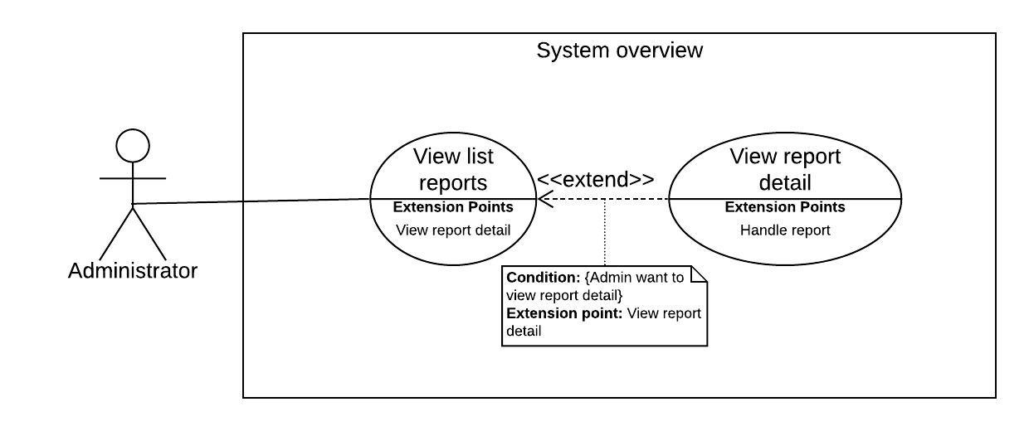

Figure 36 - <Administrator> View report detail

|  |  |  |  |
| --- | --- | --- | --- |
| **USE CASE – StoryArt_A_05** | | | |
| **Use Case No.** | StoryArt_A_05 | **Use Case Version** | 2.0 |
| **Use Case Name** | View report detail | | |
| **Author** | DatNT | | |
| **Date** | 21/03/2020 | **Priority** | Normal |
| **Actor:**   * Administrator   **Summary:**   * Allow administrator to views specified a report of users.   **Goal:**   * Administrator can view report detail.   **Triggers:**   * Administrator goes to admin page. * Administrator clicks “Quản lý báo cáo” menu. * Administrator sends request to view specified a report.   **Preconditions:**   * User logged into the system in role “Administrator”.   **Post conditions:**   * Success: System shows report detail information. * Fail: System shows error messages.   **Main Success Scenario:**   |  |  |  | | --- | --- | --- | | **Step** | **Actor Action** | **System Response** | | 1 | Administrator clicks handle button or preview button on a specified report in “Bình luận” tab. | [Exception 1]  System shows popup and displays report detail:  - “Tên người dùng”: text  - “Nội dung bình luận”: text  - “Số lượng báo cáo”: text  - “Email”: text  - Xử lí: dropdown box  - List of report: table. Include:  + Tên người báo cáo: text  + Nội dung báo cáo: text  - “Xử lý”: button  - “Hủy”: button | | 2 | Administrator clicks handle button or preview button on a specified report in “Truyện” tab. | [Exception 1]  System shows popup and displays report detail:  - “Tác giả”: text  - “Tên truyện”: text  - “Số lượng báo cáo”: text  - “Email”: text  - Xử lí: dropdown box  - List of report: table. Include:  + Tên người báo cáo: text  + Nội dung báo cáo: text  - “Xử lý”: button  - “Hủy”: button |   **Alternative Scenario:**   |  |  |  | | --- | --- | --- | | **No** | **Actor Action** | **System Response** | | 1 | User change status of report status dropdown box. | System change handle button to preview button and vice versa. |   **Exceptions:**   |  |  |  | | --- | --- | --- | | **No** | **Actor Action** | **System Response** | | 1 | Lost internet connection. | System failed to load report detail. |   **Relationships:** StoryArt_A_04, StoryArt_A_06  **Business Rules**:  If administrator want to inform to user about the report, admin need to do it manually by sending email to user. | | | |

Table 37 - <Administrator> View report detail use case specification

##### 2.3.3.6. Handle report

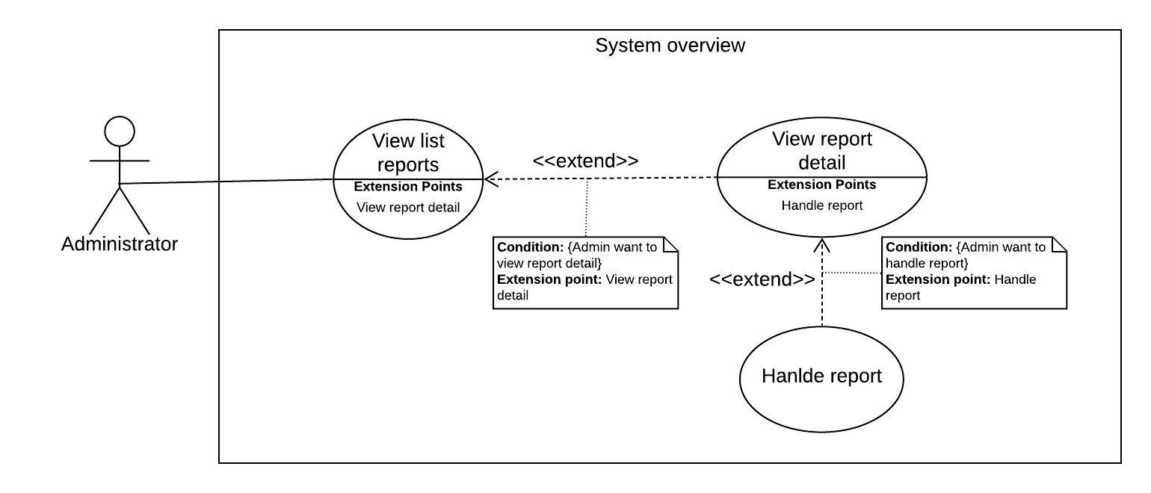

Figure 37 - <Administrator> Handle report

|  |  |  |  |
| --- | --- | --- | --- |
| **USE CASE – StoryArt_A_06** | | | |
| **Use Case No.** | StoryArt_A_06 | **Use Case Version** | 2.0 |
| **Use Case Name** | Handle report | | |
| **Author** | DatNT | | |
| **Date** | 21/03/2020 | **Priority** | Normal |
| **Actor:**   * Administrator   **Summary:**   * Allow administrator to handle specified a report of users.   **Goal:**   * Administrator can handle report.   **Triggers:**   * Administrator goes to admin page. * Administrator clicks “Quản lý báo cáo” menu. * Administrator view a specified report. * Administrator send request handle report.   **Preconditions:**   * User logged into the system in role “Administrator”.   **Post conditions:**   * Success: System change status of report to handled. * Fail: System shows error messages.   **Main Success Scenario:**   |  |  |  | | --- | --- | --- | | **Step** | **Actor Action** | **System Response** | | 1 | [Alternative 1]  Admin choose option in “Xử lí” dropdown box. | In “Bình luận” tab, system three option in dropdown box include:  - “Không xử lí”  - “Ẩn bình luận”  - “Vô hiệu hóa tài khoản”  In “Truyện” tab, system three option in dropdown box include:  - “Không xử lí”  - “Ẩn truyện”  - “Vô hiệu hóa tài khoản” | | 2 | Administrator choose option in “Xử lý” dropdown box and click “Xử lý” in popup. | [Exception 1]  System change status of comment or user and remove report in report table.  System close popup. | | 3 | Administrator click “Hủy” button in popup. | [Exception 1]  System close popup, nothing change. |   **Alternative Scenario:**   |  |  |  | | --- | --- | --- | | **No** | **Actor Action** | **System Response** | | 1 | If administrator click on preview button to preview handled reports. | System will show status of comment, user or story. Admin can change those statuses. |   **Exceptions:**   |  |  |  | | --- | --- | --- | | **No** | **Actor Action** | **System Response** | | 1 | Lost internet connection. | System failed to send handle report request. |   **Relationships:** StoryArt_A_04, StoryArt_A_05  **Business Rules**:  Handled report is moved to handled table.  Admin can view hanled report by choosing handled dropdown button. | | | |

Table 38 - <Administrator> Handle report use case specification

##### 2.3.3.7. View list tags

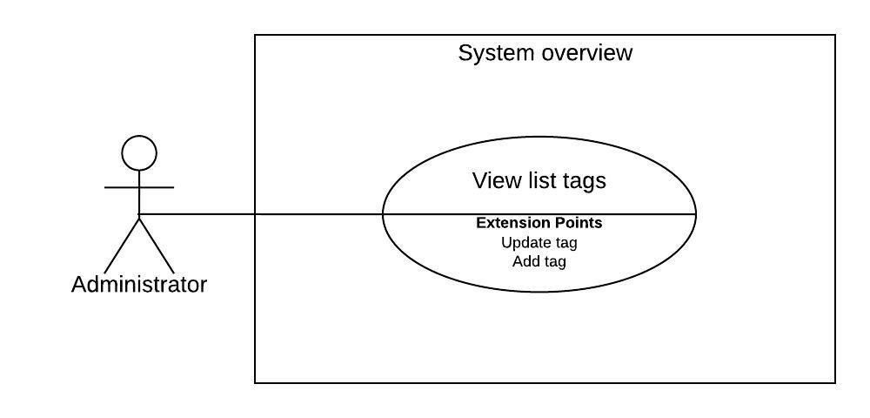

Figure 38 - <Administrator> View list tags

|  |  |  |  |
| --- | --- | --- | --- |
| **USE CASE – StoryArt_A_07** | | | |
| **Use Case No.** | StoryArt_A_07 | **Use Case Version** | 2.0 |
| **Use Case Name** | View list tags | | |
| **Author** | HaiNV | | |
| **Date** | 24/02/2020 | **Priority** | Normal |
| **Actor:**   * Administrator   **Summary:**   * Allow Administrator to view list of tags in system.   **Goal:**   * Administrator can view list of tags   **Triggers:**   * Administrator goes to admin page.   - Administrator Clicks on “Quản lý Thẻ” Button  **Preconditions:**   * Guest logged into the system with role “Administrator”.   **Post Conditions:**   * Success: Information of Tags List will be shown on Screen. * Fail: System shows error messages.   **Main Success Scenario:**   |  |  |  | | --- | --- | --- | | **Step** | **Actor Action** | **System Response** | | 1 | Administrator clicks on “Quản Lý Thẻ” button on navigation bar. | System shows “Thông Tin Thẻ” list screen.  [Exception 1] |   **Alternative Scenario:** N/A  **Exceptions 1 :**   |  |  |  | | --- | --- | --- | | **Step** | **Cause** | **System Response** | | 1 | There are some unexpected exceptions while sending request, i.e. network exception | System failed to load list tags. |   **Relationships:** StoryArt_A_08  **Business Rules:**  Administrator can view all tags in system includes active and deactive tag.  Each tag will be display with:   * Tag name * Create time * Status | | | |

Table 39 - <Administrator> View list tags use case specification

##### 2.3.3.8. Add tag

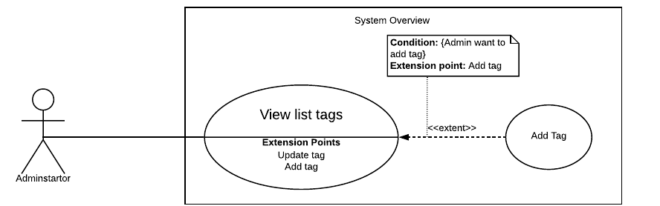

Figure 39 - < Administrator > Add Tag

|  |  |  |  |
| --- | --- | --- | --- |
| **USE CASE – StoryArt_A_08** | | | |
| **Use Case No.** | StoryArt_A_08 | **Use Case Version** | 2.0 |
| **Use Case Name** | Add tag | | |
| **Author** | HaiNV | | |
| **Date** | 24/02/2020 | **Priority** | Normal |
| **Actor:**   * Administrator   **Summary:**   * Allow Administrator to create new Tags   **Goal:**   * Administrator can create new tag   **Triggers:**  - Administrator Clicks on “Thêm Thẻ” Button  **Preconditions:**   * Guest logged into the system with role “Administrator”.   **Post Conditions:**   * Success: A new Tag must be created * Fail: System shows error messages.   **Main Success Scenario:**   |  |  |  | | --- | --- | --- | | **Step** | **Actor Action** | **System Response** | | 1 | Administrator clicks on “Thêm Thẻ” button | “Thêm Thẻ” screen is shown with following labels and fields:  + Tên Thẻ : (text : required) | | 2 | Administrator fills out data fields and clicks on “Xác Nhận” button. | System validates inputted data and shows “Thông Tin Thẻ” screen  [Exception 1, 2, 3, 4] |   **Alternative Scenario: N/A**  **Exceptions :**   |  |  |  | | --- | --- | --- | | **Step** | **Cause** | **System Response** | | 1 | Tags Title is Empty | System shows error message "Xin hãy điền tên Thẻ vào” and highlights the empty fields. | | 2 | Tags Title is existed | System show error message “Thẻ đã tồn tại” and highlight the error field. | | 3 | Administrator clicks on “Thoát” button. | System shows “Thông Tin Thẻ” screen | | 5 | There are some unexpected exceptions while sending request, i.e. network exception | System failed to add tag |   **Relationships:** StoryArt_A_07  **Business Rules:**  Only Administrator can add new Tag into system  After Administrator add tag, system will update list of tag  There is not any limit in number of tag can be added. | | | |

Table 40 - <Administrator> Add tag use case specification

##### 2.3.3.9. Update tag

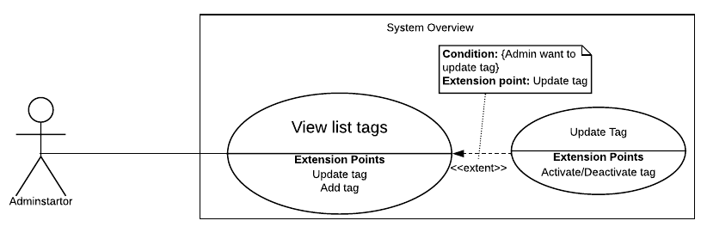

Figure 40 - < Administrator > Update Tag

|  |  |  |  |
| --- | --- | --- | --- |
| **USE CASE – StoryArt_A_09** | | | |
| **Use Case No.** | StoryArt_A_09 | **Use Case Version** | 2.0 |
| **Use Case Name** | Update tag | | |
| **Author** | HaiNV | | |
| **Date** | 24/02/2020 | **Priority** | Normal |
| **Actor:**   * Administrator   **Summary:**   * Allow Administrator to update existed Tags.   **Goal:**   * Administrator update tags successfully   **Triggers:**  - Administrator Clicks on “Cập Nhật Thẻ” Button  **Preconditions:**   * Guest logged into the system with role Administrator.   **Post Conditions:**   * Success: Tag must be updated * Fail: System shows error messages.   **Main Success Scenario:**   |  |  |  | | --- | --- | --- | | **Step** | **Actor Action** | **System Response** | | 1 | Administrator clicks on “Cập Nhật” button | “Cập Nhật Thẻ” screen is shown with following labels and fields:  + Tên Thẻ : (text : required) | | 2 | Administrator fills out data fields and clicks on “Xác Nhận” button. | System validates inputted data and shows “Thông Tin Thẻ” screen  [Exception 1, 2, 3, 4] |   **Alternative Scenario: N/A**  **Exceptions :**   |  |  |  | | --- | --- | --- | | **Step** | **Cause** | **System Response** | | 1 | Tags Title is Empty | System shows error message "Xin hãy điền tên Thẻ vào” and highlights the empty fields. | | 2 | Tags Title is existed | System show error message “Thẻ đã tồn tại” and highlight the error field. | | 3 | Administrator clicks on “Thoát” button. | System shows “Thông Tin Thẻ” screen | | 4 | There are some unexpected exceptions while sending request, i.e. network exception | System failed to update tag. |   **Relationships:** StoryArt_A_07, StoryArt_A_10  **Business Rules:**  Only Administrator can update existed Tag in system  When Administrator clicks on “Xác Nhận” button, the following data must be updated:  + Title (String)  + updatedAt(date time) | | | |

Table 41 - <Administrator> Update tag use case specification

##### 2.3.3.10. Deactivate/Activate tag

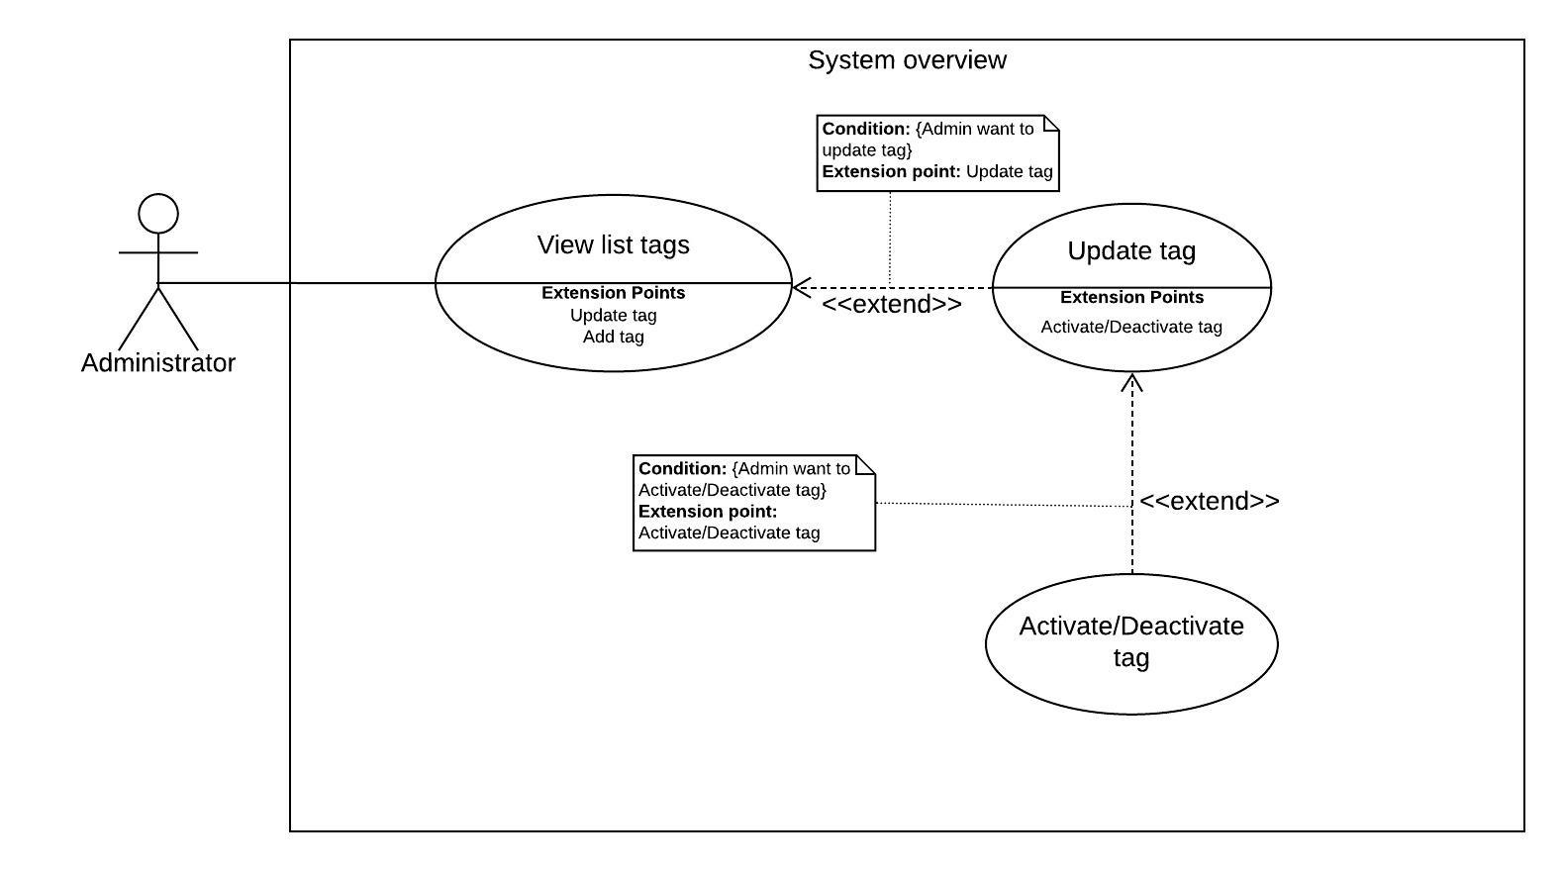

Figure 41 - < Administrator > Activate/Deactivate tag

|  |  |  |  |
| --- | --- | --- | --- |
| **USE CASE – StoryArt_A_10** | | | |
| **Use Case No.** | StoryArt_A_10 | **Use Case Version** | 2.0 |
| **Use Case Name** | Activate/Deactivate tag | | |
| **Author** | HaiNV | | |
| **Date** | 24/02/2020 | **Priority** | Normal |
| **Actor:**   * Administrator   **Summary:**   * Allow Administrator to update status of tag.   **Goal:**   * Administrator update tag’s status successfully   **Triggers:**   * Administrator Clicks on “Cập Nhật Thẻ” Button   **Preconditions:**   * Guest logged into the system with role “Administrator”.   **Post Conditions:**   * Success: Status of Tag need to be changed * Fail: System shows error messages.   **Main Success Scenario:**   |  |  |  | | --- | --- | --- | | **Step** | **Actor Action** | **System Response** | | 1 | Administrator click on “Tình Trạng” on status bar | System Show Status Bar with option “Kích Hoạt/ Hủy Kích Hoạt” | | 2 | Administrator click on option “Kích Hoạt” on status bar  [Alternative 1] | Confirmation dialog is shown with the Y/N option depend on choice:  “Kích Hoạt Thẻ sẽ khiến nó xuất hiện ở thanh tìm kiếm truyện. Bạn có chắc là muốn kích hoạt nó không?”  [Exception 2] | | 3 | Administrator click on option “Xác Nhận” button | System go back to “Thông tin Thẻ” screen. [Exception 1,3] |   **Alternative Scenario:**   |  |  |  | | --- | --- | --- | | **No** | **Actor Action** | **System Response** | | 1 | Administrator click on option “Hủy Kích Hoạt” on status bar | Confirmation dialog is shown with the Y/N option depend on choice:  “Hủy Kích Hoạt Thẻ sẽ khiến nó biến mất ở thanh tìm kiếm truyện. Bạn có chắc là muốn hủy kích hoạt nó không?”  [Exception 2] | | 2 | Administrator click on option “Xác Nhận” button | System go back to “Thông tin Thẻ” screen. [Exception 1,3] |   **Exceptions :**   |  |  |  | | --- | --- | --- | | **Step** | **Cause** | **System Response** | | 1 | Administrator click on “Hủy” button | System go back to “Thông tin Thẻ” screen | | 2 | Administrator have not choose any Status to change | System go back to “Thông tin Thẻ” screen | | 3 | There are some unexpected exceptions while sending request, i.e. network exception | System failed to activate/deactivate tag |   **Relationships:** StoryArt_A_07, StoryArt_A_09  **Business Rules:**  Only Administrator can update Tag status in system  When Administrator clicks on “Xác Nhận” button, the following data must be updated:  + isActive (Boolean) | | | |

Table 42 - <Administrator> Activate/Deactivate tag use case specification

##### 2.3.3.11. View all stories

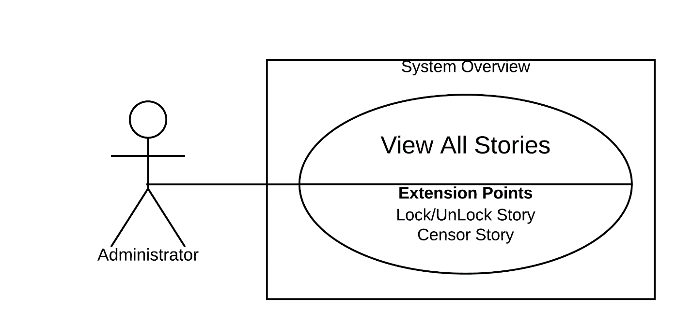

Figure 42 - <Administrator> View All Stories

|  |  |  |  |
| --- | --- | --- | --- |
| **USE CASE – StoryArt_A_11** | | | |
| **Use Case No.** | StoryArt_A_11 | **Use Case Version** | 2.0 |
| **Use Case Name** | View All Stories | | |
| **Author** | HaiNV | | |
| **Date** | 08/06/2020 | **Priority** | Normal |
| **Actor:**   * Administrator   **Summary:**   * This use case allows Administrator to View all stories in system   **Goal:**   * List of all stories is shown successfully   **Triggers:**   * Administrator click on “Quản lý truyện” in menu navigator bar   **Preconditions:**   * Guest logged into the system with role admin.   **Post Conditions:**   * Success**:** System shows list of all stories in system * Fail**:** System shows error messages.   **Main Success Scenario:**   |  |  |  | | --- | --- | --- | | **Step** | **Actor Action** | **System Response** | | 1 | Admin clicks “Quản lý truyện” on menu. | “Quản Lý Truyện” page will show with following data:  1st card contains :  “Quản Lý Truyện” : text   * Search box : blank text input with text holder : “tìm truyện, tác giả” * “Sắp Xếp Theo”: dropdown box * “Thứ Tự”: dropdown box * “Trạng Thái Kiểm Duyệt”:   dropdown box   * “Tìm Kiến”: Search button   2st card contains:  System show all stories table:   * “STT”: text * “Ảnh”: image * “Ngày tạo”: text * “Số màn hình”: text * “Lượt đọc”: text * “Lượt bình luận”: text * “Lượt đánh giá”: text * “Đánh giá trung bình”: text * “Trạng thái”: text * “Tác giả”: text * “Nhãn”: text * Handle button with following action:   + “Xem Truyện”: Button  + “KhóaTruyện/Khôi Phục Truyện”: Button  [Exception 1] |   **Alternative Scenario:** N/A  **Exceptions:**   |  |  |  | | --- | --- | --- | | **Step** | **Cause** | **System Response** | | 1 | Lost internet connection | System failed to load list stories |   **Relationships:** StoryArt_A_12, StoryArt_A_13  **Business Rules:**   * Administrator can view all of stories in system. * Card contain filter and search bar always on top for administrator can search easily. * “Sắp Xếp Theo” Filter contains following items:   + “Ngày Tạo”   + “Lượt Đánh Giá”   + “Số Màn Hình”   + “Lượt Bình Luận”   + “Lượt Đọc”   + “Đánh Giá Trung Bình” * “Thứ Tự” Filter contains following items:   + “Tăng Dần”   + “Giảm Dần” * “Trạng Thái Kiểm Duyệt” Filter contains following items:   + “Chấp Nhận Kiểm Duyệt”   + “Xem Xét Kiểm Duyệt”   + “Từ Chối Kiểm Duyệt” * Once Administrator click “ Tìm Kiếm” button, table of stories will refresh and sort based on all filters. * In Handle Action, “Xem Truyện” button will lead to story censor page * In Handle Action, if stories status is "Chưa Khóa”, then Button will be “Khóa Truyện” and if stories status is “ Đã Bị Khóa”, then Button will be “Khôi Phục Truyện” * Table contains max 10 items per page. | | | |

Table 43 - <Administrator> View All Stories use case specification

##### 2.3.3.12. Lock/unlock story

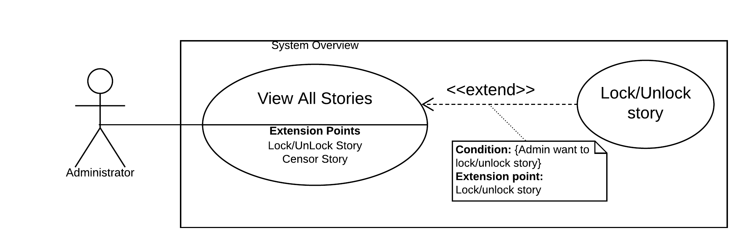

Figure 43 - <Administrator> Lock/UnLock Stories

|  |  |  |  |
| --- | --- | --- | --- |
| **USE CASE – StoryArt_A_12** | | | |
| **Use Case No.** | StoryArt_A_12 | **Use Case Version** | 2.0 |
| **Use Case Name** | View All Stories | | |
| **Author** | HaiNV | | |
| **Date** | 08/06/2020 | **Priority** | Normal |
| **Actor:**   * Administrator   **Summary:**   * This use case allows Administrator to Lock and Unlock Stories in system   **Goal:**   * Story’ status is changed   **Triggers:**   * Administrator click on “Khóa Truyện/ Khôi Phục Truyện” in handle actions   **Preconditions:**   * Guest logged into the system with role admin. * Administrator click on “Quản lý truyện” in menu navigator bar   **Post Conditions:**   * Success**:** Story’ status is changed successfully. * Fail**:** System shows error messages.   **Main Success Scenario:**   |  |  |  | | --- | --- | --- | | **Step** | **Actor Action** | **System Response** | | 1 | Admin clicks “Khóa Truyện” on Handle actions of a story  [Alternative 1] | System shows administrator a confirm modal: - “Bạn Có chắc chắn muốn khóa truyện này chứ” | | 2 | Administrator clicks “Đồng ý” button change status of story [Alternative 2] | System closes the modal and refresh page that contents changed status of story  [Exception 1] |   **Alternative Scenario:**   |  |  |  | | --- | --- | --- | | **No** | **Actor Action** | **System Response** | | 1 | Admin clicks “Khôi Phục Truyện” on Handle actions of a story  Administrator clicks “Đồng ý” button change status of story  [Alternative 2] | System shows administrator a confirm modal: - “Bạn Có chắc chắn muốn khôi phục truyện này chứ”  System closes the modal and refresh page that contents changed status of story  [Exception 1] | | 2 | Administrator clicks on “Huỷ bỏ” button or outside the area of modal to cancel request change status | System closes modal. |   **Exceptions 1 :**   |  |  |  | | --- | --- | --- | | **Step** | **Cause** | **System Response** | | 1 | Lost internet connection | System failed to load list stories |   **Relationships:** StoryArt_A_11  **Business Rules:**   * Only Administrator can lock and unlock stories * Author can not change stories status been lock by Administrator * Stories been locked by Administrator will not shown up in homepage or read anymore | | | |

Table 44 - <Administrator> Lock/UnLock Stories

##### 2.3.3.13. Censor story

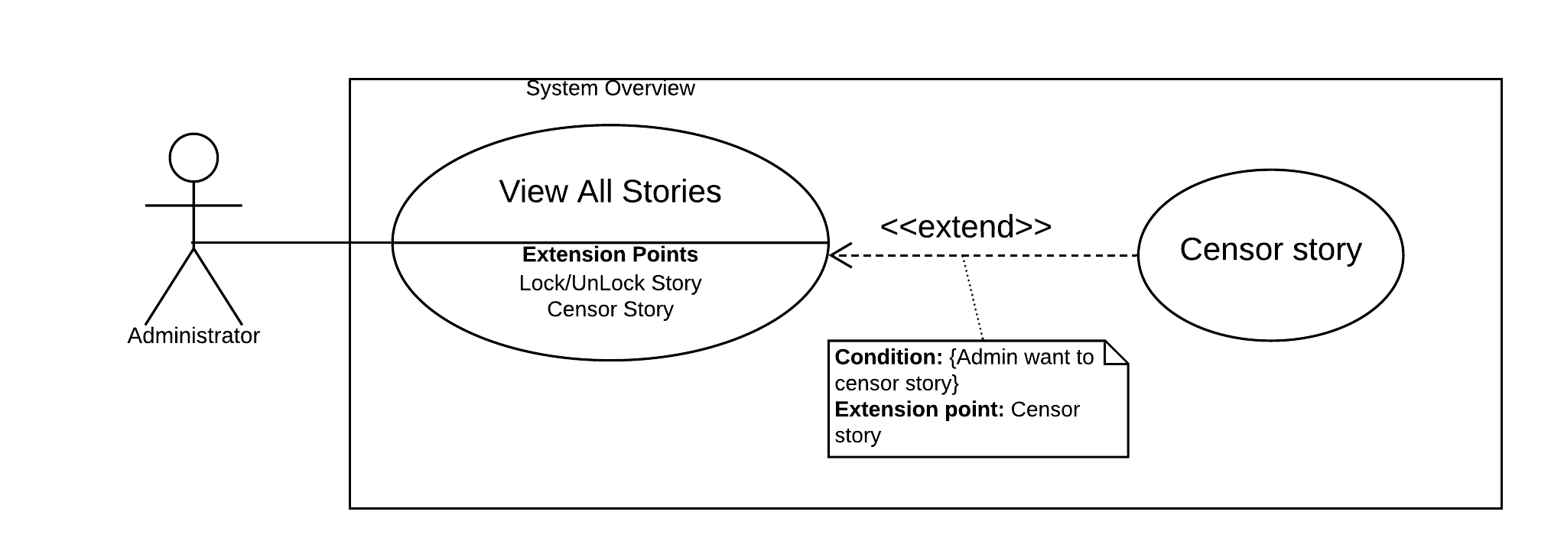

Figure 44 - <Administrator> Censor story

|  |  |  |  |
| --- | --- | --- | --- |
| **USE CASE – StoryArt_A_13** | | | |
| **Use Case No.** | StoryArt_A_13 | **Use Case Version** | 2.0 |
| **Use Case Name** | Censor story | | |
| **Author** | HaiNV | | |
| **Date** | 08/06/2020 | **Priority** | Normal |
| **Actor:**   * Administrator   **Summary:**   * This use case allows Administrator to Censor story in system   **Goal:**   * Story censorship status is changed   **Triggers:**   * Administrator click on “Xen Truyện” in handle actions   **Preconditions:**   * Guest logged into the system with role admin. * Administrator click on “Quản lý truyện” in menu navigator bar   **Post Conditions:**   * Success**:** Story censorship status is changed successfully. * Fail**:** System shows error messages.   **Main Success Scenario:**   |  |  |  | | --- | --- | --- | | **Step** | **Actor Action** | **System Response** | | 1 | Admin clicks “Xem Truyện” on Handle actions of a story | “Kiểm Duyệt Truyện” page will show three tabs:  - Nội dung đã kiểm duyệt lần trước: tab  - Nội dung kiểm duyệt: tab  - Kiểm duyệt : tab | | 2 | Admin clicks “Nội dung đã kiểm duyệt lần trước” tab | System show previous censor story with following datas:   * Image: image * “Tiêu Đề”: text * “Tác giả”: text * “Hiệu Ứng”: text * “Thể loại”: text * “Thông tin”: text * “Điều kiện”: text * Các đường dẫn”: text   + Story-line chart.  System show screen detail include:  - Screen title: text  - Screen content: text  - Actions: buttons | | 3 | Admin clicks “Nội dung kiểm duyệt” tab | System show current censor story with following datas:   * Image: image * “Tiêu Đề”: text * “Tác giả”: text * “Hiệu Ứng”: text * “Thể loại”: text * “Thông tin”: text * “Điều kiện”: text * Các đường dẫn”: text   + Story-line chart.  System show screen detail include:  - Screen title: text  - Screen content: text  - Actions: buttons | | 4 | Admin clicks “Kiểm Duyệt” tab | System show “Kiểm Duyệt” page with following datas:   * “Kiểm Duyệt”: text * “Trạng Thái Kiểm Duyệt”: dropdown list with following items   + “Chấp Nhận Kiểm Duyệt”   + “Từ Chối Kiểm Duyệt” * “Admin Note”: Blank input text * “Lưu”: Button   System show Censor history detail include table with following data:   * “User’ note”: text * “Admin’ note”: text * “Thời gian tạo”: text * “Thời gian xử lý”: text * “Trạng Thái”: text | | 5 | Admin clicks “Lưu” button | System will alert notification and closes dialog after change story censorship status  [Exceptions 1] |   **Alternative Scenario:** N/A  **Exceptions:**   |  |  |  | | --- | --- | --- | | **Step** | **Cause** | **System Response** | | 1 | Lost internet connection | System failed to save story censorship status |   **Relationships:** StoryArt_A_11  **Business Rules:**   * Only Administrator can censor story * System will not show “Thông Tin” and “Điều kiện” if story does not have any Information * System will show all Links belong to story in “Các Đường Dẫn” * Screen details will be shown when Administrator click on screen in Story-line chart. * “Lịch sử kiểm duyệt” table will show all record of history censor in the past * Story censorship status will change based on status Administrator choose in “Trạng Thái Kiểm Duyệt” dropdown list. * Story censorship status will change to “APPROVED” if Administrator select “Chấp nhận kiểm duyệt” and “REJECTED” if Administrator select “Từ chối kiểm duyệt” * After change story censorship status , system will save this current censor in to system | | | |

Table 45 - <Administrator> Censor story use case specification

#### 2.3.4. <System admin> Overview Use Case

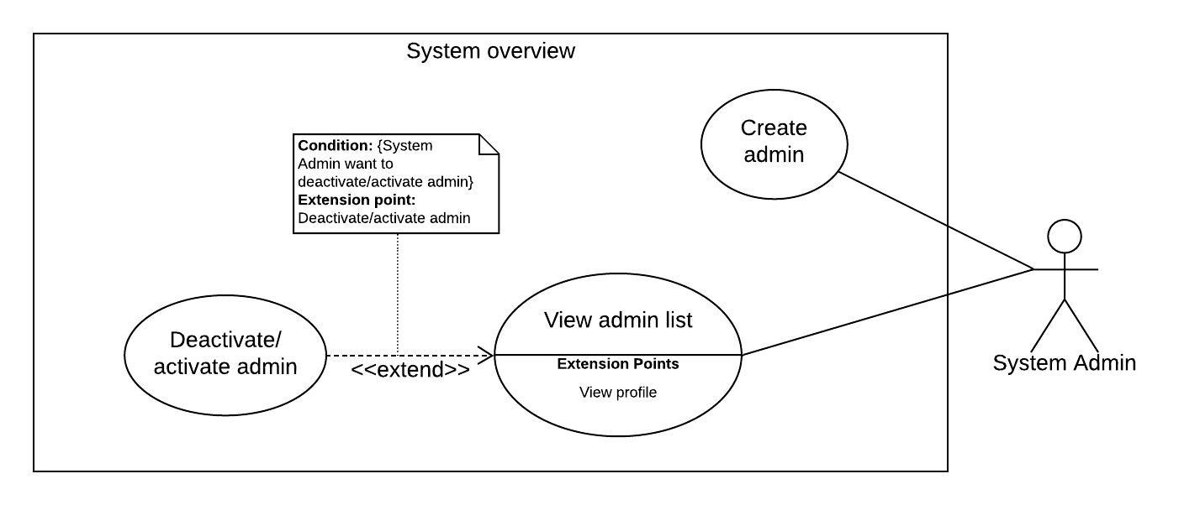

Figure 45 - <System admin> Overview use case

##### 2.3.4.1. View admin list

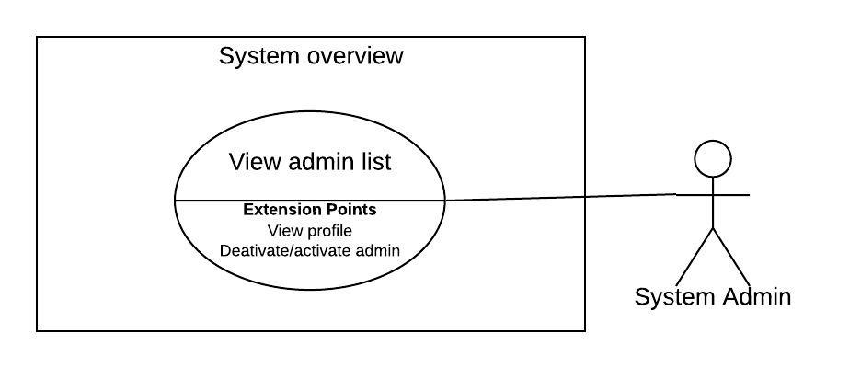

Figure 46 - <System admin> View admin list

|  |  |  |  |
| --- | --- | --- | --- |
| **USE CASE – StoryArt_SA_01** | | | |
| **Use Case No.** | StoryArt_SA_01 | **Use Case Version** | 2.0 |
| **Use Case Name** | View admin list | | |
| **Author** | AnhTHT | | |
| **Date** | 10/4/2020 | **Priority** | Normal |
| **Actor:**   * System Administrator   **Summary:**   * This use case allows system administrator to view administrator accounts in the system.   **Goal:**   * System administrator can view administrator accounts in the system.   **Triggers:**   * System administrator clicks on “Đi tới trang quản lý hệ thống” button in the menu.   **Preconditions:**   * Guest logged into the system with role “System Admin”.   **Post conditions:**   * **Success:** System administrator see a table administrator accounts in the system * **Fail:** System shows error messages.   **Main Success Scenario:**   |  |  |  | | --- | --- | --- | | **Step** | **Actor Action** | **System Response** | | 1 | System administrator clicks “Đi tới trang quản lý hệ thống” button on menu in home page. | System redirects system administrator to administrator list page that contain table of administrator accounts |   **Alternative Scenario: N/A**  **Exceptions:**   |  |  |  | | --- | --- | --- | | **No** | **Actor Action** | **System Response** | | 1 | Lost internet connection. | System failed to load admin list. |   **Relationships:** StoryArt_SA_02  **Business Rules:**  Table of accounts has maximum 10 row items.  System admin can deactivate/ activate admin account. | | | |

Table 46 - <System admin> View admin list use case specification

##### 2.3.4.2. Deactivate/ activate admin

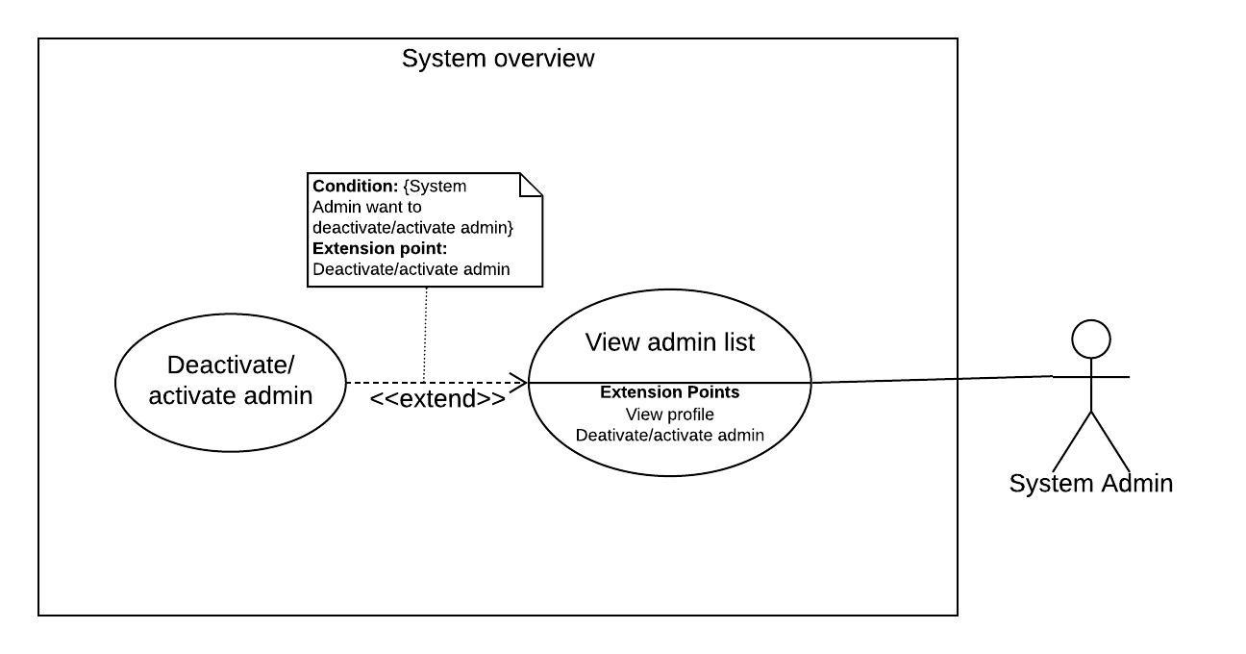

Figure 47 - <System admin> Deactivate/activate admin

|  |  |  |  |
| --- | --- | --- | --- |
| **USE CASE – StoryArt_SA_02** | | | |
| **Use Case No.** | StoryArt_SA_02 | **Use Case Version** | 2.0 |
| **Use Case Name** | Deactivate/activate admin | | |
| **Author** | AnhTHT | | |
| **Date** | 10/04/2020 | **Priority** | Normal |
| **Actor:**   * System Administrator   **Summary:**   * This use case allows System Administrator to deactive or active an administrator account.   **Goal:**   * Status of selected admin has changed   **Triggers:**   * System administrator click on “Đi tới trang quản lý hệ thống”   **Preconditions:**   * Guest logged into the system with role “Administrator”.   **Post conditions:**   * **Success:** Status of an administrator account changes * **Fail:** System shows error messages.   **Main Success Scenario:**   |  |  |  | | --- | --- | --- | | **Step** | **Actor Action** | **System Response** | | 1 | System Administrator clicks on “Đi tới trang quản lý” button on menu | System redirects System Administrator to view administrator account list page | | 2 | System Administrator clicks on status button of an administrator account | System shows System Administrator a confirm modal | | 3 | System Administrator clicks “Đồng ý” button change status of administrator account[Alternative 1] [Alternative 2] | System closes the modal and refresh page of table that contents changed status administrator account |   **Alternative Scenario:**   |  |  |  | | --- | --- | --- | | **No** | **Actor Action** | **System Response** | | 1 | System Administrator clicks on “Huỷ bỏ” button or outside the area of modal to cancel request change status | System closes modal. |   **Exceptions:**   |  |  |  | | --- | --- | --- | | **No** | **Actor Action** | **System Response** | | 1 | Lost internet connection. | System failed to change status of admin account. |   **Relationships:** StoryArt_SA_01  **Business Rules:**  System admin can deactivate/activate any admin account.  Status of admin will be changed after System Admin press “Đồng ý” in modal. | | | |

Table 47 - <System admin> Deactivate/activate admin use case specification

##### 2.3.4.3. Create admin

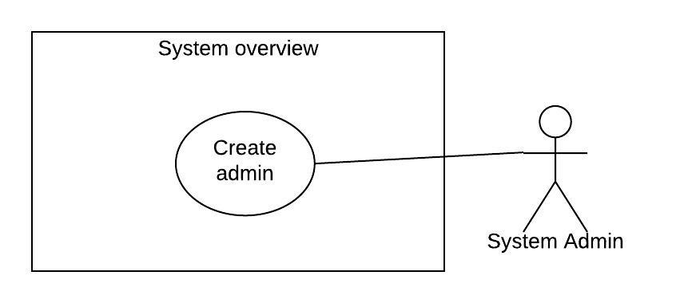

Figure 48 - <System admin> Create admin

|  |  |  |  |
| --- | --- | --- | --- |
| **USE CASE – StoryArt_SA_03** | | | |
| **Use Case No.** | StoryArt_SA_03 | **Use Case Version** | 2.0 |
| **Use Case Name** | Create administrator | | |
| **Author** | AnhTHT | | |
| **Date** | 10/04/2020 | **Priority** | Normal |
| **Actor:**   * System administrator   **Summary:**   * This use case allows system administrator to add administrator into the system.   **Goal:**   * System administrator can add administrator into the system.   **Triggers:**   * System administrator clicks on “Đi tới trang quản lý hệ thống” button in the menu home page.   **Preconditions:**   * Guest logged into the system with role “Administrator”.   **Post conditions:**   * **Success:** Created administrator row added in top of list admin table * **Fail:** System shows error messages.   **Main Success Scenario:**   |  |  |  | | --- | --- | --- | | **Step** | **Actor Action** | **System Response** | | 1 | System administrator clicks “Thêm quản trị viên”. | System shows dialog :  -Tên đăng nhập: blank text input  -Mật khẩu: blank text input  -Tên đầy đủ: blank text input  - Email: blank text input  - Thông tin giới thiệu về bạn: blank text input | | 2 | System administrator inputs information |  | | 3 | System administrator clicks “Lưu” button to add administrator to system. [Alternative 1] | [Exception 1,2,3,4,5,6,7,8]  System closes dialog and shows table of admistrators that has created administrator row. |   **Alternative Scenario:**   |  |  |  | | --- | --- | --- | | **No** | **Actor Action** | **System Response** | | 1 | System administrator clicks on “Thoát” button | System closes dialog. |   **Exceptions:**   |  |  |  | | --- | --- | --- | | **No** | **Actor Action** | **System Response** | | 1 | System administrator does not enter, enters blank or enter username not be between 3 and 15 characters. | System shows error message “Tên đăng nhập phải có từ 3 đến 15 ký tự ” | | 2 | System administrator does not enter , enters blank or enter name not be between 3 and 40 characters | System shows error message “ Tên phải có từ 3 đến 15 ký tự” | | 3 | System administrator does not enter , enters blank or enter password not be between 8 and 100 characters. | System shows error message “Mật khẩu phải có từ 8 đến 100 ký tự” | | 4 | System administrator does not enter email or enters blank | System shows error message “Email không được để trống” | System shows error message “Tên đăng nhập không được để trống” | | 5 | System administrator enters email is not validated with email standard form | System shows error message “Email không đúng định dạng. Vui lòng nhập lại” | | 6 | System administrator enters an username used by another account | System shows error message “Tên đăng nhập này đã được đăng ký bởi ai đó” | | 7 | System administrator enters an email used by another account | System shows error message “Email này đã được đăng ký bởi ai đó” | | 8 | System administrator does not enter, enter blank or enter introduction information has not a maximum length of 300 characters | System shows error message “Thông tin giới thiệu có độ dài tối đa là 300 ký tự” |   **Relationships:** N/A  **Business Rules:**   * Introduction information has a maximum length of 300 characters. * Email must be validated email standard form. * Email must not be blank. * Name must be between 3 and 40 characters. * Username must be between 3 and 15 characters. * Password must be between 8 and 100 characters. * An email is only used to register for one person. * A username is only used to register for one person. | | | |

Table 48 - <System admin> Create admin use case specification

#### 2.3.5. <System handler> Overview Use Case

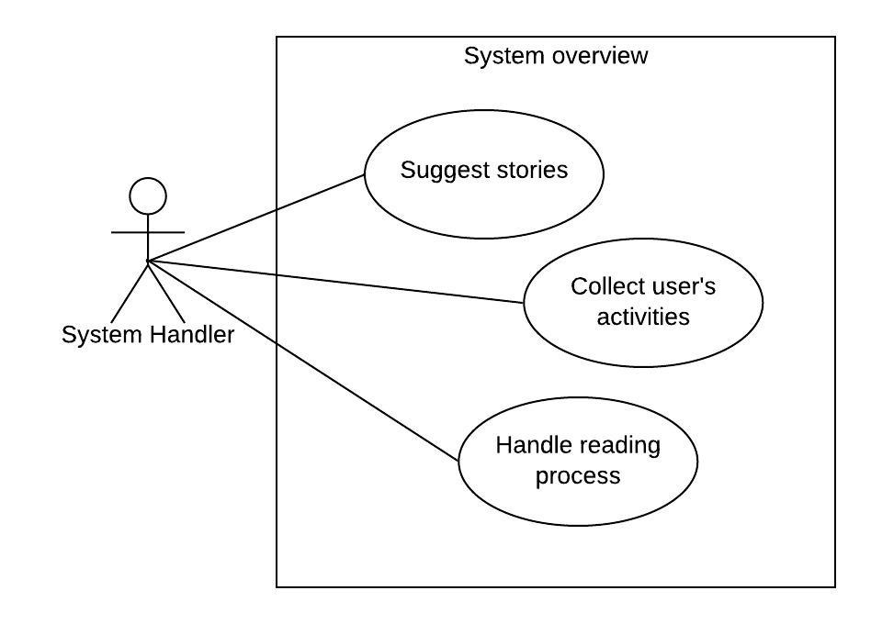

Figure 49 - <System handler> Overview use case

##### 2.3.5.1. Suggest stories

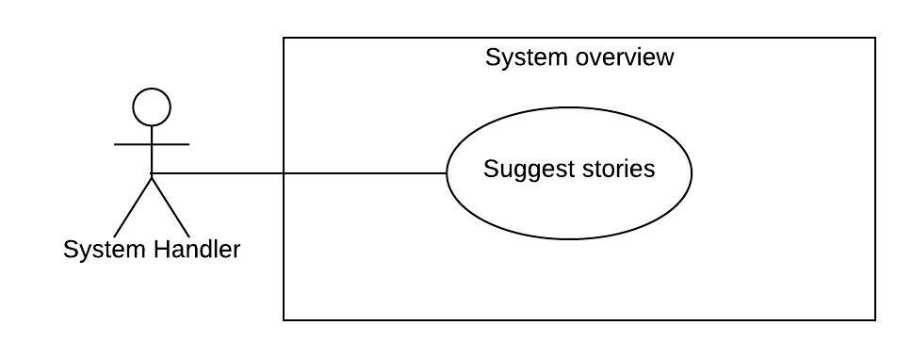

Figure 50 - <System handler> Suggest stories

|  |  |  |  |
| --- | --- | --- | --- |
| **USE CASE – UC_SH_01** | | | |
| **Use Case No.** | UC_SH_01 | **Use Case Version** | 2.0 |
| **Use Case Name** | Suggest Stories | | |
| **Author** | HaiNV | | |
| **Date** | 24/02/2020 | **Priority** | Normal |
| **Actor:**   * System handler   **Summary:**   * This use case describes the system suggesting the list of stories to the user/guest when the user access to homepage   **Goal:**   * The list of suggested stories is displayed successfully.   **Triggers:**   * Guest access to homepage * Guest logged into the system and access to homepage   **Preconditions:**   * System received request to get suggestions.   **Post Conditions:**   * Success: The suggested stories list is displayed. * Fail: System shows error messages.   **Main Success Scenario:**   |  |  |  | | --- | --- | --- | | **Step** | **Actor Action** | **System Response** | | 1 | Guest click access to Homepage  [Alternative 1] | System shows on “Danh Sách Gợi ý” with the list of suggested stories by top view of all time.  System shows on “Danh Sách Thịnh Hành” with the list of suggested stories by top view of previous 7 days.  [Exception 1] |   **Alternative Scenario:**   |  |  |  | | --- | --- | --- | | **No** | **Actor Action** | **System Response** | | 1 | Guest logged into the system and access homepage  User have enough data to calculate Suggestion  [Alternative 2] | System shows on “Danh Sách Gợi ý” with the list of suggested stories by Rating  System shows on “Danh Sách Thịnh Hành” with the list of suggested stories by top view of previous 7 days.  [Exception 1] | | 2 | Guest logged into the system and access homepage.  User do not have enough data to calculate Suggestion | System shows on “Danh Sách Gợi ý” with the list of suggested stories by top view of all time.  System shows on “Danh Sách Thịnh Hành” with the list of suggested stories by top view of previous 7 days.  [Exception 1] |   **Exceptions:**   |  |  |  | | --- | --- | --- | | **Step** | **Cause** | **System Response** | | 1 | There are some unexpected exceptions while sending request, i.e. network exception | System failed to load suggestions |   **Relationships:** N/A  **Business Rules:**  - When Guest click access to Homepage, list of suggested stories is based on top view of all time in system  - When Guest logged into the system and do not have enough data to calculated, list of suggested stories is based on top view of all time in system  - When Guest logged into the system and do not have enough data to calculated, list of suggested stories is based on the similarity of the Rating between the readers and calculate probability future Rating.  - The list of suggested stories based on Most view in previous 7 days is always shown  The internet connection is required to run this function. | | | |

Table 49 - <System handler> Suggest stories use case specification

##### 2.3.5.2. Collect user’s activities

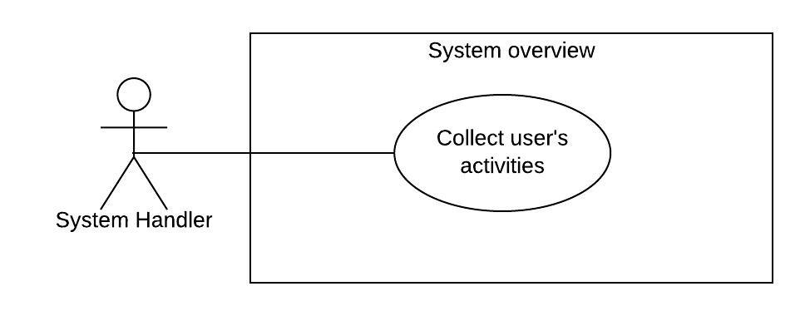

Figure 51 - <System handler> Collect user’s activities

|  |  |  |  |
| --- | --- | --- | --- |
| **USE CASE – UC_SH_02** | | | |
| **Use Case No.** | UC_SH_02 | **Use Case Version** | 2.0 |
| **Use Case Name** | Collect user’s activities | | |
| **Author** | TaiBD | | |
| **Date** | 24/02/2020 | **Priority** | Normal |
| **Actor:**   * System Handler   **Summary:**   * This use case describes the system get user insights such as: time of reading per screens of story, the number of click links in the action, reading history.   **Goal:**   * The statistics of a story is saved to the system.   **Triggers:**   * Guest or authorized user access to story reading page and * Guest select action and switch between the screens of story * Guest click the link in action   **Preconditions:**   * Guest read story.   **Post Conditions:**   * Success: The data is saved in the system for statistics. * Fail: System cannot save user’s insight.   **Main Success Scenario:**   |  |  |  | | --- | --- | --- | | **Step** | **Actor Action** | **System Response** | | 1 | Guest click access to reading story page and click to “Bắt đầu đọc truyện”. | System will render the screen and start counting the number of seconds that user is on the screen before switching to other screen. | | 2 | Guest click to action of the screen and switch to another screen | System will send the number of seconds that counted to server | | 3 | Guest click to action that contains the link. | System will open new tab in browser follow that link and save the click link to server | | 4 | Guest finish reading the story by reading to the end or leave the reading page while reading. | System save the reading information. |   **Exceptions:** N/A  **Relationships:** N/A  **Business Rules:**  When user read the story to the end or leave the reading while reading, the reading history data will send to server by the system.  The system counts the number of seconds that user is reading on every screens. If user doesn’t have any activity like: mouse move, scroll, click, key press. System will show a pop up ask user want to continue reading or not and stop counting time:   * If user choose continue reading, system continue counting time and close pop up. * If user choose not continue reading, system direct user to story detail page, finish reading and send time counted database.   Maximum reading time counted is 15 minutes.  The system saves the click to action link on every user’s click to action of redirect.  The internet connection is required to run this function. | | | |

Table 50 - <System handler> Collect user’s activities use case specification

##### 2.3.5.3. Handle reading process

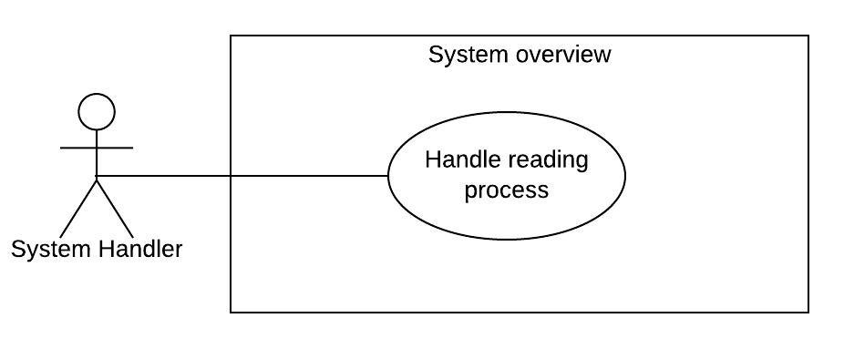

Figure 52 - <System handler> Hanlde reading process

|  |  |  |  |
| --- | --- | --- | --- |
| **USE CASE – UC_SH_03** | | | |
| **Use Case No.** | UC_SH_03 | **Use Case Version** | 2.0 |
| **Use Case Name** | Handle reading process | | |
| **Author** | TaiBD | | |
| **Date** | 24/02/2020 | **Priority** | Normal |
| **Actor:**   * System Handler   **Summary:**   * This use case describes the system to calculate current story’s information, update story’s information, switch to another screen and display screen, redirect to a link when user select action.   **Goal:**   * Handle reading story process   **Triggers:**   * Guest or authorized user access to story reading page, read story and select action   **Preconditions:**   * Guest read story and select action.   **Post Conditions:**   * Success: The screen is displayed, information updated successfully, redirect to link, go to next screen. * Fail: System cannot update information or cannot display screen.   **Main Success Scenario:**   |  |  |  | | --- | --- | --- | | **Step** | **Actor Action** | **System Response** | | 1 | Guest or user click access to reading story page and click to “Bắt đầu đọc truyện”. | System will render the first screen of story | | 2 | Guest click to action of the screen with action type redirect | System will open new tab on browser and redirect to that link in action value. | | 3 | Guest click to action of the screen with action type next screen | System will find the screen with the id in action value and display that screen, hide the current screen. | | 4 | Guest click to action of the screen with action type update information. | System will update information and check the information’s conditions. If the current value of information is match with the condition, system will show the screen base on condition. If not, system will show default next screen of action. |   **Alternative Scenario:** N/A  **Exceptions:** N/A  **Relationships:** N/A  **Business Rules:**  The system handler process information, screen, action when user read story and select action. | | | |

Table 51 - <System handler> Handle reading process use case specification

#### 2.3.6. <Authorized User> Overview Use Case

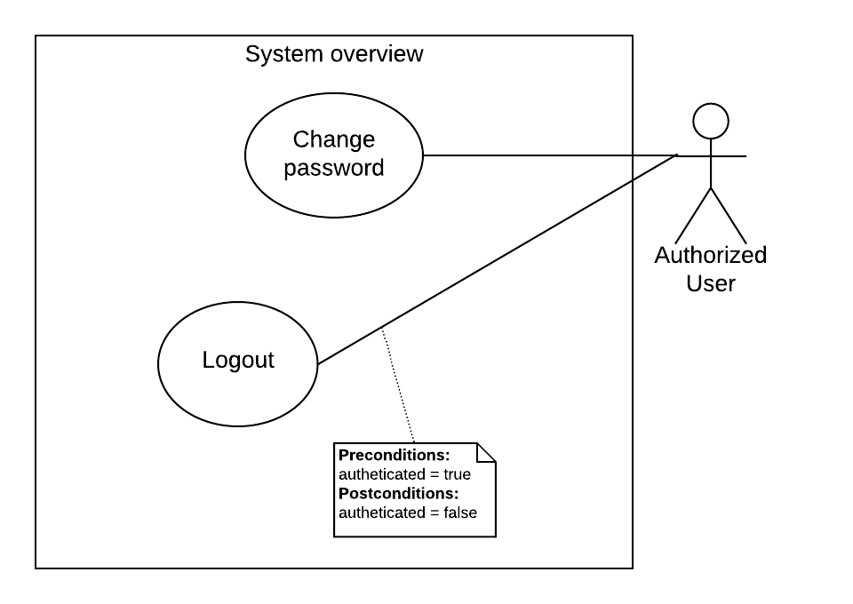

Figure 53 - <Authorized User> Overview use case

##### 2.3.6.1. Logout

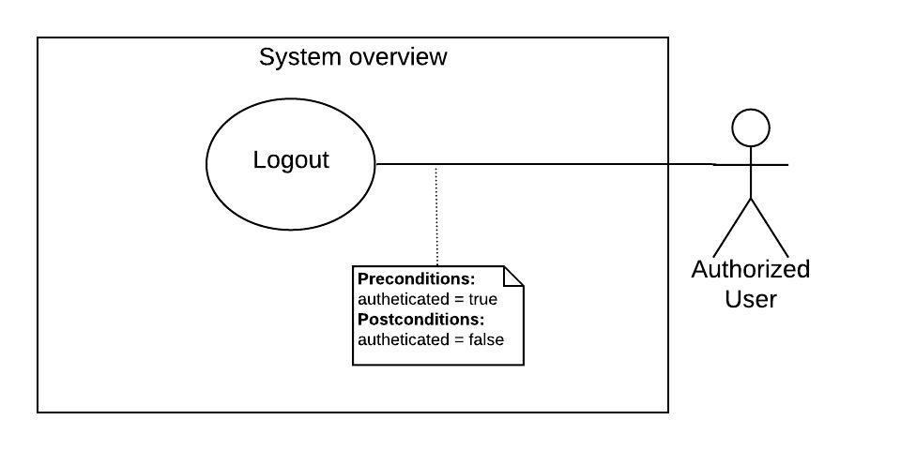

Figure 54 - <User> Logout

|  |  |  |  |
| --- | --- | --- | --- |
| **USE CASE – StoryArt_AU_01** | | | |
| **Use Case No.** | StoryArt_AU_01 | **Use Case Version** | 2.0 |
| **Use Case Name** | Logout | | |
| **Author** | HaiNV | | |
| **Date** | 24/02/2020 | **Priority** | Normal |
| **Actor:**   * User   **Summary:**   * Allow User to log out of the system.   **Goal:**   * User stops accessing the system.   **Triggers:**   * User Clicks on “Đăng Xuất” Button   **Preconditions:**   * Guest logged into the system with role “User”.   **Post Conditions:**   * Success: Account is log out successfully, user’s authentication changed to false. * Fail: System shows error messages.   **Main Success Scenario:**   |  |  |  | | --- | --- | --- | | **Step** | **Actor Action** | **System Response** | | 1 | User clicks on “Đăng Xuất” button on navigation bar | The action would terminate the user session and delete user token.  The authenticated user navigated to the homepage. [Exception 1] |   **Alternative Scenario:** N/A  **Exceptions :** N/A  **Relationships:** N/A  **Business Rules:**  User must be authenticated user.  After logout successfully, the role “Authorized User” become “Unauthorized User”.  If user’s role is “Authorized User”, system will direct user to homepage.  If user’s role is “Aministrator” or “System Admin”, system will direct user to login page. | | | |

Table 52 - <User> Logout use case specification

##### 2.3.6.2. Change password

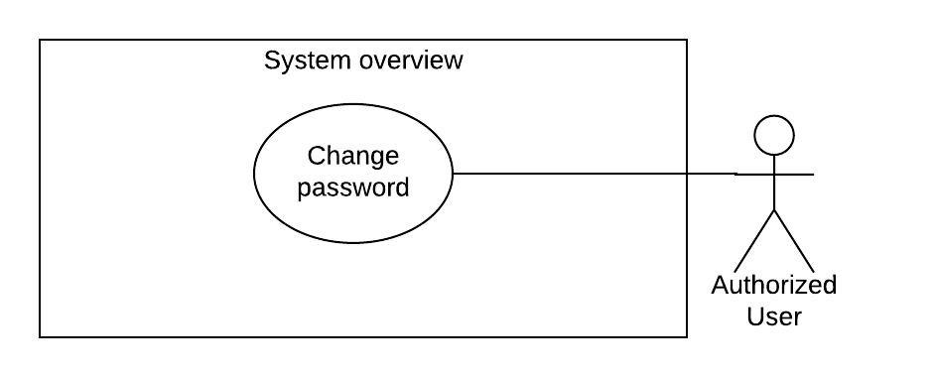

Figure 55 - <User> Change password

|  |  |  |  |
| --- | --- | --- | --- |
| **USE CASE – StoryArt_AU_02** | | | |
| **Use Case No.** | StoryArt_AU_02 | **Use Case Version** | 2.0 |
| **Use Case Name** | Change password | | |
| **Author** | AnhTHT | | |
| **Date** | 10/4/2020 | **Priority** | Normal |
| **Actor:**   * Authorized User   **Summary:**   * Allow Authorized User to change his password   **Goal:**   * Authorized User can change password.   **Triggers:**   * Authorized User clicks on avatar button on menu. * Authorized User clicks “Đổi mật khẩu” sub menu. * Authorized User sends request to change password.   **Preconditions:**   * Authorized User logged in to system with role “User”, “Administrator”, “System Admin”.   **Post conditions:**   * Success: System shows success messages. * Fail: System shows error messages.   **Main Success Scenario:**   |  |  |  | | --- | --- | --- | | **Step** | **Actor Action** | **System Response** | | 1 | User clicks on their avatar button on menu | System shows user sub menu that content “Đổi mật khẩu” button | | 2 | User click on “Đổi mật khẩu” button on sub menu | System goes to change password page of user:  - Mật khẩu mới: blank password input  - Nhập lại mật khẩu mới: blank password input | | 3 | User inputs fields. |  | | 4 | User clicks on “Lưu thay đổi” button. | System shows success message: “Lưu thành công”.  [Exception 1,2,3] |   **Exceptions:**   |  |  |  | | --- | --- | --- | | **No** | **Actor Action** | **System Response** | | 1 | User click in reset link since more than 30 minutes from sending time | System shows error message “Token đã hết hạn. Vui lòng gửi lại yêu cầu đạt lại mật khẩu” | | 2 | User re-enter password that not same with password. | System shows error message “Mật khẩu nhập lại không trùng.” | | 3 | User does not enter password or enter password that not between 8 and 100 characters. | System shows error message “Mật phải có từ 8 đến 100 ký tự” |   **Relationships:** N/A.  **Business Rules:**   * Password must be between 8 and 100 characters. * Re-enter password must same with password. | | | |

Table 53 - <User> Change password use case specification

## 3. Software System Attribute

### 3.1. Usability

Website’s UI is fit for each browser on each device

Font style: Arial, Sans-serif

Font size: 12px -26px

Color: violet, green, black, red, white, blue, …

Background: white, violet, gray, …

### 3.2. Reliability

The information storing on the database is permanent.

### 3.3. Availability

The system must be available at any time 24/7.

### 3.4. Security

Only System Admin has fully access to the system.

Input data is validated before saving to database.

### 3.5. Maintainability

The system is divided into separate modules for easy maintain.

Back-end side is designed with Micro-service structure for easy maintain.

### 3.6. Portability

Web application can be run on Chrome browser version 42 or later.

### 3.7. Performance

System has successfully test with basic standard.

## 4. Conceptual Diagram

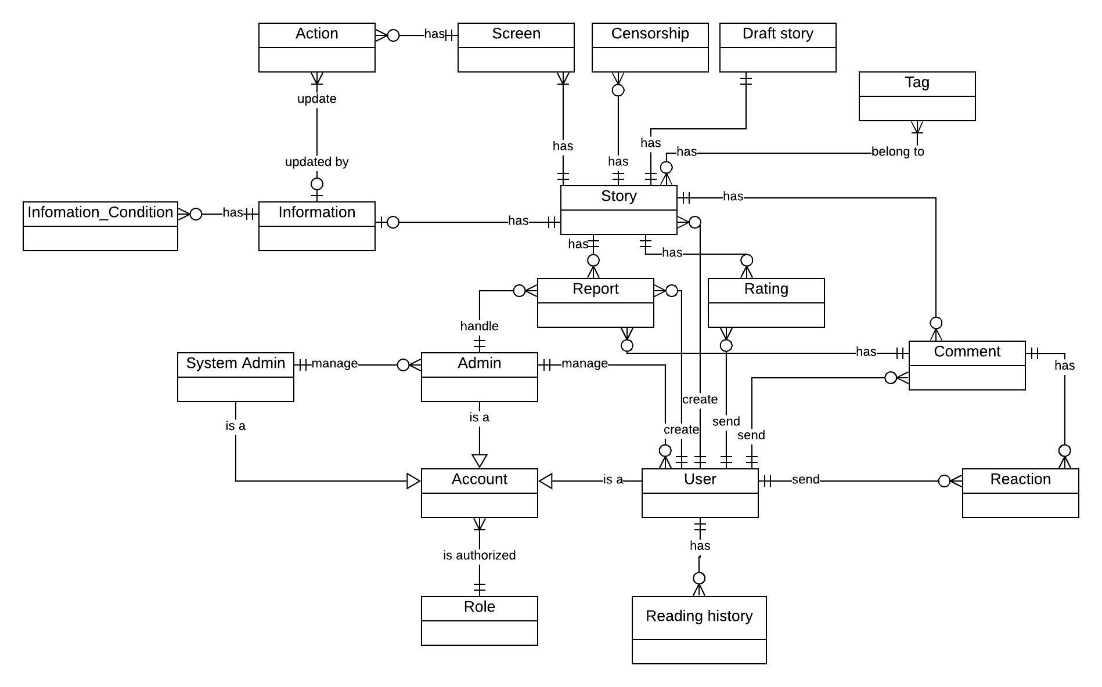

Figure 56 – Conceptual diagram

# D. Software Design Description

## 1. Design Overview

This document describes the technical and user interface design of MSSC System. It includes the architectural design, the detailed design of common functions and business functions and the design of database model.

The architectural design describes the overall architecture of the system and the architecture of each main component and subsystem.

The detailed design describes static and dynamic structure for each component and functions. It includes class diagrams, class explanations and sequence diagrams for each use cases.

The database design describes the relationships between entities and details of each entity.

Document overview:

* Section 2: gives an overall description of the system architecture design.
* Section 3: gives component diagrams that describe the connection and integration of the system.
* Section 4: gives the detail design description which includes class diagram, class explanation, and sequence diagram to details the application functions.
* Section 5: describe screens design.
* Section 6: describe a fully attributed ERD.
* Section 7: describe algorithms

## 2. System Architectural Design

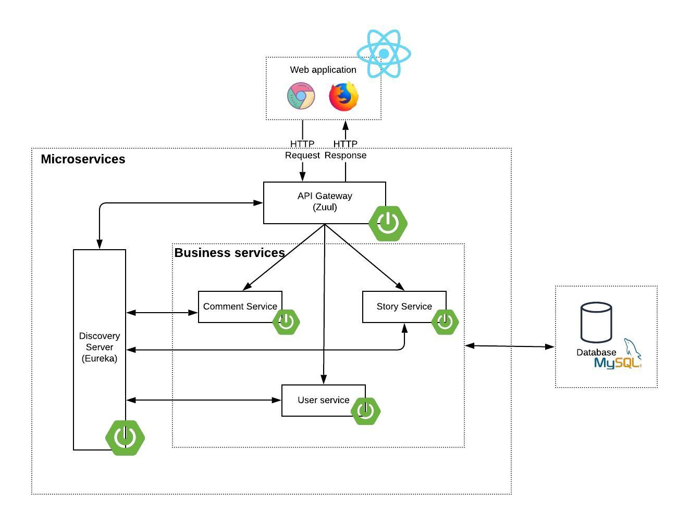

Figure 57 - System Architectural Design

### 2.1. Web Application Architectural Description

In the client side, we choose Reactjs because:

* ReactJS is quite easy to be learnt.
* ReactJS is easy to maintain isolated components in React.
* Convenient React is highly competitive to MVC. One-way data flow provides maintainability and efficient arrangement of data and DOM elements.

### 2.2. Web Service Architectural Description

**In Web Service Application, the system is developed under Microservice architecture style. We choose this architecture for Web Application because of following advantages:**

* With microservice architecture, applications become easier to build and maintain when they’re split into a set of smaller, composable fragments.
* Managing the code also becomes less painful because each microservice is a separate chunk of code.
* Services can be implemented using different programming languages, databases and software environments.

This allows each service to be deployed, rebuilt, re-deployed and managed independently.

## 3. Component Diagram

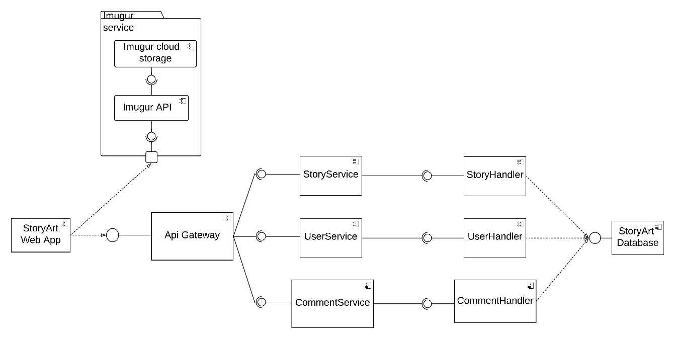

Figure 58 – System Component Diagram

|  |  |
| --- | --- |
| **COMPONENT DICTIONARY: DESCRIBES COMPONENTS** | |
| Api Gateway Service | service in micro-service system that handles receive all requests from client and forward that requests to business service, then receive response from business services and return response to client |
| Story Service | service handles business logic about story,reading history, rating, statistics |
| Comment Service | service in micro-service system that handles business logic for comment, reaction, report |
| User Service | service in micro-service system that handles user account, authentication, authorrization, role |
| StoryArt Web App | a service for render view using reactjs |
| Userhandler, CommentHandler, StoryHandler | includes controllers, filters, service, repositories to handle business logic request |
| StoryArt Database | store data(MySQL) |
| Imgur cloud storage | It is an open service developed by Imgur. System uses it to handle images storage. Reference: https://apidocs.imgur.com/ |
| Imgur API | It is an open service developed by Imgur. System uses it to handle get image shortlink and send image to storage  Reference: https://apidocs.imgur.com/ |

Table 54 - System Component Dictionary

## 4. Detailed Description

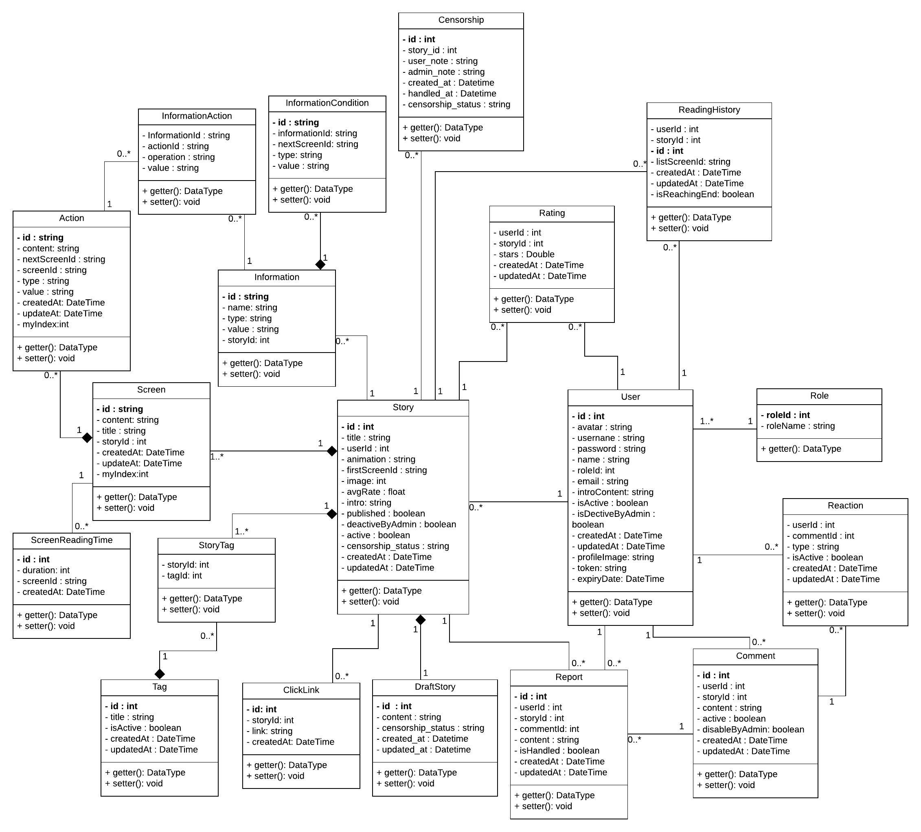

Figure 59 – Class diagram

### 4.1. Class Dictionary

|  |  |  |
| --- | --- | --- |
| **Class dictionary: describe Class** | | |
| **Class Name** | **Mapping column with Conceptual diagram** | **Description** |
| Story | Story | Contain the Story information. |
| Report | Report | Contain the Report information. |
| Comment | Comment | Contain the Comment information |
| Reaction | Reaction | Contain the Reaction information. |
| User | User | Contain the User information. |
| Role | Role | Contain the Role information. |
| Rating | Rating | Contain the Rating information. |
| ReadingHistory | Reading_History | Contain the Reading History information. |
| Tag | Tag | Contain the Tag information. |
| Screen | Screen | Contain the Screen information. |
| Action | Action | Contain the Action information. |
| Information | Information | Contain the Information Detail. |
| InformationAction | N/A | Contain the Information Action Detail. |
| InformationCondition | Information_Condition | Contain the Information Condition Detail. |
| SceenReadingTime | N/A | Contain the Screen Reading Time Information |
| StoryTag | N/A | Contain the Story and Tag information. |
| ClickLink | N/A | Contain the Click Link Information |
| Censorship | Censorship | Contain the Censorship Information |
| DraftStory | Draft story | Contain the Draft Story Information |

Table 55 - Class Diagram Dictionary

### 4.2. Class Diagram Explanation

#### 4.2.1. Story

|  |  |  |  |
| --- | --- | --- | --- |
| **Attribute** | **Type** | **Visibility** | **Description** |
| id | int | Private | Unique identifier of a Story |
| title | string | Private | The title of Story |
| userId | Int | Private | Unique identifier of a User |
| introContent | string | Private | The description content of Story |
| animation | string | Private | Animation of Story |
| active | Boolean | Private | The status of Story |
| published | Boolean | Private | The publishing of Story |
| isDeactiveByAdmin | Boolean | Private | The Remove of Admin to Story |
| firstScreenIdDeactive | String | Private | Unique identifier of a Screen |
| image | string | Private | The Path of Image |
| avgRate | Float | Private | The average rate of Story |
| censorshipStatus | string | Private | The censorship’ status of Story |
| createdAt | DateTime | Private | The creation date of Story |

Table 56 - Story Attribute

|  |  |  |  |
| --- | --- | --- | --- |
| **Method** | **Return Type** | **Visibility** | **Description** |
| Getter | Attribute type | Public | Get attribute value. |
| Setter | Void | Public | Set value of attribute. |

Table 57 - Story Method

#### 4.2.2. Report

|  |  |  |  |
| --- | --- | --- | --- |
| **Attribute** | **Return Type** | **Visibility** | **Description** |
| id | Int | Private | Unique identifier of a Report |
| userId | Int | Private | Unique identifier of a User |
| storyId | Int | Private | Unique identifier of a Story |
| commentId | Int | Private | Unique identifier of a Comment |
| content | String | Private | The Content of Report |
| createdAt | DateTime | Private | The creation date of Report |
| updatedAt | DateTime | Private | The updated date of Report |
| isHandled | Boolean | Private | The Status of Report |

Table 58 - Report Attribute

|  |  |  |  |
| --- | --- | --- | --- |
| **Method** | **Return Type** | **Visibility** | **Description** |
| Getter | Attribute type | Public | Get attribute value. |
| Setter | Void | Public | Set value of attribute. |

Table 59 - Report Method

#### 4.2.3. Comment

|  |  |  |  |
| --- | --- | --- | --- |
| **Attribute** | **Return Type** | **Visibility** | **Description** |
| id | Int | Private | Unique identifier of a Comment |
| userId | Int | Private | Unique identifier of a User |
| storyId | Int | Private | Unique identifier of a Story |
| content | String | Private | The Content of Comment |
| createdAt | DateTime | Private | The creation date of Comment |
| updatedAt | DateTime | Private | The updated date of Comment |
| active | Boolean | Private | The Status of Comment |
| isDisableByAdmin | Boolean | Private | The Remove of Admin to Comment |

Table 60 - Comment Attribute

|  |  |  |  |
| --- | --- | --- | --- |
| **Method** | **Return Type** | **Visibility** | **Description** |
| Getter | Attribute type | Public | Get attribute value. |
| Setter | Void | Public | Set value of attribute. |

Table 61 - Comment Method

#### 4.2.4. Reaction

|  |  |  |  |
| --- | --- | --- | --- |
| **Attribute** | **Type** | **Visibility** | **Description** |
| userId | int | Private | Unique identifier of a User |
| commendId | int | Private | Unique identifier of a Comment |
| type | String | Private | The Type of Reaction |
| createdAt | DateTime | Private | The creation date of Comment |
| updatedAt | DateTime | Private | The updated date of Comment |
| isActive | Boolean | Private | The Status of Comment |

Table 62 - Reaction Attribute

|  |  |  |  |
| --- | --- | --- | --- |
| **Method** | **Return Type** | **Visibility** | **Description** |
| Getter | Attribute type | Public | Get attribute value. |
| Setter | Void | Public | Set value of attribute. |

Table 63 - Reaction Method

#### 4.2.5. User

|  |  |  |  |
| --- | --- | --- | --- |
| **Attribute** | **Return Type** | **Visibility** | **Description** |
| id | int | Private | Unique identifier of a User |
| avatar | String | Private | The Avatar of User |
| username | String | Private | The Username of User |
| password | String | Private | The Password of User |
| name | String | Private | The Name of User |
| roleID | Int | Private | Unique identifier of a Role |
| email | String | Private | The Email of User |
| introContent | String | Private | The Introduction of User |
| createdAt | DateTime | Private | The creation date of User |
| updatedAt | DateTime | Private | The updated date of User |
| isActive | Boolean | Private | The Status of User |
| profileImage | string | Private | The Profile Image of User |
| token | string | Private | The Token of Uer |
| expiryDate | DateTime | Private | The Expiry Date of User |

Table 64 - User Attribute

|  |  |  |  |
| --- | --- | --- | --- |
| **Method** | **Return Type** | **Visibility** | **Description** |
| Getter | Attribute type | Public | Get attribute value. |
| Setter | Void | Public | Set value of attribute. |

Table 65 - User Method

#### 4.2.6. Role

|  |  |  |  |
| --- | --- | --- | --- |
| **Attribute** | **Type** | **Visibility** | **Description** |
| id | int | Private | Unique identifier of a Role |
| roleName | String | Private | The Name of Role |

Table 66 - Role Attribute

|  |  |  |  |
| --- | --- | --- | --- |
| **Method** | **Return Type** | **Visibility** | **Description** |
| Getter | Attribute type | Public | Get attribute value. |

Table 67 - Role Method

#### 4.2.7. Rating

|  |  |  |  |
| --- | --- | --- | --- |
| **Attribute** | **Type** | **Visibility** | **Description** |
| userId | int | Private | Unique identifier of a User |
| storyId | int | Private | Unique identifier of a Story |
| stars | Double | Private | The Rate Point of Rating |
| createdAt | DateTime | Private | The creation date of Rating |
| updatedAt | DateTime | Private | The updated date of Rating |

Table 68 - Rating Attribute

|  |  |  |  |
| --- | --- | --- | --- |
| **Method** | **Return Type** | **Visibility** | **Description** |
| Getter | Attribute type | Public | Get attribute value. |
| Setter | Void | Public | Set value of attribute. |

Table 69 - Rating Method

#### 4.2.8. Reading history

|  |  |  |  |
| --- | --- | --- | --- |
| **Attribute** | **Return Type** | **Visibility** | **Description** |
| userId | int | Private | Unique identifier of a User |
| storyId | int | Private | Unique identifier of a Story |
| id | Int | Private | Unique identifier of a History |
| listScreenId | String | Private | The list Section of History |
| createdAt | DateTime | Private | The creation date of Rating |
| updatedAt | DateTime | Private | The updated date of Rating |
| isReachingEnd | boolean | Private | The Status of History Is Reaching End of Story |

Table 70 – Reading History Attribute

|  |  |  |  |
| --- | --- | --- | --- |
| **Method** | **Return Type** | **Visibility** | **Description** |
| Getter | Attribute type | Public | Get attribute value. |
| Setter | Void | Public | Set value of attribute. |

Table 71 – Reading History Method

#### 4.2.9. Tag

|  |  |  |  |
| --- | --- | --- | --- |
| **Attribute** | **Type** | **Visibility** | **Description** |
| id | int | Private | Unique identifier of a Tag |
| title | string | Private | The title of the Tag |
| createdAt | DateTime | Private | The creation date of Tag |
| updatedAt | DateTime | Private | The updated date of Tag |
| isActive | Boolean | Private | The Status of Tag |

Table 72 - Tag Attribute

|  |  |  |  |
| --- | --- | --- | --- |
| **Method** | **Return Type** | **Visibility** | **Description** |
| Getter | Attribute type | Public | Get attribute value. |
| Setter | Void | Public | Set value of attribute. |

Table 73 - Tag Method

#### 4.2.10. Screen

|  |  |  |  |
| --- | --- | --- | --- |
| **Attribute** | **Type** | **Visibility** | **Description** |
| id | string | Private | Unique identifier of a Screen |
| content | string | Private | The Content of Screen |
| title | string | Private | The Title of Screen |
| storyId | int | Private | Unique identifier of a Story |
| createdAt | DateTime | Private | The creation date of Screen |
| updatedAt | DateTime | Private | The updated date of Screen |
| myIndex | int | private | The Index of Screen |

Table 74 - Screen Attribute

|  |  |  |  |
| --- | --- | --- | --- |
| **Method** | **Return Type** | **Visibility** | **Description** |
| Getter | Attribute type | Public | Get attribute value. |
| Setter | Void | Public | Set value of attribute. |

Table 75 - Screen Method

#### 4.2.11. Action

|  |  |  |  |
| --- | --- | --- | --- |
| **Attribute** | **Type** | **Visibility** | **Description** |
| id | string | Private | Unique identifier of an Action |
| content | string | Private | The Content of Action |
| nextScreenId | string | Private | Unique identifier of a Screen |
| screenId | string | Private | Unique identifier of a Screen |
| Type | string | Private | The Type of Action |
| value | string | Private | The Value of Action |
| createdAt | DateTime | Private | The creation date of Action |
| updatedAt | DateTime | Private | The updated date of Action |
| myIndex | int | private | The Index of Action |

Table 76 - Action Attribute

|  |  |  |  |
| --- | --- | --- | --- |
| **Method** | **Return Type** | **Visibility** | **Description** |
| Getter | Attribute type | Public | Get attribute value. |
| Setter | Void | Public | Set value of attribute. |

Table 77 - Action Method

#### 4.2.12. Information Action

|  |  |  |  |
| --- | --- | --- | --- |
| **Attribute** | **Type** | **Visibility** | **Description** |
| informationId | string | Private | Unique identifier of an Information |
| actionId | string | Private | Unique identifier of an Action |
| operation | string | Private | The Operation of Information Action |
| value | string | Private | The Value of Information Action |

Table 78 – Information Action Attribute

|  |  |  |  |
| --- | --- | --- | --- |
| **Method** | **Return Type** | **Visibility** | **Description** |
| Getter | Attribute type | Public | Get attribute value. |
| Setter | Void | Public | Set value of attribute. |

Table 79 - Information Action Method

#### 4.2.13. Information

|  |  |  |  |
| --- | --- | --- | --- |
| **Attribute** | **Type** | **Visibility** | **Description** |
| id | string | Private | Unique identifier of an Information |
| name | string | Private | The Name of Information |
| storyId | int | Private | Unique identifier of a Story |
| type | string | Private | The Type of Information |
| value | String | Private | The Value of Information |
| unit | string | Private | The Unit of Information |

Table 80 - Information Attribute

|  |  |  |  |
| --- | --- | --- | --- |
| **Method** | **Return Type** | **Visibility** | **Description** |
| Getter | Attribute type | Public | Get attribute value. |
| Setter | Void | Public | Set value of attribute. |

Table 81 - Information Method

#### 4.2.14. Information Condition

|  |  |  |  |
| --- | --- | --- | --- |
| **Attribute** | **Type** | **Visibility** | **Description** |
| id | string | Private | Unique identifier of an Information Condition |
| nextScreenId | string | Private | Unique identifier of a Screen |
| informationId | int | Private | Unique identifier of an Information |
| type | string | Private | The Type of Information Condition |
| value | String | Private | The Value of Information Condition |

Table 82 - Information Condition Attribute

|  |  |  |  |
| --- | --- | --- | --- |
| **Method** | **Return Type** | **Visibility** | **Description** |
| Getter | Attribute type | Public | Get attribute value. |
| Setter | Void | Public | Set value of attribute. |

Table 83 - Information Condition Method

#### 4.2.15. Screen Reading Time

|  |  |  |  |
| --- | --- | --- | --- |
| **Attribute** | **Type** | **Visibility** | **Description** |
| id | string | Private | Unique identifier of a Screen Reading Time |
| duration | int | Private | The Duration of Screen Reading Time |
| screenId | string | Private | Unique identifier of a Screen |
| createdAt | string | Private | The Creation date of Screen Reading Time |

Table 84 – Screen Reading Time Attribute

|  |  |  |  |
| --- | --- | --- | --- |
| **Method** | **Return Type** | **Visibility** | **Description** |
| Getter | Attribute type | Public | Get attribute value. |
| Setter | Void | Public | Set value of attribute. |

Table 85 - Screen Reading Time Method

#### 4.2.16. Story Tag

|  |  |  |  |
| --- | --- | --- | --- |
| **Attribute** | **Type** | **Visibility** | **Description** |
| tagId | int | Private | Unique identifier of a Tag |
| storyId | int | Private | Unique identifier of a Story |

Table 86 – Story Tag Attribute

|  |  |  |  |
| --- | --- | --- | --- |
| **Method** | **Return Type** | **Visibility** | **Description** |
| Getter | Attribute type | Public | Get attribute value. |
| Setter | Void | Public | Set value of attribute. |

Table 87 - Story Tag Method

#### 4.2.17. Click Link

|  |  |  |  |
| --- | --- | --- | --- |
| **Attribute** | **Type** | **Visibility** | **Description** |
| id | int | Private | Unique identifier of a Click Link |
| link | string | Private | The link of the click_link |
| storyId | int | Private | Unique identifier of a Story |
| createdAt | DateTime | Private | The Creation date of Click Link |

Table 88 – Click Link Attribute

|  |  |  |  |
| --- | --- | --- | --- |
| **Method** | **Return Type** | **Visibility** | **Description** |
| Getter | Attribute type | Public | Get attribute value. |
| Setter | Void | Public | Set value of attribute. |

Table 89 – Click Link Method

#### 4.2.18. Censorship

|  |  |  |  |
| --- | --- | --- | --- |
| **Attribute** | **Type** | **Visibility** | **Description** |
| id | int | Private | Unique identifier of a Censorship |
| censorshipStatus | String | Private | The CensorShip’ status of a Story |
| storyId | int | Private | Unique identifier of a Story |
| userNote | String | Private | The Note of a User |
| adminNote | string | Private | The Note of a Admin |
| handledAt | DateTime | Private | The Handle date of Censorship |
| createdAt | DateTime | Private | The Creation date of Censorship |

Table 90 – Censorship Attribute

|  |  |  |  |
| --- | --- | --- | --- |
| **Method** | **Return Type** | **Visibility** | **Description** |
| Getter | Attribute type | Public | Get attribute value. |
| Setter | Void | Public | Set value of attribute. |

Table 91 – Censorship Method

#### 4.2.19. Draft Story

|  |  |  |  |
| --- | --- | --- | --- |
| **Attribute** | **Type** | **Visibility** | **Description** |
| id | int | Private | Unique identifier of a Draft Story |
| censorshipStatus | String | Private | The CensorShip’ status of a Draft Story |
| content | string | Private | The Content of a Draft Story |
| updatedAt | DateTime | Private | The Updated date of a Draft Story |
| createdAt | DateTime | Private | The Creation date of a Draft Story |

Table 92 – Draft Story Attribute

|  |  |  |  |
| --- | --- | --- | --- |
| **Method** | **Return Type** | **Visibility** | **Description** |
| Getter | Attribute type | Public | Get attribute value. |
| Setter | Void | Public | Set value of attribute. |

Table 93 – Draft Story Method

### 4.3. Interaction Diagram

#### 4.3.1. Register

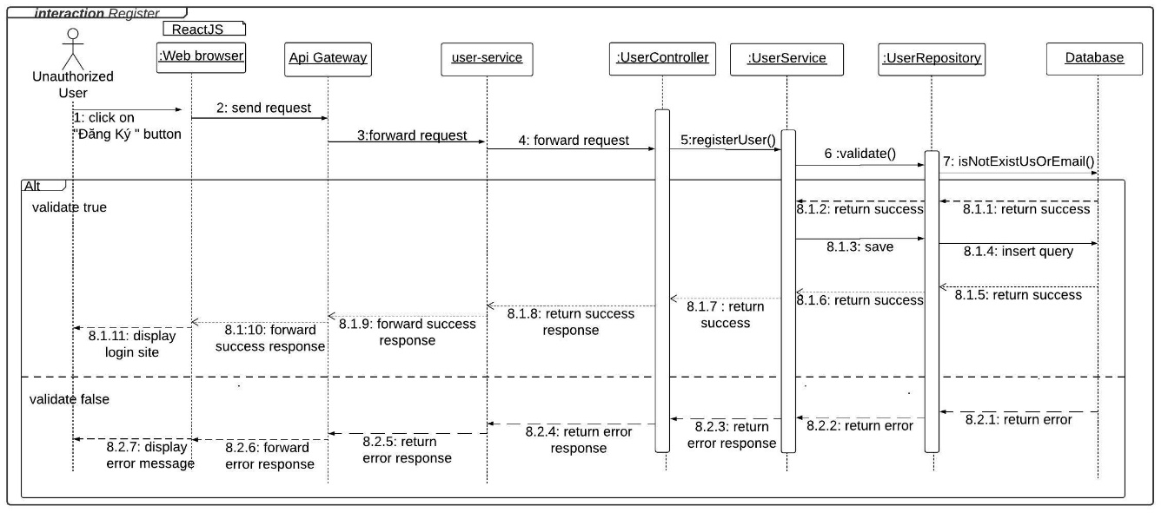

Figure 60 - <Interaction diagram> Register

#### 4.3.2. Login

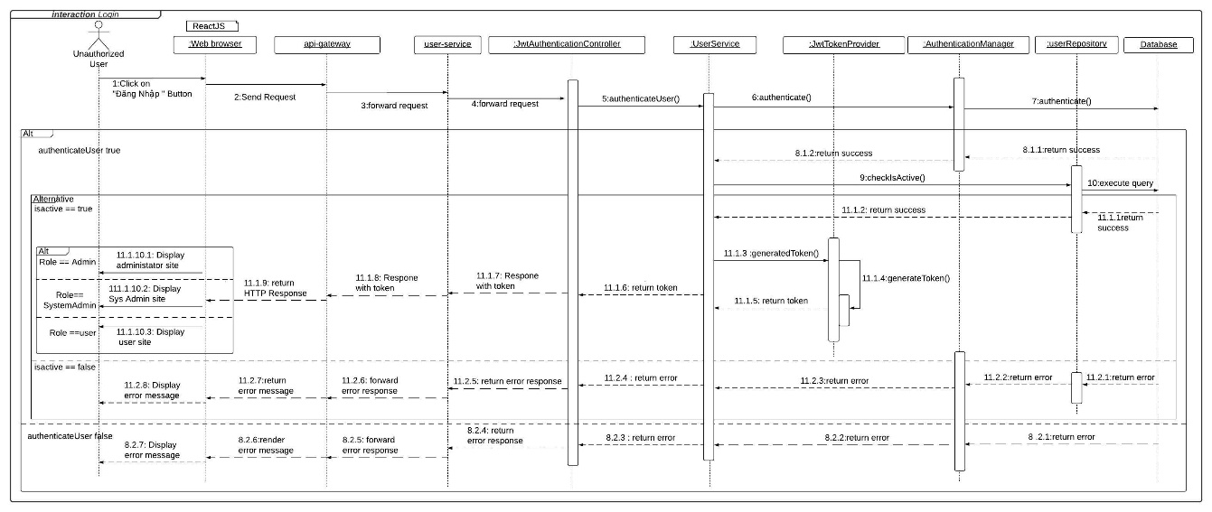

Figure 61 - <Interaction diagram> Login

#### 4.3.3. Generate story

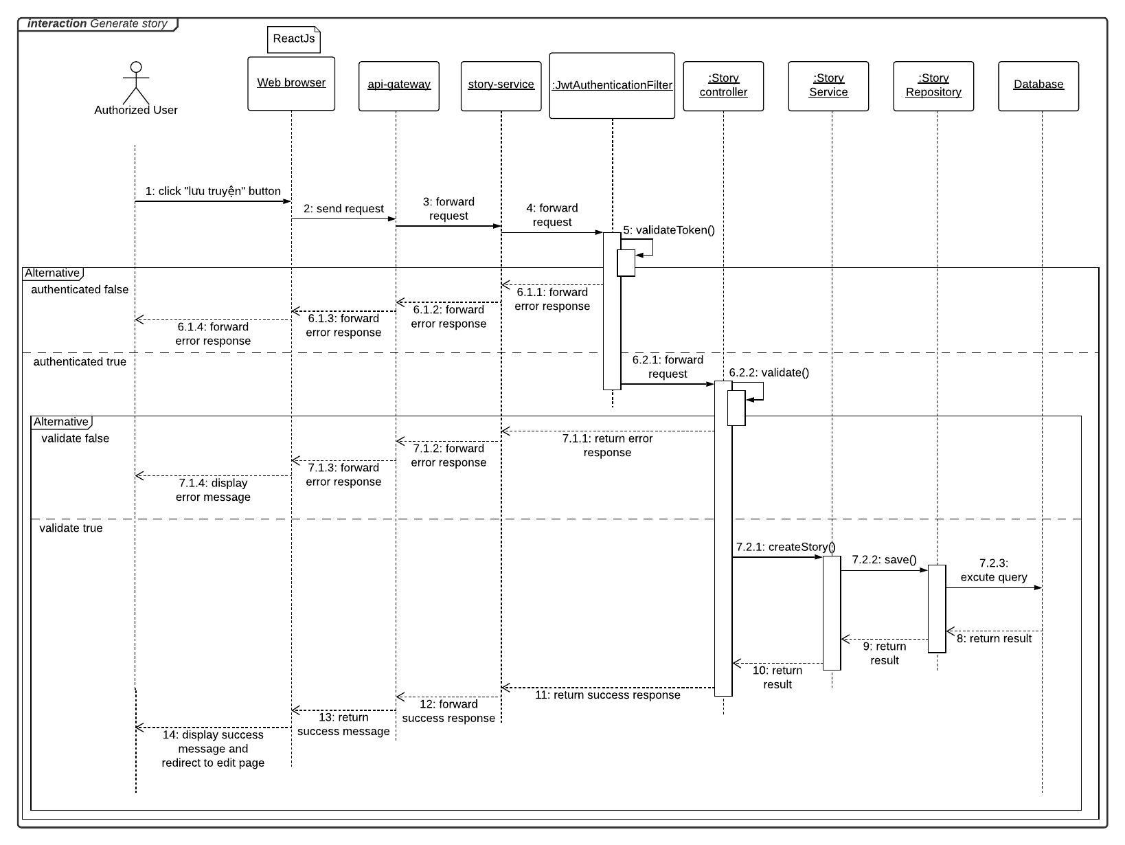

Figure 62 - <Interaction diagram> Generate story

#### 4.3.4. Read story

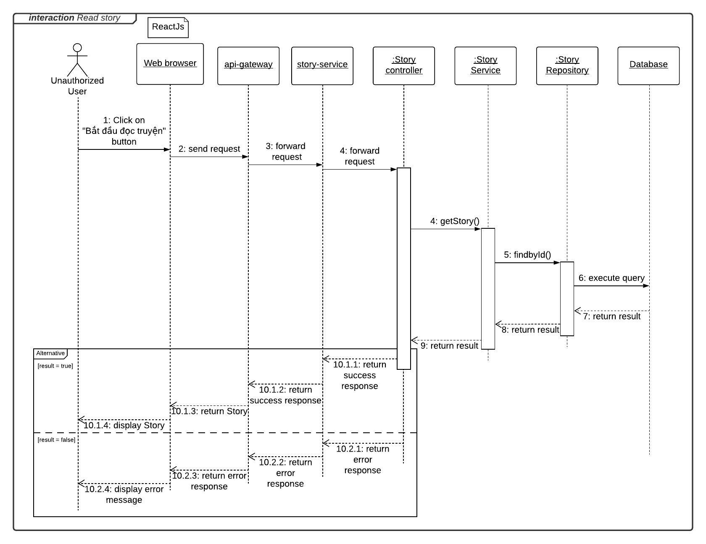

Figure 63 - <Interaction diagram> Read story

#### 4.3.5. Send comment

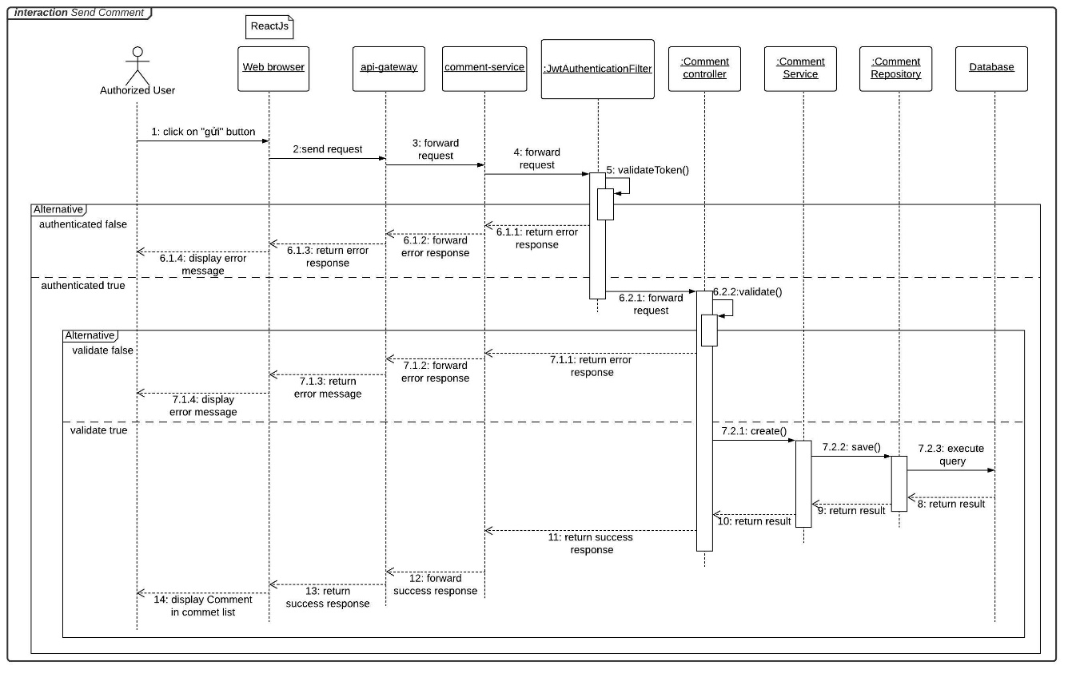

Figure 64 - <Interaction diagram> Send comment

#### 4.3.6. Create tag

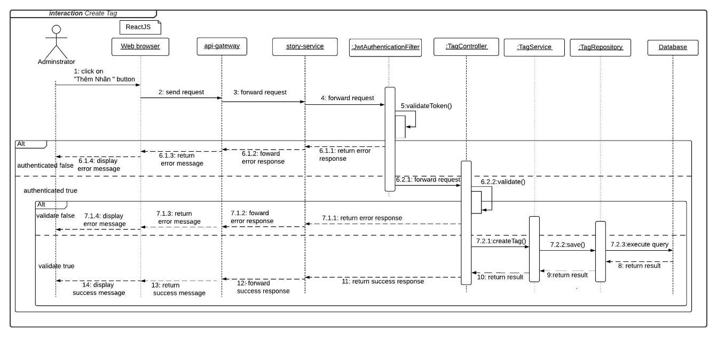

Figure 65 - <Interaction diagram> Create tag

#### 4.3.7. Update tag

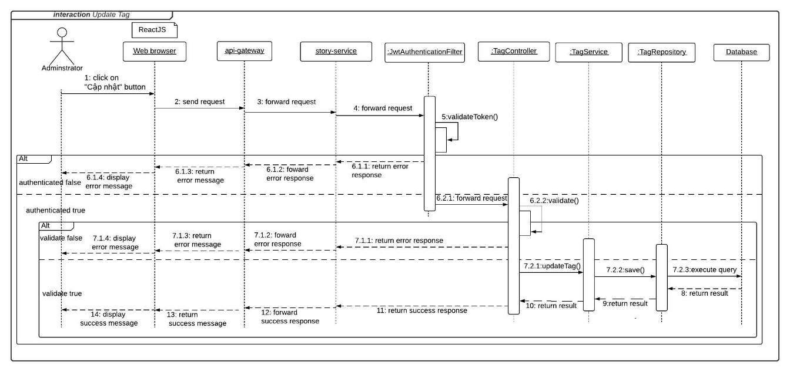

Figure 66 - <Interaction diagram> Update tag

#### 4.3.8. Update admin status

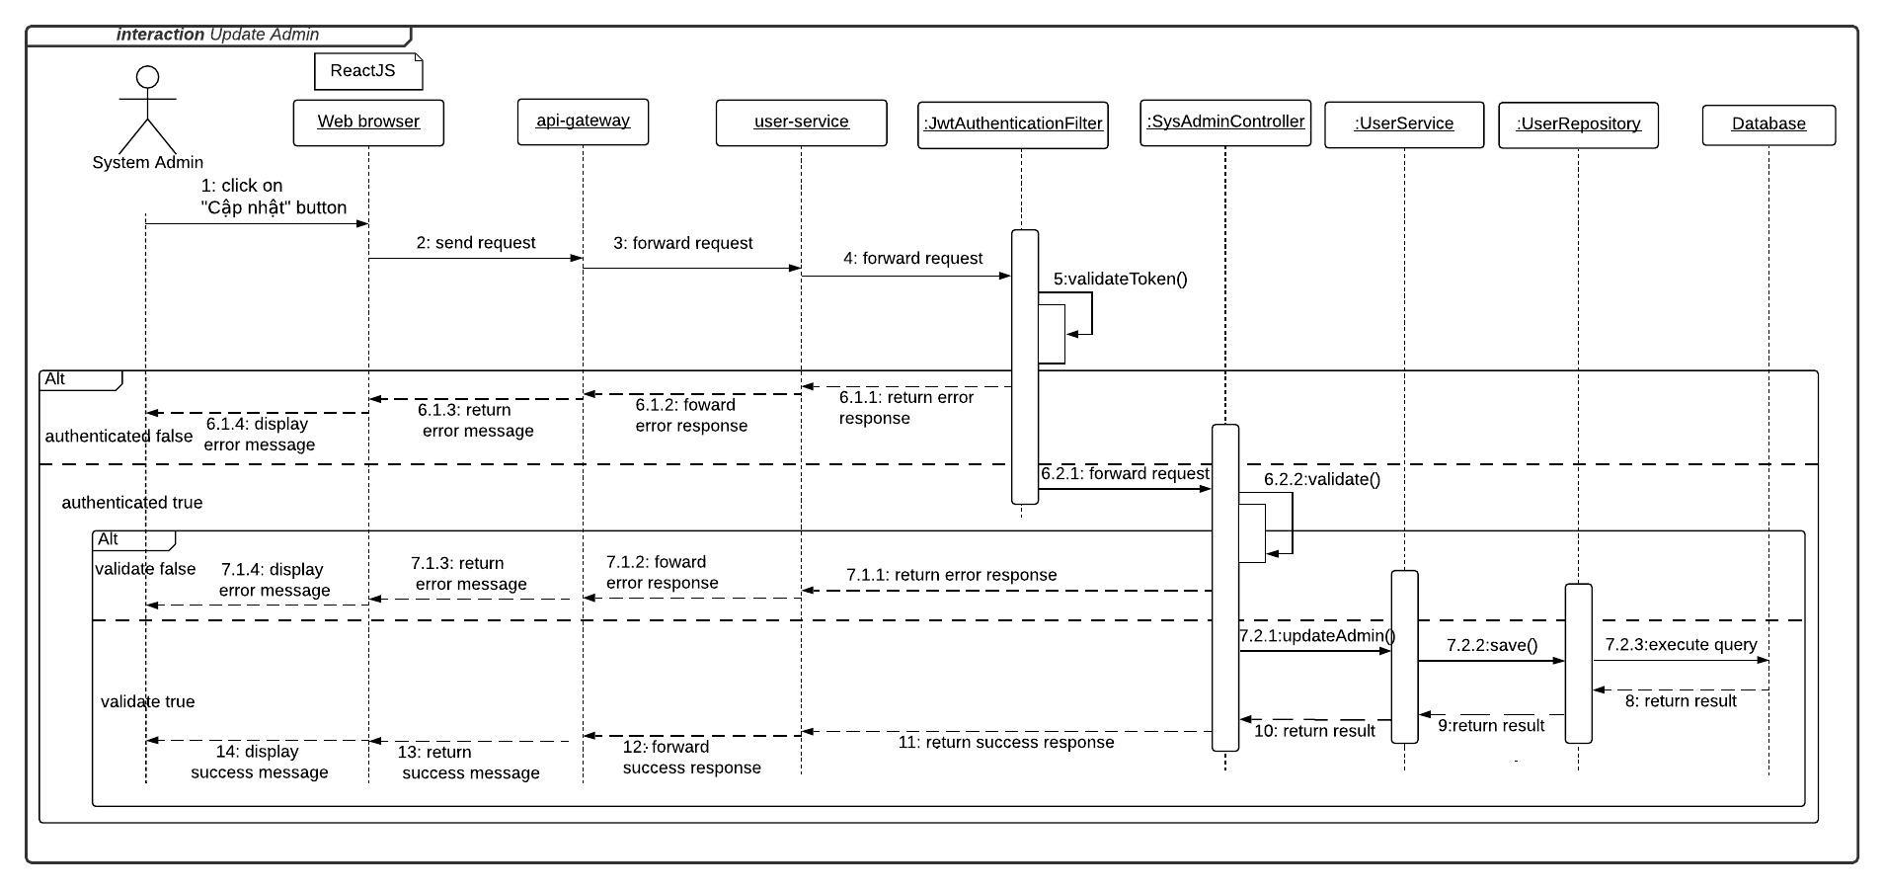

Figure 67 - <Interaction diagram> Update admin

#### 4.3.9. Update user status

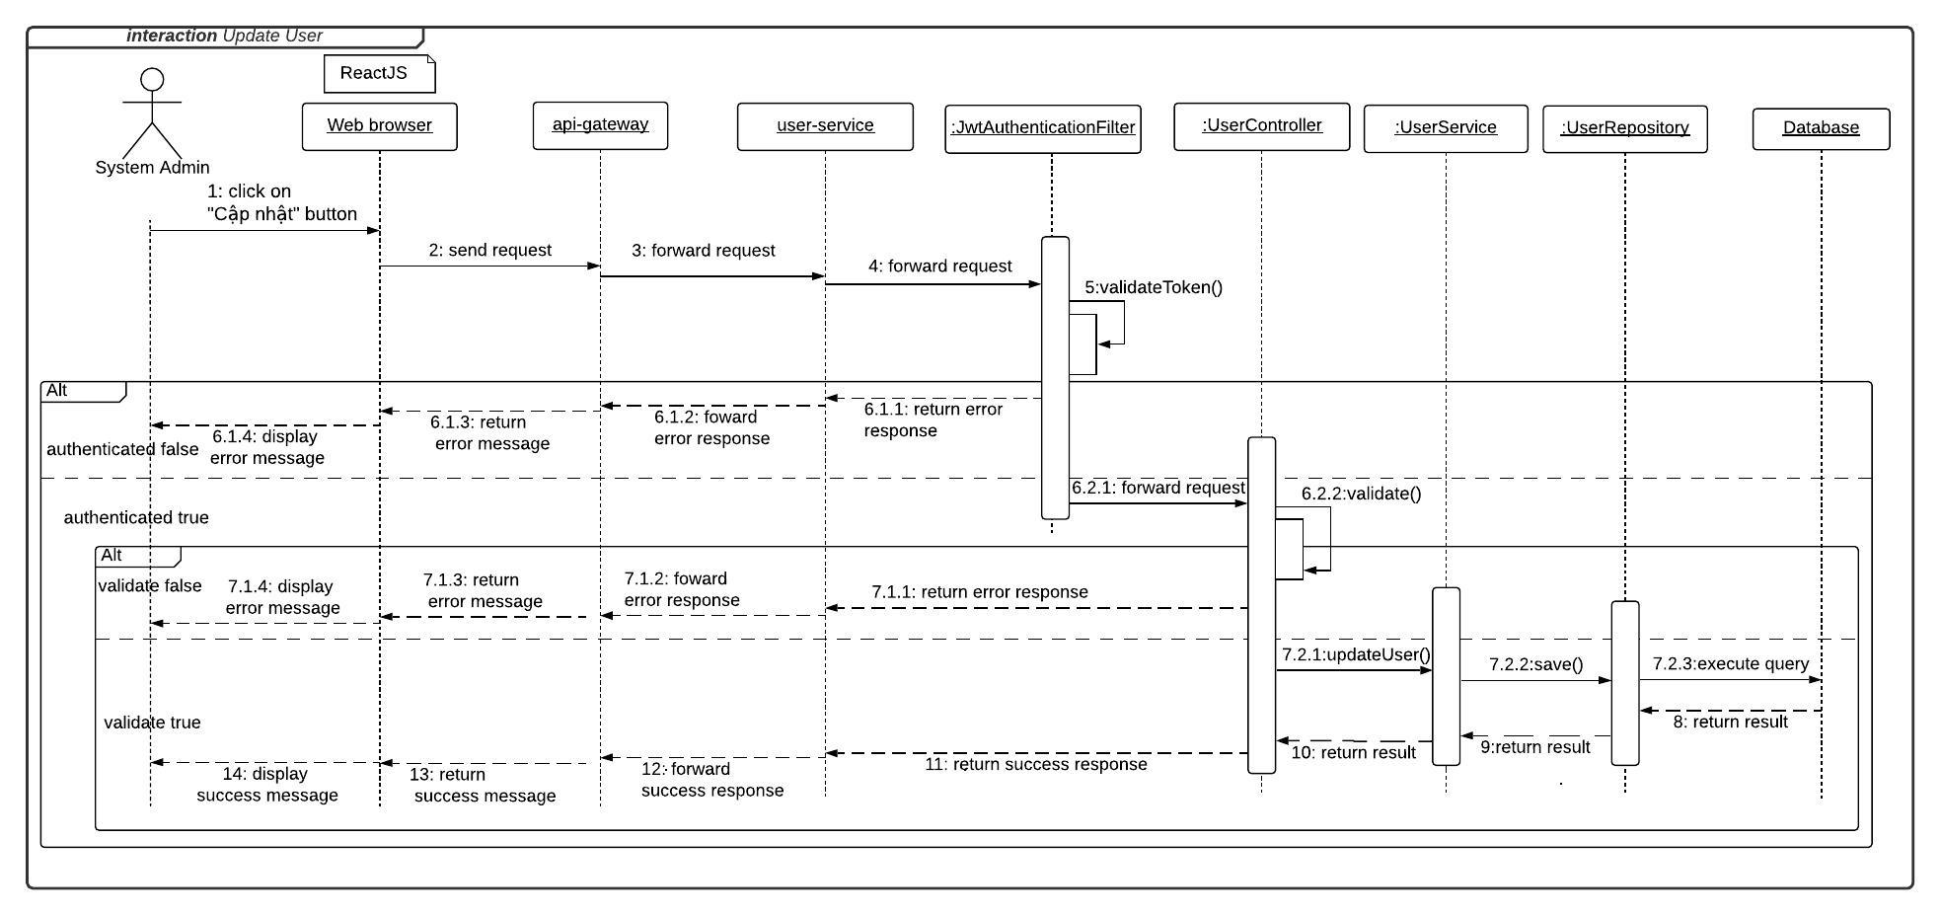

Figure 68 - <Interaction diagram> Update user

#### 4.3.10. Create admin

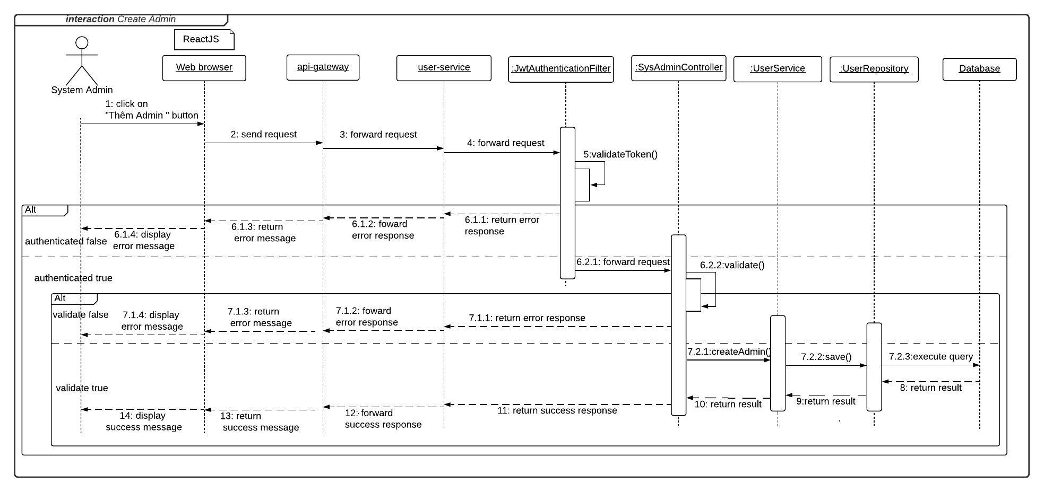

Figure 69 - <Interaction diagram> Create admin

#### 4.3.11. Create user

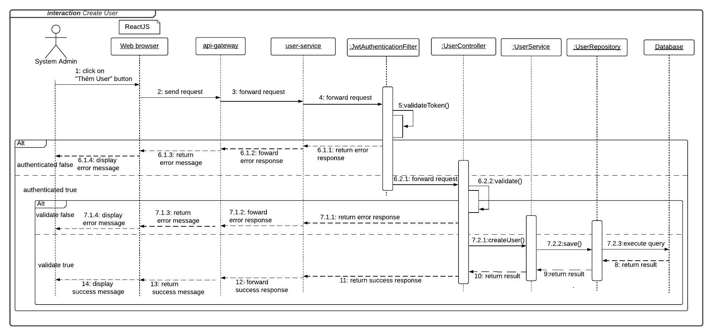

Figure 70 - <Interaction diagram> Create user

#### 4.3.12. Get story suggestions

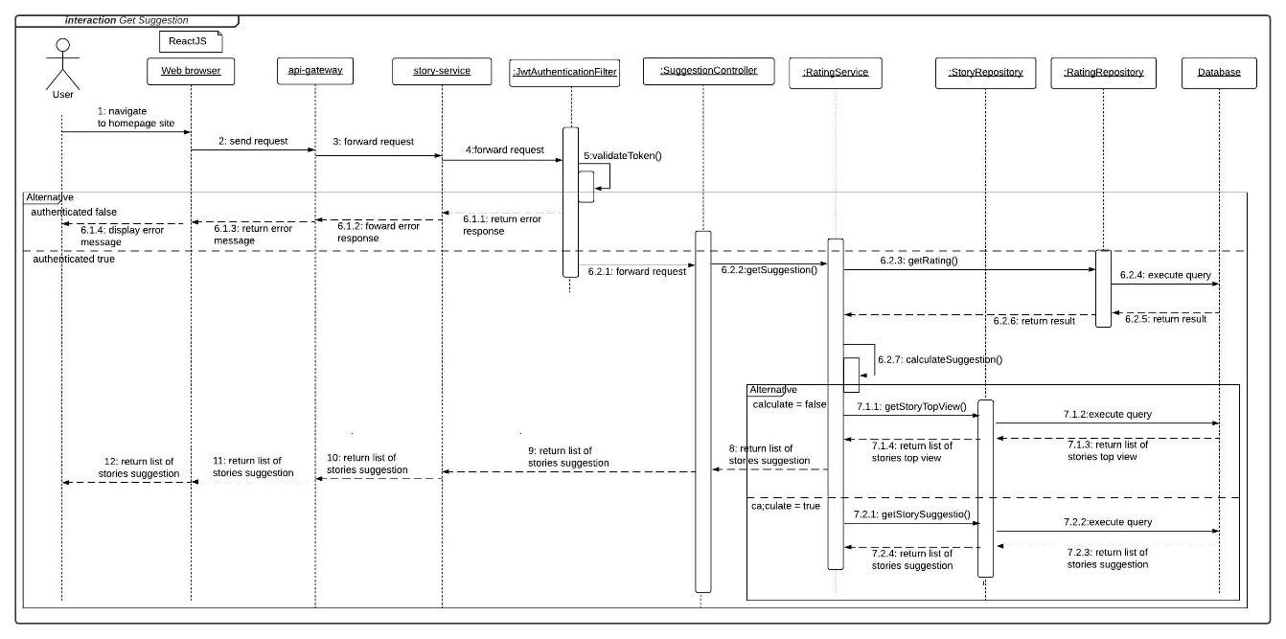

Figure 71 - <Interaction diagram> Get story suggestions

#### 4.3.13. Handle report

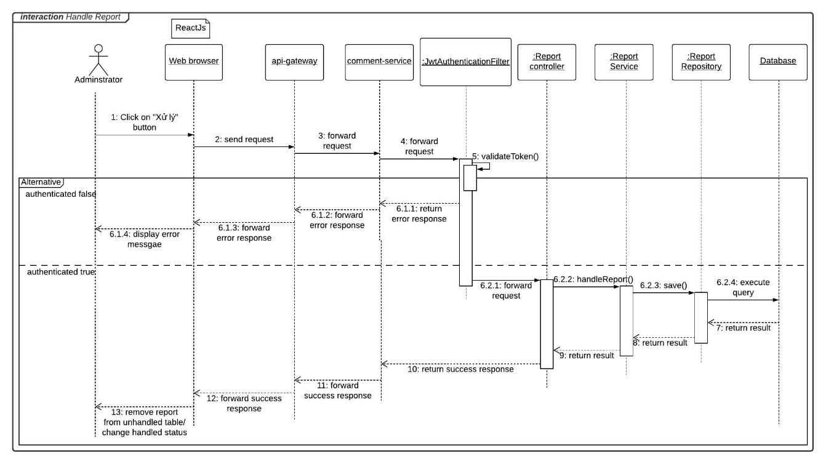

Figure 72 - <Interaction diagram> Handle report

#### 4.3.14. Edit user profile

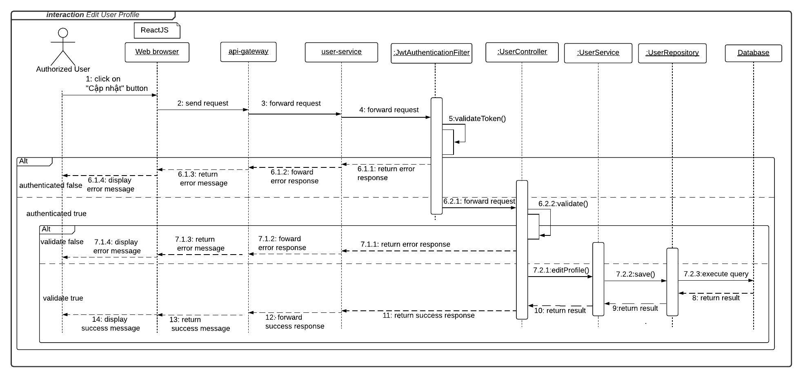

Figure 73 - <Interaction diagram> Edit user profile

## 5. Interface

### 5.1. Guest

#### 5.1.1. Menu bar



Figure 74 - <Guest> Menu bar interface

Buttons/Hyperlinks

|  |  |  |  |  |
| --- | --- | --- | --- | --- |
| **No** | **Function** | **Description** | **Validation** | **Outcome** |
| 1 | Logo | Go to homepage | N/A | Transfer to homepage |
| 2 | Login | Login into the system | N/A | Transfer to login page |
| 3 | Register | Register to the system | N/A | Transfer to register page |

Table 86 - <Buttons/Hyperlinks> Menu bar

#### 5.1.2. Login

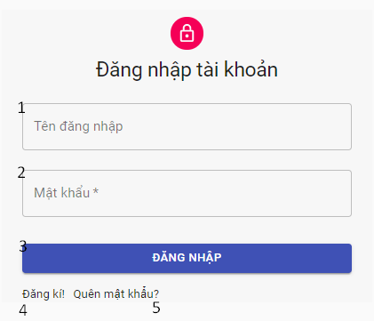

Figure 75 - <Guest> Login interface

Fields

|  |  |  |  |  |  |  |
| --- | --- | --- | --- | --- | --- | --- |
| **No** | **Field Name** | **Description** | **Read only** | **Mandatory** | **Control Type** | **Data Type** |
| 1 | Username | Username to login | No | Yes | TextBox | String |
| 2 | Password | Password to login | No | Yes | TextBox | String |

Table 87 - <Fields> Log in

Buttons/Hyperlinks

|  |  |  |  |  |
| --- | --- | --- | --- | --- |
| **No** | **Function** | **Description** | **Validation** | **Outcome** |
| 3 | Login | Login into the system | Require |  |
| 4 | Register | Register to the system | N/A | Transfer to register page |
| 5 | Forget password | Recovery user password | N/A | Transfer to email submit to recive reset password |

Table 88 - <Buttons/Hyperlinks> Log in

#### 5.1.3. Register

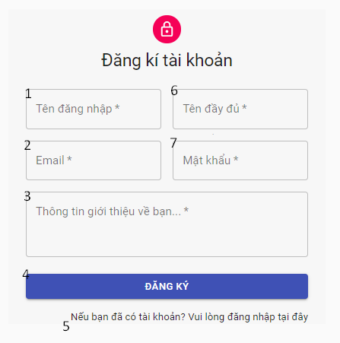

Figure 76 - <Guest> Register interface

Fields

|  |  |  |  |  |  |  |
| --- | --- | --- | --- | --- | --- | --- |
| **No** | **Field Name** | **Description** | **Read only** | **Mandatory** | **Control Type** | **Data Type** |
| 1 | Username | User name to register | No | Yes | TextBox | String |
| 2 | Email | Email | No | Yes | TextBox | String |
| 3 | Introduction | Introduction information of user | No | No | TextArea | String |
| 6 | Name | Name of user | No | Yes | TextBox | String |
| 7 | Password | Password of user | No | Yes | TextBox | String |

Table 89 - <Fields> Register information

Buttons/Hyperlinks

|  |  |  |  |  |
| --- | --- | --- | --- | --- |
| **No** | **Function** | **Description** | **Validation** | **Outcome** |
| 5 | Register | Register to the system | Required | Transfer to login page |
| 6 | [Go to login](http://localhost:3001/login) page | Go to login page | No | Transfer to login page |

Table 90 - <Buttons/Hyperlinks> Register information

#### 5.1.4. Home page

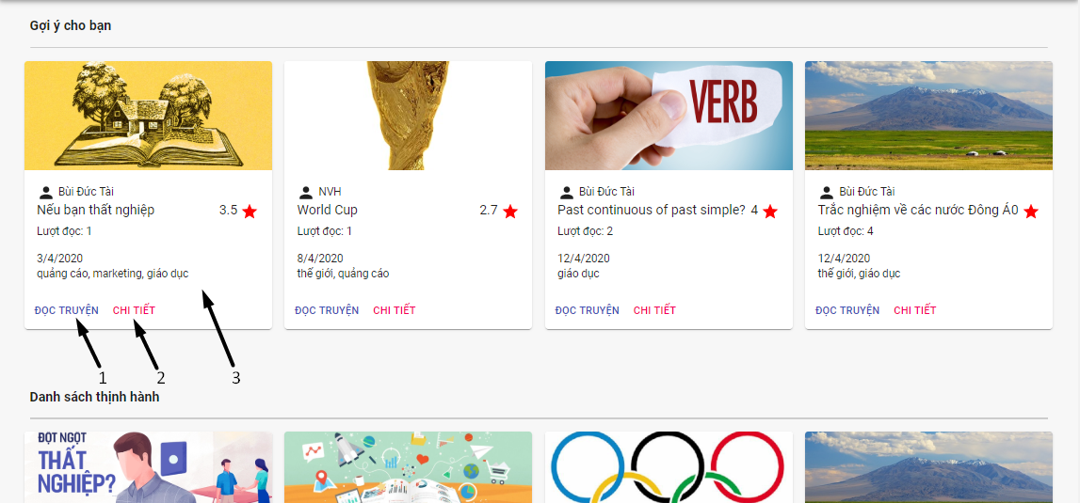

Figure 77 - <Guest> Homepage interface

Buttons/Hyperlinks

|  |  |  |  |  |
| --- | --- | --- | --- | --- |
| **No** | **Function** | **Description** | **Validation** | **Outcome** |
| 1 | Read story | Read story | N/A | Transfer to read story page |
| 2 | View detail of story | View detail of story | N/A | Tranfer to story detail page |
| 3 | View detail of story | View detail of story | N/A | Tranfer to story detail page |

Table 91 - <Buttons/Hyperlinks> Homepage

#### 5.1.5. Submit email

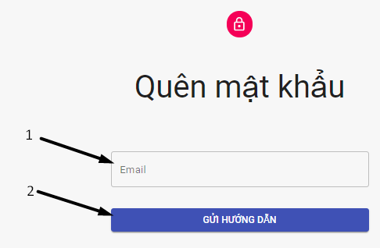

Figure 78 - <Guest> Submit email interface

Fields

|  |  |  |  |  |  |  |
| --- | --- | --- | --- | --- | --- | --- |
| **No** | **Field Name** | **Description** | **Read only** | **Mandatory** | **Control Type** | **Data Type** |
| 1 | Email | Email address to recieve reset password link | No | Yes | TextBox | String |

Table 2 - <Fields> Submit email information

Buttons/Hyperlinks

|  |  |  |  |  |
| --- | --- | --- | --- | --- |
| **No** | **Function** | **Description** | **Validation** | **Outcome** |
| 1 | Send intruction | Send reset password link to user submit email address | Required |  |

Table 93 - <Buttons/Hyperlinks> Submit email

#### 5.1.6. Reset password

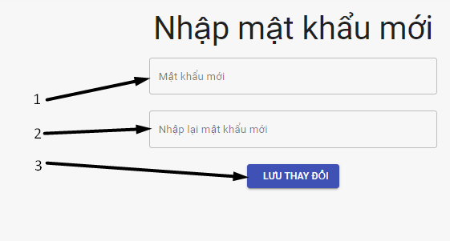

Figure 79 - <Guest> Reset password interface

Fields

|  |  |  |  |  |  |  |
| --- | --- | --- | --- | --- | --- | --- |
| **No** | **Field Name** | **Description** | **Read only** | **Mandatory** | **Control Type** | **Data Type** |
| 1 | New password | New password of user | No | Yes | TextBox | String |
| 2 | Re-password | Re-password of user | No | Yes | TextBox | String |

Table 94 - <Fields> Reset password information

Buttons/Hyperlinks

|  |  |  |  |  |
| --- | --- | --- | --- | --- |
| **No** | **Function** | **Description** | **Validation** | **Outcome** |
| 3 | Save password | Save new password | Required | Tranfer to homepage |

Table 95 - <Buttons/Hyperlinks> Reset password

#### 5.1.7. Navigation



Figure 80 - <Guest> Navigation interface

Buttons/Hyperlinks

|  |  |  |  |  |
| --- | --- | --- | --- | --- |
| **No** | **Function** | **Description** | **Validation** | **Outcome** |
| 1 | Hide navigation |  | No |  |
| 2 | Go to homepage | Go to homepage | No | Tranfer to homepage |
| 3 | Go to search story page | Go to search story page | No | Tranfer to search storypage |

Table 96 - <Buttons/Hyperlinks> Navigation

#### 5.1.8. Story detail

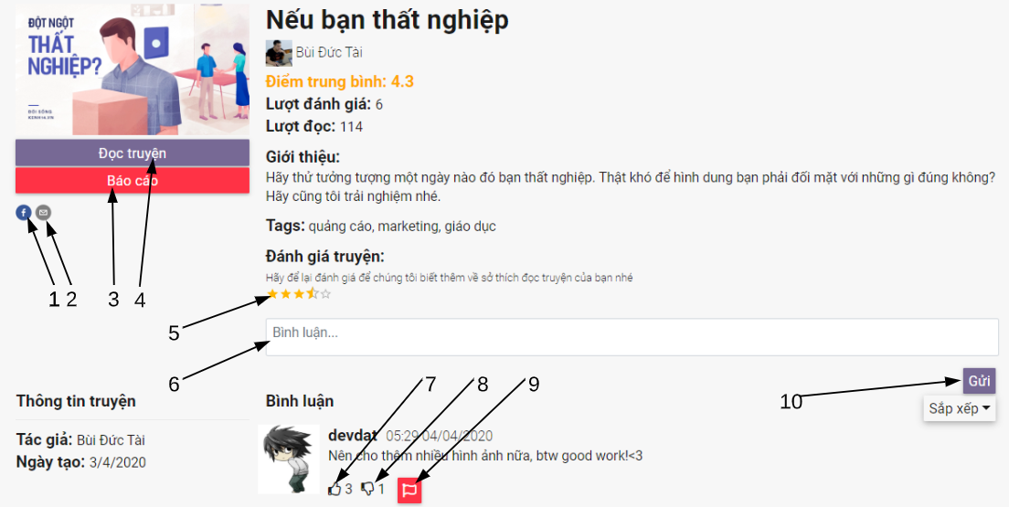

Figure 81 - <Guest> Story detail interface

Fields

|  |  |  |  |  |  |  |
| --- | --- | --- | --- | --- | --- | --- |
| **No** | **Field Name** | **Description** | **Read only** | **Mandatory** | **Control Type** | **Data Type** |
| 6 | Comment | Comment to the story | No | No | TextArea | String |

Table 97 - <Fields> Story detail

Buttons/Hyperlinks

|  |  |  |  |  |
| --- | --- | --- | --- | --- |
| **No** | **Function** | **Description** | **Validation** | **Outcome** |
| 1 | Share to facebook | Share story to facebook | No | Open facebook share window |
| 2 | Send email | Send email | No | Open email compose window |
| 3 | Report | Report story to administrator | Required |  |
| 4 | Read story | Read story | No | Tranfer to read story page |
| 5 | Rating | Rate story | Required |  |
| 7 | Like comment |  | Required |  |
| 8 | Dislike comment |  | Required |  |
| 9 | Report comment | Report comment to administrator | Required |  |
| 10 | Send comment | Send comment to the story | Required |  |

Table 94 - <Buttons/Hyperlinks> Story detail

#### 5.1.9. Search story page

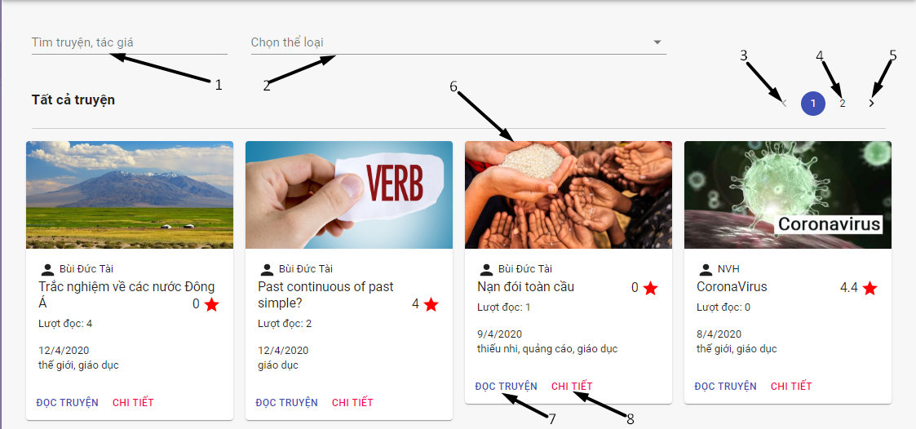

Figure 82 - <Guest> Search story interface

Fields

|  |  |  |  |  |  |  |
| --- | --- | --- | --- | --- | --- | --- |
| **No** | **Field Name** | **Description** | **Read only** | **Mandatory** | **Control Type** | **Data Type** |
| 1 | Story title / author | Title and author of story | No | No | TextBox | String |
| 2 | Tag | Tag of story | No | No | TextBox | String |

Table 95 - <Fields> Search story

Buttons/Hyperlinks

|  |  |  |  |  |
| --- | --- | --- | --- | --- |
| **No** | **Function** | **Description** | **Validation** | **Outcome** |
| 3 | Select previous page | Back to previous page of searching stories | No | View previous page of searching stories |
| 4 | Select page | Select page of searching story | No | View specific page of searching stories |
| 5 | Select next page | Back to next page of searching stories | No | View next page of searching stories |
| 6 | View detail of story | View detail of story | No | Tranfer to story detail page |
| 7 | Read story | Read story | No | Transfer to read story page |
| 8 | View detail of story | View detail of story | No | Tranfer to story detail page |

Table 96 - <Buttons/Hyperlinks> Search story

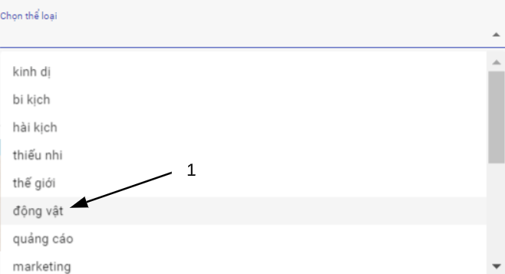

Figure 83 - <Guest> Select tag interface

Buttons/Hyperlinks

|  |  |  |  |  |
| --- | --- | --- | --- | --- |
| **No** | **Function** | **Description** | **Validation** | **Outcome** |
| 1 | Select tag | Select tag | No |  |

Table 97 - <Buttons/Hyperlinks> Select tag

#### 5.1.10. Read story

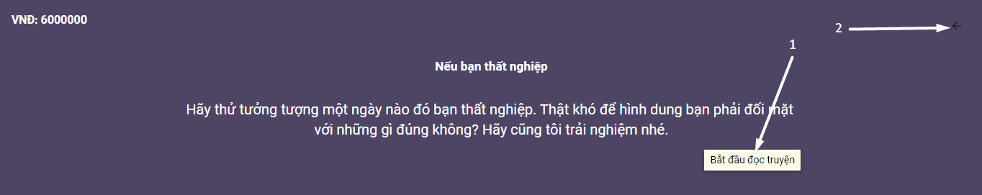

Figure 84 - <Guest> Introduction screen interface

Buttons/Hyperlinks

|  |  |  |  |  |
| --- | --- | --- | --- | --- |
| **No** | **Function** | **Description** | **Validation** | **Outcome** |
| 1 | Start reading | Go to start screen | No | View start screen |
| 2 | Back to story detail |  | No | Transfer to story detail page |

Table 98 - <Buttons/Hyperlinks> Introduction screen

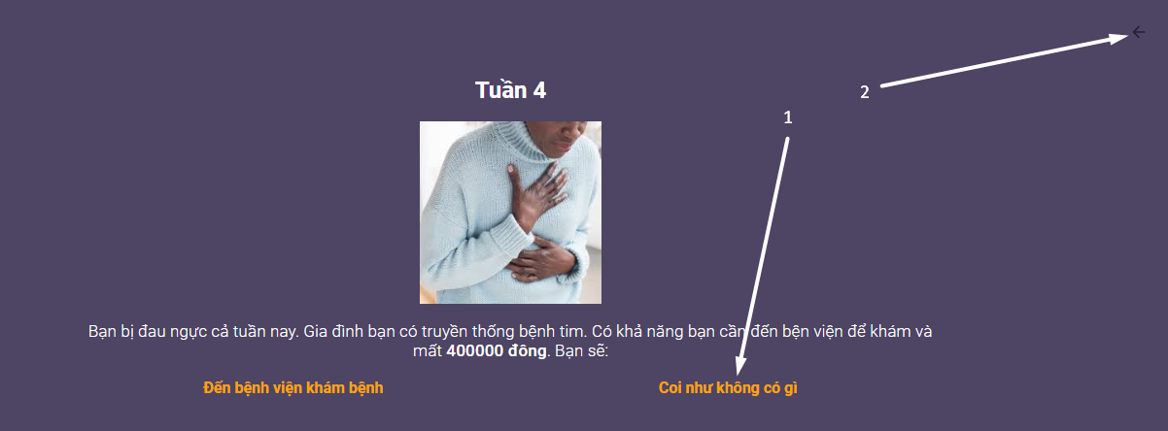

Figure 85 - <Guest> Content screen interface

Buttons/Hyperlinks

|  |  |  |  |  |
| --- | --- | --- | --- | --- |
| **No** | **Function** | **Description** | **Validation** | **Outcome** |
| 1 | Do screen action |  | No | View next screen, update information or open a url window |
| 2 | Back to story detail |  | No | Transfer to story detail page |

Table 99 - <Buttons/Hyperlinks> Content screen

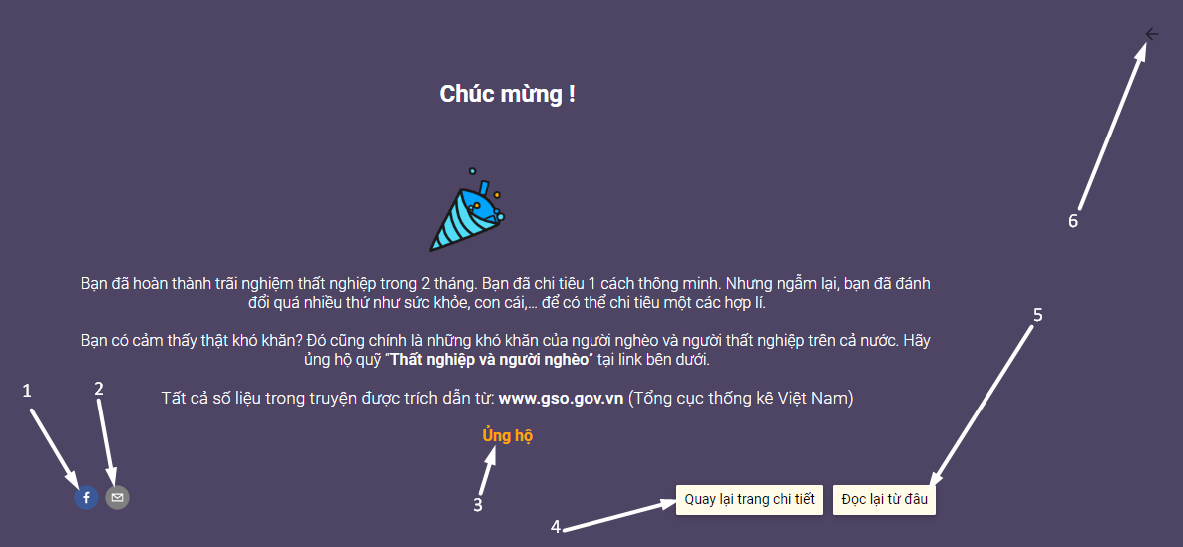

Figure 86 - <Guest> End screen interface

Buttons/Hyperlinks

|  |  |  |  |  |
| --- | --- | --- | --- | --- |
| **No** | **Function** | **Description** | **Validation** | **Outcome** |
| 1 | Share to facebook | Share story to facebook | No | Open facebook share window |
| 2 | Send email | Send email | No | Open email compose window |
| 3 | Do screen action |  | No | View next screen, update information or open a url window |
| 4 | Back to story detail |  | No | Transfer to story detail page |
| 5 | Back to start screen | Back to start screen | No | View start screen |
| 6 | Back to story detail |  | No | Transfer to story detail page |

Table 100 - <Buttons/Hyperlinks> End screen

### 5.2. User

#### 5.2.1. User menu



Figure 87 - <User> User menu interface

Buttons/Hyperlinks

|  |  |  |  |  |
| --- | --- | --- | --- | --- |
| **No** | **Function** | **Description** | **Validation** | **Outcome** |
| 1 | Show navigation | Show user navigation | Required | View user navigation |
| 2 | Go to homepage |  | N/A | Transfer to homepage |
| 3 | Go to user profile | User profile detail | Required | Transfer to user profile |

Table 101 - <Buttons/Hyperlinks> User menu

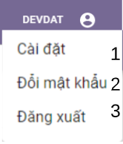

Figure 88 - <User> User settings menu interface

Buttons/Hyperlinks

|  |  |  |  |  |
| --- | --- | --- | --- | --- |
| **No** | **Function** | **Description** | **Validation** | **Outcome** |
| 1 | Settings | View edit user profile page | Required | Transfer to edit user profile page |
| 2 | Change password | View change password page | Required | Transfer to change password page |
| 3 | Logout |  | Required | Open logout modal |

Table 102 - <Buttons/Hyperlinks> User settings menu bar

#### 5.2.2. User navigation

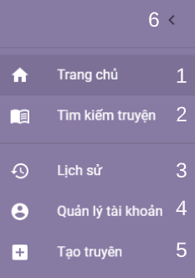

Figure 89 - < User > User navigation interface

Buttons/Hyperlinks

|  |  |  |  |  |
| --- | --- | --- | --- | --- |
| **No** | **Function** | **Description** | **Validation** | **Outcome** |
| 1 | Go to homepage | Show user navigation | Required | Transfer to home page |
| 2 | Go to search story | Show user search story page | N/A | Transfer to search story page |
| 3 | Go to history | Go to page of user history : story readings, reactions and comments | Required | Transfer to user history page |
| 4 | Go to user profile | Go to view user profile | Required | Transfer to user profile page |
| 5 | Go to create story | Go to create story page | Required | Transfer to create story page |
| 6 | Hide navigation | Close user navigation | N/A | Close user navigation |

Table 103 - <Buttons/Hyperlinks> User navigation

#### 5.2.3. User history navigation



Figure 90 - < User > User history navigation interface

Buttons/Hyperlinks

|  |  |  |  |  |
| --- | --- | --- | --- | --- |
| **No** | **Function** | **Description** | **Validation** | **Outcome** |
| 1 | Show reading history | Show user navigation | Required | Show user reading history tab |
| 2 | Show comment history | Show user search story page | N/A | Show user comment history tab |
| 3 | Show reaction history | Go to page of user history : story readings, reactions and comments | Required | Show user reaction history tab |

Table 104 - <Buttons/Hyperlinks> User history navigation

#### 5.2.4. User reading history tab

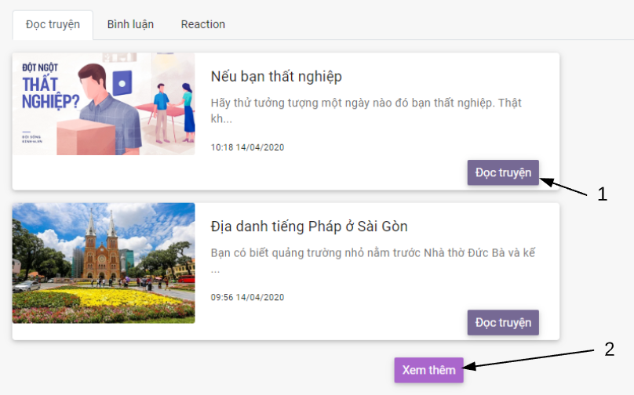

Figure 91 - < User > User reading history tab interface

Buttons/Hyperlinks

|  |  |  |  |  |
| --- | --- | --- | --- | --- |
| **No** | **Function** | **Description** | **Validation** | **Outcome** |
| 1 | Go to story detail | Go to story detail | N/A | Open new window of story detail page |
| 2 | Load more | Show more read stories in reading history | Required | Show more read stories in reading history |
| 3 | Show reaction history | Go to page of user history : story readings, reactions and comments | Required | Show user reaction history tab |

Table 105 - <Buttons/Hyperlinks> User reading history tab

#### 5.2.5. User comment history tab

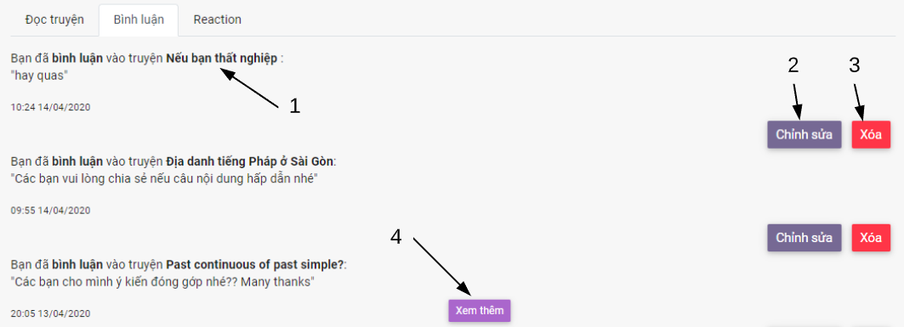

Figure 92 - < User > User comment history tab interface

Buttons/Hyperlinks

|  |  |  |  |  |
| --- | --- | --- | --- | --- |
| **No** | **Function** | **Description** | **Validation** | **Outcome** |
| 1 | Go to story detail | Go to story detail | N/A | Open new window of story detail page |
| 2 | Open edit comment dialog | Edit user comment of the story | Required | Open edit comment dialog |
| 3 | Delete comment | Delete user comment of the story | Required | Send delete comment request |
| 4 | Load more | Show more comment of user in comment history | Required | Show more comments in comment history |

Table 106 - <Buttons/Hyperlinks> User comment history tab

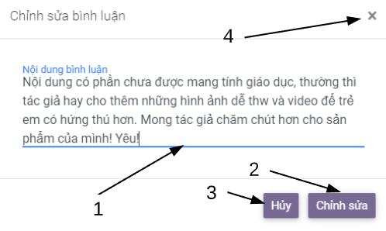

Figure 93 - < User > User edit comment dialog interface

Fields

|  |  |  |  |  |  |  |
| --- | --- | --- | --- | --- | --- | --- |
| **No** | **Field Name** | **Description** | **Read only** | **Mandatory** | **Control Type** | **Data Type** |
| 1 | User edit comment | Edit comment of user | N/A | N/A | TextArea | String |

Table 107 - <Fields> User edit comment dialog

Buttons/Hyperlinks

|  |  |  |  |  |
| --- | --- | --- | --- | --- |
| **No** | **Function** | **Description** | **Validation** | **Outcome** |
| 2 | Save comment | Save changes of comment | Required | Save changes of comment and close dialog |
| 3 | Cancel | Cancel the changes of comment | N/A | Cancel changes of comment and close dialog |
| 4 | Cancel | Cancel the changes of comment | N/A | Cancel changes of comment and close dialog |

Table 108 - <Buttons/Hyperlinks> User edit comment dialog

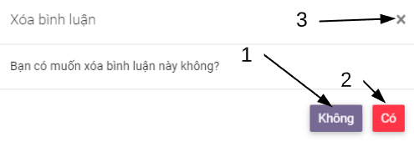

Figure 94 - < User > User delete comment dialog interface

Buttons/Hyperlinks

|  |  |  |  |  |
| --- | --- | --- | --- | --- |
| **No** | **Function** | **Description** | **Validation** | **Outcome** |
| 1 | Cancel |  | N/A | Close dialog |
| 2 | Delete comment | Delete user comment of the story | Required | Save changes of comment and close dialog |
| 3 | Cancel |  | N/A | Close dialog |

Table 109 - <Buttons/Hyperlinks> User edit comment dialog

#### 5.2.6. User reaction history tab

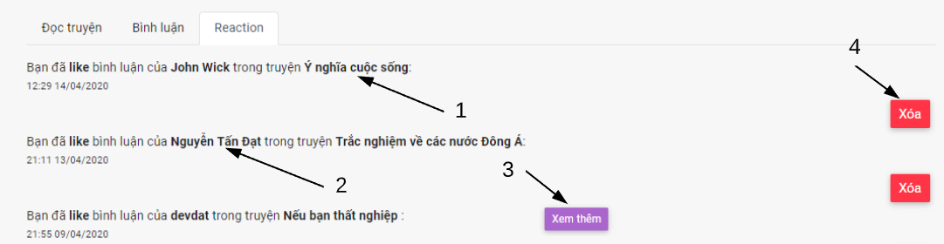

Figure 95 - < User > User reaction history tab interface

Buttons/Hyperlinks

|  |  |  |  |  |
| --- | --- | --- | --- | --- |
| **No** | **Function** | **Description** | **Validation** | **Outcome** |
| 1 | Go to story detail | Go to story detail | N/A | Open new window of story detail page |
| 2 | Go to user profile | Go to user profile | N/A | Go to user profile page |
| 3 | Load more | Show more reaction of user in reaction | Required | Show more comments in comment history |
| 4 | Delete reaction | Delete user reaction of the story | Required | Send delete reaction request |

Table 110 - <Buttons/Hyperlinks> User comment history tab

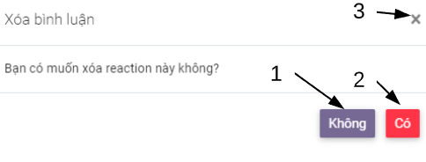

Figure 96 - < User > User delete reaction dialog interface

Buttons/Hyperlinks

|  |  |  |  |  |
| --- | --- | --- | --- | --- |
| **No** | **Function** | **Description** | **Validation** | **Outcome** |
| 1 | Cancel |  | N/A | Close dialog |
| 2 | Delete reaction | Delete user reaction of the comment | Required | Send reaction delete request and close dialog |
| 3 | Cancel |  | N/A | Close dialog |

Table 111 - <Buttons/Hyperlinks> User delete reaction dialog

#### 5.2.7. View own profile

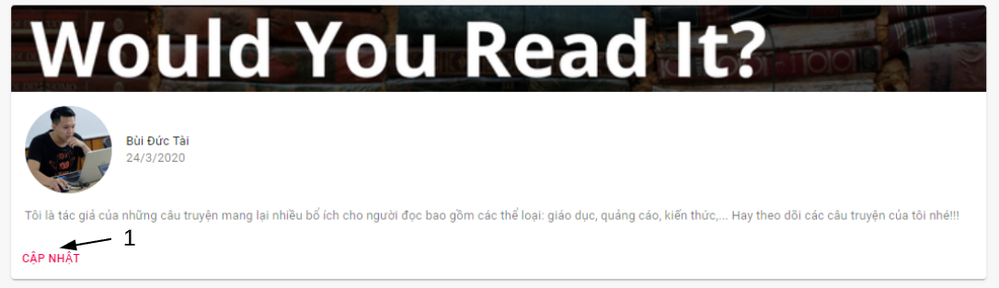

Figure 97 - < User > User introduction interface

Buttons/Hyperlinks

|  |  |  |  |  |
| --- | --- | --- | --- | --- |
| **No** | **Function** | **Description** | **Validation** | **Outcome** |
| 1 | Edit user profile | Edit user profile | N/A | Tranfer to edit user profile page |

Table 112 - <Buttons/Hyperlinks> User introduction

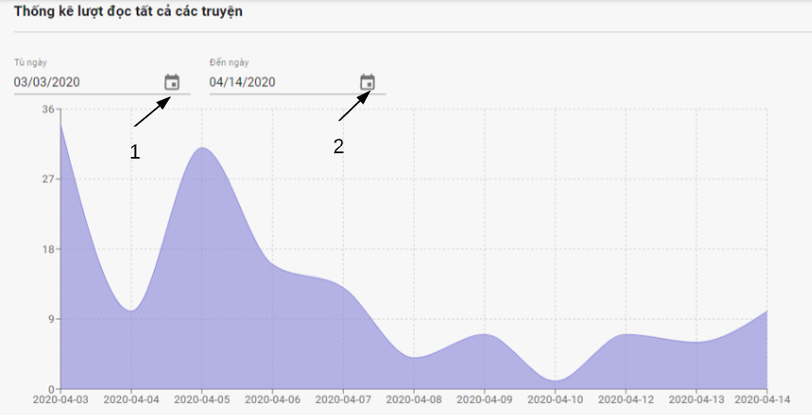

Figure 98 - < User > User stories view statictic interface

Fields

|  |  |  |  |  |  |  |
| --- | --- | --- | --- | --- | --- | --- |
| **No** | **Field Name** | **Description** | **Read only** | **Mandatory** | **Control Type** | **Data Type** |
| 1 | Start date | Start date of time range in statistics table of stories view number by day | N/A | Yes | DatetimePicker | String |
| 2 | End date | Start date of time range in statistics table of stories view number by day | N/A | Yes | DatetimePicker | String |

Table 113 - <Buttons/Hyperlinks> User stories view statistic

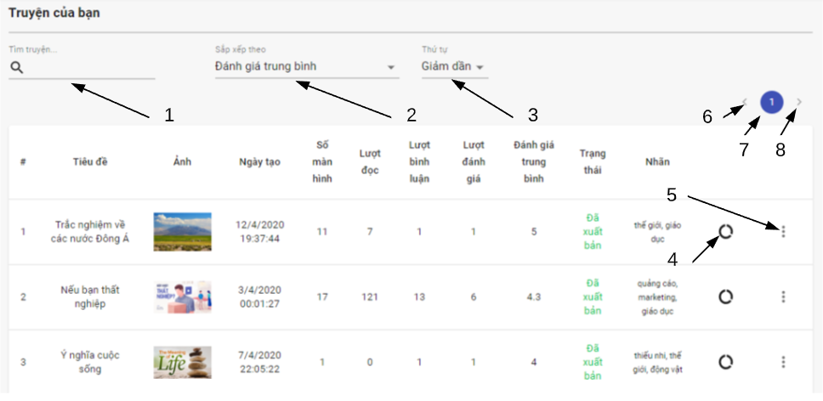

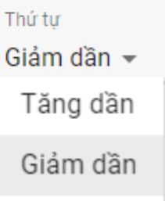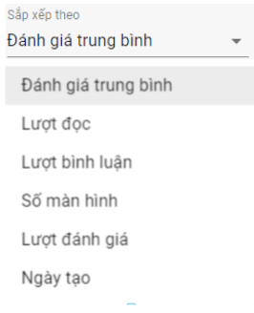

Figure 99 - < User > User’s stories search interface

Fields

|  |  |  |  |  |  |  |
| --- | --- | --- | --- | --- | --- | --- |
| **No** | **Field Name** | **Description** | **Read only** | **Mandatory** | **Control Type** | **Data Type** |
| 1 | Story title | Title of searching story | No | No | TextBox | String |

Table 114 - <Fields> View user’s stories

Buttons/Hyperlinks

|  |  |  |  |  |
| --- | --- | --- | --- | --- |
| **No** | **Function** | **Description** | **Validation** | **Outcome** |
| 2 | Choose criteria of story to order | Choose criteria of story like avg Rate, number of view,… | N/A |  |
| 3 | Choose order type | Choose order type to order list of story by criteria | N/A |  |
| 4 | Go to the story statistic |  | Required | Transfer to view story statistic |
| 5 | Open story settings |  | N/A |  |
| 6 | Select previous page | Back to previous page of searching stories | N/A | View previous page of searching stories |
| 7 | Select page | Select page of searching story | N/A | View specific page of searching stories |
| 8 | Select next page | Back to next page of searching stories | N/A | View next page of searching stories |

Table 115 - <Buttons/Hyperlinks> View user’s stories

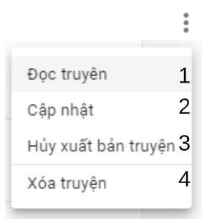

Figure 100 - < User > User’s story settings interface

Buttons/Hyperlinks

|  |  |  |  |  |
| --- | --- | --- | --- | --- |
| **No** | **Function** | **Description** | **Validation** | **Outcome** |
|  | Read story | Choose criteria of story like avg Rate, number of view,… | N/A | Transfer to read story page |
|  | Delete story |  | Required | Send delete story request |

Table 116 - <Buttons/Hyperlinks> User’s story settings interface

#### 5.2.8. Edit profle

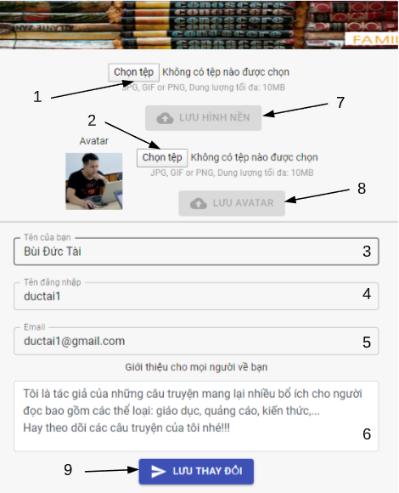

Figure 101 - < User > User edit profile interface

Fields

|  |  |  |  |  |  |  |
| --- | --- | --- | --- | --- | --- | --- |
| **No** | **Field Name** | **Description** | **Read only** | **Mandatory** | **Control Type** | **Data Type** |
| 1 | Background image |  | No | N/A | FileUpload | File |
| 2 | Avatar |  | No | N/A | FileUpload | File |
| 3 | Name |  | No | Yes | TextBox | String |
| 4 | Username |  | Yes | Yes | TextBox | String |
| 5 | Email |  | No | Yes | TextBox | String |
| 6 | Introduction |  | No | N/A | TextArea | String |

Table 117 - <Fields> User edit profile

Buttons/Hyperlinks

|  |  |  |  |  |
| --- | --- | --- | --- | --- |
| **No** | **Function** | **Description** | **Validation** | **Outcome** |
| 7 | Save background image | Save backgound image changes | Required | Upload backgound image |
| 8 | Save avatar | Save avatar changes | Required | Upload avatar |
| 9 | Save user information changes | Save user information changes include name, email, introduction | Required | Send profile update request |

Table 118 - <Buttons/Hyperlinks> User edit profile

#### 5.2.9. Change password

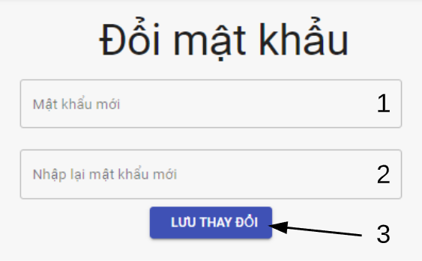

Figure 102 - < User > User change password interface

Fields

|  |  |  |  |  |  |  |
| --- | --- | --- | --- | --- | --- | --- |
| **No** | **Field Name** | **Description** | **Read only** | **Mandatory** | **Control Type** | **Data Type** |
| 1 | New password | New password to be updated | No | Yes | TextBox | String |
| 2 | Re-enter new password | Re enter new password that must be same with new password | No | Yes | TextBox | String |

Table 119 - <Fields> User change password

Buttons/Hyperlinks

|  |  |  |  |  |
| --- | --- | --- | --- | --- |
| **No** | **Function** | **Description** | **Validation** | **Outcome** |
| 3 | Save changes | Save new password | Required | Send update password request |

Table 120 - <Buttons/Hyperlinks> User change password

#### 5.2.10. Report story dialog

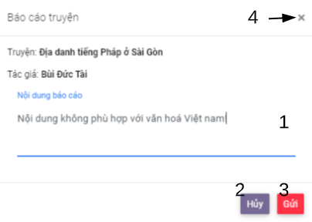

Figure 103 - < User > User report story interface

Fields

|  |  |  |  |  |  |  |
| --- | --- | --- | --- | --- | --- | --- |
| **No** | **Field Name** | **Description** | **Read only** | **Mandatory** | **Control Type** | **Data Type** |
| 1 | New password | New password to be updated | No | No | TextBox | String |

Table 121 - <Fields> User report story

Buttons/Hyperlinks

|  |  |  |  |  |
| --- | --- | --- | --- | --- |
| **No** | **Function** | **Description** | **Validation** | **Outcome** |
| 2 | Discard |  | N/A | Close dialog |
| 3 | Report story |  | Required | Send report request and close dialog |
| 4 | Discard |  | N/A | Close dialog |

Table 122 - <Buttons/Hyperlinks> User report story

#### 5.2.10. Create story navigation bar



Figure 104 - <User> Create story navigation interface

Buttons/Hyperlinks

|  |  |  |  |  |
| --- | --- | --- | --- | --- |
| **No** | **Function** | **Description** | **Validation** | **Outcome** |
| 1 | View story introduction detail tab |  | N/A | Show story introduction detail tab |
| 2 | View story screens detail tab |  | N/A | Show story screens detail tab |

Table 123 - <Buttons/Hyperlinks> Create story navigation

#### 5.2.11. Story introduction detail tab

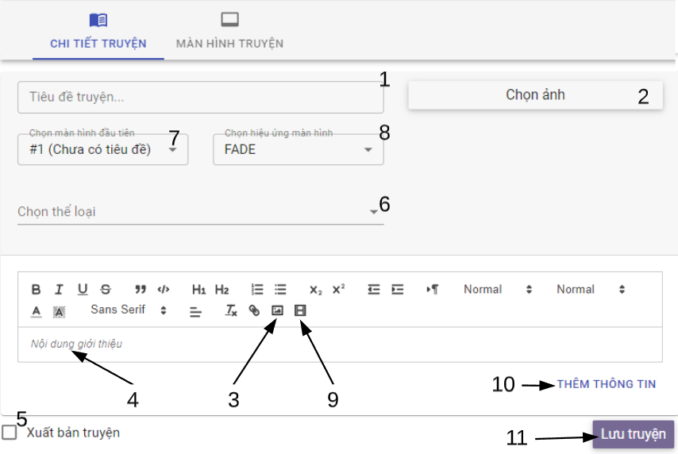 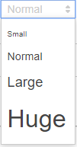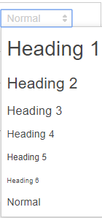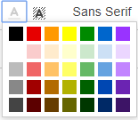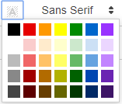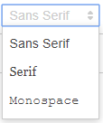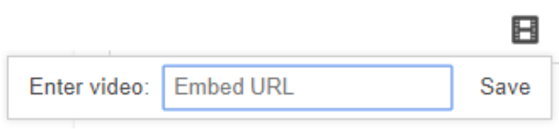

Figure 105 - <User> Story introduction detail tab interface

Fields

|  |  |  |  |  |  |  |
| --- | --- | --- | --- | --- | --- | --- |
| **No** | **Field Name** | **Description** | **Read only** | **Mandatory** | **Control Type** | **Data Type** |
| 1 | Story tittle | Name of story | No | Yes | TextBox | String |
| 2 | Story image | Avatar of story | No | No | FileUpload | File |
| 3 | Story introduction ‘s image | Image inside introduction | No | No | FileUpload | File |
| 4 | Introduction of story |  | No | Yes | TextArea | String |
| 5 | Publishing status |  | No | No | CheckBox | Boolean |
| 6 | Tag | Tag of story | No | Yes | TextBox | String |

Table 124 - <Fields> Story introduction detail tab

Buttons/Hyperlinks

|  |  |  |  |  |
| --- | --- | --- | --- | --- |
| **No** | **Function** | **Description** | **Validation** | **Outcome** |
| 7 | Set start screen |  | No | Open select screen menu |
| 8 | Set effect | Presentation effect of start screen | No | Open select effect menu |
| 9 | Embed video url |  | No | Open video url input dialog |
| 10 | Add story information |  | No | Show information input area |
| 11 | Save story |  | Yes | Send create story request and tranfer to edit story page |

Table 125 - <Buttons/Hyperlinks> Story introduction detail tab

#### 5.2.12. Select tag

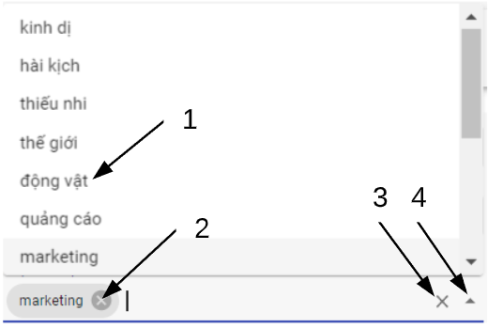

Figure 106 - <User> Select tag interface

Buttons/Hyperlinks

|  |  |  |  |  |
| --- | --- | --- | --- | --- |
| **No** | **Function** | **Description** | **Validation** | **Outcome** |
| 1 | Select tag |  | N/A | Tag added to tag textbox |
| 2 | Remove a tag | Remove tag out of tag text box | N/A | Tag removed out of tag textbox |
| 3 | Remove all tags | Remove all seleted tag out of tag text box | N/A | All tags removed of tag textbox |
| 4 | Close tag menu |  | N/A | Close tag menu |

Table 126 - <Buttons/Hyperlinks> Select tag

#### 5.2.13. Embed video

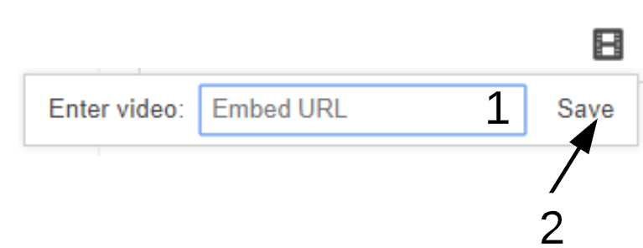

Figure 107 - < User >Embed video interface

Fields

|  |  |  |  |  |  |  |
| --- | --- | --- | --- | --- | --- | --- |
| **No** | **Field Name** | **Description** | **Read only** | **Mandatory** | **Control Type** | **Data Type** |
| 1 | Video url |  | No | No | TextBox | String |

Table 127 - <Fields> Embed video

Buttons/Hyperlinks

|  |  |  |  |  |
| --- | --- | --- | --- | --- |
| **No** | **Function** | **Description** | **Validation** | **Outcome** |
| 2 | Embed video by url |  | N/A | Show embeded video by url in introduction of story |

Table 128 - <Buttons/Hyperlinks> Embed video

#### 5.2.14. Add story information

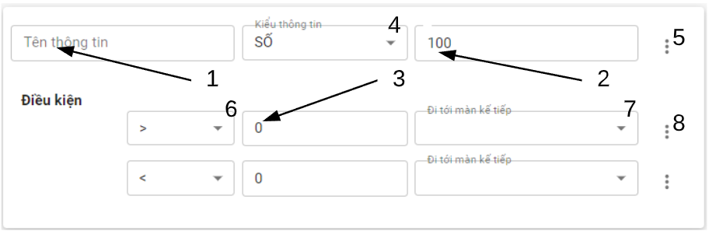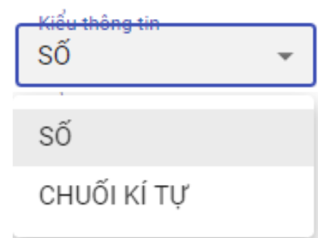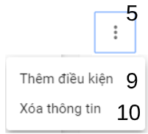 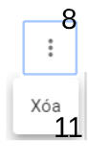 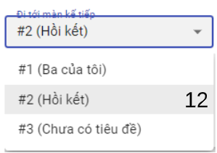

Figure 108 - < User >Add story information interface

Fields

|  |  |  |  |  |  |  |
| --- | --- | --- | --- | --- | --- | --- |
| **No** | **Field Name** | **Description** | **Read only** | **Mandatory** | **Control Type** | **Data Type** |
| 1 | Information name |  | No | Yes | TextBox | String |
| 2 | Information Initial value | Value of information, if information type is number then datatype of value is number, type is String then datatype of value is string | No | Yes | TextBox | String |
| 3 | Condition value |  | No | No | TextBox | String |

Table 129 - <Fields> Add story information

Buttons/Hyperlinks

|  |  |  |  |  |
| --- | --- | --- | --- | --- |
| **No** | **Function** | **Description** | **Validation** | **Outcome** |
| 4 | Select type information |  | N/A | Open information type menu |
| 5 | Open information settings |  | N/A | Open information settings menu |
| 6 | Select condition comparable sign | User information value will use sign to compare with condition value, example: equal(=), bigger(>), smaller(<),... | N/A | Open sign menu |
| 7 | Open following screens | Following screen after user information value violate the conditon | N/A | Open list screen menu |
| 8 | Open condition settings |  | N/A | Open condition settings menu |
| 9 | Add condition | Add condition to information | N/A | Show another condition input |
| 10 | Delete information |  | N/A | Close information and its conditions input |
| 11 | Delete condition |  | N/A | Close condition input |
| 12 | Select following screen |  | N/A | Select screen and close menu |

Table 130 - <Buttons/Hyperlinks> Add story information

#### 5.2.15. Story screens detail tab

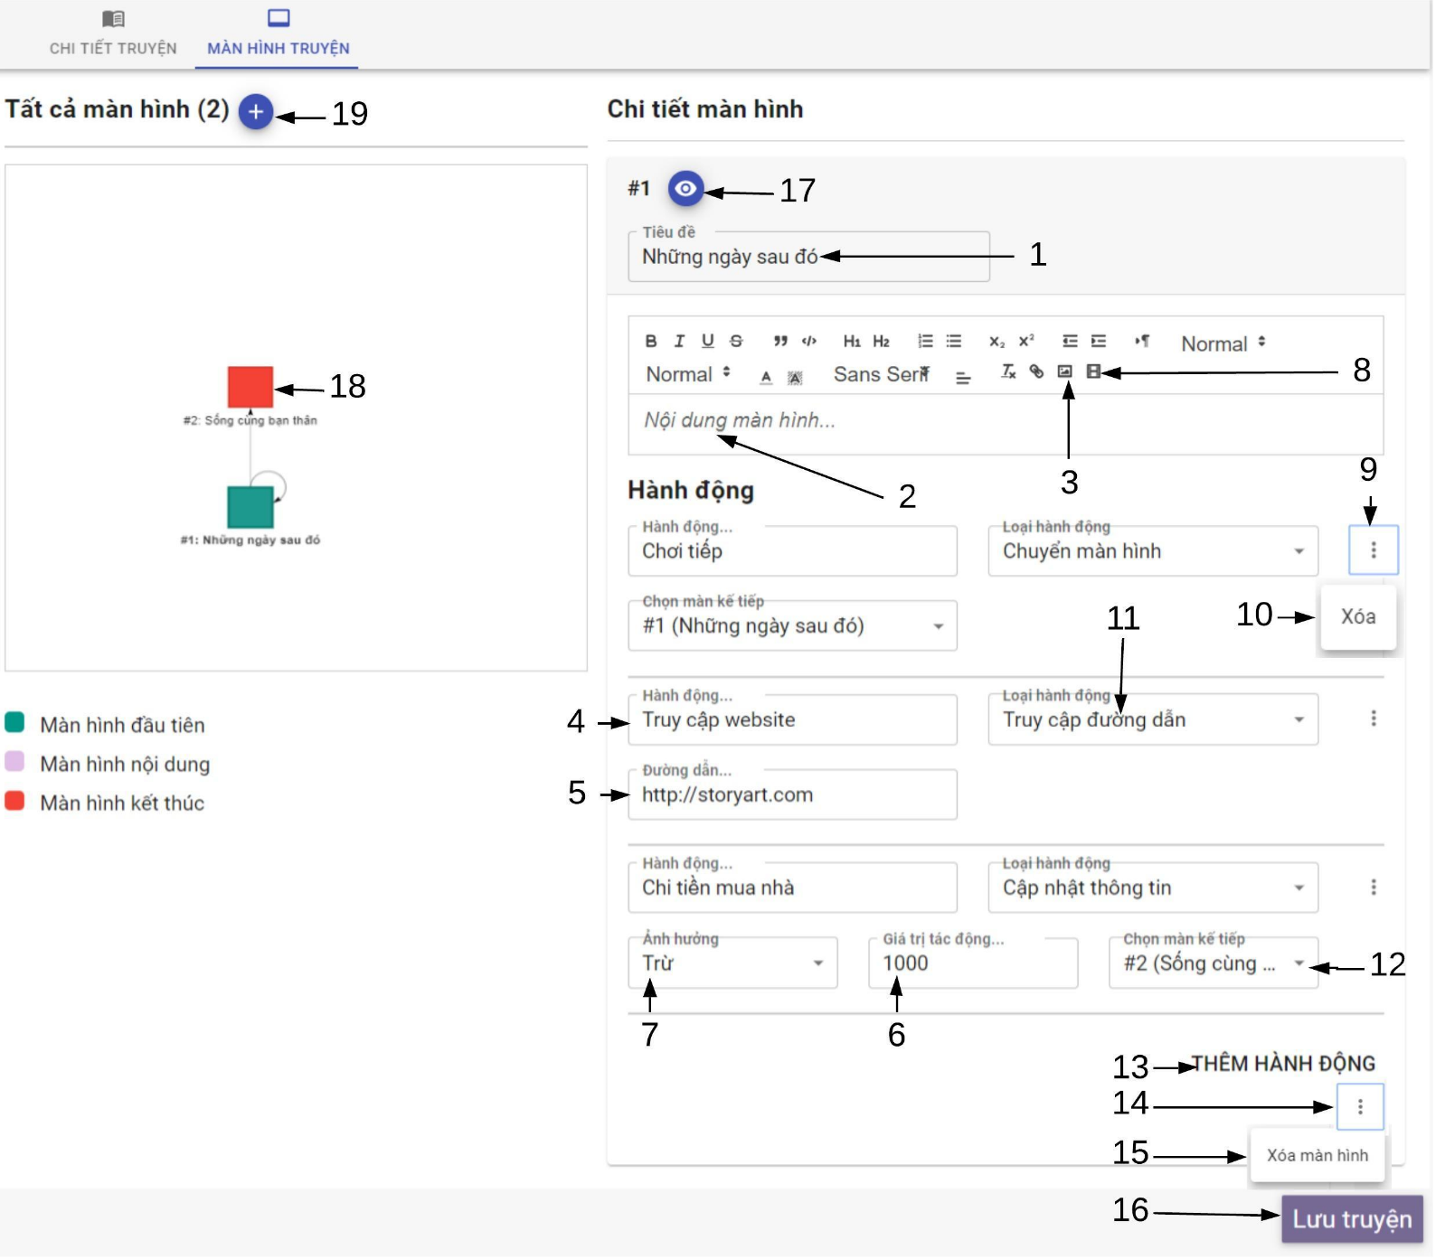

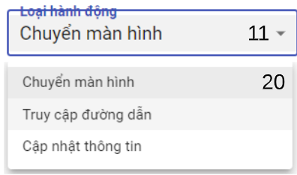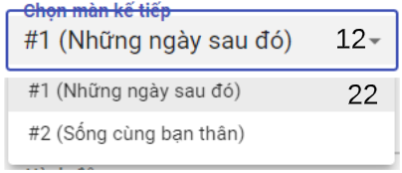

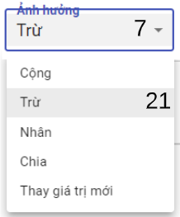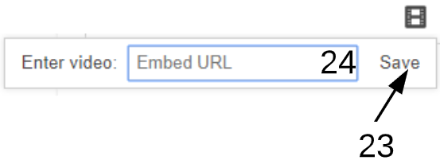

Figure 109 - < User >Story screens detail tabinterface

Fields

|  |  |  |  |  |  |  |
| --- | --- | --- | --- | --- | --- | --- |
| **No** | **Field Name** | **Description** | **Read only** | **Mandatory** | **Control Type** | **Data Type** |
| 1 | Screen title |  | No | Yes | TextBox | String |
| 2 | Content of Screen |  | No | Yes | TextArea | String |
| 3 | Screen content ‘s image | Image displayed inside screen content | No | No | FileUpload | File |
| 4 | Action title | Title of action | No | Yes | TextBox | String |
| 5 | Action url | Embed url in action | No | No | TextBox | String |
| 6 | Action impact value |  | No | No | TextBox | String |
| 24 | Video url |  |  |  |  |  |

Table 131 - <Fields>Story screens detail tab

Buttons/Hyperlinks

|  |  |  |  |  |
| --- | --- | --- | --- | --- |
| **No** | **Function** | **Description** | **Validation** | **Outcome** |
| 7 | Open operator menu | Select operator will impact to reader information value by action impact value | No | Show operator menu |
| 8 | Open video url dialog | Embed video into screen content | No | Open video url input dialog |
| 9 | Setting action |  | No | Show action settings |
| 10 | Delete action |  | No | Delete the action input fragment |
| 11 | Open action types menu |  | No | Show action type menu |
| 12 | Open next screen list menu |  | No | Show list of screen menu |
| 13 | Add action |  | No | Show another action input fragment |
| 14 | Setting screen |  | No | Show screen setting |
| 15 | Delete screen |  | No | Delete screen |
| 16 | Save story |  | Yes | Send create story request and tranfer to edit story page |
| 17 | Preview screen |  | No | Show screen preview dialog |
| 18 | Select screen |  | No | Show screen edit detail |
| 19 | Add screen |  | No | Create screen |
| 20 | Select action type |  | No |  |
| 21 | Select operator |  | No |  |
| 22 | Select next screen |  | No |  |
| 23 | Embed video into screen content |  | No | Show video frame into screen content |

Table 132 - <Buttons/Hyperlinks>Story screens detail tab

#### 5.2.16. Preview screen

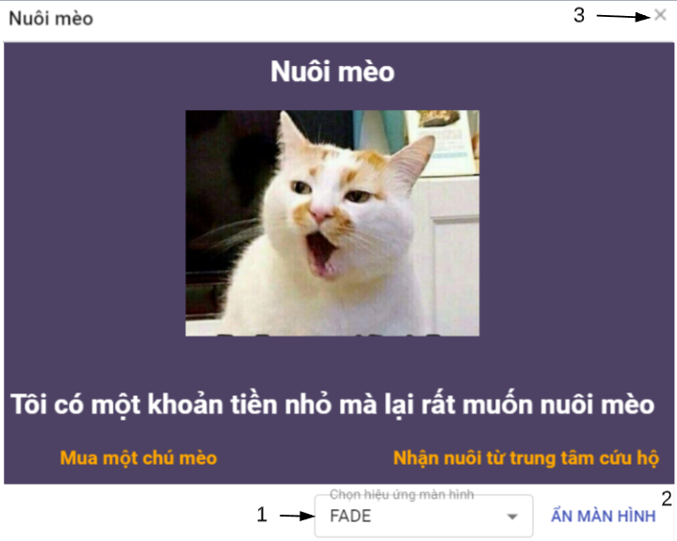

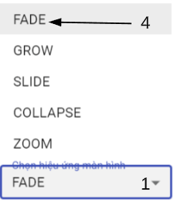

Figure 110 - < User > Preview screen interface

Buttons/Hyperlinks

|  |  |  |  |  |
| --- | --- | --- | --- | --- |
| **No** | **Function** | **Description** | **Validation** | **Outcome** |
| 1 | Open present effect | Present effects on screen when reader change screen | N/A | Show effect menu |
| 2 | Show/hide screen | To preview present effect | N/A | Show/hide screen on selected effect |
| 3 | Close preview |  | N/A | Close screen preview |

Table 133 - <Buttons/Hyperlinks> Preview screen

### 5.3. Administrator

#### 5.3.1. View user list

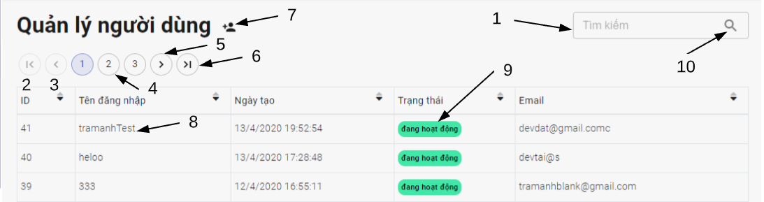

Figure 111 - <Admin> View user account

Fields

|  |  |  |  |  |  |  |
| --- | --- | --- | --- | --- | --- | --- |
| **No** | **Field Name** | **Description** | **Read only** | **Mandatory** | **Control Type** | **Data Type** |
| 1 | Username or email of user | Username or email of user to be search | No | No | TextBox | String |

Table 134 - <Fields> View user list

|  |  |  |  |  |
| --- | --- | --- | --- | --- |
| **No** | **Function** | **Description** | **Validation** | **Outcome** |
| 2 | Go to first user page | Go to first user page | Required | Show first user page |
| 3 | Select previous page | Back to previous page of user | Required | View previous page of user |
| 4 | Select page | Select page of user | Required | View specific page of user |
| 5 | Select next page | Back to next page of user | Required | View next page of user |
| 6 | Go to last user page | Go to last user page | Required | Show last user page |
| 7 | Add user |  | N/A | Open add user dialog |
| 8 | View user profle |  |  | Transfer to user profle page |
| 9 | Active/ deactive user |  |  | Open deactive/active modal |
| 10 | Search user | Search user by username or email |  | Send search user by username or email request |

Buttons/Hyperlinks

Table 135 - <Buttons/Hyperlinks> View user list

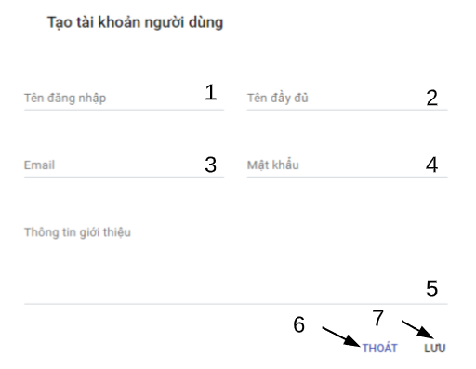

Figure 112 - <Admin> Add user account interface

Fields

|  |  |  |  |  |  |  |
| --- | --- | --- | --- | --- | --- | --- |
| **No** | **Field Name** | **Description** | **Read only** | **Mandatory** | **Control Type** | **Data Type** |
| 1 | Username | User name to register | No | Yes | TextBox | String |
| 2 | Name | Name of user | No | Yes | TextBox | String |
| 3 | Email | Email | No | Yes | TextBox | String |
| 4 | Password | Password of user | No | Yes | TextBox | String |
| 5 | Introduction | Introduction information of user | No | No | TextArea | String |

Table 136 - <Fields> Add user

|  |  |  |  |  |
| --- | --- | --- | --- | --- |
| **No** | **Function** | **Description** | **Validation** | **Outcome** |
| 6 | Exit |  | N/A | Close dialog |
| 7 | Save new user account |  | Required | Send create user account request and close dialog |

Buttons/Hyperlinks

Table 137 - <Buttons/Hyperlinks> Add user

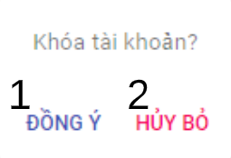

Figure 113 - <Admin> Deactive/active user

|  |  |  |  |  |
| --- | --- | --- | --- | --- |
| **No** | **Function** | **Description** | **Validation** | **Outcome** |
| 1 | Change status of user |  | Required | Send deactivated /activated user status request and close modal |
| 2 | Discard |  | N/A | Close modal |

Buttons/Hyperlinks

Table 138 - <Buttons/Hyperlinks> Deactive/active user

#### 5.3.2. Admin menu bar



Figure 114 - <Admin>Admin menu interface

Buttons/Hyperlinks

|  |  |  |  |  |
| --- | --- | --- | --- | --- |
| **No** | **Function** | **Description** | **Validation** | **Outcome** |
| 1 | Show navigation | Show user navigation | Required | View admin navigation |
| 2 | Go to homepage |  | N/A | Transfer to homepage |
| 3 | Go to adminmagement |  |  | Transfer to admin management page |
| 4 | Go to profile | User profile detail | Required | Transfer to admin profile |

Table 139 - <Buttons/Hyperlinks> User menu



Figure 115 - <Admin> Admin settings menu interface

Buttons/Hyperlinks

|  |  |  |  |  |
| --- | --- | --- | --- | --- |
| **No** | **Function** | **Description** | **Validation** | **Outcome** |
| 1 | Settings | View edit profile page | Required | Transfer to edit profile page |
| 2 | Change password | View change password page | Required | Transfer to change password page |
| 3 | Logout |  | Required | Open logout modal |

Table 140 - <Buttons/Hyperlinks> Admin settings menu bar

#### 5.3.3. Admin navigation

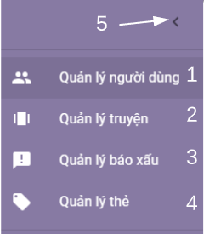

Figure 116 - < Admin > Admin navigation interface

Buttons/Hyperlinks

|  |  |  |  |  |
| --- | --- | --- | --- | --- |
| **No** | **Function** | **Description** | **Validation** | **Outcome** |
| 1 | User management |  | Required | Transfer to view user list page |
| 2 | Story management |  | Required | Transfer to view story list page |
| 3 | Report management | Report include story and comment reports | Required | Transfer to user history page |
| 4 | Tag management | Manage tag of story | Required | Transfer to user profile page |
| 5 | Hide admin navigation |  | N/A | Close admin navigation |

Table 141 - <Buttons/Hyperlinks> Admin navigation

#### 5.3.4. View story list

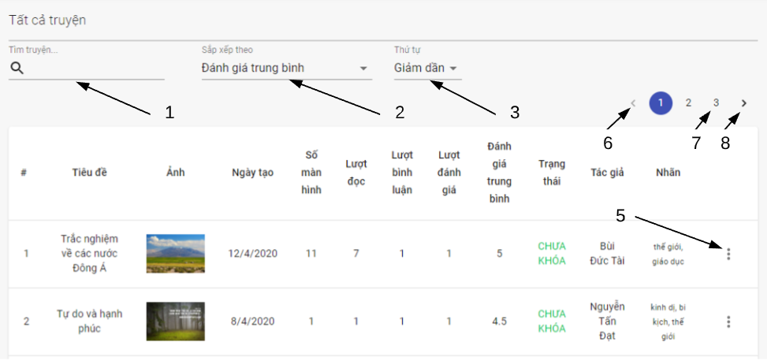



Figure 117 - <Admin> View story list interface

Fields

|  |  |  |  |  |  |  |
| --- | --- | --- | --- | --- | --- | --- |
| **No** | **Field Name** | **Description** | **Read only** | **Mandatory** | **Control Type** | **Data Type** |
| 1 | Story title | Title of searching story | No | No | TextBox | String |

Table 142 - <Fields> View stories

Buttons/Hyperlinks

|  |  |  |  |  |
| --- | --- | --- | --- | --- |
| **No** | **Function** | **Description** | **Validation** | **Outcome** |
| 2 | Choose criteria of story to order | Choose criteria of story like avg Rate, number of view,… | N/A |  |
| 3 | Choose order type | Choose order type to order list of story by criteria | N/A |  |
| 4 | Go to the story statistic |  | Required | Transfer to view story statistic |
| 5 | Open story settings |  | N/A |  |
| 6 | Select previous page | Back to previous page of searching stories | N/A | View previous page of searching stories |
| 7 | Select page | Select page of searching story | N/A | View specific page of searching stories |
| 8 | Select next page | Back to next page of searching stories | N/A | View next page of searching stories |

Table 143 - <Buttons/Hyperlinks> View user’s stories

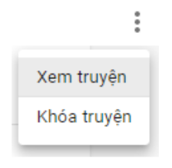

Figure 118 - < User > Story settings interface

Buttons/Hyperlinks

|  |  |  |  |  |
| --- | --- | --- | --- | --- |
| **No** | **Function** | **Description** | **Validation** | **Outcome** |
|  | View story details |  | N/A | Transfer to story detail page |
|  | Delete story |  | Required | Send delete story request |

Table 144 - <Buttons/Hyperlinks> Story settings

#### 5.3.5. Admin report navigation



Figure 119 - < Admin> Admin report navigation interface

Buttons/Hyperlinks

|  |  |  |  |  |
| --- | --- | --- | --- | --- |
| **No** | **Function** | **Description** | **Validation** | **Outcome** |
| 1 | Show comment report |  | Required | Show comment report tab |
| 2 | Show story report |  | Required | Show story report tab |

Table 145 - <Buttons/Hyperlinks> Admin report navigation

#### 5.3.6. View comment report tab

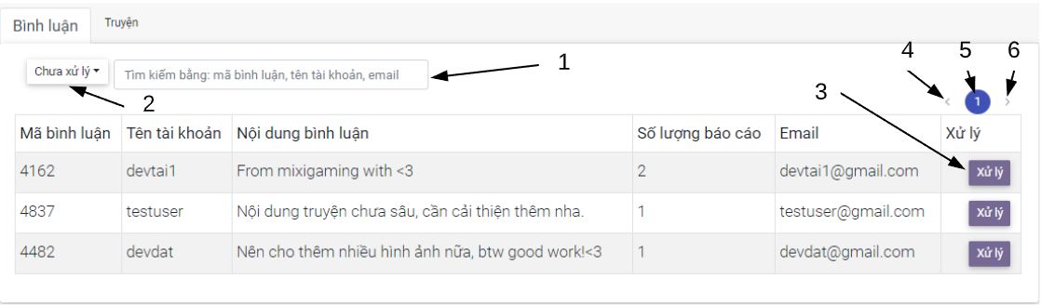

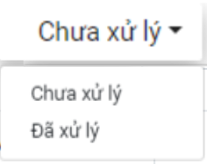

Figure 120 - <Admin> View comment report tab interface

Fields

|  |  |  |  |  |  |  |
| --- | --- | --- | --- | --- | --- | --- |
| **No** | **Field Name** | **Description** | **Read only** | **Mandatory** | **Control Type** | **Data Type** |
| 1 | Comment id , username or email | Comment id , username/ email of user belong to searching comment | No | No | TextBox | String |

Table 146 - <Fields> View stories

Buttons/Hyperlinks

|  |  |  |  |  |
| --- | --- | --- | --- | --- |
| **No** | **Function** | **Description** | **Validation** | **Outcome** |
| 2 | Choose report filter type | Filter report by type : handled or still not handle | N/A |  |
| 3 | Handle comment report | Choose order type to order list | N/A | Open report handle dialog |
| 4 | Select previous page | Back to previous page | N/A | View previous page |
| 5 | Select page | Select page | N/A | View specific page |
| 6 | Select next page | Back to next page | N/A | View next page |

Table 147 - <Buttons/Hyperlinks> View user’s stories

#### 5.3.7. Admin Handle comment report dialog

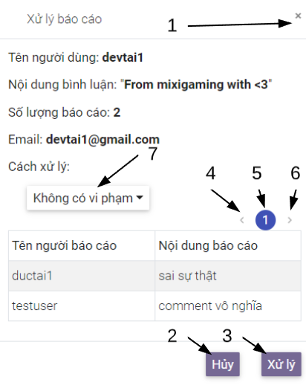

Figure 121 - < Admin> Admin handle comment report dialog interface

Buttons/Hyperlinks

|  |  |  |  |  |
| --- | --- | --- | --- | --- |
| **No** | **Function** | **Description** | **Validation** | **Outcome** |
| 1 | Close dialog |  | N/A | Close handle report dialog |
| 2 | Close dialog |  | N/A | Close handle report dialog |
| 3 | Handle report |  | Required | Send handle report request and close dialog |
| 4 | Select previous page | Back to previous page | N/A | View previous page |
| 5 | Select page | Select page | N/A | View specific page |
| 6 | Select next page | Back to next page | N/A | View next page |
| 7 | Choose handle options |  | No | Open handle options menu |

Table 148 - <Buttons/Hyperlinks> Admin handle comment report dialog

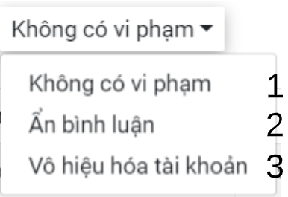

Figure 122 - < Admin> Admin handle options menu interface

Buttons/Hyperlinks

|  |  |  |  |  |
| --- | --- | --- | --- | --- |
| **No** | **Function** | **Description** | **Validation** | **Outcome** |
| 1 | Handle report | Change status of report to handled | Required |  |
| 2 | Hide comment | Hide comment | Required |  |
| 3 | Deactive user account | Ban user account | Required |  |

Table 149 - <Buttons/Hyperlinks> Admin handle option menu

#### 5.3.8. View story report tab

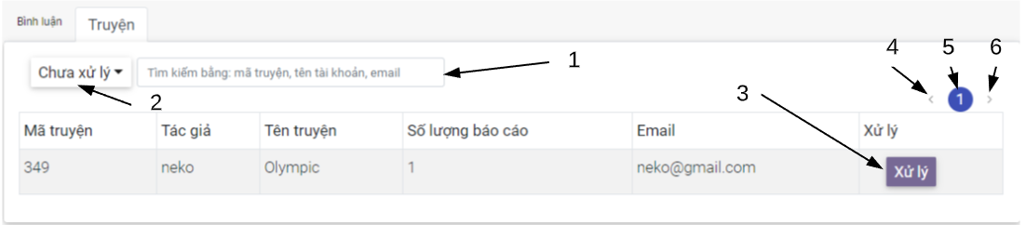



Figure 123 - <Admin> View story report tab interface

Fields

|  |  |  |  |  |  |  |
| --- | --- | --- | --- | --- | --- | --- |
| **No** | **Field Name** | **Description** | **Read only** | **Mandatory** | **Control Type** | **Data Type** |
| 1 | Story id , username or email | Story id , username/ email of user own story | No | No | TextBox | String |

Table 150 - <Fields> View stories

Buttons/Hyperlinks

|  |  |  |  |  |
| --- | --- | --- | --- | --- |
| **No** | **Function** | **Description** | **Validation** | **Outcome** |
| 2 | Choose report filter type | Filter report by type : handled or still not handle | N/A |  |
| 3 | Handle story report | Choose order type to order list | N/A | Open report handle dialog |
| 4 | Select previous page | Back to previous page | N/A | View previous page |
| 5 | Select page | Select page | N/A | View specific page |
| 6 | Select next page | Back to next page | N/A | View next page |

Table 151 - <Buttons/Hyperlinks> View user’s stories

#### 5.3.9. Admin Handle story report dialog

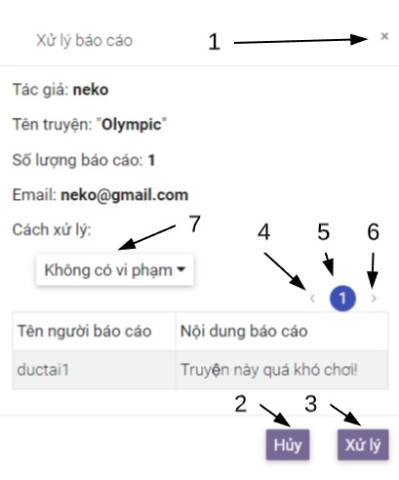

Figure 124 - < Admin> Admin handle story report dialog interface

Buttons/Hyperlinks

|  |  |  |  |  |
| --- | --- | --- | --- | --- |
| **No** | **Function** | **Description** | **Validation** | **Outcome** |
| 1 | Close dialog |  | N/A | Close handle report dialog |
| 2 | Close dialog |  | N/A | Close handle report dialog |
| 3 | Handle report | Handle report by selected option in handle options menu | Required | Send handle report request and close dialog |
| 4 | Select previous page | Back to previous page | N/A | View previous page |
| 5 | Select page | Select page | N/A | View specific page |
| 6 | Select next page | Back to next page | N/A | View next page |
| 7 | Choose handle option |  | N/A | Open handle options menu |

Table 152 - <Buttons/Hyperlinks> Admin handle comment report dialog

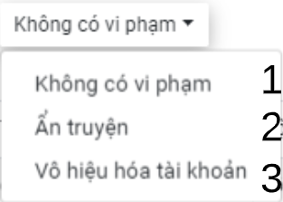

Figure 125 - < Admin> Admin handle options menu interface

Buttons/Hyperlinks

|  |  |  |  |  |
| --- | --- | --- | --- | --- |
| **No** | **Function** | **Description** | **Validation** | **Outcome** |
| 1 | Handle report | Change status of report to handled | Required |  |
| 2 | Hide story | Hide story from user | Required |  |
| 3 | Deactive user account | Ban user account | Required |  |

Table 153 - <Buttons/Hyperlinks> Admin handle option menu

#### 5.3.10. View story report tab

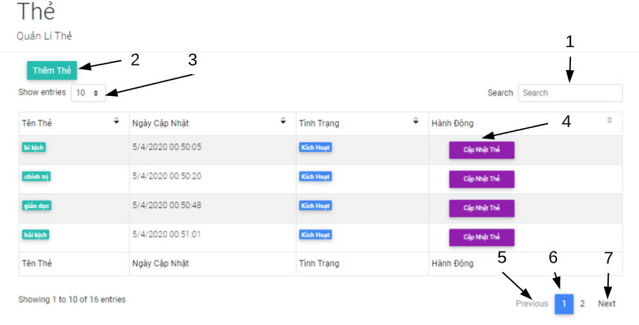

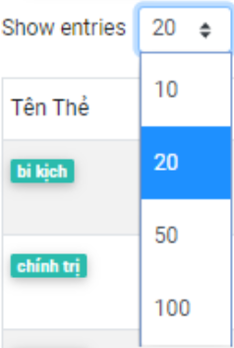

Figure 126 - <Admin> View tag list interface

Fields

|  |  |  |  |  |  |  |
| --- | --- | --- | --- | --- | --- | --- |
| **No** | **Field Name** | **Description** | **Read only** | **Mandatory** | **Control Type** | **Data Type** |
| 1 | Tag name | Name of tag to be search in page of tag table | No | No | TextBox | String |

Table 154 - <Fields> View tag list

Buttons/Hyperlinks

|  |  |  |  |  |
| --- | --- | --- | --- | --- |
| **No** | **Function** | **Description** | **Validation** | **Outcome** |
| 2 | Add tag |  | N/A | Open add tag dialog |
| 3 | Choose number of tag | Choose number of tag to be loaded in tag table | N/A | Open number menu |
| 4 | Edit tag |  | N/A | Open edit tag dialog |
| 5 | Select previous page | Back to previous page | N/A | View previous page |
| 6 | Select page | Select page | N/A | View specific page |
| 7 | Select next page | Back to next page | N/A | View next page |

Table 155 - <Buttons/Hyperlinks> View tag list

#### 5.3.11. Add tag dialog

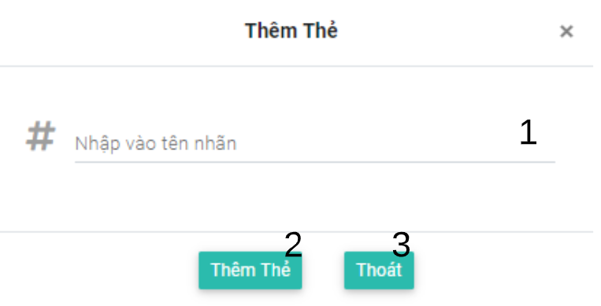

Figure 127 - <Admin> Add tag dialog interface

Fields

|  |  |  |  |  |  |  |
| --- | --- | --- | --- | --- | --- | --- |
| **No** | **Field Name** | **Description** | **Read only** | **Mandatory** | **Control Type** | **Data Type** |
| 1 | Tag name | Name of tag to be added | No | Yes | TextBox | String |

Table 156 - <Fields> View tag list

Buttons/Hyperlinks

|  |  |  |  |  |
| --- | --- | --- | --- | --- |
| **No** | **Function** | **Description** | **Validation** | **Outcome** |
| 2 | Add tag |  | N/A | Send add tag request and close dialog |
| 3 | Exit |  | N/A | Close dialog |

Table 157 - <Buttons/Hyperlinks> Add tag

#### 5.3.12. Edit tag dialog

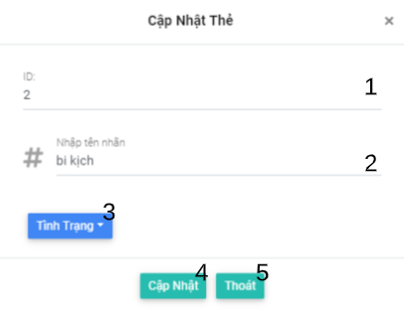

Figure 128 - <Admin> Add tag dialog interface

Fields

|  |  |  |  |  |  |  |
| --- | --- | --- | --- | --- | --- | --- |
| **No** | **Field Name** | **Description** | **Read only** | **Mandatory** | **Control Type** | **Data Type** |
| 1 | Tag id | Id of tag to be edited | Yes | No | TextBox | String |
| 2 | Tag name | Name of tag to be edited | No | Yes | TextBox | String |

Table 158 - <Fields> Edit tag

Buttons/Hyperlinks

|  |  |  |  |  |
| --- | --- | --- | --- | --- |
| **No** | **Function** | **Description** | **Validation** | **Outcome** |
| 3 | Change tag status |  | N/A | Open tag status option menu |
| 3 | Update changes | Update change of the tag | Required | Send update tag request and close dialog |
| 4 | Exit | Discard change of tag | N/A | Discard change and close dialog |

Table 159 - <Buttons/Hyperlinks> Edit tag

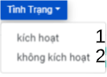

Figure 129 - <Admin> Tag status menu interface

Buttons/Hyperlinks

|  |  |  |  |  |
| --- | --- | --- | --- | --- |
| **No** | **Function** | **Description** | **Validation** | **Outcome** |
| 1 | Change tag status to activated |  | N/A | Set change of tag status to activated |
| 2 | Change tag status to deactivated |  | N/A | Set change of tag status to deactivated |

Table 160 - <Buttons/Hyperlinks> Tag status menu

### 5.4. System admin

#### 5.4.1. System admin navigation

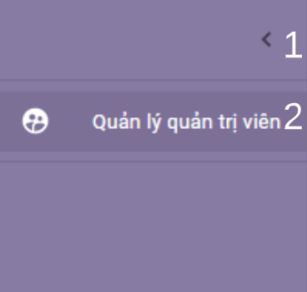

Figure 130 - <System Admin> System admin navigation interface

Buttons/Hyperlinks

|  |  |  |  |  |
| --- | --- | --- | --- | --- |
| No | Function | Description | Validation | Outcome |
| 1 | Hide navigation |  | N/A | Hide navigation |
| 2 | Go to view admin list |  | Required | Transfer to view admin list page |

Table 161 - <Buttons/Hyperlinks> System admin navigation

#### 5.4.2. View admin list

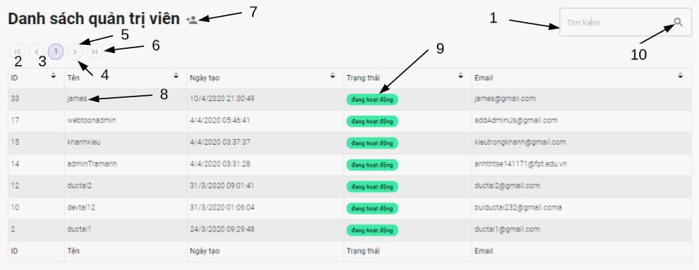

Figure 131 - <System Admin> View admin list interface

Fields

|  |  |  |  |  |  |  |
| --- | --- | --- | --- | --- | --- | --- |
| No | Field Name | Description | Read only | Mandatory | Control Type | Data Type |
| 1 | Username or email of admin to be searched |  | No | No | TextBox | String |

Table 162 - <Fields> View admin list

Buttons/Hyperlinks

|  |  |  |  |  |
| --- | --- | --- | --- | --- |
| No | Function | Description | Validation | Outcome |
| 2 | Go to first admin page | Go to first admin page | Required | Show first admin page |
| 3 | Select previous page | Back to previous page of admin | Required | View previous page of admin |
| 4 | Select page | Select page of admin | Required | View specific page of admin |
| 5 | Select next page | Back to next page of admin | Required | View next page of admin |
| 6 | Go to last admin page | Go to last admin page | Required | Show last admin page |
| 7 | Add admin |  | N/A | Open add admin dialog |
| 8 | View profle |  | N/A | Transfer to profle page |
| 9 | Active/ deactive admin |  | Required | Open deactive/active modal |
| 10 | Search admin | Search admin by username or email | Required | Send search admin by username or email request |

Table 163 - <Buttons/Hyperlinks> View admin list

#### 5.4.3. Add admin

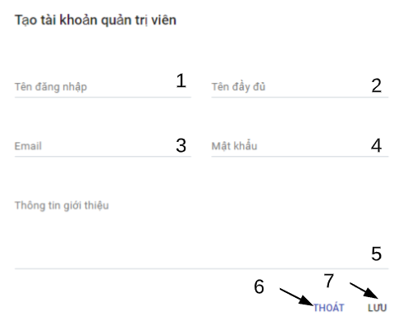

Figure 132 - <System Admin> Add admin account interface

Fields

|  |  |  |  |  |  |  |
| --- | --- | --- | --- | --- | --- | --- |
| **No** | **Field Name** | **Description** | **Read only** | **Mandatory** | **Control Type** | **Data Type** |
| 1 | Username | Username to register | No | Yes | TextBox | String |
| 2 | Name | Name of admin | No | Yes | TextBox | String |
| 3 | Email | Email | No | Yes | TextBox | String |
| 4 | Password | Password of user | No | Yes | TextBox | String |
| 5 | Introduction | Introduction information of admin | No | No | TextArea | String |

Table 164 - <Fields> Add admin

|  |  |  |  |  |
| --- | --- | --- | --- | --- |
| **No** | **Function** | **Description** | **Validation** | **Outcome** |
| 6 | Exit |  | N/A | Close dialog |
| 7 | Save new admin account |  | Required | Send create admin account request and close dialog |

Buttons/Hyperlinks

Table 165 - <Buttons/Hyperlinks> Add admin

#### 5.4.4. Active/deative admin



Figure 133 - <Admin> Deactive/active admin

|  |  |  |  |  |
| --- | --- | --- | --- | --- |
| **No** | **Function** | **Description** | **Validation** | **Outcome** |
| 1 | Change status of admin |  | Required | Send deactivated /activated admin status request and close modal |
| 2 | Discard |  | N/A | Close modal |

Buttons/Hyperlinks

Table 166 - <Buttons/Hyperlinks> Deactive/active admin

## 6. Database Design

### 6.1. Entity Relationship Diagram

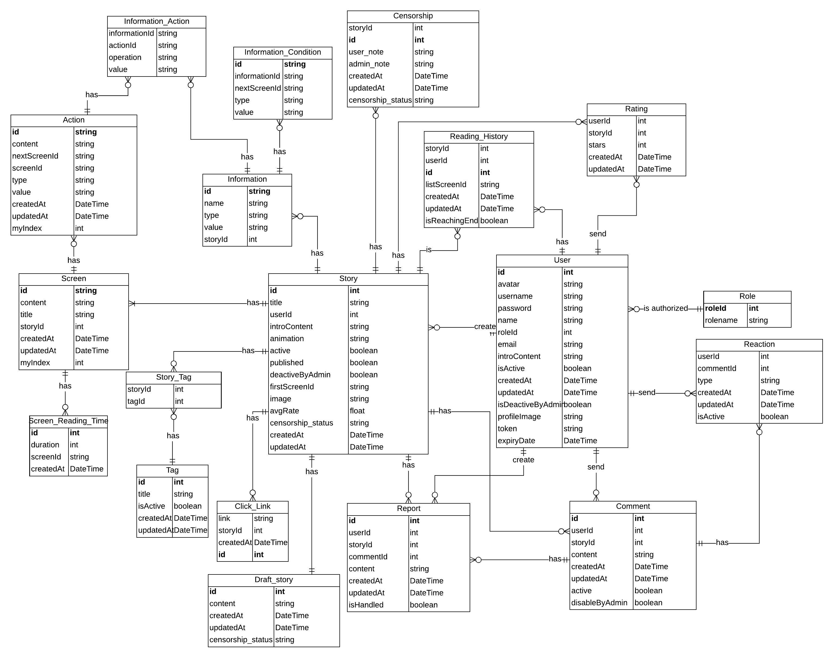

Figure 134- Entity Relationship Diagram

### 6.2. Data Dictionary

|  |  |  |
| --- | --- | --- |
| **Entity dictionary: describe Entity** | | |
| **Enitity Name** | **Mapping column with Conceptual diagram** | **Description** |
| Story | Story | Contain the Story information. |
| Report | Report | Contain the Report information. |
| Comment | Comment | Contain the Comment information |
| Reaction | Reaction | Contain the Reaction information. |
| Role | Role | Contain the Role information. |
| Rating | Rating | Contain the Rating information. |
| ReadingHistory | Reading_History | Contain the Reading History information. |
| Tag | Tag | Contain the Tag information. |
| StoryTag | N/A | Contain the Story and Tag information. |
| Screen | Screen | Contain the Screen information. |
| Action | Action | Contain the Action information. |
| Information | Information | Contain the Information Detail. |
| InformationAction | N/A | Contain the Information Action Detail. |
| InformationCondition | Information_Condition | Contain the Information Condition Detail. |
| ClickLink | N/A | Contain the Click Link Information |
| ScreenReadingTime | N/A | Contain the Screen Reading Time Information |
| Censorship | Censorship | Contain the Censorship Information |
| DraftStory | Draft story | Contain the Draft Story Information |

Table 167 - Entity Relationship Diagram Dictionary

## 7. Algorithms

### 7.1. Find users the others users that have similar stories rating

#### 7.1.1. Definition

This purpose of this algorithm is to help the user find the other users which have the similar stories rating. this will help to predict future rating of stories user haven’t rating.

#### 7.1.2. Define Problem

To help user find appropriate interested stories, by acquiring the information on the stories that the user and other users has rated into the application, the algorithm will be helpful later on predict future rating of stories user haven’t rating.

#### 7.1.3. Solution

The cosine similarity is used to measure the similarity between users. By considering stories rating, the algorithm will base on the information of the stories that the users have rated into the application. We will then calculate and through the results, will then be used to calculate future rating of stories

But first of all we need to normalized Utility Matrix of users rating by minus average rate of users and replace all stories that user have not rating by 0. This will have we to calculate and store data easier.

To find the appropriate user, we use the formula:

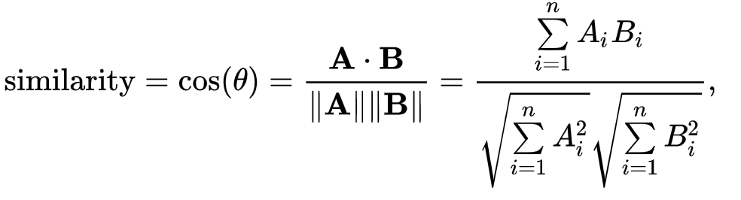

Where:

Ai: Rating in story i of user A

Bi: Rating in story i of user B

#### 7.1.4. Complexity

The complexity of this algorithm is: O(n)2

#### 7.1.5. Example

First, we have list of users with the information of the stories they have. The information is displayed in the matrix:

|  |  |  |  |  |  |  |
| --- | --- | --- | --- | --- | --- | --- |
| **Story**    **User** | **Corona** | **Olympic** | **World Cup** | **Ngựa Hoang** | **Hố Đen** | **Ông Hàng Xóm** |
|
| **Nguyen Duy Thanh** | 4 | 5 | ? | ? | 2 | ? |
| **Nguyen Tan Dat** | 5 | ? | 4 | ? | 2 | 4 |
| **TH Tram Anh** | 4 | ? | 2 | 4 | 1 | ? |
| **Nguyen Viet Hai** | 4 | ? | ? | 3 | 5 | 2 |
| **Bui Duc Tai** | 5 | 2 | 2 | 4 | ? | 3 |

Table 168 – The matrix information of the stories and rating each user has rated

We consider the user Nguyen Duy Thanh is the main user of our system in this scenario. The remaining users are the users that are on the list of suggestion to the main user.

We list out the following stories : Corona, Olympic, World Cup, Ngựa Hoang, Hố Đen, Ông Hàng Xóm.

We then find each users average rate:

|  |  |
| --- | --- |
| **Story**  **User** | **Average** |
| **Nguyen Duy Thanh** | **3.67** |
| **Nguyen Tan Dat** | **3.75** |
| **TH Tram Anh** | **2.75** |
| **Nguyen Viet Hai** | **3.5** |
| **Bui Duc Tai** | **3.2** |

Table 169 – Information of the average of each user has rated

Now we normalized Utility Matrix of Table 170 by minus each user rating with their average and replace all “?” of stories with 0.

|  |  |  |  |  |  |  |
| --- | --- | --- | --- | --- | --- | --- |
| **Story**    **User** | **Corona** | **Olympic** | **World Cup** | **Ngựa Hoang** | **Hố Đen** | **Ông Hàng Xóm** |
|
| **Nguyen Duy Thanh** | 0.33 | 1.33 | 0 | 0 | -1.66 | 0 |
| **Nguyen Tan Dat** | 1.25 | 0 | 0.25 | 0 | -1.75 | 0.25 |
| **TH Tram Anh** | 1.25 | 0 | -0.75 | 1.25 | -1.75 | 0 |
| **Nguyen Viet Hai** | 0.5 | 0 | 0 | -0.5 | 1.5 | -1.5 |
| **Bui Duc Tai** | 1.8 | -1.2 | -1.2 | 0.8 | 0 | -0.2 |

Table 170 – The matrix information of the stories and rating each user has rated after normalized

Based on the data on the matrix, we have the coordinates of each user:

User Nguyen Duy Thanh coordinate = {0.33, 1.33, 0, 0, -1.66, 0}

User Nguyen Tan Dat coordinate = {1.25, 0, 0.25, 0, -1.75, 0.25}

User TH Tram Anh coordinate = {1.25, 0, -0.75, 1.25, -1.75, 0}

User Nguyen Viet Hai coordinate = {0.5, 0, 0, -0.5, 1.5, -1.5}

User Bui Duc Tai coordinate = {1.8, -1.2, -1.2, 0.8, 0, -0.2}

We calculate the similarity of user Nguyen Duy Thanh with the other user Nguyen Tan Dat by Cosine Similarity:

Similarity(NDT,NTD) = $\frac{0.33*1.25 + 1.33*0 + 0.25*0 + 0*0 + \left(-1.66 * -1.75\right) + 0*0.25 }{\sqrt{{0.33}^{2}+ {1.33}^{2}+ {(-1.66)}^{2}} * \sqrt{{1.25}^{2}+ {0.25}^{2}+ {0.25}^{2}+ {(-1.75)}^{2}}}=0.707$

Similar we have:

Similarity(NDT,THTA) = $\frac{0.33*1.25 + 1.33*0 +(-0.75)*0 + 1.25*0 + \left(-1.66 * -1.75\right) + 0*0 }{\sqrt{{0.33}^{2}+ {1.33}^{2}+ {(-1.66)}^{2}} * \sqrt{{1.25}^{2}+ {(-0.75)}^{2}+ {1.25}^{2}+ {(-1.75)}^{2}}}=0.54$

Similarity(NDT,NVH) = $\frac{0.33*0.5 + 1.33*0 + 0*0 +(-0.5)*0 + \left(-1.66 * 1.5\right) + 0*(-1.5) }{\sqrt{{0.33}^{2}+ {1.33}^{2}+ {(-1.66)}^{2}} * \sqrt{{0.5}^{2}+ {(-0.5)}^{2}+ {1.5}^{2}+ {(-1.5)}^{2}}}= -0.48$

Similarity(NDT,NTD) = $\frac{0.33*1.8 + 1.33*(-1.2) + 1.2*0 + 0.8*0 + \left(-1.66 * 0\right) + 0*(-0.2) }{\sqrt{{0.33}^{2}+ {1.33}^{2}+ {(-1.66)}^{2}} * \sqrt{{1.8}^{2}+ {(-1.2)}^{2}+ {1.2}^{2}+ {(0.2)}^{2}}}=$-0.175

Result range: [-1, 1] with 1 is the most similar

We then will eliminate all user who have similarity with user Nguyen Duy Thanh lower than 0.5. after that we will store 2 users with the similarity of these two users is the closest to Nguyen Duy Thanh to calculate further.

The result value of user Nguyen Tan Dat and user TH Tram Anh is the highest of all, therefore the similarity of these two users is the closest.

If there is not any user similarity to requested user after eliminate, in this case is Nguyen Duy Thanh, we will suggest top stories which have most view in the previous 7 days for requested user.

#### 7.1.6. Flowchart

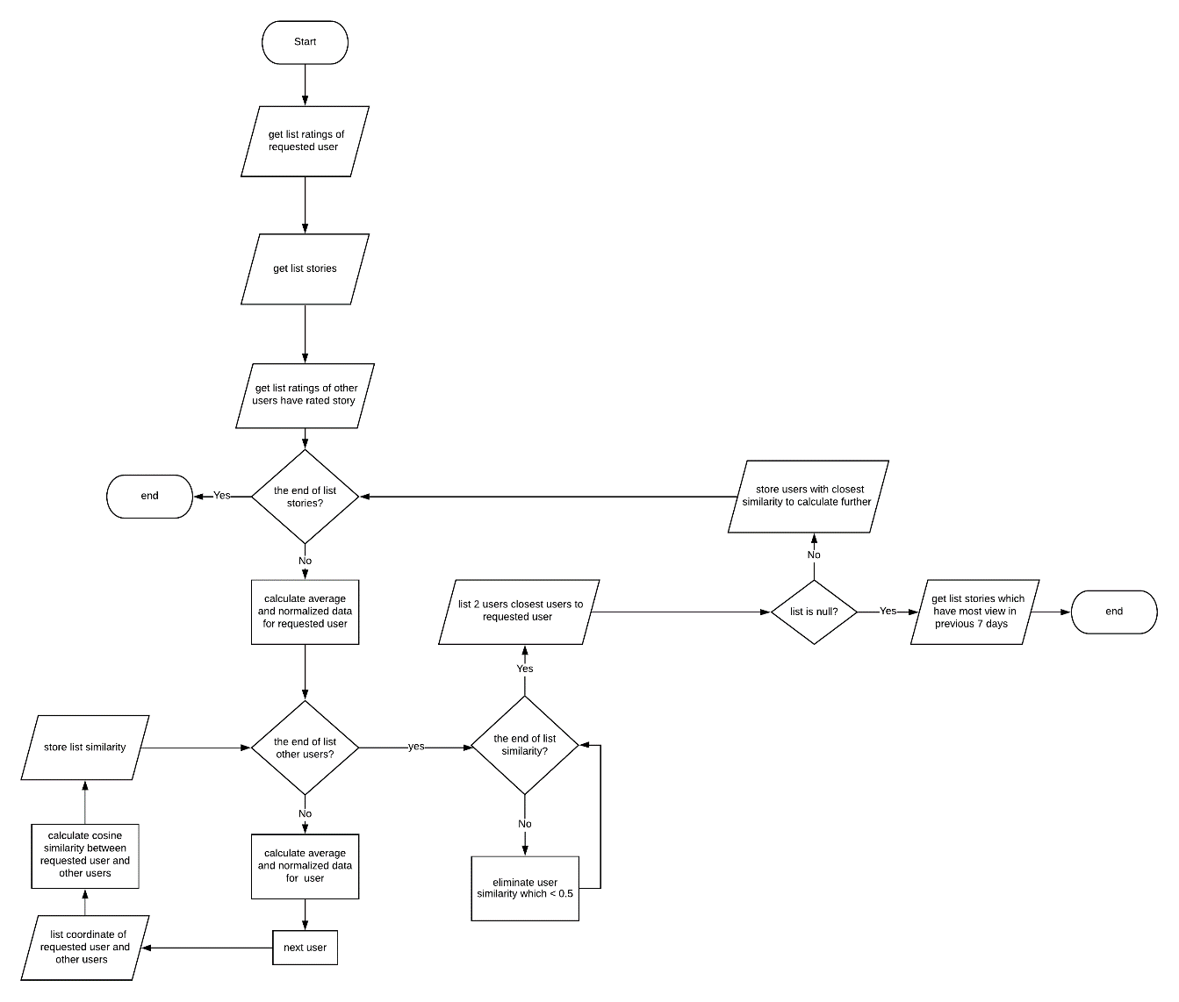

Figure 135 - Finding most similar algorithm

### 7.2. Predicting stories rating for requested user

#### 7.2.1. Definition

This purpose of this algorithm is to help the user find stories their most interested stories though predict their future rating to which stories.

#### 7.2.2. Define Problem

To help user find appropriate interested stories, by acquiring the information on the stories that the user and other users has rated into the application, then predict future rating of requested stories though others user similarity with requested user with rating prediction algorithm

#### 7.2.3. Solution

Rating Prediction algorithm is used to predict future rating of requested user based on similarity of requested user with other users. the algorithm will base on the similarity of others user with their rating of the stories that the user has not rated into the application. We will then calculate and through the results, will then sort and display the suggestions to the users on the top list of the system screen.

First of all, we get 2 closest similar users to requested user. Then find normalized rating of 2 closest users to stories that we need to predict.

To predict future rating of requested user, we use the formula:

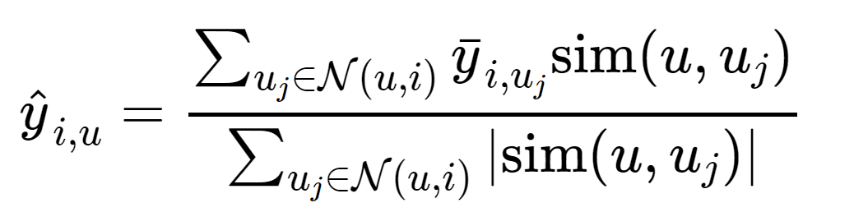

Where: N(u,i) = similarity of k users that have rated i

The complexity of this algorithm is: O(n)

#### 7.2.4. Example

In our case the requested user is Nguyen Duy Thanh and 2 closest users are Nguyen Tan Dat and TH Tram Anh. The example story we need to predict is World Cup

We have:

Similarities of Nguyen Tan Dat and TH Tram Anh to Nguyen Duy Thanh are 0.707 and 0.54

Normalized rating of Nguyen Tan Dat and TH Tram Anh to World Cup are 0.25 and -0.75

Predict Rate(World Cup) = = -0.18

Similar we have:

|  |  |  |  |  |  |  |
| --- | --- | --- | --- | --- | --- | --- |
| **Story**  **User** | **Corona** | **Olympic** | **World Cup** | **Ngựa Hoang** | **Hố Đen** | **Ông Hàng Xóm** |
|
| **Nguyen Duy Thanh** | 0.33 | 1.33 | -0.18 | 1.77 | -1.66 | 0.46 |

Table 171 – Predict rate of requested user to each stories before

After that we will add average of requested user to predict rate of each stories. In this case, average of Nguyen Duy Thanh is 3.67

|  |  |  |  |  |  |  |
| --- | --- | --- | --- | --- | --- | --- |
| **Story**  **User** | **Corona** | **Olympic** | **World Cup** | **Ngựa Hoang** | **Hố Đen** | **Ông Hàng Xóm** |
|
| **Nguyen Duy Thanh** | 4 | 5 | 3.5 | 5 | 2 | 4 |

Table 172 – Predict rate of requested user to each stories

(This number have already been rounding)

We will then eliminate all story which have predict rate lower than 3 and through the results, will then sort and display the suggestions to the users on the top list of the system screen.

If there are not any stories after eliminated, we will then suggest top stories which have most view in the previous 7 days for requested user.

#### 7.2.5. Complexity

The complexity of this algorithm is: O(n)

#### 7.2.6. Flowchart

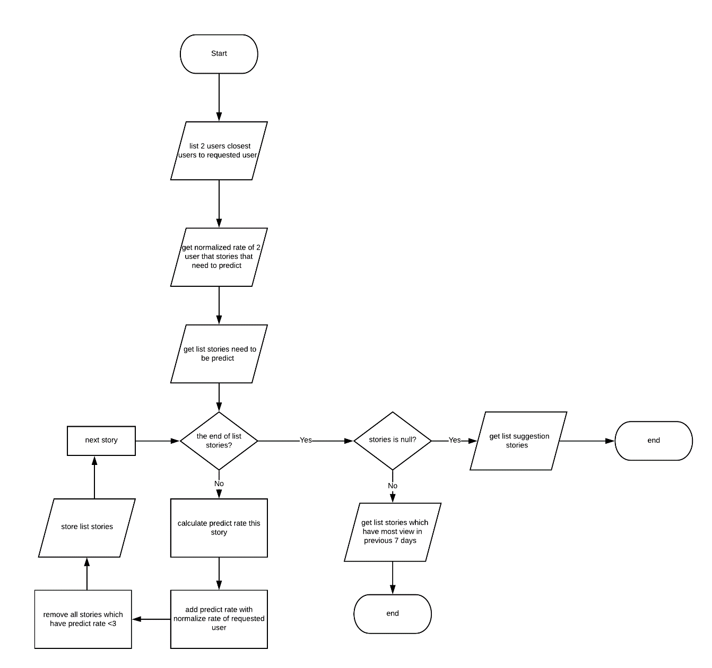

Figure 136 - Suggesting user algorithm

# E. System Implementation & Test

## 1. Introduction

### 1.1. Overview

This section describes approach and methodologies used by our team to plan, organize and manage testing process of StoryArt.

It provides all necessary information about implementation and testing procedure of the system including test plans, test cases, test results and pass/fail criteria as well as testing flow to cover all possible cases.

### 1.2. Test Approach

* Goal: Test main features in the whole StoryArt based on core flow.
* Method: Black-box testing.
* Size: System Component.
* Technique: Check list.

## 2. Data Relationship Diagram

### 2.1. Physical Diagram

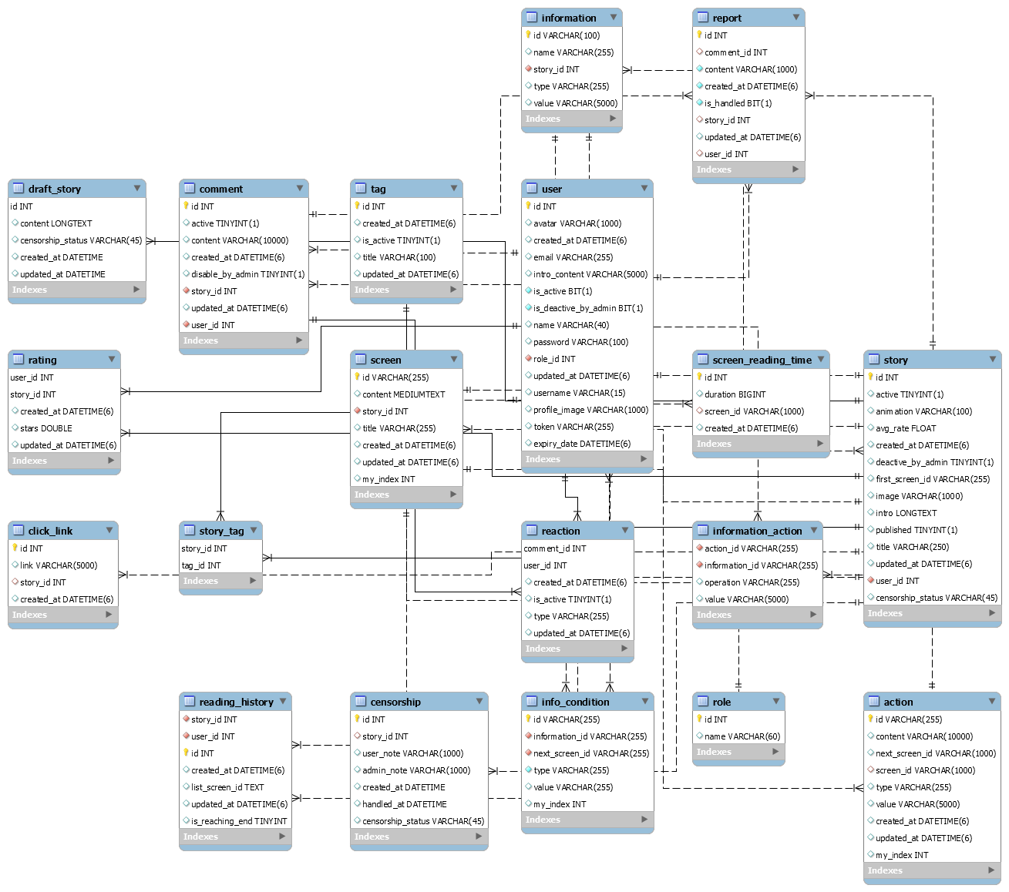

Figure 137 – Physical Diagram

|  |  |  |
| --- | --- | --- |
| **Data Dictionary: Describe content of all table** | | |
| **No** | **Table Name** | **Description** |
| 1 | story | Contain story information |
| 2 | user | Contain user information |
| 3 | screen | Contain screen information |
| 4 | report | Contain report information |
| 5 | tag | Contain tag information |
| 6 | action | Contain action information |
| 7 | information | Contain story’s information information. |
| 8 | info_condition | Contain information of story’s information’s condition. |
| 9 | information_action | Contain story’s information and action information. |
| 10 | comment | Contain comment information |
| 11 | reaction | Contain reaction information |
| 12 | story_tag | Contain story and tag information |
| 13 | reading_history | Contain reading history information |
| 14 | role | Contain role information |
| 15 | screen_reading_time | Contain time of reading screen information |
| 16 | rating | Contain rating information |
| 17 | click_link | Contain click link information |

Table 173 - Physical Diagram Dictionary

### 2.2. Database Diagram Explanation

#### 2.2.1. Story

|  |  |  |
| --- | --- | --- |
| Attribute | Type | Description |
| id | int | Unique identifier of a story |
| active | datetime | The status of story |
| animation | varchar(100) | The animation of story |
| avg_rate | float | The average rate of story |
| deactive_by_admin | tinyint | The deactivate by admin status of story |
| first_screen_id | varchar(100) | The id of first screen of story |
| image | varchar(1000) | The image of story |
| intro | longtext | The introduction of story |
| published | tinyint | The published status of story |
| title | varchar(250) | The title of story |
| user_id | int | The user id of story |
| censorship_status | Varchar(45) | The censorship’ status of Story |
| id | int | Unique identifier of a story |
| active | datetime | The status of story |

Table 174 - Story Attribute

#### 2.2.2. User

|  |  |  |
| --- | --- | --- |
| Attribute | Type | Description |
| id | int | Unique identifier of a role |
| avatar | varchar(1000) | The avatar of the user |
| email | varchar(255) | The email of the user |
| intro_content | varchar(5000) | The intro content of the user |
| is_active | bit | The status of the user |
| is_deactive_by_admin | bit | The deactive by admin status of the user |
| name | varchar(40) | The name of the user |
| password | varchar(100) | The hashed password of the user |
| role_id | int | The role id of the user |
| username | varchar(15) | The username of the user |
| profile_image | varchar(1000) | The profile image of the user |
| token | varchar(255) | The token of the user |
| expiry_date | datetime | The expiry of the user |
| created_at | datetime | The time user was created |
| updated_at | datetime | The time user was updated |

Table 175 - User Attribute

#### 2.2.3. Report

|  |  |  |
| --- | --- | --- |
| Attribute | Type | Description |
| id | int | Unique identifier of a report |
| comment_id | int | The comment’s id of report |
| content | varchar(1000) | The content of report |
| is_handled | bit | The status handled by admin of report |
| story_id | int | The story’s id of report |
| user_id | int | The user’s id of report |
| created_at | datetime | The time report was created |
| updated_at | datetime | The time report was updated |

Table 176 - Report Attribute

#### 2.2.4. Screen

|  |  |  |
| --- | --- | --- |
| Attribute | Type | Description |
| id | varchar(255) | Unique identifier of a screen |
| content | longtext | The content of screen |
| story_id | int | The story’s id of screen |
| title | varchar(255) | The title of screen |
| my_index | int | The index of screen |
| created_at | datetime | The time screen was created |
| updated_at | datetime | The time screen was updated |

Table 177 - Screen Attribute

#### 2.2.5. Tag

|  |  |  |
| --- | --- | --- |
| Attribute | Type | Description |
| id | Int | Unique identifier of a tag |
| title | varchar(100) | The title of the tag |
| is_active | tinyint | The status of the tag |
| created_at | datetime | The time tag was created |
| updated_at | datetime | The time tag was updated |

Table 178 - Tag Attribute

#### 2.2.6. Action

|  |  |  |
| --- | --- | --- |
| Attribute | Type | Description |
| id | varchar(255) | Unique identifier of an action |
| content | varchar(10000) | The content of action |
| next_screen_id | varchar(1000) | The next screen id of action |
| screen_id | varchar(1000) | The screen id of action |
| type | varchar(255) | The type of action |
| value | varchar(255) | The value of action |
| my_index | int | The index of action |
| created_at | datetime | The time action was created |
| updated_at | datetime | The time action was updated |

Table 179 - Action Attribute

#### 2.2.7. Information

|  |  |  |
| --- | --- | --- |
| Attribute | Type | Description |
| id | varchar(255) | Unique identifier of an information |
| name | nvarchar(50) | The name of the information |
| story_id | nvarchar(20) | The story id of the information |
| type | nvarchar(100) | The type of the information |
| value | varchar(255) | The value of the information |

Table 180 - Information Attribute

#### 2.2.8. Info_condition

|  |  |  |
| --- | --- | --- |
| Attribute | Type | Description |
| id | varchar(255) | Unique identifier of an info_condition |
| information_id | varchar(255) | The information id of info_condition |
| next_screen_id | varchar(255) | The next screen id of info_condition |
| type | varchar(255) | The type of info_condition |
| value | varchar(255) | The value of info_condition |

Table 181 – Info_condition Attribute

#### 2.2.9. Information_action

|  |  |  |
| --- | --- | --- |
| Attribute | Type | Description |
| action_id | Varchar(255) | The action id of information_action |
| information_id | varchar(255) | The information id of information_action |
| operation | varchar(255) | The operation of information_action |
| value | varchar(5000) | The value of information_action |

Table 182 – Information_action Attribute

#### 2.2.10. Comment

|  |  |  |
| --- | --- | --- |
| Attribute | Type | Description |
| id | int | Unique identifier of a comment |
| active | tinyint | The status of comment |
| content | varchar(10000) | The content of comment |
| disable_by_admin | tinyint) | The status disable by admin of comment |
| story_id | int | The story id of comment |
| user_id | float | The user id of comment |
| created_at | datetime | The time comment was created |
| updated_at | datetime | The time comment was updated |

Table 183 - Comment Attribute

#### 2.2.11. Reaction

|  |  |  |
| --- | --- | --- |
| Attribute | Type | Description |
| comment_id | int | The comment id of reaction |
| user_id | int | The user id of reaction |
| is_active | tinyint | The status id of reaction |
| type | varchar(255) | The type id of reaction |
| created_at | datetime | The time reaction was created |
| updated_at | datetime | The time reaction was updated |

Table 184 - Reaction Attribute

#### 2.2.12. Story_tag

|  |  |  |
| --- | --- | --- |
| Attribute | Type | Description |
| tag_Id | int | The tag id of story tag |
| story_Id | int | The story id of story tag |

Table 185 - Story_tag Attribute

#### 2.2.13. Reading_history

|  |  |  |
| --- | --- | --- |
| Attribute | Type | Description |
| user_Id | int | The user id of reading history |
| story_Id | int | The story id of reading history |
| id | int | Unique identifier of a History |
| List_screen_id | text | The list Section of History |
| created_at | datetime | The creation date of History |
| updated_at | datetime | The updated date of History |
| is_reaching_end | tinyint | The Status of History Is Reaching End of Story |

Table 186 - Reading_history Attribute

#### 2.2.14. Role

|  |  |  |
| --- | --- | --- |
| Attribute | Type | Description |
| id | int | Unique identifier of a Role |
| name | varchar(60) | The Name of Role |

Table 187 - Role Attribute

#### 2.2.15. Screen_reading_time

|  |  |  |
| --- | --- | --- |
| Attribute | Type | Description |
| id | int | Unique identifier of a screen_reading_time |
| duration | bigint | The duration of the screen_reading_time |
| screen_Id | varchar(1000) | The screen id of the screen_reading_time |
| created_At | datetime | The time the screen_reading_time was created |

Table 188 – Screen_reading_time Attribute

#### 2.2.16. Click_link

|  |  |  |
| --- | --- | --- |
| Attribute | Type | Description |
| id | int | Unique identifier of a click_link |
| link | varchar(5000) | The link of the click_link |
| story_id | int | The story id of the click_link |
| created_at | datetime | The time click_link was created |

Table 189 – Click_link Attribute

#### 2.2.17. Rating

|  |  |  |
| --- | --- | --- |
| Attribute | Type | Description |
| user_id | int | The user id of rating |
| story_id | int | The story id of rating |
| stars | double | The stars of rating |
| created_at | datetime | The time rating was created |
| updated_at | datetime | The time rating was updated |

Table 190 – Rating Attribute

#### 2.2.18. Censorship

|  |  |  |
| --- | --- | --- |
| Attribute | Type | Description |
| id | int | Unique identifier of a censorship |
| story_id | int | The story id of censorship |
| user_note | Varchar(1000) | The Note of a user |
| admin_note | Varchar(1000) | The Note of a admin |
| created_at | datetime | The time rating was created |
| handled_at | datetime | The time censorship was handled |
| censorship_status | Varchar(45) | The status of Censorship |

Table 191 – Censorship Attribute

#### 2.2.19. Draft_Story

|  |  |  |
| --- | --- | --- |
| Attribute | Type | Description |
| id | int | Unique identifier of a Draft Story |
| content | longtext | The content of Draft Story |
| censorship_status | Varchar(45) | The Censorship‘ status of a story |
| created_at | datetime | The time Draft Story was created |
| updated_at | datetime | The time Draft Story was updated |

Table 192 – Draft_Story Attribute

## 3. Test Plan

### 3.1. Feature to be tested

* Story test
* Comment test
* User test
* Reaction test
* Report test
* Tag test

### 3.2. Feature not to be tested

* Login
* Log out

## 4. System testing test case

### 4.1. <User> Story test

|  |  |  |  |  |  |  |
| --- | --- | --- | --- | --- | --- | --- |
| ID | Test Case Description | Test case procedure | Expected output | Inter Dependence Test Case | Result | Test Date |
|
| S1 | User create story without select tags | 1. User clicks “Tạo truyện” on side menu  2. User do not select tags for story  3. User click “Lưu truyện” | System shows error messages. "Chưa gắn thẻ cho truyện" | N/A | Pass | 16/04/2020 |
| S2 | User create story with invalid story’s data | 1. User clicks “Tạo truyện” on side menu  2. User input invalid story’s data such as leave the title empty.  3. User clicks "Lưu truyện" button | System shows error messages. | N/A | Pass | 16/04/2020 |
| S3 | User create story with invalid screens’ data | 1. User clicks “Tạo truyện” on side menu  2. User input invalid screens’ data  3. User clicks "Lưu truyện" button | System shows error messages. | N/A | Pass | 16/04/2020 |
| S4 | User create story with invalid actions’ data | 1. User clicks “Tạo truyện” on side menu  2. User input invalid actions’ data  3. User clicks "Lưu truyện" button | System shows error messages. | N/A | Pass | 16/04/2020 |
| S5 | User create story with invalid story information’s data (parameter) | 1. User clicks “Tạo truyện” on side menu  2. User input invalid story’s information data such as leave the name of parameter empty.  3. User clicks "Lưu truyện" button | System shows error messages. | N/A | Pass | 16/04/2020 |
| S6 | User update story without select tags | 1. User clicks “Quản lý tài khoản” on side menu.  2. User click on “Cập nhật” on dropdown menu on story list table.  2. User do not select tags  3. User clicks "Lưu truyện" button | System shows error messages. "Chưa gắn thẻ cho truyện" | N/A | Pass | 16/04/2020 |
| S7 | User update story with invalid story’s data | 1. User clicks “Quản lý tài khoản” on side menu.  2. User click on “Cập nhật” on dropdown menu on story list table.  3. User input invalid story’s data  4. User clicks "Lưu truyện" button | System shows error messages. | N/A | Pass | 16/04/2020 |
| S8 | User update story with invalid screens’ data | 1. User clicks “Quản lý tài khoản” on side menu.  2. User click on “Cập nhật” on dropdown menu on story list table.  3. User input invalid screens’ data  4. User clicks "Lưu truyện" button | System shows error messages. | N/A | Pass | 16/04/2020 |
| S9 | User update story with invalid actions’ data | 1. User clicks “Quản lý tài khoản” on side menu.  2. User click on “Cập nhật” on dropdown menu on story list table.  3. User input invalid actions’ data  4. User clicks "Lưu truyện" button | System shows error messages. | N/A | Pass | 16/04/2020 |
| S10 | User update story with invalid story information’s data (parameter) | 1. User clicks “Quản lý tài khoản” on side menu.  2. User click on “Cập nhật” on dropdown menu on story list table.  3. User input invalid story’s parameter’s data  4. User clicks "Lưu truyện" button | System shows error messages. | N/A | Pass | 16/04/2020 |
| S11 | User update story with valid data | 1. User clicks “Quản lý tài khoản” on side menu.  2. User click on “Cập nhật” on dropdown menu on story list table.  3. User input valid story’s data, story’s information’s data, screens’ data, actions’ data  4. User clicks "Lưu truyện" button | System shows success message. “Lưu thành công” | N/A | Pass | 16/04/2020 |
| S12 | User create story with valid data | 1. User clicks “Tạo truyện” on side menu  2. User input valid story’s data, story’s information’s data, screens’ data, actions’ data  3. User clicks "Lưu truyện" button | System shows success message. “Lưu thành công” | N/A | Pass | 16/04/2020 |
| S13 | User delete story | 1. User clicks “Quản lý tài khoản” on side menu.  2. User click on “Cập nhật” on dropdown menu on story list table.  3. User input valid story’s data, story’s information’s data, screens’ data, actions’ data  4. User clicks "Xóa truyện" button  5. A dialog confirm show up to ask user “Bạn có chắc muốn xóa truyện này chứ?”  6. User click “ĐỒNG Ý” button | System change the active status to false then shows success message. “Xóa thành công” and redirect user to his/her profile page. | N/A | Pass | 16/04/2020 |
| S14 | Admin lock story | 1. Admin clicks “Quản lý truyện” on side menu.  2. User click on “Khóa truyện” on dropdown menu on story list table.  3. A dialog confirm show up to ask user “Bạn có chắc chắn muốn khóa truyện này chứ?”  4. User clicks "ĐỒNG Ý" button | System change the status deactive_by_admin to true then shows success message. “Cập nhật thành công”. Then change the text from “CHƯA KHÓA” to “ĐÃ BỊ KHÓA” | N/A | Pass | 16/04/2020 |
| S15 | Admin unlock story | 1. Admin clicks “Quản lý truyện” on side menu.  2. User click on “Khóa truyện” on dropdown menu on story list table.  3. A dialog confirm show up to ask user “Bạn có chắc chắn muốn khôi phục truyện này chứ?”  4. User clicks "ĐỒNG Ý" button | System change the status deactive_by_admin to true then shows success message. “Cập nhật thành công”. Then change the text from “ĐÃ BỊ KHÓA” to “CHƯA KHÓA” | N/A | Pass | 16/04/2020 |
| S16 | User stop publishing story | 1. User clicks “Quản lý tài khoản” on side menu.  2. User click on “Hủy xuất bản truyện” on dropdown menu on story list table. | System change the story’s published status to false and then show success message: “Đổi trạng thái xuất bản thành công” | N/A | Pass | 16/04/2020 |
| S17 | User turn on publishing story | 1. User clicks “Quản lý tài khoản” on side menu.  2. User click on “Xuất bản truyện” on dropdown menu on story list table. | System change the story’s published status to true and then show success message: “Đổi trạng thái xuất bản thành công” | N/A | Pass | 16/04/2020 |

Table 193 - <User> Story test

### 4.2. <User> Comment test

|  |  |  |  |  |  |  |
| --- | --- | --- | --- | --- | --- | --- |
| ID | Test Case Description | Test case procedure | Expected output | Inter Dependence Test Case | Result | Test Date |
|
| C1 | User create comment | 1. User clicks story detail page  2. User fills comment content  3. User clicks "Gửi" button | System shows success message: “Gửi bình luận thành công” | N/A | Pass | 16/04/2020 |
| C2 | User create comment with empty content. | 1. User clicks story detail page  2. User left comment content empty  3. User clicks "Gửi" button | System show error message: “Xin vui lòng nhập bình luận”. | C1 | Pass | 16/04/2020 |
| C3 | User edit comment | 1. User clicks edit comment button in comment list  2. User fills comment content  3. User clicks "Chỉnh sửa" button | System shows success message: “Chỉnh sửa bình luận thành công” | N/A | Pass | 16/04/2020 |
| C4 | User edit comment with empty content | 1. User clicks edit comment button in comment list  2. User left comment content empty  3. User clicks "Bình luận" button | System show error message: “Xin vui lòng nhập bình luận” | C3 | Pass | 16/04/2020 |
| C5 | User delete comment | 1. User clicks delete comment button in comment list  2. User click “Có” button in popup | System removed comment in comment list | N/A | Pass | 16/04/2020 |

Table 194 - <User> Comment test

### 4.3. <User> Reaction test

|  |  |  |  |  |  |  |
| --- | --- | --- | --- | --- | --- | --- |
| ID | Test Case Description | Test case procedure | Expected output | Inter Dependence Test Case | Result | Test Date |
|
| R1 | User like/dislike comment | 1. User clicks like/dislike button of each comment in commnet list | System shows comment is liked/disliked and adds number of like/dislike to commnet | N/A | Pass | 16/04/2020 |
| R2 | User remove like/dislike commnet | 1. User clicks like/dislike button of each commnet is liked/disliked in commnet list | System remove liked/disliked and minus number of like/dislike to comment | N/A | Pass | 16/04/2020 |

Table 195 - <User> Reaction test

### 4.4. <User, Adminstrator> Report test

|  |  |  |  |  |  |  |
| --- | --- | --- | --- | --- | --- | --- |
| ID | Test Case Description | Test case procedure | Expected output | Inter Dependence Test Case | Result | Test Date |
|
| RP1 | User report story | 1. User clicks “Báo cáo” button in story detail page  2. User fills report content  3. User clicks "Gửi" button | System shows success message: “Đã gửi báo cáo” | N/A | Pass | 16/04/2020 |
| RP2 | User report story with empty content | 1. User clicks story detail page  2. User left report content empty  3. User clicks "Gửi" button | System shows error message: “Vui lòng không để trống nội dung báo cáo” | RP1 | Pass | 16/04/2020 |
| RP3 | User report story duplicated. | 1. User clicks story detail page  2. User report story/comment duplicated.  3. User clicks "Gửi" button | System shows error message: “Bạn đã báo cáo bình luận này vui lòng đợi quản trị viên xử lý” | RP1 | Pass | 16/04/2020 |
| RP4 | User report comment | 1. User clicks report button in comment list.  2. User fills report content  3. User clicks "Gửi" button | System shows success message: “Đã gửi báo cáo” | N/A | Pass | 16/04/2020 |
| RP5 | User report comment with empty content | 1. User clicks story detail page  2. User left report content empty  3. User clicks "Gửi" button | System shows error message: “Vui lòng không để trống nội dung báo cáo” | RP1 | Pass | 16/04/2020 |
| RP6 | User report comment duplicated. | 1. User clicks story detail page  2. User report story/comment duplicated.  3. User clicks "Gửi" button | System shows error message: “Bạn đã báo cáo bình luận này vui lòng đợi quản trị viên xử lý” | RP1 | Pass | 16/04/2020 |
| RP7 | Admin handle report | 1. Admin clicks “Xử lý” in report popup | System remove report from unhandled report table and move it to handled report table.  System change status of user/story/comment. | N/A | Pass | 16/04/2020 |
| RP8 | Admin change status of user/story/comment in review report popup | 1. Admin clicks “Đổi trạng thái” in review report popup. | System change status of user/story/comment. | N/A | Pass | 16/04/2020 |

Table 196 - <User, Administrator> Report test

### 4.5. <Administrator> Tag test

|  |  |  |  |  |  |  |
| --- | --- | --- | --- | --- | --- | --- |
| **ID** | **Test Case Description** | **Test case procedure** | **Expected output** | **Inter Dependence Test Case** | **Result** | **Test Date** |
|
| N1 | Administrator create tag without filling Tag Title | 1. Administrator clicks “Thêm Thẻ” button  2. Administrator do not input “Tên Thẻ”  3. Administrator clicks “Xác Nhận” | System shows error messages. "Xin hãy nhập Nhãn" | N/A | Pass | 16/04/2020 |
| N2 | Administrator create Tag filling invalid information | 1. Administrator clicks “Thêm Thẻ” button  2. Administrator input “Tên Thẻ” that already existed  3. Administrator clicks “Xác Nhận” | System shows error messages. "Xin lỗi, Nhãn đã tồn tại" | N/A | Pass | 16/04/2020 |
| N2 | Administrator create tag filling valid information | 1. Administrator clicks “Thêm Thẻ” button  2. Administrator input valid tag information  3. Administrator clicks “Xác Nhận” | System shows success message. “Thêm Nhãn thành công” | N/A | Pass | 16/04/2020 |
| N3 | Administrator update tag without filling Tag Title | 1. Administrator clicks “Cập Nhật Thẻ” button  2. Administrator do not input “Tên Thẻ”  3. Administrator clicks “Xác Nhận” | System shows error messages. "Xin hãy nhập Nhãn" | N/A | Pass | 16/04/2020 |
| N4 | Administrator update tag filling invalid information | 1. Administrator clicks “Cập Nhật Thẻ” button  2. Administrator input “Tên Thẻ” that already existed  3. Administrator clicks “Xác Nhận” | System shows error messages. "Xin lỗi, Nhãn đã tồn tại" | N/A | Pass | 16/04/2020 |
| N5 | Administrator update tag filling valid information | 1. Administrator clicks “Cập Nhật Thẻ” button  2. Administrator input valid tag information  3. Administrator clicks “Xác Nhận” | System shows success message. “Cập Nhật thành công” | N/A | Pass | 16/04/2020 |
| N6 | Administrator delete tag | 1. Administrator clicks “Cập Nhật Thẻ” button  2. Administrator click on “Tình Trạng Thẻ” and select option “Dừng Hoạt Động”  4. A dialog confirm show up to ask user “Dừng hoạt động nhãn sẽ khiến nó mất đi ở thanh tìm kiếm, bạn có chắc muốn dừng hoạt động nó chứ?”  3. Administrator clicks “Xác Nhận” | System change the active status to false then shows success message. “Xóa thành công” | N/A | Pass | 16/04/2020 |

Table 197 - <Administrator> Tag Test

### 4.6. <Guest, User, Administrator, System Admin> User test

|  |  |  |  |  |  |  |
| --- | --- | --- | --- | --- | --- | --- |
| **ID** | **Test Case Description** | **Test case procedure** | **Expected output** | **Inter Dependence test Case** | **Result** | **Test Date** |
|
| U1 | Guest enters invalid sign-up information | 1. Guest accesses login page  2. Guest does not enter username, leave username blank or enters spaces, or enter <3 & >15 characters string  3. Guest clicks on “Đăng ký” button | System shows error messages. "Tên đăng nhập phải có từ 3 đến 15 ký tự" | N/A | Pass | 16/04/2020 |
| U2 | Guest enters invalid sign-up information | 1. Guest accesses login page  2. Guest does not enter password, leave it blank or enters spaces, or enter <8 & >100 characters string  3. Guest clicks on “Đăng ký” button | System shows error messages. "Mật khẩu phải có từ 8 đến 100 ký tự" | N/A | Pass | 16/04/2020 |
| U3 | Guest enters invalid sign-up information | 1. Guest accesses login page  2. Guest does not enter name, leave name blank or enters spaces, or enter <3 & >40 characters string  3. Guest clicks on “Đăng ký” button | System shows error messages. "Tên phải có từ 3 đến 40 ký tự" | N/A | Pass | 16/04/2020 |
| U4 | Guest enters invalid sign-up information | 1. Guest accesses login page  2. Guest does not enter email, leave email blank or enters spaces  3. Guest clicks on “Đăng ký” button | System shows error messages. "Email không được để trống" | N/A | Pass | 16/04/2020 |
| U5 | Guest enters invalid sign-up information | 1. Guest accesses login page  2. Guest enters wrong email format such as not have @  3. Guest clicks on “Đăng ký” button | System shows error messages. "Không đúng định dạng email!" | N/A | Pass | 16/04/2020 |
| U6 | Guest enters valid sign-up information | 1. Guest accesses login page  2. Guest enters registered username  3. Guest clicks on “Đăng ký” button | System shows error messages. "Tên đăng nhập đã tồn tại” | N/A | Pass | 16/04/2020 |
| U7 | Guest enters valid sign-up information | 1. Guest accesses login page  2. Guest enters registered email  3. Guest clicks on “Đăng ký” button | System shows success messages. "Email đã được đăng ký bởi ai đó!” | N/A | Pass | 16/04/2020 |
| U8 | Guest enters invalid sign-up information | 1. Guest accesses login page  2. Guest enters introduction content >300 characters string  3. Guest clicks on “Đăng ký” button | System shows error messages. "Thông tin giới thiệu có độ dài tối đa là 300 ký tự!" | N/A | Pass | 16/04/2020 |
| U9 | Guest enters valid sign-up information | 1. Guest accesses login page  2. Guest enters valid information  3. Guest clicks on “Đăng ký” button | System shows success messages. "Đăng ký thành công” | N/A | Pass | 16/04/2020 |
| U10 | Guest enters invalid email to recieve reset password link | 1. Guest click on login button on top menu to view login page  2. Guest click on “Quên mật khẩu” to view forgot password page  3. Guest does not enter email, leave email blank or enters spaces  4. Guest clicks on “Gửi hướng dẫn” button | System shows error messages. "Email không được để trống" | N/A | Pass | 16/04/2020 |
| U11 | Guest enters invalid email to recieve reset password link | 1. Guest click on login button on top menu to view login page  2. Guest click on “Quên mật khẩu” to view forgot password page  3.Guest enters wrong email format such as not have @  4. Guest clicks on “Gửi hướng dẫn” button | System shows error messages. "Không đúng định dạng email!" | N/A | Pass | 16/04/2020 |
| U12 | Guest enters un-registered email to recieve reset password link | 1. Guest click on login button on top menu to view login page  2. Guest click on “Quên mật khẩu” to view forgot password page  3.Guest enters un-registered email  4. Guest clicks on “Gửi hướng dẫn” button | System shows error messages. " Không tồn tại người dùng với email này!” | N/A | Pass | 16/04/2020 |
| U13 | Guest enters valid and registered email to recieve reset password link | 1. Guest click on login button on top menu to view login page  2. Guest click on “Quên mật khẩu” to view forgot password page  3.Guest enters valid and registered email  4. Guest clicks on “Gửi hướng dẫn” button | System shows success message “Bạn sẽ sớm nhận được một email hướng dẫn .Nếu bạn vẫn cần hỗ trợ, hãy liên hệ qua mail: [storyartcapstone@gmail.com](mailto:storyartcapstone@gmail.com)” | N/A | Pass | 16/04/2020 |
| U14 | Guest enters invalid new reset password | 1. Guest click on reset password link recieve in reset password request in email  2. Guest does not enter new password, leave it blank or enters spaces, or enter <8 & >100 characters string  3. Guest click on “Lưu thay đổi” button | System shows error messages. "Mật khẩu phải có từ 8 đến 100 ký tự" | N/A | Pass | 16/04/2020 |
| U15 | Guest enters invalid re-enter reset password | 1. Guest click on reset password link recieve in reset password request in email  2. Guest enter re-enter password not be the same with new password  3.Guest click on “Lưu thay đổi” button | System shows error messages. "Mật khẩu nhập lại chưa trùng" | N/A | Pass | 16/04/2020 |
| U16 | Guest enters invalid re-enter reset password | 1. Guest click on reset password link recieve in reset password request in email  2. Guest enter re-enter password same with new valid password  3.Guest click on “Lưu thay đổi” button | System shows success messge"Lưu thành công” and redirect to homepage with changed password logged account | N/A | Pass | 16/04/2020 |
| U17 | Administrator enters invalid user information | 1. Administrator accesses view users page  2. Administrator clicks on “Thêm người dùng” button  3. Administrator does not enter username, leave username blank or enters spaces, or enter <3 & > 15 string  4. Administrator clicks on “Lưu” button | System shows error messages. "Tên đăng nhập phải có từ 3 đến 15 ký tự" | N/A | Pass | 16/04/2020 |
| U18 | Administrator enters invalid user information | 1. Administrator accesses view users page 2. Administrator clicks on “Thêm người dùng” button  3. Administrator does not enter password, leave it blank or enters spaces, or enter <8 & >100 characters string  4. Administrator clicks on “Lưu” button | System shows error messages. "Mật khẩu phải có từ 8 đến 100 ký tự" | N/A | Pass | 16/04/2020 |
| U19 | Administrator enters invalid user information | 1. Administrator accesses view users page 2. Administrator clicks on “Thêm người dùng” button  3. Administrator does not enter name, leave name blank or enters spaces, or enter <3 & >40 characters string  4. Administrator clicks on “Lưu” button | System shows error messages. "Tên phải có từ 3 đến 40 ký tự" | N/A | Pass | 16/04/2020 |
| U20 | Administrator enters invalid user information | 1. Administrator accesses view users page 2. Administrator clicks on “Thêm người dùng” button  3. Administrator does not enter email, leave email blank or enters spaces  4. Administrator clicks on “Lưu” button | System shows error messages. "Email không được để trống" | N/A | Pass | 16/04/2020 |
| U21 | Administrator enters invalid user information | 1. Administrator accesses view users page 2. Administrator clicks on “Thêm người dùng” button  3. Administrator enter wrong email format such as not have @  4. Administrator clicks on “Lưu” button | System shows error messages. "Không đúng định dạng email!" | N/A | Pass | 16/04/2020 |
| U22 | Administrator enters invalid user information | 1. Administrator accesses view users page 2. Administrator clicks on “Thêm người dùng” button  3. Administrator enters >300 characters string introduction content  4. Administrator clicks on “Lưu” button | System shows error messages. "Thông tin giới thiệu có độ dài tối đa là 300 ký tự!" | N/A | Pass | 16/04/2020 |
| U23 | Administrator enters valid user information | 1. Administrator accesses view users page  2. Administrator enters registered username  3. Administrator clicks on “Lưu” button | System shows error messages. "Tên đăng nhập đã tồn tại” | N/A | Pass | 16/04/2020 |
| U24 | Administrator enters valid user information | 1. Administrator accesses view users page  2. Administrator enters registered email  3. Administrator clicks on “Lưu” button | System shows success messages. "Email đã được đăng ký bởi ai đó!” | N/A | Pass | 16/04/2020 |
|  | Administrator enters valid user information | 1. Administrator accesses view users page  2. Administrator enters valid information  3. Administrator clicks on “Lưu” button | System shows success messages. "Tạo thành công” | N/A | Pass | 16/04/2020 |
| U25 | Administrator change status of user | 1. Administrator accesses view users page  2. Administrator clicks on adminsistrator status button  3. Administrator clicks on “Huỷ” | System shows status of user not changed the color and content | N/A | Pass | 16/04/2020 |
| U26 | Administrator change status of user | 1. Administrator accesses view users page  2. Administrator clicks on adminsistrator status button  3. Administrator clicks on X button on the top-right corner. | System shows status button of user not changed the color and content | N/A | Pass | 16/04/2020 |
| U27 | Administrator change status of user | 1. Administrator accesses view users page  2. Administrator clicks on adminsistrator status button  3. Administrator clicks on “Lưu” button | System shows status button of user has been changed the color and content | N/A | Pass | 16/04/2020 |
| U28 | Administrator enters invalid value at search field | 1. Administrator accesses view users page  2. Administrator not enters, enter blank or spaces at search field  3. Administrator clicks on search button | System shows succes message that found out at total number of users | N/A | Pass | 16/04/2020 |
| U29 | System administrator enters invalid administrator information | 1. System administrator accesses view administrators page  2. System administrator clicks on “Thêm quản trị viên” button  3. System administrator does not enter username, leave username blank, or enter <3 & >15 characters string  4. System administrator clicks on “Lưu” button | System shows error messages. "Tên đăng nhập phải có từ 3 đến 15 ký tự" | N/A | Pass | 16/04/2020 |
| U30 | System administrator enters invalid administrator information | 1. System administrator accesses view administrators page  2. System administrator clicks on “Thêm quản trị viên” button  3. System administrator does not enter password, leave it blank or enters spaces, or enter <8 & >100 characters string  4. System administrator clicks on “Lưu” button | System shows error messages. "Mật khẩu phải có từ 8 đến 100 ký tự" | N/A | Pass | 16/04/2020 |
| U31 | System administrator enters invalid administrator information | 1. System administrator accesses view administrators page  2. System administrator clicks on “Thêm quản trị viên” button  3. System administrator does not enter name, leave name blank or enters spaces, or enter <3 & >40 characters string  4. System administrator clicks on “Lưu” button | System shows error messages. "Tên phải có từ 3 đến 40 ký tự" | N/A | Pass | 16/04/2020 |
| U32 | System administrator enters invalid administrator information | 1. System administrator accesses view administrators page  2. System administrator clicks on “Thêm quản trị viên” button  3. System administrator does not enter email, leave email blank or enters spaces  4. System administrator clicks on “Lưu” button | System shows error messages. "Email không được để trống" | N/A | Pass | 16/04/2020 |
| U33 | System administrator enters invalid administrator information | 1. System administrator accesses view administrators page  2. System administrator clicks on “Thêm quản trị viên” button  3. System administrator enters wrong email format such as not have @  4. System administrator clicks on “Lưu” button | System shows error messages. "Không đúng định dạng email!" | N/A | Pass | 16/04/2020 |
| U34 | System administrator enters invalid administrator information | 1. System administrator accesses view administrators page  2. System administrator clicks on “Thêm quản trị viên” button  3. System administrator enters >300 characters string introduction content  4. System administrator clicks on “Lưu” button | System shows error messages. "Thông tin giới thiệu có độ dài tối đa là 300 ký tự!" | N/A | Pass | 16/04/2020 |
| U35 | System administrator enters valid administrator information | 1. System administrator accesses view administrators page  2. System administrator enters registered username  3. System administrator clicks on “Lưu” button | System shows error messages. "Tên đăng nhập đã tồn tại” | N/A | Pass | 16/04/2020 |
| U36 | System administrator enters valid administrator information | 1. System administrator accesses view users page  2. System administrator enters registered email  3. System administrator clicks on “Lưu” button | System shows success messages. "Email đã được đăng ký bởi ai đó!” | N/A | Pass | 16/04/2020 |
| U37 | System administrator enters valid administrator information | 1. System administrator accesses view administrators page  2. System administrator enters valid information  3. System administrator clicks on “Lưu” button | System shows success messages. "Tạo thành công” | N/A | Pass | 16/04/2020 |
| U38 | System administrator change status of administrator | 1. System administrator accesses view administrators page  2. System administrator clicks on adminsistrator status button  3. System administrator clicks on “Huỷ” | System shows status of administrator not changed the color and content | N/A | Pass | 16/04/2020 |
| U39 | System administrator change status of administrator | 1. System administrator accesses view administrators page  2. System administrator clicks on adminsistrator status button  3. System administrator clicks on X button on the top-right corner. | System shows status button of administrator not changed the color and content | N/A | Pass | 16/04/2020 |
| U40 | System administrator change status of administrator | 1. System administrator accesses view administrators page  2. System administrator clicks on adminsistrator status button  3. System administrator clicks on “Lưu” button | System shows status button of administrator has been changed the color and content | N/A | Pass | 16/04/2020 |
| U41 | System administrator enters invalid value at search field | 1. System administrator accesses view administrators page  2. System administrator not enters, enter blank or spaces at search field  3. System administrator clicks on search button | System shows succes message that found out at total number of administrators | N/A | Pass | 16/04/2020 |
| U42 | User choose invalid avatar image file | 1. User accesses update profile page  2. User clicks on “Chọn tệp” button to update avatar  3. User choose invalid file such as >10MB image, or click on “Cancel” button  4. User click on “Lưu avatar” button | System shows error message “Upload thất bại. Thử lại!” | N/A | Pass | 16/04/2020 |
| U43 | User choose valid avatar image file | 1. User accesses update profile page  2. User clicks on “Chọn tệp” button to update avatar  3.User choose image file  4.User click on “Lưu avatar” button | System shows error message ”Đã cập nhật thành công!” | N/A | Pass | 16/04/2020 |
| U44 | User choose invalid background image file | 1. User accesses update profile page  2. User clicks on “Chọn tệp” button to update background  3.User choose invalid file such as >10MB image, or click on “Cancel” button  4.User click on “Lưu hình nền” button | System shows error message “Upload thất bại. Thử lại!” | N/A | Pass | 16/04/2020 |
| U45 | User choose valid background image file | 1. User accesses update profile page  2. User clicks on “Chọn tệp” button to update background  3.User choose image file  4.User click on “Lưu hình nền” button | System shows error message ”Đã cập nhật thành công!” | N/A | Pass | 16/04/2020 |
| U46 | User enters invalid update information | 1. User accesses update profile page  2. User does not enter name, leave name blank or enters spaces, or enter <3 & >40 characters string  3. User clicks on “Lưu thay đổi” button | System shows error messages. "Tên phải có từ 3 đến 40 ký tự" | N/A | Pass | 16/04/2020 |
| U47 | User enters invalid update information | 1. User accesses update profile page  2. User does not enter email, leave email blank or enters spaces  3. User clicks on “Lưu thay đổi” button | System shows error messages. "Email không được để trống" | N/A | Pass | 16/04/2020 |
| U48 | User enters invalid update information | 1. User accesses update profile page  2. User enters wrong email format such as not have @  3. User clicks on “Lưu thay đổi” button | System shows error messages. "Không đúng định dạng email!" | N/A | Pass | 16/04/2020 |
| U49 | User enters invalid update information | 1. User accesses update profile page  2. User enters registered email  3. User clicks on “Lưu thay đổi” button | System shows success messages. "Email đã được đăng ký bởi ai đó!” | N/A | Pass | 16/04/2020 |
| U50 | User enters valid update information | 1. User accesses update profile page  2. User enters valid information  3. User clicks on “Lưu thay đổi” button | System shows success messages. "Lưu thay đổi thành công” | N/A | Pass | 16/04/2020 |
|  | User enters invalid user information | 1. User accesses update profile page  2. User enters >300 characters string introduction content  3.User clicks on “Lưu thay đổi” button | System shows error messages. "Thông tin giới thiệu có độ dài tối đa là 300 ký tự!" | N/A | Pass | 16/04/2020 |
| U51 | User enters invalid new password | 1. User click on avatar button on top menu  2. User clicks on “Đổi mật khẩu” button to tranfer to change password page  3.User does not enter new password, leave it blank or enters spaces, or enter <8 & >100 characters string  4.User click on “Lưu thay đổi” button | System shows error messages. "Mật khẩu phải có từ 8 đến 100 ký tự" | N/A | Pass | 16/04/2020 |
| U55 | User enters invalid re-enter password | 1. User click on avatar button on top menu  2. User clicks on “Đổi mật khẩu” button to tranfer to change password page  3.User enter re-enter password not be the same with new password  4.User click on “Lưu thay đổi” button | System shows error messages. "Mật khẩu nhập lại không đúng. Vui lòng nhập lại!" | N/A | Pass | 16/04/2020 |

Table 198 - <Guest, User, Administrator, System Admin> User Test

# F. Software User’s Manual

## 1. Installation Guide

### 1.1. Setting up environment at server side

#### 1.1.1. Hardware requirements

|  |  |  |
| --- | --- | --- |
| **Server** | **Minimum Requirements** | **Recommended** |
| **Internet Connection** | Cable, Wi-Fi (4 Mbps) | Cable, Wi-Fi (8 Mbps) |
| **Operating System** | Windows 7, 8.1, Windows Server 2008 | Windows 10, Windows Server 2012 |
| **Computer Processor** | Intel® Xeon ® 1.4GHz | Intel® Xeon ® Quad-Core (12M Cache, 2.50 GHz) |
| **Computer Memory** | 4GB RAM | 32GB RAM or more |
| **Storage space** | 4GB | 8GB or more |

Table 199 - Hardware requirement for server

#### 1.1.2. Software requirements

|  |  |  |
| --- | --- | --- |
| **Name** | **Name/Version** | **Description** |
| **Environment** | Java EE 8.0, Node v12.14.1, npm v6.13.4 | Specification for developing web application |
| **Operating System** | Window 10 | Operating system and platform for development |
| **Modeling tool** | Lucid Chart | Used to design diagram |
| **IDE** | IntelliJ IDEA,  Visual Studio Code | Programming tools |
| **DBMS** | MySql Workbench 8.0 | Used to create & manage the database for system |
| **Web server** | Apache Tomcat | Deployment environment |
| **Web browser** | Chrome 69 or above. | Testing browser |

Table 200 - Software requirement for server

### 1.2. Deployment at server side

#### 1.2.1 Prepare development package

**Step 1:** Download and Install Java 8

Link download: <http://www.oracle.com/technetwork/java/javase/downloads/java-archive-javase8-2177648.html>

**Step 2:** Download and Install IntelliJ IDE

Link download: <https://www.jetbrains.com/idea/download/#section=windows>

**Step 3:** Download spring boot project from spring initializr

Link download: <https://start.spring.io/>

#### 1.2.2 Configure server before deploy

**Step 1:** Configure eureka server

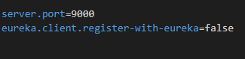

Figure 138 - Configure eureka server

**Step 2:** Configure api gateway service

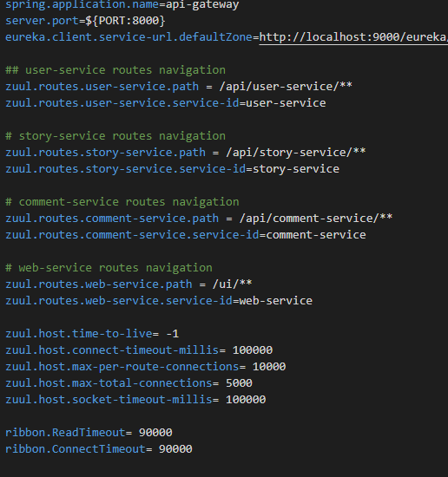

Figure 139 – Configure api gateway service

**Step 3:** Configure story service

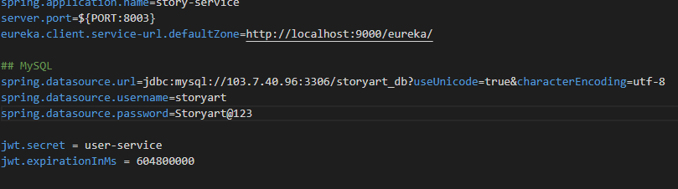

Figure 140 – Configure story service

**Step 4:** Configure user service

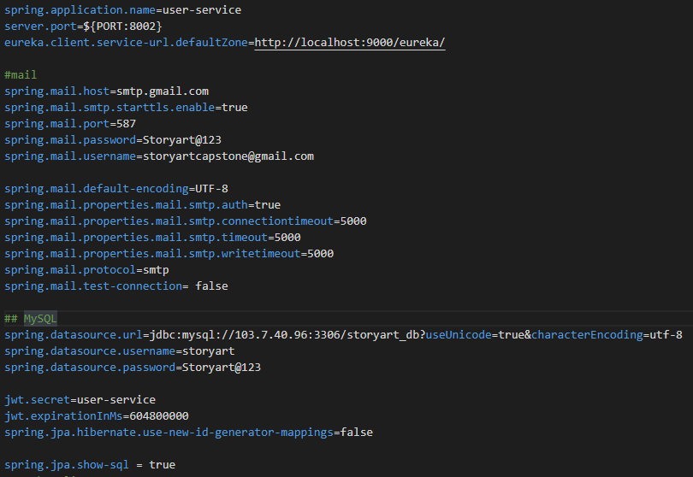

Figure 141 – Configure user service

**Step 5:** Configure comment service

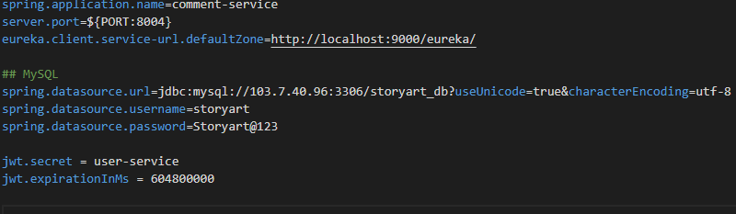

Figure 142 – Configure comment service

### 1.3. Setting up environment at client side

The client devices should have one of the following browsers to access the website: Google Chrome. Link download: <https://www.google.com/chrome/>

## 2. User Guide

### 2.1 System Admin

#### 2.1.1 View admin list

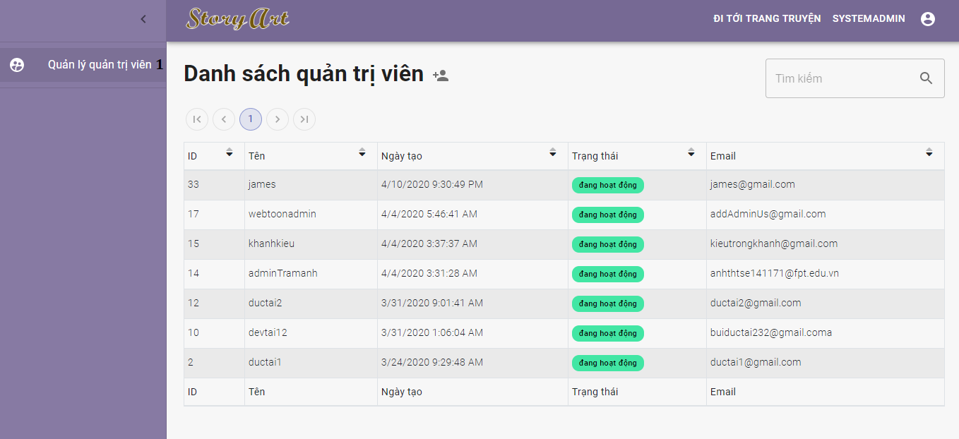

Figure 143 - <Admin> View admin list

|  |  |
| --- | --- |
| **Step** | **Description** |
| Pre-condition | Login as role “System Admin” |
| 1 | Click on “Quản lý quản trị viên” |

Table 201 - <Admin> View admin list

#### 2.1.2 Create admin

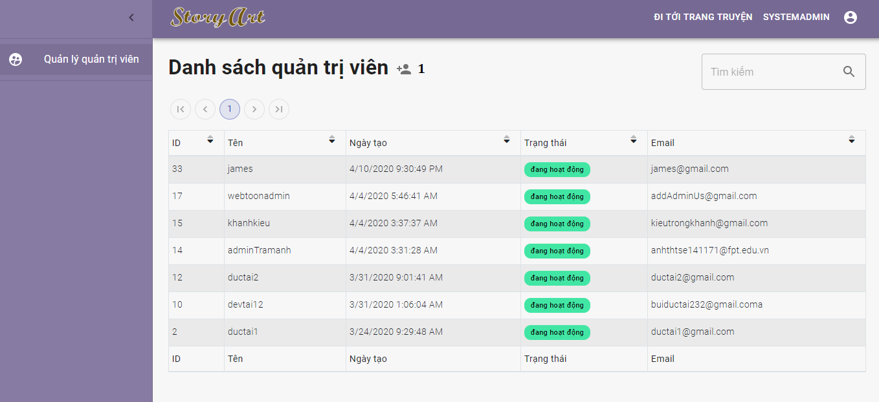

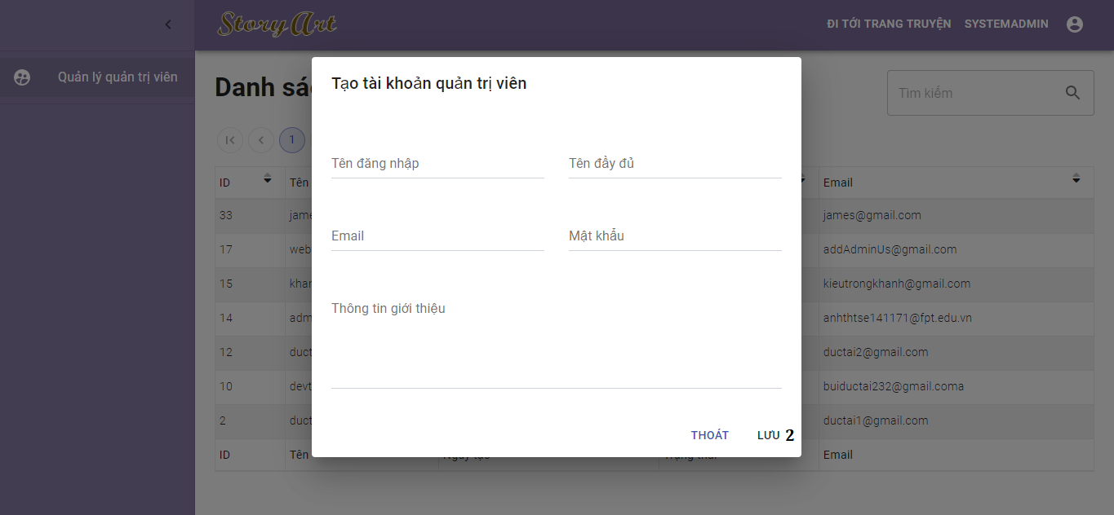

Figure 144 - <Admin> Create admin guide

|  |  |
| --- | --- |
| **Step** | **Description** |
| Pre-condition | Login as role “System Admin” |
| 1 | Click on create admin button |
| 2 | After filled all fields in popup, click on “Lưu” button to add admin |

Table 202 - <Admin> Create admin guide

#### 2.1.3 Deactivate/activate admin

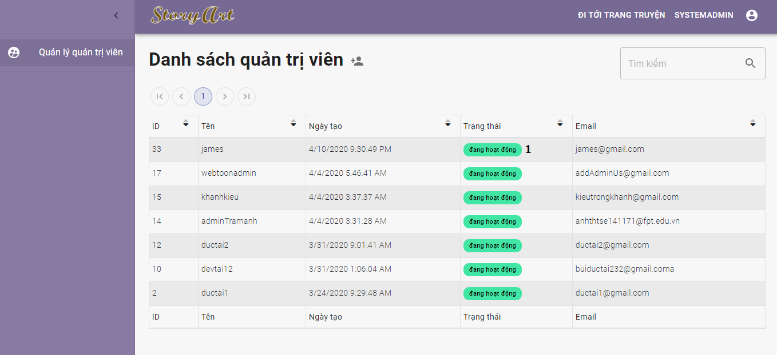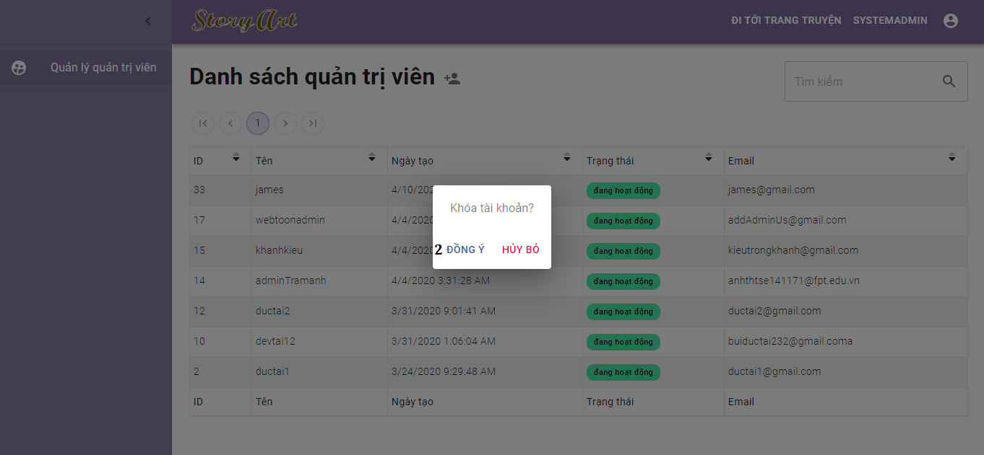

Figure 145 - <Admin> Deactivate/Activate admin

|  |  |
| --- | --- |
| **Step** | **Description** |
| Pre-condition | Login as role “System Admin” |
| 1 | Click on status of each admin |
| 2 | Click on “Đồng ý” button shown in popup |

Table 203 - <Admin> Deactivate/Activate admin

### 2.2 Administrator

#### 2.2.1 View user list

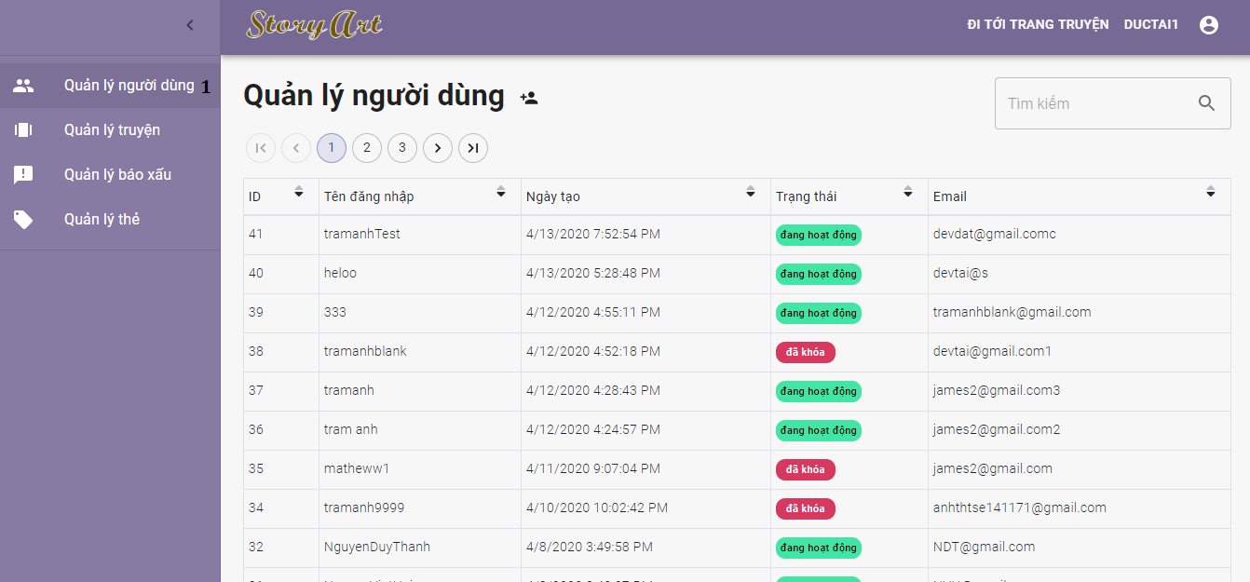

Figure 146 - <Admin> View user list

|  |  |
| --- | --- |
| **Step** | **Description** |
| Pre-condition | Login as role “Administrator” |
| 1 | Click on “Quản lý người dùng” |

Table 204 - <Admin> View user list

#### 2.2.2 Create user

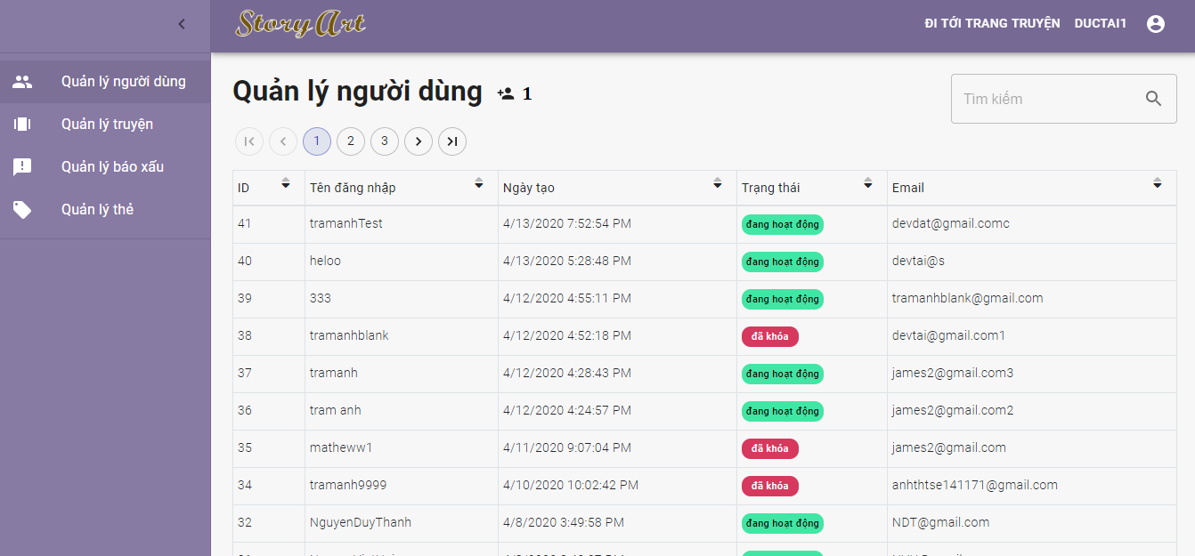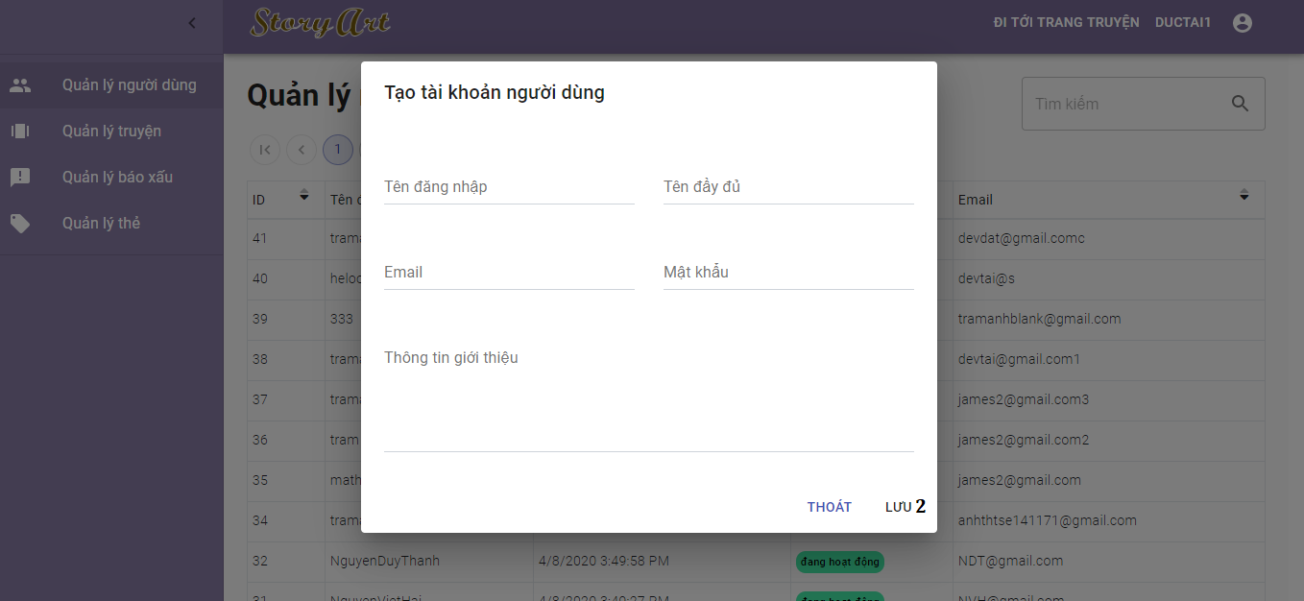

Figure 147 - <Admin> Create user guide

|  |  |
| --- | --- |
| **Step** | **Description** |
| Pre-condition | Login as role “Administrator” |
| 1 | Click on create user button |
| 2 | After filled all fields in popup, click on “Lưu” button to add user |

Table 205 - <Admin> Create user guide

#### 2.2.3 Deactivate/activate user

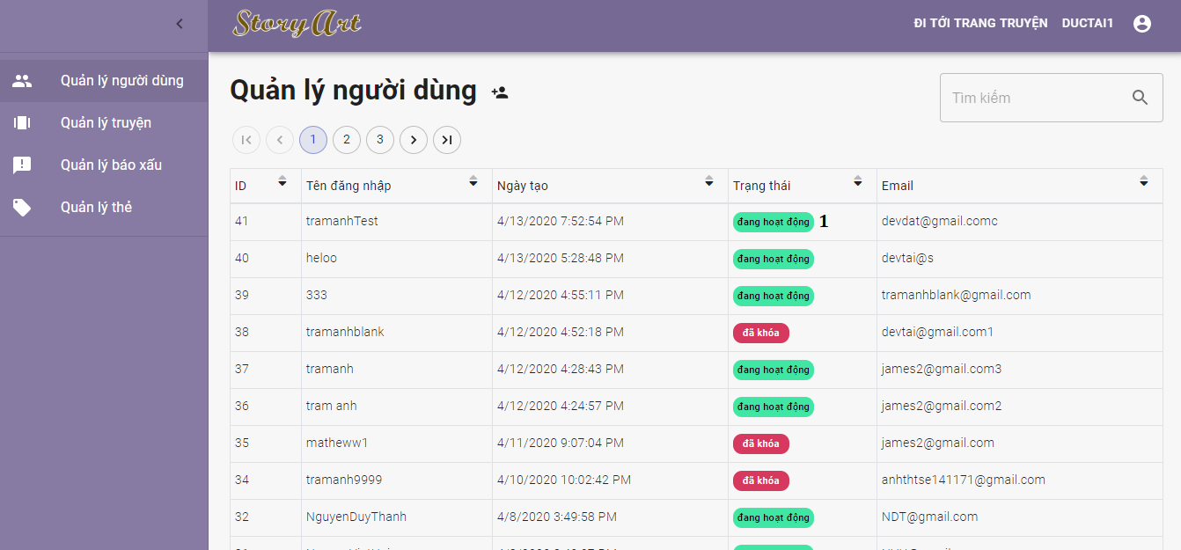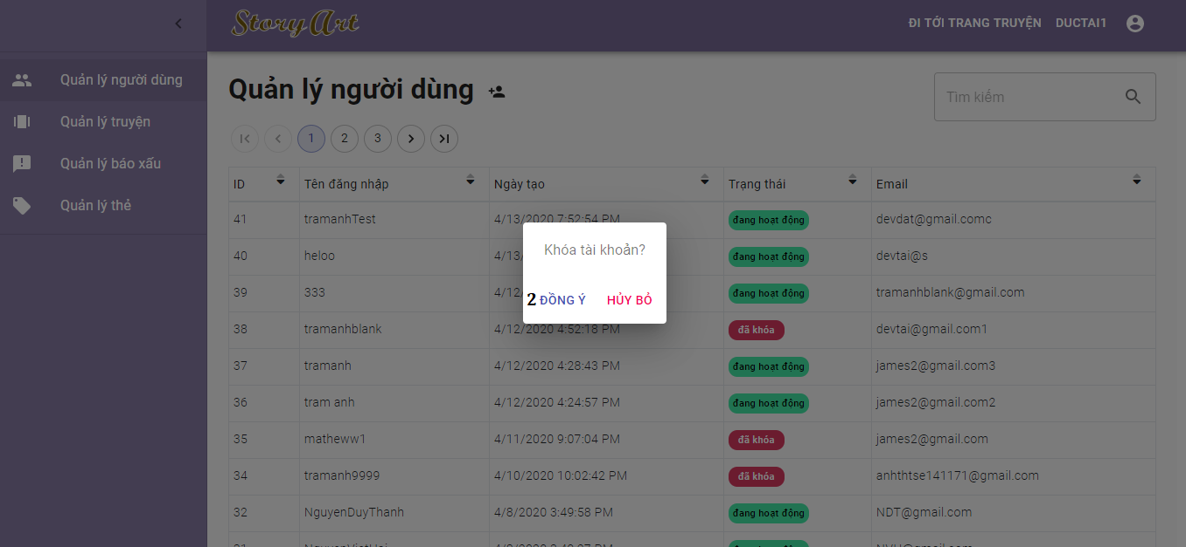

Figure 148 - <Admin> Deactivate/activate user

|  |  |
| --- | --- |
| **Step** | **Description** |
| Pre-condition | Login as role “Administrator” |
| 1 | Click on status of each user |
| 2 | Click on “Đồng ý” button shown in popup |

Table 206 - <Admin> Deactivate/activate user

#### 2.2.4 View story list

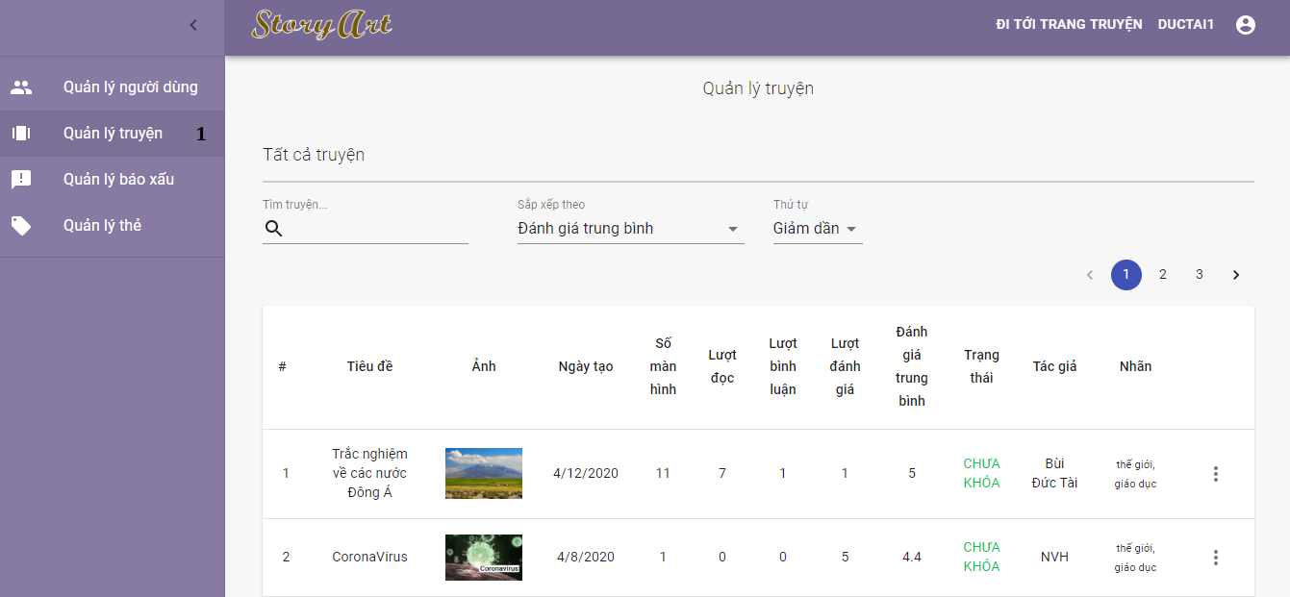

Figure 149 - <Admin> View story list

|  |  |
| --- | --- |
| **Step** | **Description** |
| Pre-condition | Login as role “Administrator” |
| 1 | Click on “Quản lý truyện” |

Table 207 - <Admin> View user list

#### 2.2.5 Deactivate/activate story

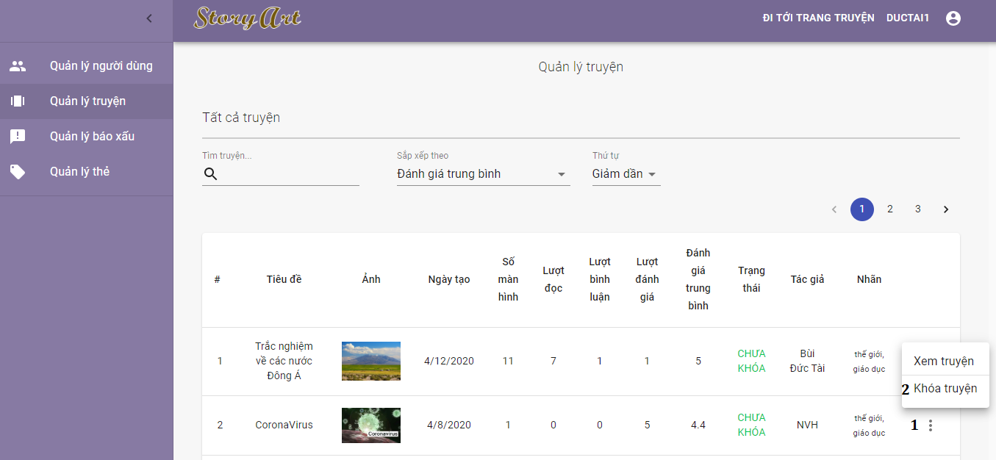

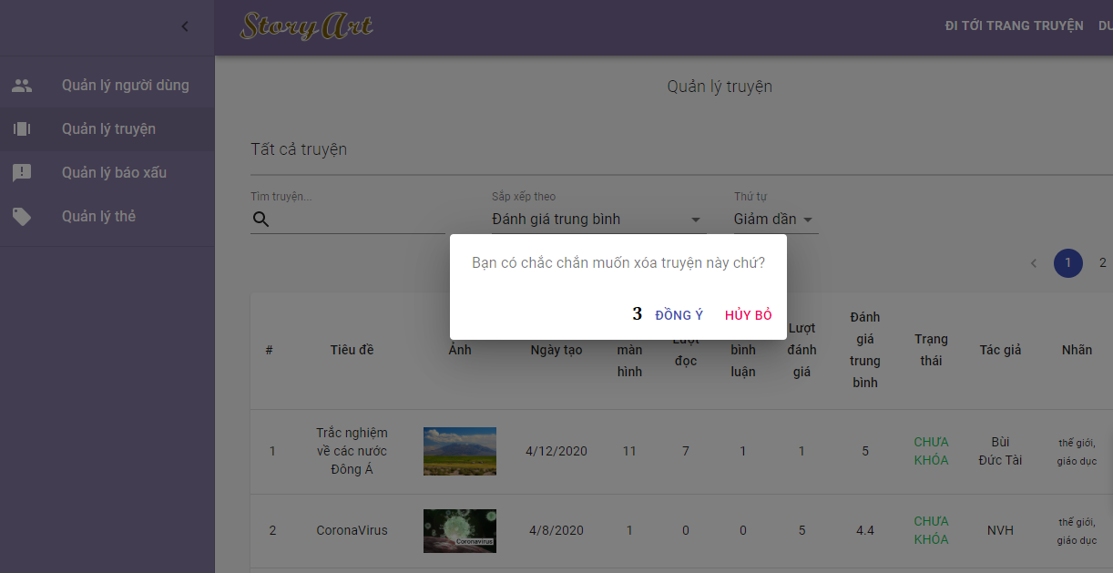

Figure 150 - <Admin> Deactivate/activate story

|  |  |
| --- | --- |
| **Step** | **Description** |
| Pre-condition | Login as role “Administrator” |
| 1 | Click on action button of each story. |
| 2 | Click on “Khóa truyện” or “Phục hồi truyện”. |
| 3 | Click on “Đồng ý” button |

Table 208 - <Admin> Deactivate/activate story

#### 2.2.6 View report list

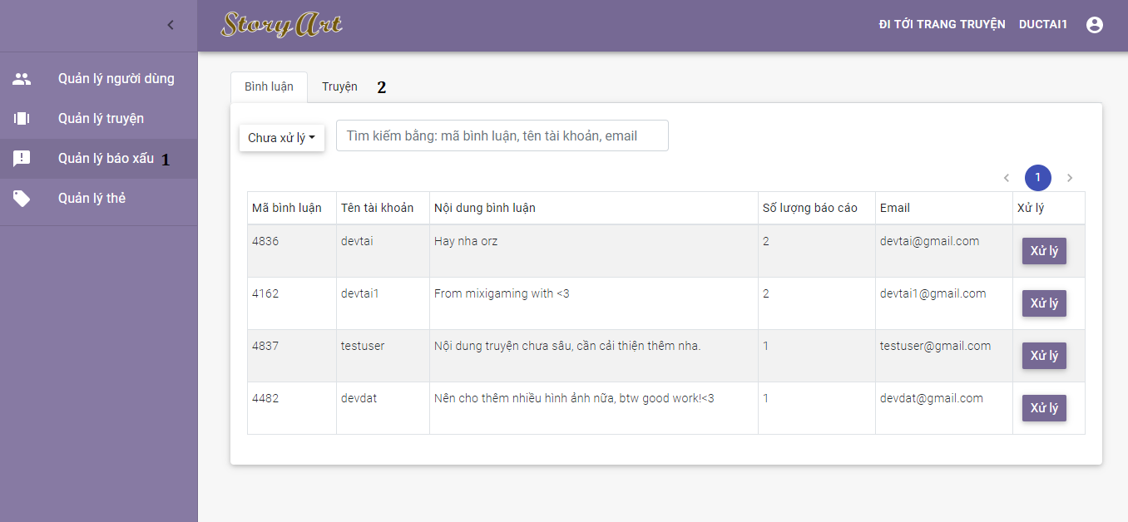

Figure 151 - <Admin> View report list

|  |  |
| --- | --- |
| **Step** | **Description** |
| Pre-condition | Login as role “Administrator” |
| 1 | Click on “Quản lý báo xấu” |
| 2 | Click on “Bình luận” or “Truyện” tab. |

Table 209 - <Admin> View report list

#### 2.2.7 Handle report

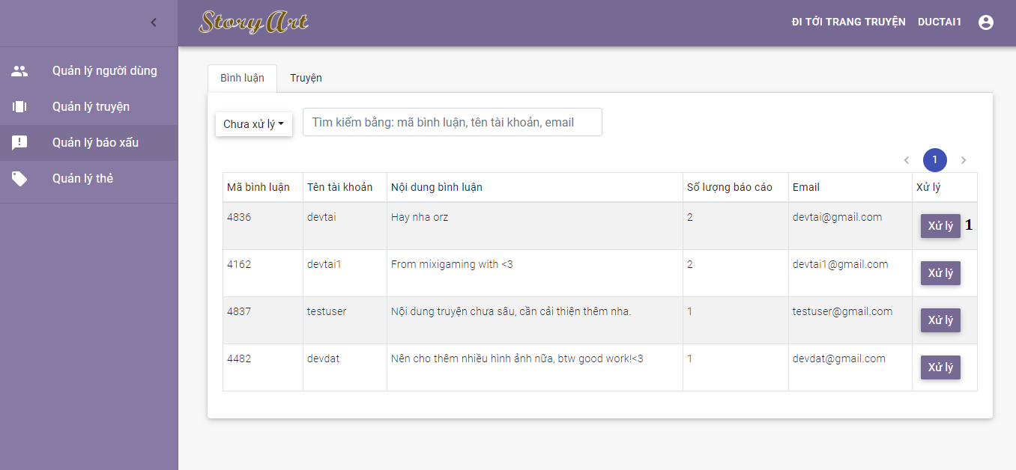

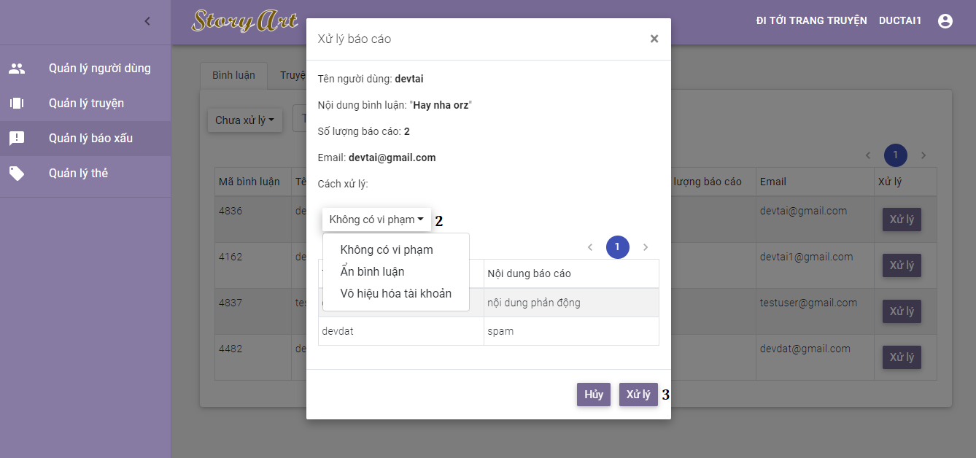

Figure 152 - <Admin> Handle report

|  |  |
| --- | --- |
| **Step** | **Description** |
| Pre-condition | Login as role “Administrator” |
| 1 | Click on “Xử lý” button |
| 2 | Choose handle type |
| 3 | Click on “Xử lý” button in popup |

Table 210 - <Admin> Handle report

#### 2.2.8 View tag list

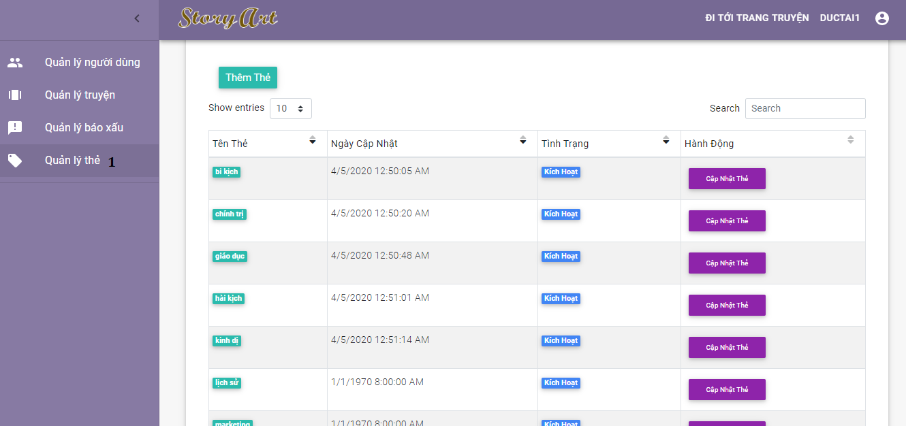

Figure 153 - <Admin> View tag list

|  |  |
| --- | --- |
| **Step** | **Description** |
| Pre-condition | Login as role “Administrator” |
| 1 | Click on “Quản lý thẻ” |

Table 211 - <Admin> View tag list

#### 2.2.9 Create tag

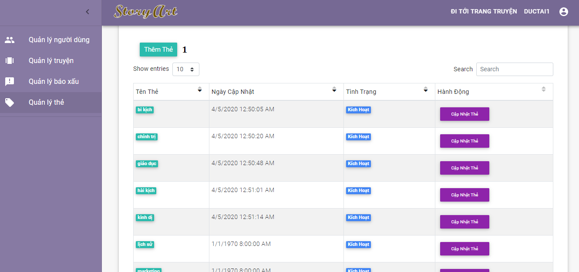

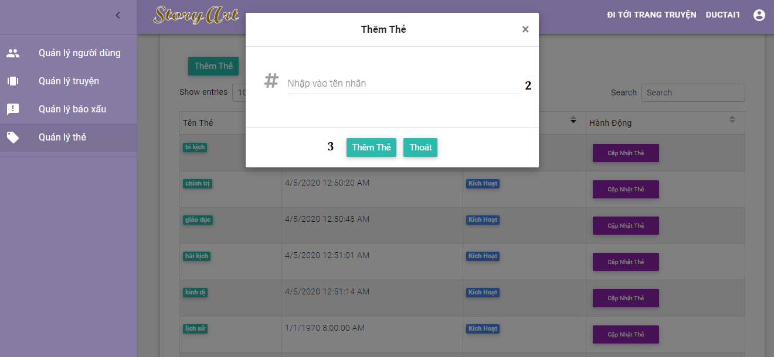

Figure 154 - <Admin> Create tag guide

|  |  |
| --- | --- |
| **Step** | **Description** |
| Pre-condition | Login as role “Administrator” |
| 1 | Click on “Thêm thẻ” button |
| 2 | Input tag name |
| 3 | Click on “Thêm thẻ” button |

Table 212 - <Admin> Create tag guide

#### 2.2.10 Update tag

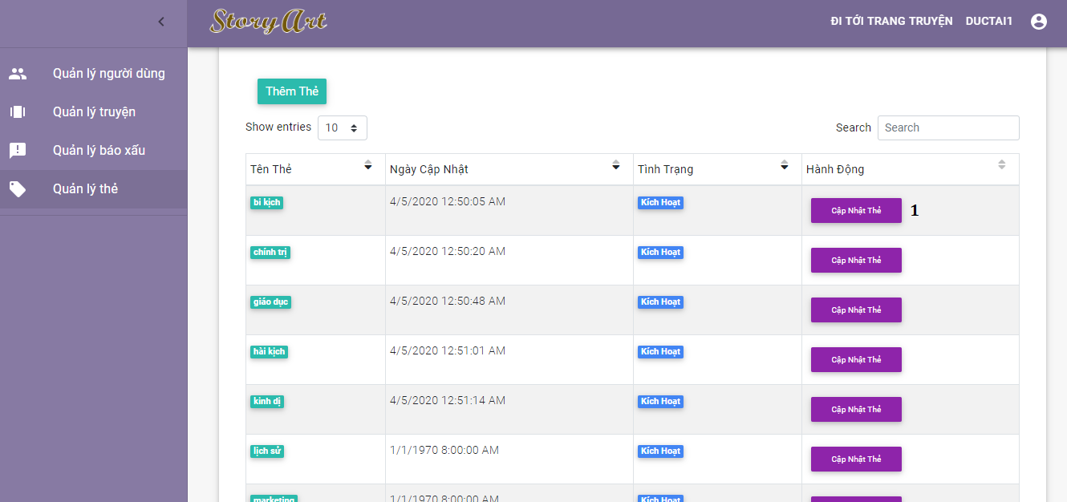

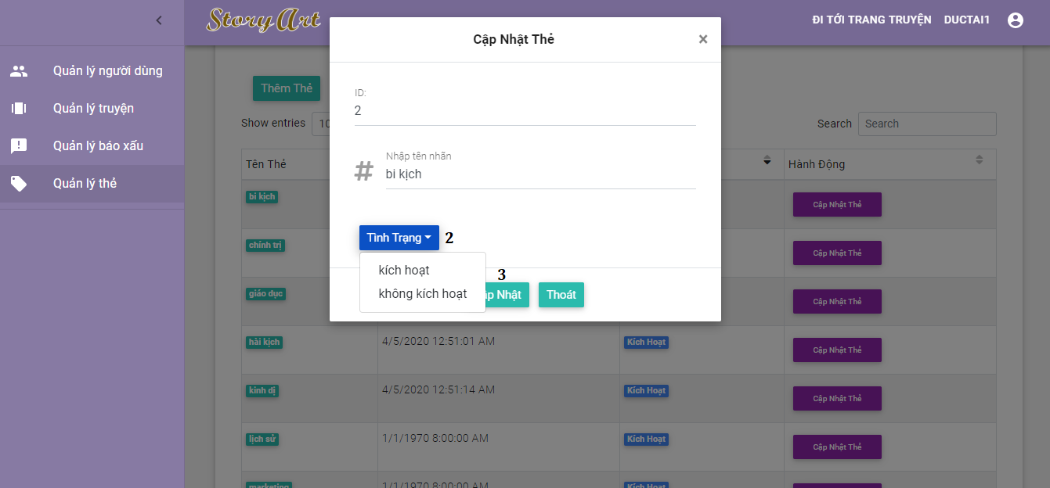

Figure 155 - <Admin> Update tag guide

|  |  |
| --- | --- |
| **Step** | **Description** |
| Pre-condition | Login as role “Administrator” |
| 1 | Click on “Cập nhật thẻ” button |
| 2 | Filled all fields in popup and choose tag status |
| 3 | Click on “Cập nhật” button |

Table 213 - <Admin> Update tag guide

### 2.3 User

#### 2.3.1 Generate story

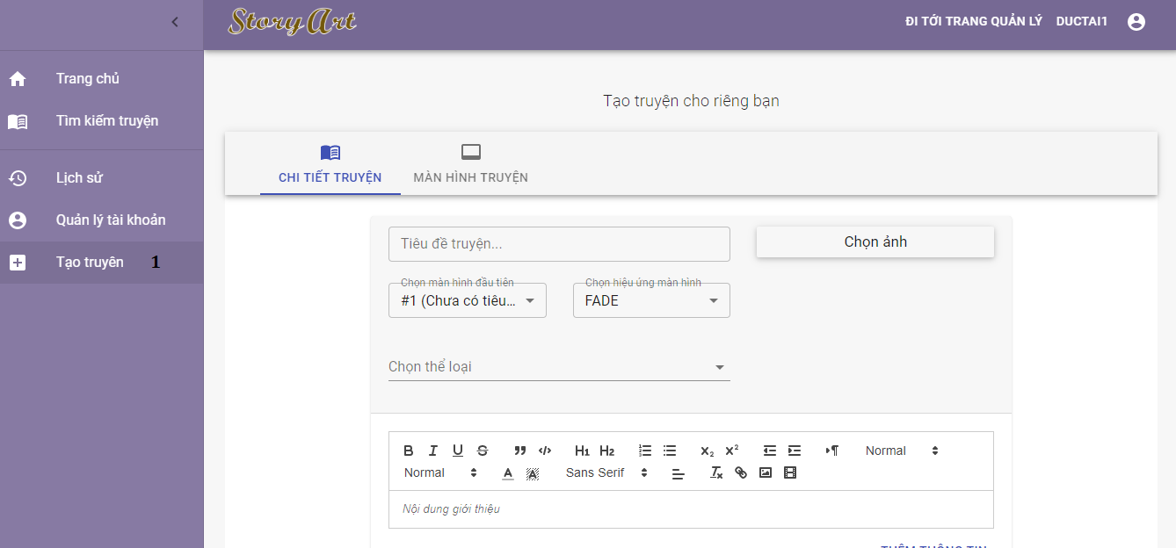

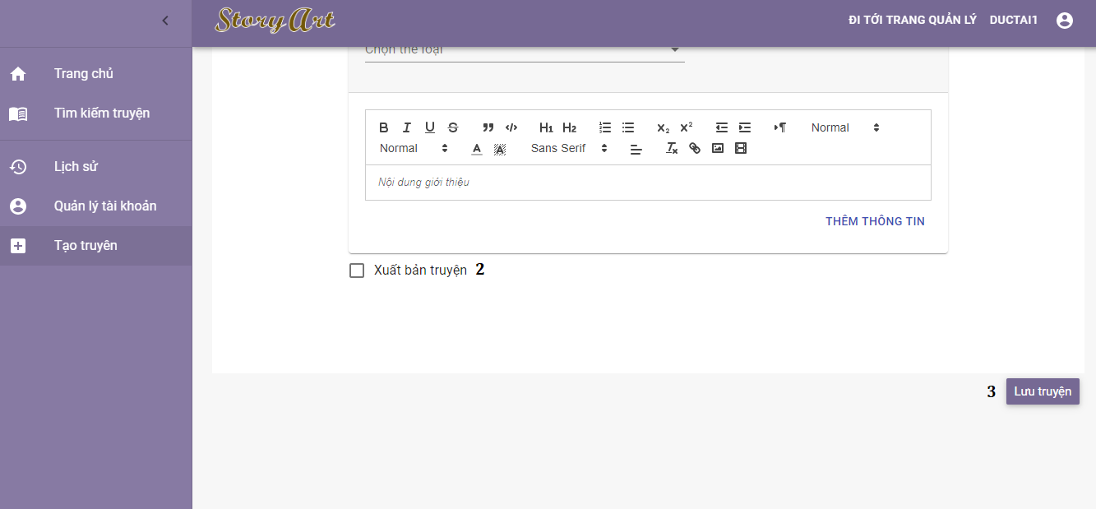

Figure 156 - <User> Generate story guide

|  |  |
| --- | --- |
| **Step** | **Description** |
| Pre-condition | Login as role “Authorized User” |
| 1 | Click on “Tạo truyện” |
| 2 | After filled all fields in popup, user choose “Xuất bản truyện” or not |
| 3 | Click on “Lưu truyện” button |

Table 214 - <User> Generate story guide

#### 2.3.2 Rate story

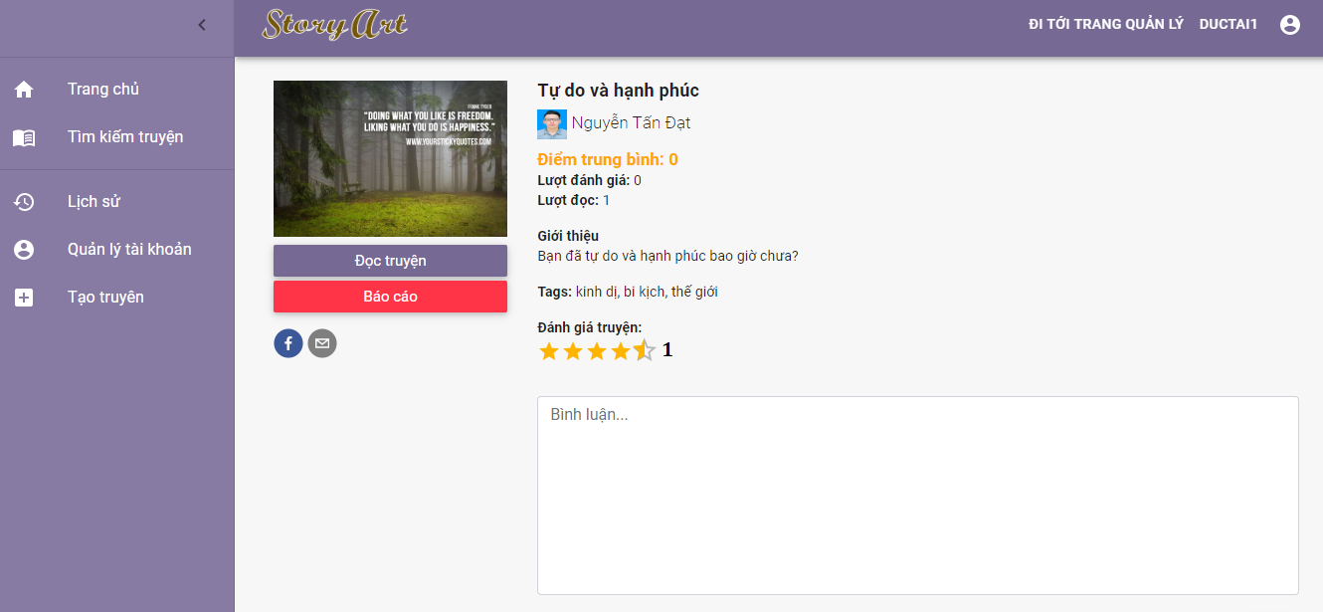

Figure 157 - <User> Rate story guide

|  |  |
| --- | --- |
| **Step** | **Description** |
| Pre-condition | Login as role “Authorized User” |
| 1 | Click on rating bar |

Table 215 - <User> Rate story guide

#### 2.3.3 Send comment

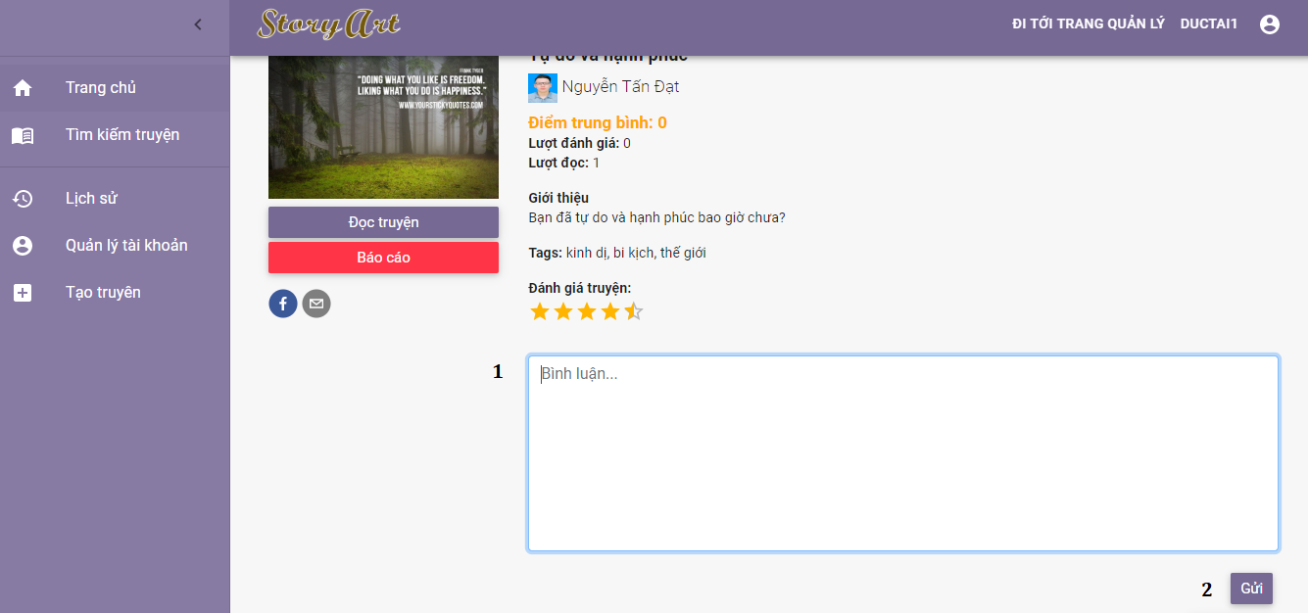

Figure 158 - <User> Send comment guide

|  |  |
| --- | --- |
| **Step** | **Description** |
| Pre-condition | Login as role “Authorized User” |
| 1 | Input comment content |
| 2 | Click on “Gửi” button |

Table 216 - <User> Send comment guide

#### 2.3.5 Report story

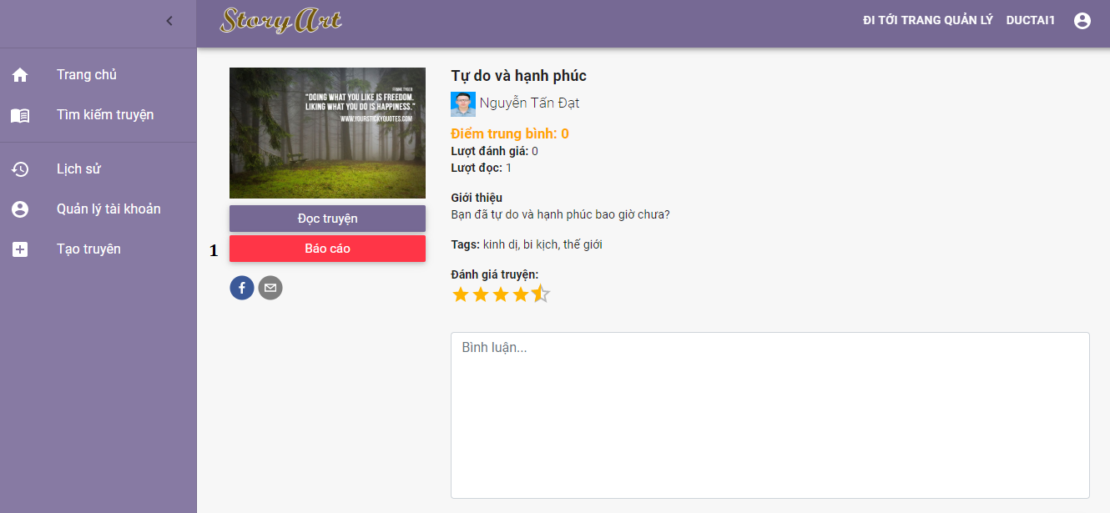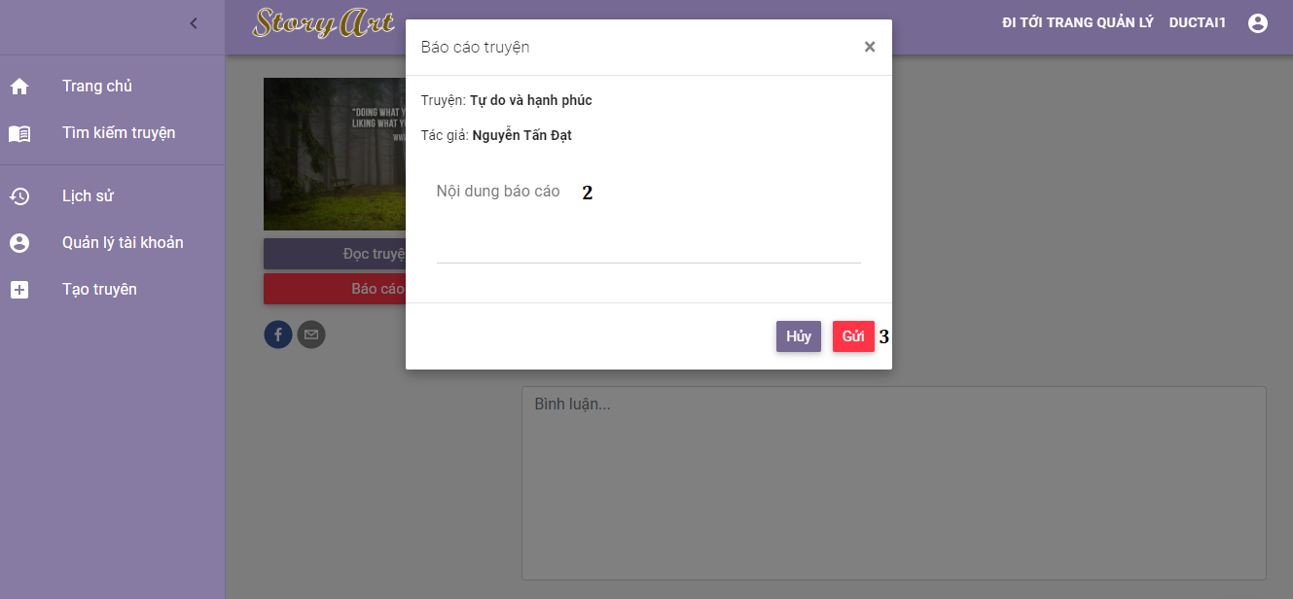

Figure 159 - <User> Report story guide

|  |  |
| --- | --- |
| **Step** | **Description** |
| Pre-condition | Login as role “Authorized User” |
| 1 | Click on “Báo cáo” button in story detail page |
| 2 | Input report content |
| 3 | Click on “Gửi” button |

Table 217 - <User> Report story guide

#### 2.3.6 Report comment

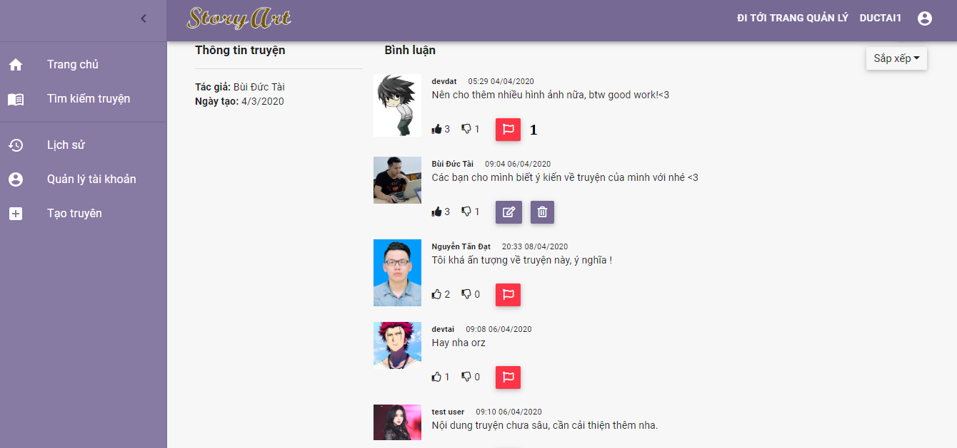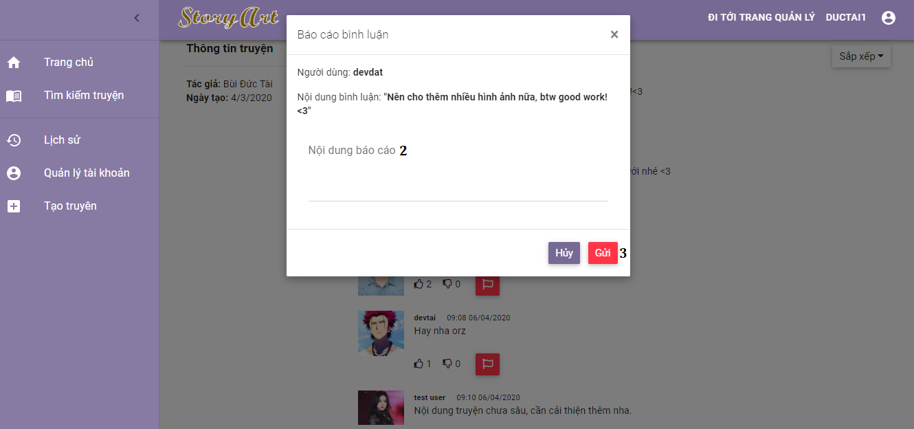

Figure 160 - <User> Report comment guide

|  |  |
| --- | --- |
| **Step** | **Description** |
| Pre-condition | Login as role “Authorized User” |
| 1 | Click on report button in comment list |
| 2 | Input report content |
| 3 | Click on “Gửi” button |

Table 218 - <User> Report comment guide

#### 2.3.7 Edit comment

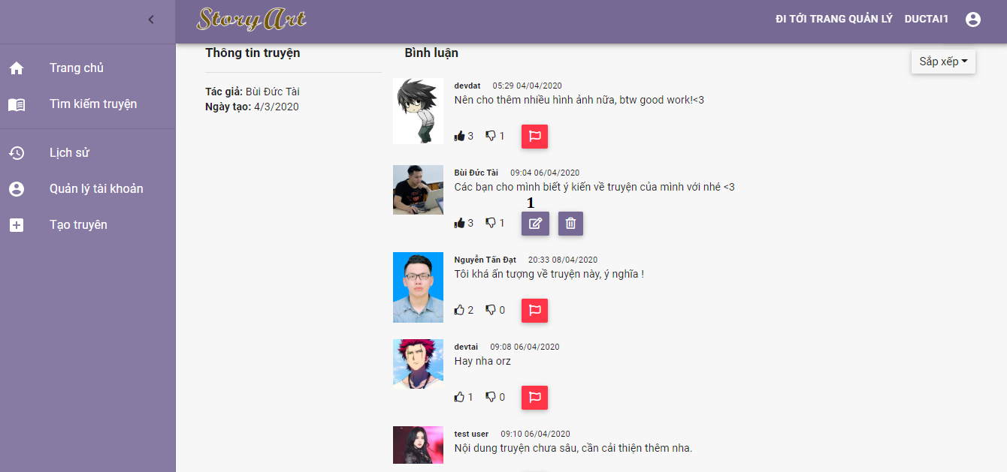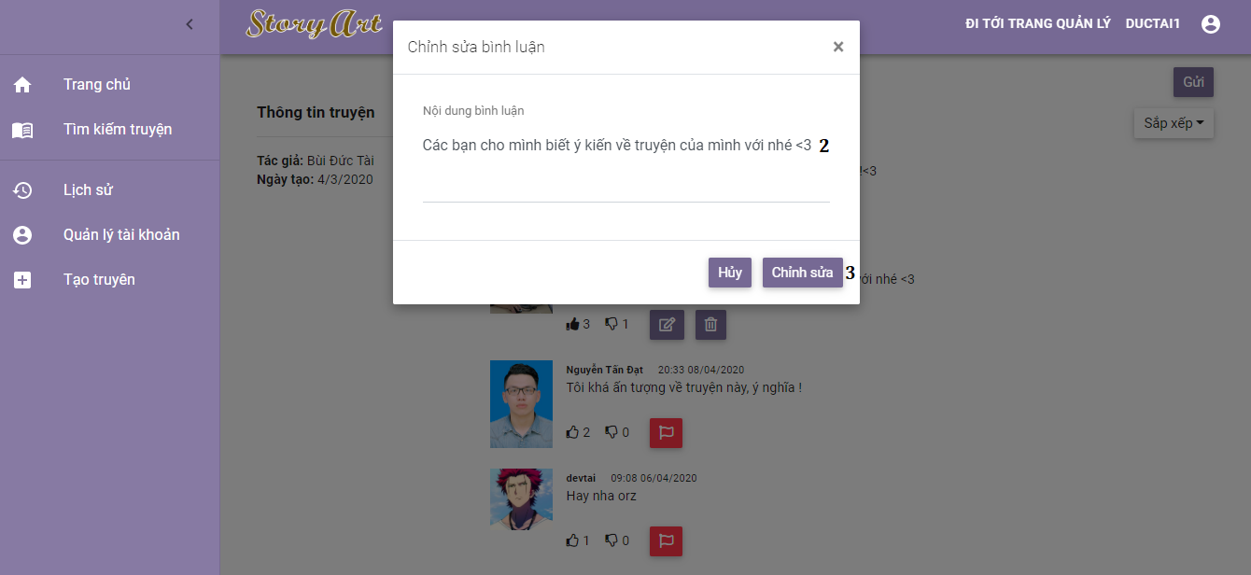

Figure 161 - <User> Edit comment guide

|  |  |
| --- | --- |
| **Step** | **Description** |
| Pre-condition | Login as role “Authorized User” |
| 1 | Click on edit button in comment list |
| 2 | Input comment content |
| 3 | Click on “Chỉnh sửa” button |

Table 219 - <User> Edit comment guide

#### 2.3.8 Delete comment

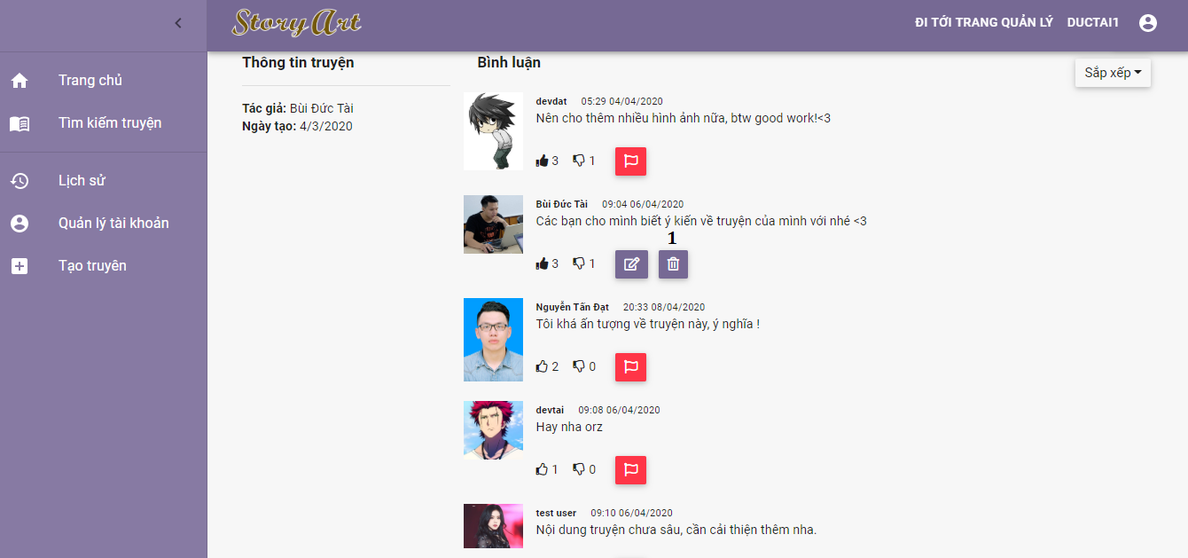

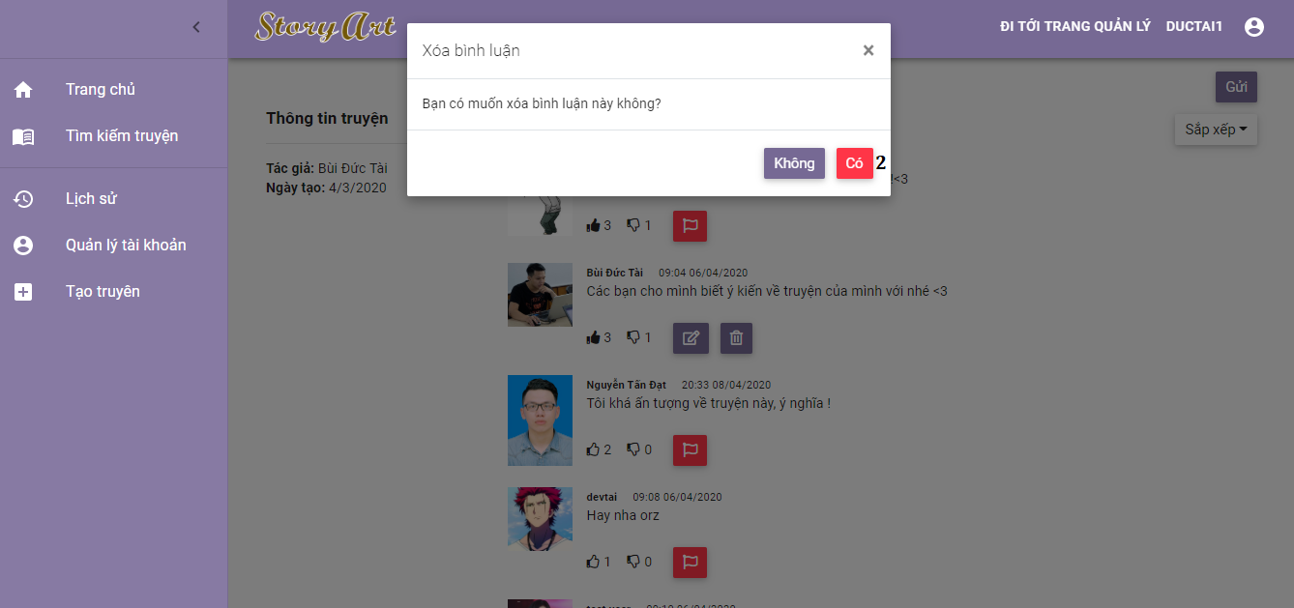

Figure 162 - <User> Edit comment guide

|  |  |
| --- | --- |
| **Step** | **Description** |
| Pre-condition | Login as role “Authorized User” |
| 1 | Click on delete button in comment list |
| 2 | Click on “Có” button |

Table 220 - <User> Edit comment guide

#### 2.3.9 View profile

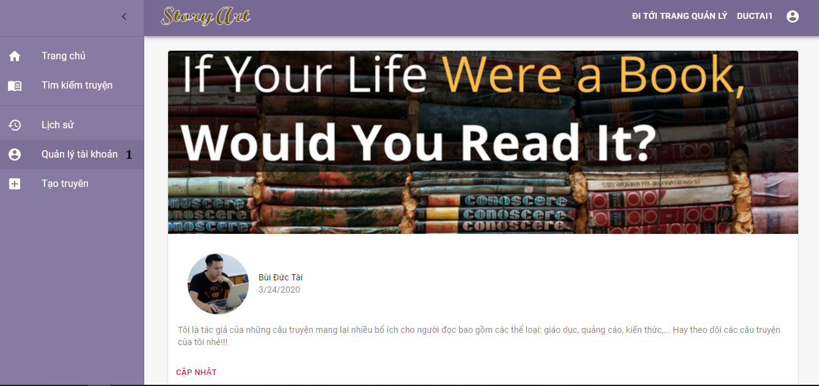

Figure 163 - <User> View profile guide

|  |  |
| --- | --- |
| **Step** | **Description** |
| Pre-condition | Login as role “Authorized User” |
| 1 | Click on “Quản lý tài khoản” |

Table 221 - < User > View profile guide

#### 2.3.10 Edit profile

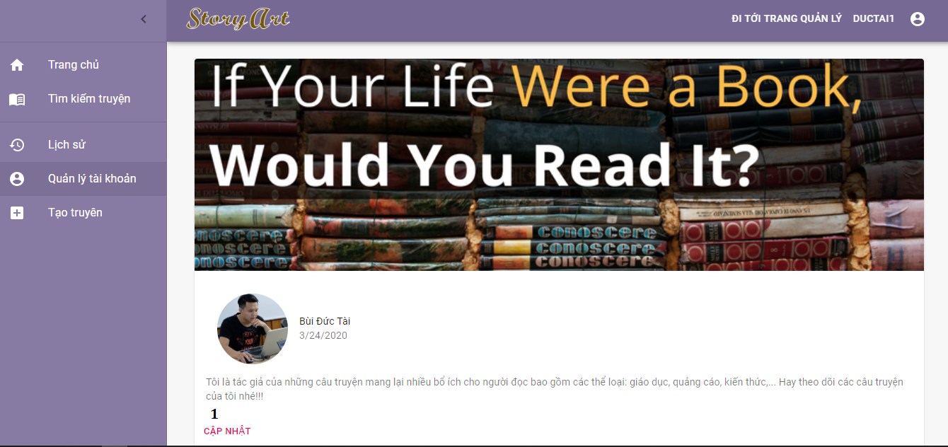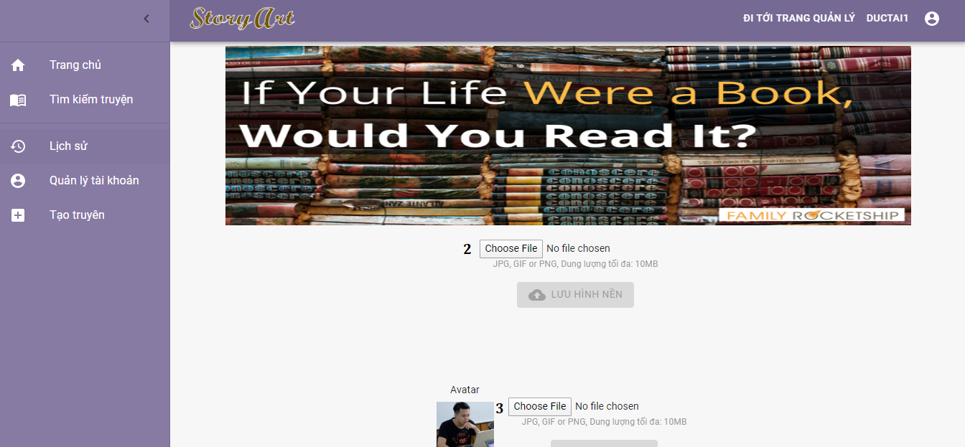

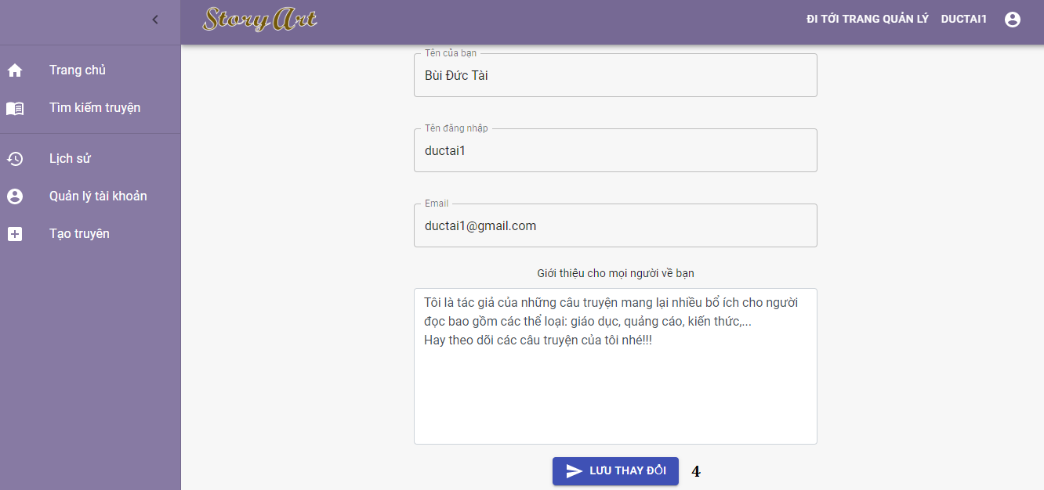

Figure 164 - <User> Edit profile guide

|  |  |
| --- | --- |
| **Step** | **Description** |
| Pre-condition | Login as role “Authorized User” |
| 1 | Click on “Cập nhật” button in comment list |
| 2 | Upload banner |
| 3 | Upload avatar |
| 4 | After filled all field, click on “Lưu thay đổi” button |

Table 222 - <User> Edit profile guide

#### 2.3.11 View story statistics

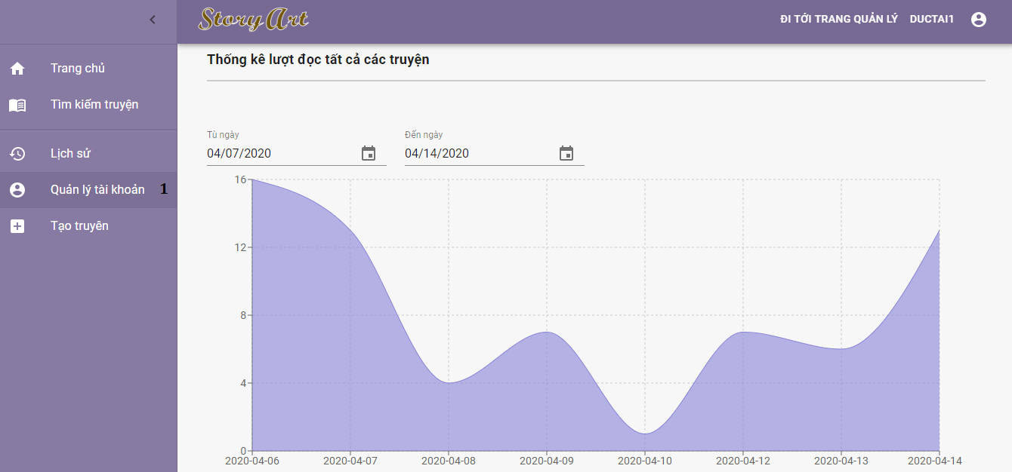

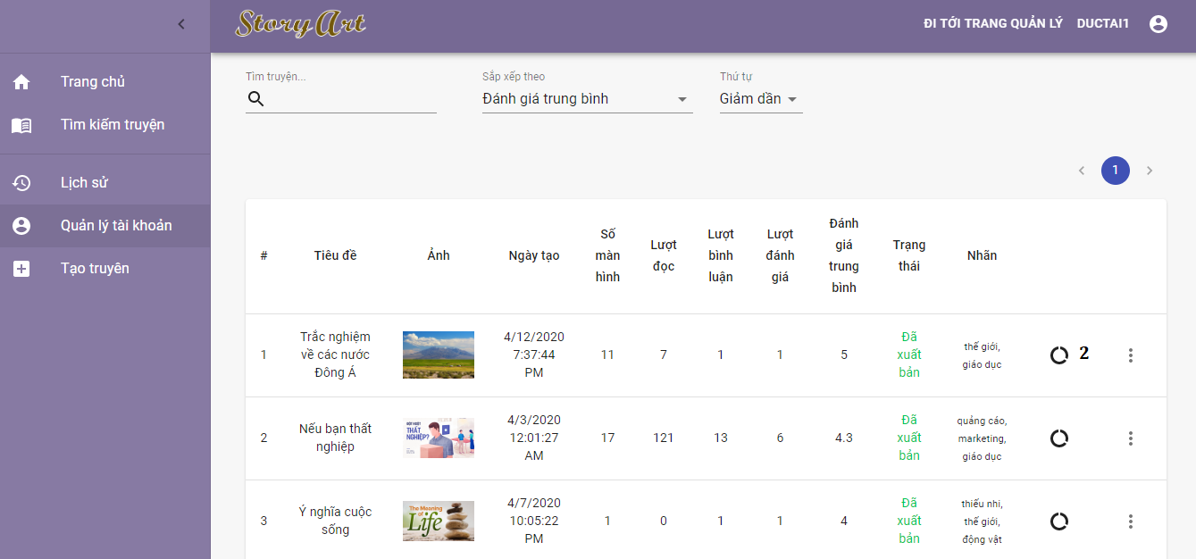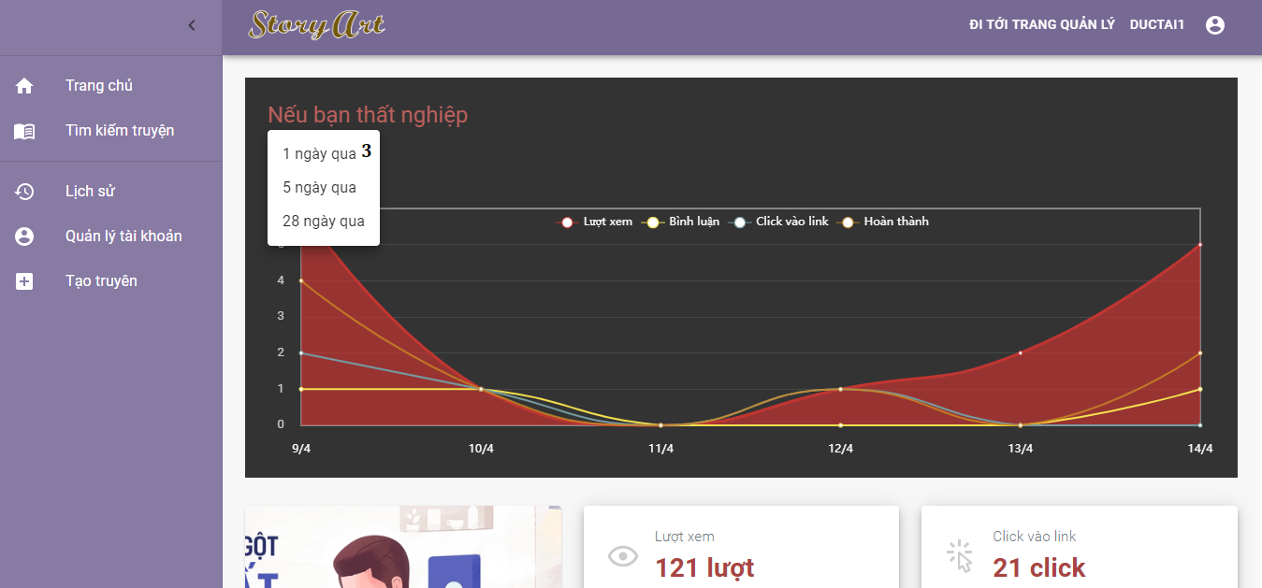

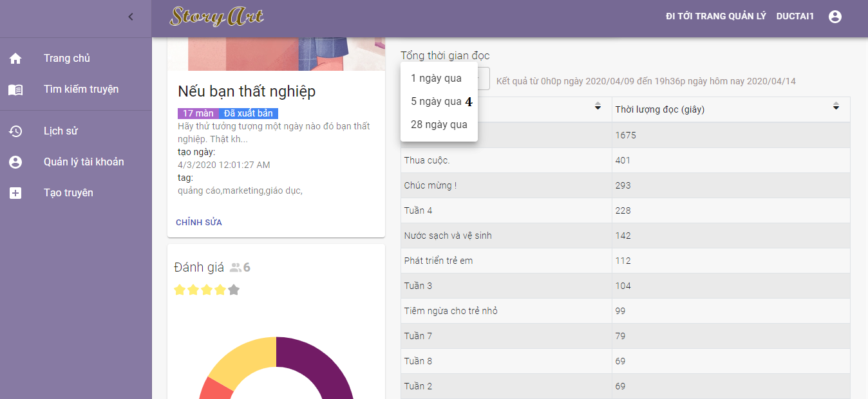

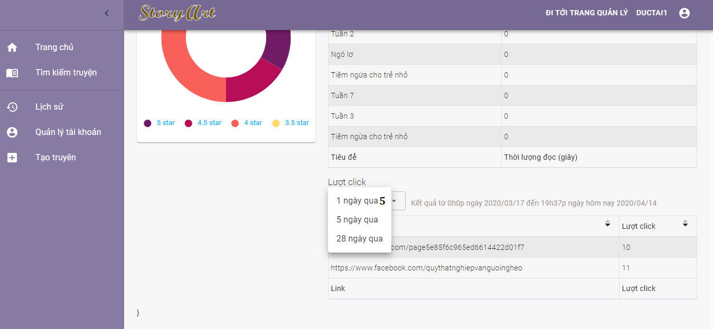

Figure 165 - <User> View story’s statistics guide

|  |  |
| --- | --- |
| **Step** | **Description** |
| Pre-condition | Login as role “Authorized User” |
| 1 | Click on “Quản lý tài khoản” |
| 2 | Click on view story’s statistics button |
| 3 | Choose days in dropdown box |
| 4 | Choose days in dropdown box |
| 5 | Choose days in dropdown box |

Table 223 - < User > View story’s statistics guide

### 2.4 Guest

#### 2.4.1 Search story

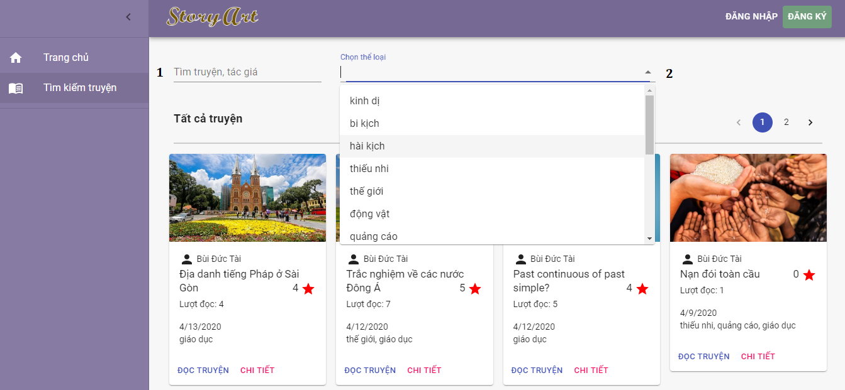

Figure 166 - <Guest> Search story guide

|  |  |
| --- | --- |
| **Step** | **Description** |
| Pre-condition | Guest access to the website |
| 1 | Input name of story |
| 2 | Select tag want to search |

Table 224 - <Guest> Search story guide

#### 2.4.2 Read story

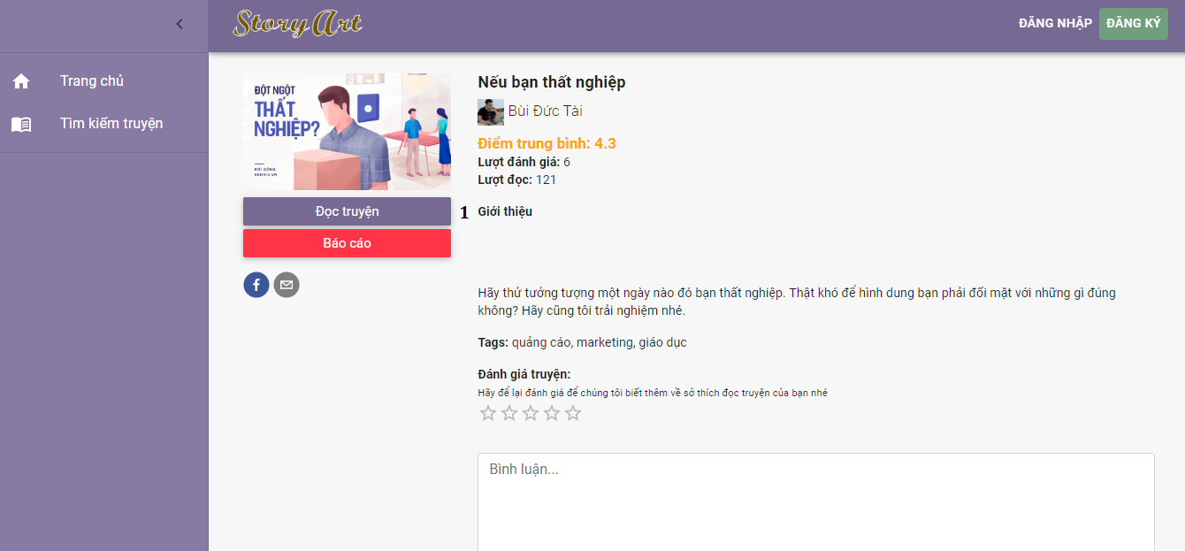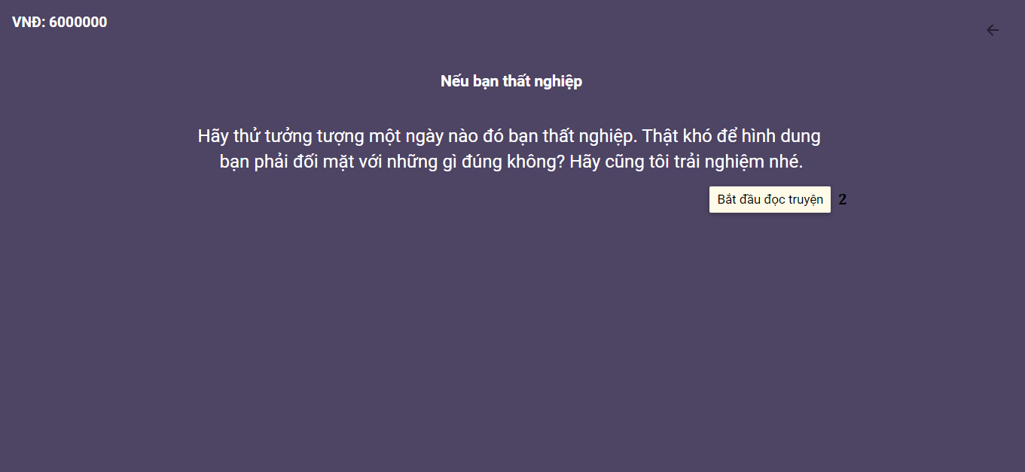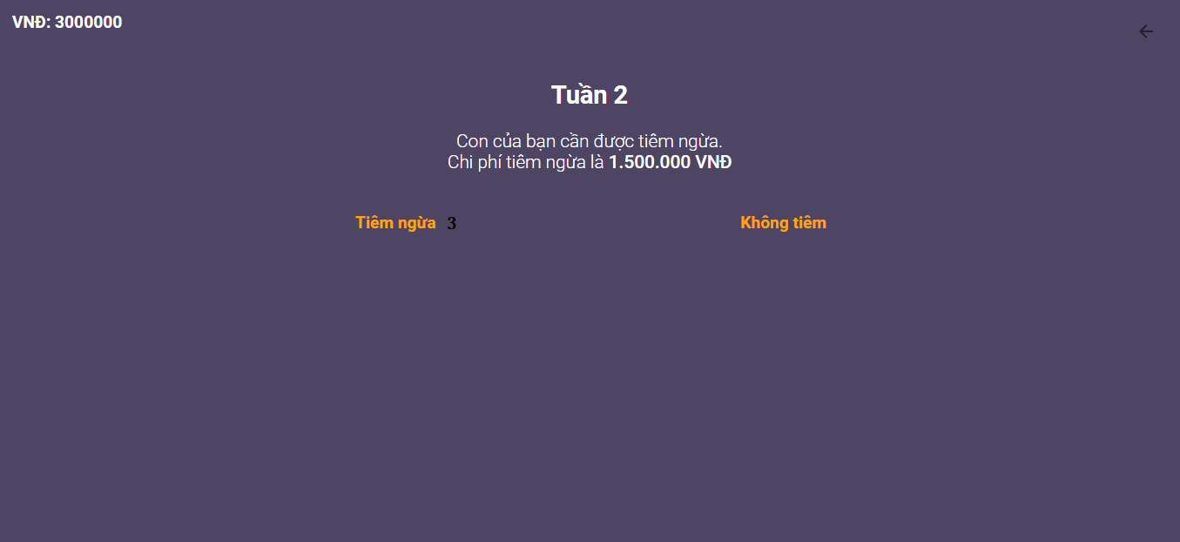

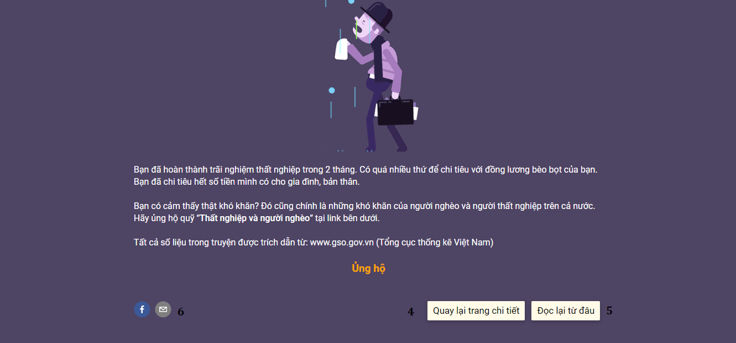

Figure 167 - <Guest> Search story guide

|  |  |
| --- | --- |
| **Step** | **Description** |
| Pre-condition | Guest access to the website |
| 1 | Click on “Đọc truyện” button |
| 2 | Click on “Bắt đầu đọc truyện” button |
| 3 | Choose action |
| 4 | Back to detail page |
| 5 | Read again |
| 6 | Share story |

Table 225 - <Guest> Search story guide

# G. Appendix

1. **The Unified Modeling Language** *[Online]* Available: <https://www.omg.org/spec/UML/2.0/About-UML/> Accessed on: Jan. 2020.
2. **Multitier Architecture** *[Online]* Available: <https://www.ibm.com/support/knowledgecenter/en/SSAW57_8.5.5/com.ibm.websphere.nd.multiplatform.doc/ae/covr_3-tier.html> Accessed on: Jan. 2020.
3. Chen, P.P., "The Entity-Relationship Model: Toward a Unified View of Data". *ACM Trans. on Database Systems*.
4. **MySQL** *[Online]* Available: <https://dev.mysql.com/doc/> Accessed on: Jan. 2020.
5. **Spring Framework** *[Online]* Available: <https://spring.io/docs> Accessed on: Jan. 2020.
6. **ReactJS** *[Online]* Available: <https://reactjs.org/docs/getting-started.html> Accessed on: Jan. 2020.
7. **Material-UI** *[Online]* Available: <https://material-ui.com/getting-started/installation/> Accessed on: Jan. 2020.
8. **MDB React** *[Online]* Available: <https://mdbootstrap.com/docs/react/> Accessed on: Jan. 2020.
9. **Vis-Network** *[Online]* Available:<https://visjs.github.io/vis-network/docs/network/> Accessed on: Jan. 2020.
10. **Recharts** *[Online]* Available: <https://recharts.org/en-US/guide> Accessed on: Jan. 2020.
11. **ChartJs** *[Online]* Available:<https://www.chartjs.org/docs/latest/> Accessed on: Jan. 2020.
12. **EChart** *[Online]* Available: <https://echarts.apache.org/en/tutorial.html> Accessed on: Jan. 2020.